**This software package consists of an excel document "cheque.xls" and a ruby program "final.rb". Please ensure that both these files are present in the same working directory.**

**For Ubuntu users.**

$ sudo apt-get install ruby-full

Use the preceding command on the terminal to install Ruby, and jump to point **3)Ruby Gems 'spreadsheet' and 'prawn'**. Continue from then on.

**For Windows Users.**

**Requirements :**

1) Ruby version 2.0 or above (INCLUDED IN SOFTWARES)

2) Ruby Development Kit (INCLUDED IN SOFTWARES)

3) Ruby Gems 'spreadsheet' , 'prawn', and 'rupees'.

**1) Installing Ruby :-**

* Double click on the "rubyinstaller-2.1.6" given in the software folder.(Or download via the hyperlink given at the end of the document)
* Select language English and continue.
* Click on "I accept the license" radio button and Click "Next".
* Follow the steps shown in the following image.

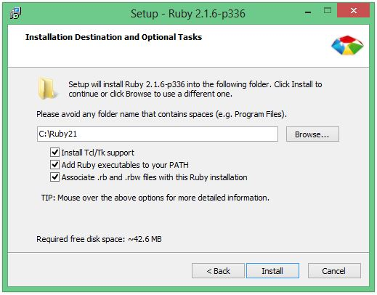

* Click on "Install".
* Click on Finish to complete the setup.

**2) Installing Devkit**

* Double click on "DevKit-mingw64-32-4.7.2-20130224-1151-sfx" given in the Softwares folder.(Or download via the hyperlink given at the end of the document)
* Extract to "C:\DevKit" as shown in the image below.
* Click on Extract.

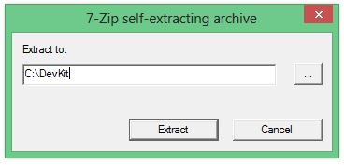

* Now open Command Prompt. ( Type "Windows+R" shortcut for Run and in the dialog box type "cmd"). Click on OK.

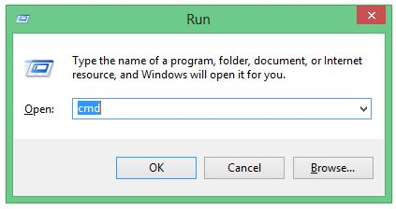

* In command prompt type " cd C:\DevKit " and press Enter.
* Now type " ruby dk.rb init " and press Enter.
* Now type " ruby dk.rb install " and press Enter.

**3)Installing Ruby Gems**

* Open Command Prompt ( as before )
* Type " gem install spreadsheet " and press Enter. **Ensure that you get the message "gem installed".**
* **If you get an error Type the command again and run it.**

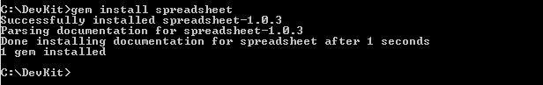

* Now type " gem install prawn " and press Enter. **Ensure that you get the message "gem installed".**
* **If you get an error Type the command again and run it.**

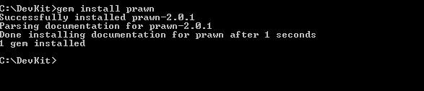

* To install Gem ‘rupees’ we follow a different method. Open command prompt.
* Navigate to ‘ PrintCheques\Softwares\Ruby_Rupees\rupees-0.1.0’ folder within the main Folder provided.(use cd)
* Run following command “gem install rupees-0.1.0.alpha.1.gem”

**4)Running the program**

Open notepad and create a new document.

* Enter the following 2 lines in the document as shown. The blue highlighted line needs to be the address of the folder where the application is stored.
* Save the file as "Run.bat" .

**This is only a one time requirement.**

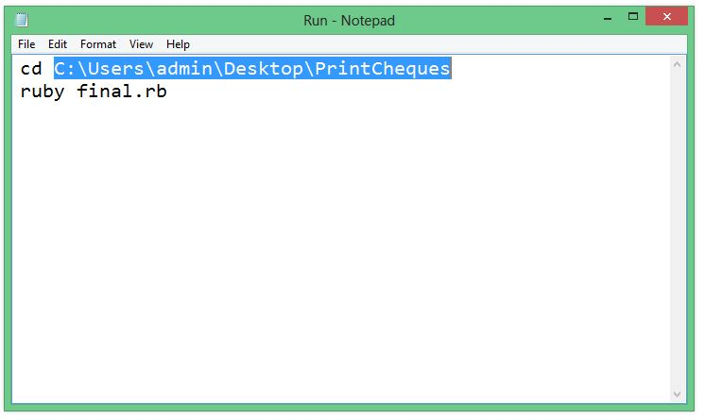

* Now double click on Run.bat file. (**Ensure that Printpdf file is not open at this time.**)

The input that you entered in "cheque.xls" is now formatted into "Printpdf.pdf" file.

* Open the Printpdf file and Click on Print.
* Goto "PageSetup" option at the bottom left of the dialog box.
* Set the paper Size as "Custom".

Click on "Print" .Now you can Print the cheques successfully.

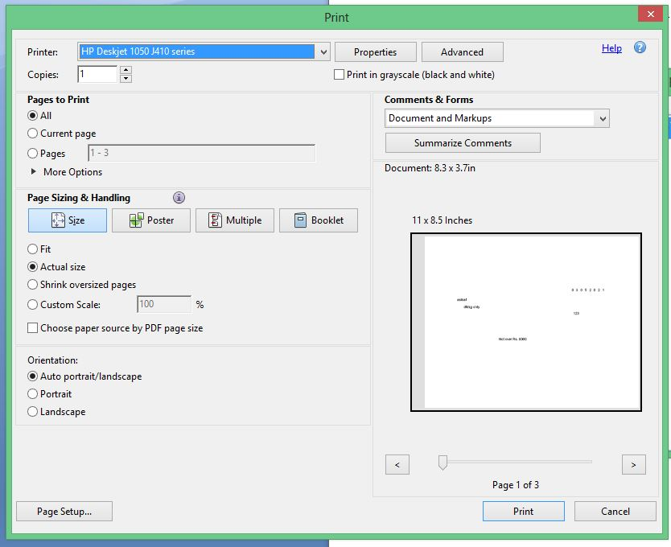

**ONLINE REPOSITORY**

Link for Ruby installer for windows:

<http://dl.bintray.com/oneclick/rubyinstaller/rubyinstaller-2.1.6.exe>

Link for Ruby Development Kit for windows:

<http://dl.bintray.com/oneclick/rubyinstaller/DevKit-mingw64-32-4.7.2-20130224-1151-sfx.exe>

In case of problems feel free to mail at

[shantanu110795@gmail.com](mailto:shantanu110795@gmail.com)

sherkipraneet@gmail.com