**This software package consists of an excel document "master.xls" and a ruby program "parsing.rb". Please ensure that both these files are present in the same working directory.**

**For Ubuntu users.**

$ sudo apt-get install ruby-full

Use the preceding command on the terminal to install Ruby, and jump to point **3)Ruby Gems 'spreadsheet' and 'prawn'**. Continue from then on.

**For Windows Users.**

**Requirements :**

1) Ruby version 2.0 or above (INCLUDED IN SOFTWARES)

2) Ruby Development Kit (INCLUDED IN SOFTWARES)

3) Ruby Gem 'spreadsheet' .

**1) Installing Ruby :-**

* Double click on the "rubyinstaller-2.1.6" given in the software folder.(Or download via the hyperlink given at the end of the document)
* Select language English and continue.
* Click on "I accept the license" radio button and Click "Next".
* Follow the steps shown in the following image.

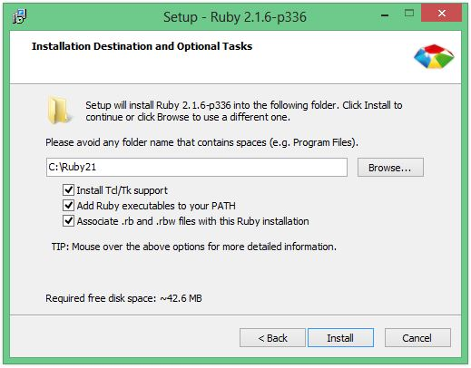

* Click on "Install".
* Click on Finish to complete the setup.

**2) Installing Devkit**

* Double click on "DevKit-mingw64-32-4.7.2-20130224-1151-sfx" given in the Softwares folder.(Or download via the hyperlink given at the end of the document)
* Extract to "C:\DevKit" as shown in the image below.
* Click on Extract.

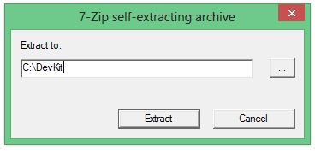

* Now open Command Prompt. ( Type "Windows+R" shortcut for Run and in the dialog box type "cmd"). Click on OK.

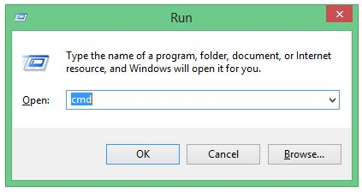

* In command prompt type " cd C:\DevKit " and press Enter.
* Now type " ruby dk.rb init " and press Enter.
* Now type " ruby dk.rb install " and press Enter.

**3)Installing Ruby Gems**

* Open Command Prompt ( as before )
* Type " gem install spreadsheet " and press Enter. **Ensure that you get the message "gem installed".**
* **If you get an error Type the command again and run it.**

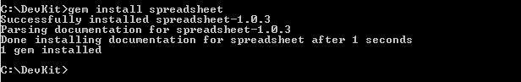

**4)Running the program**

Open notepad and create a new document.

* Enter the following 2 lines in the document as shown. The blue highlighted line needs to be the address of the folder where the application is stored.
* Save the file as "Run.bat" .

**This is only a one time requirement.**

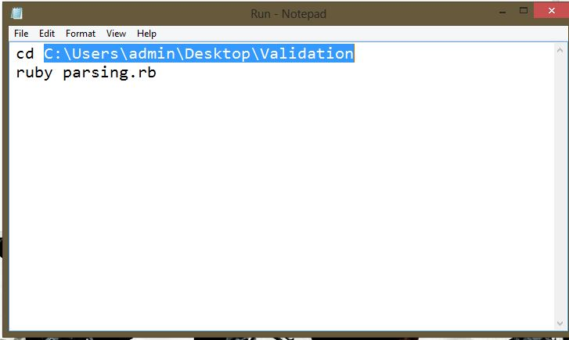

* Now double click on Run.bat file. (**Ensure that errors file is not open at this time.**)

Ensure that the UDI file to be checked for errors is named as "udi" in .xls format and is present in the same directory. Now the file is checked with reference to "master" and the rows which contain errors are highlighted in the new document that has been generated "errors.xls".

**ONLINE REPOSITORY**

Link for Ruby installer for windows:

<http://dl.bintray.com/oneclick/rubyinstaller/rubyinstaller-2.1.6.exe>

Link for Ruby Development Kit for windows:

<http://dl.bintray.com/oneclick/rubyinstaller/DevKit-mingw64-32-4.7.2-20130224-1151-sfx.exe>

In case of problems feel free to mail at

[shantanu110795@gmail.com](mailto:shantanu110795@gmail.com)

sherkipraneet@gmail.com