1. Drag folder

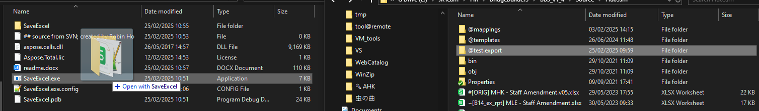

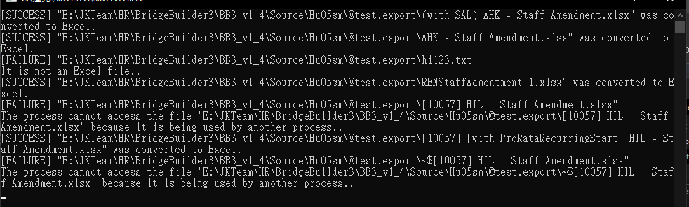

1. Drag single file

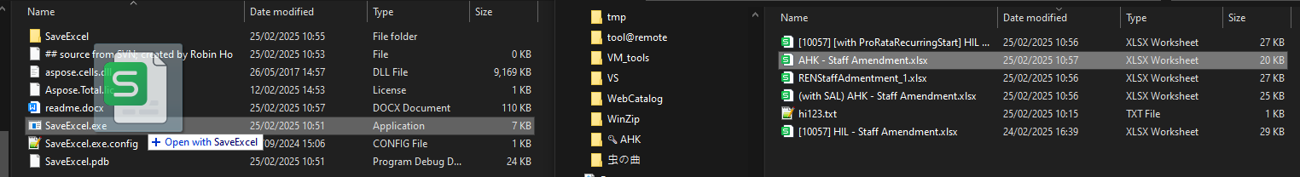

when success:



when failed:

