RGB-Controller Setup Guide

1. First, make sure your LEDs are 12V.
2. Download the Blynk app on Play store or Appstore.

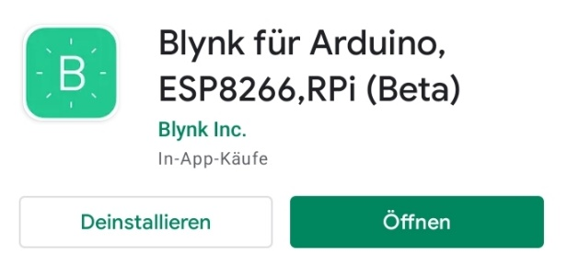

1. Click the “Scan QR-code” button and scan the QR-code.

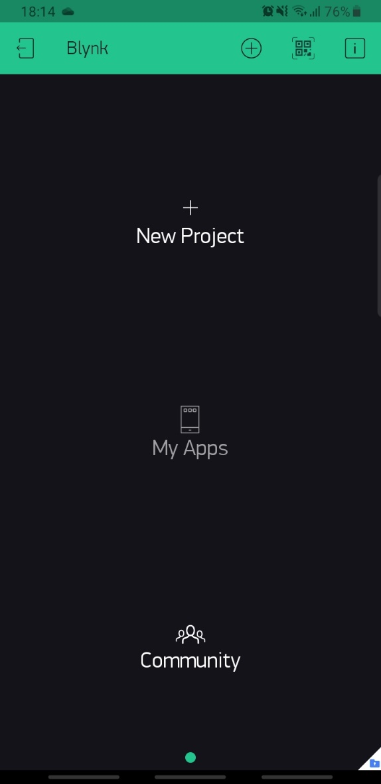

1. Click the Settings button and go to the “Devices” tab.

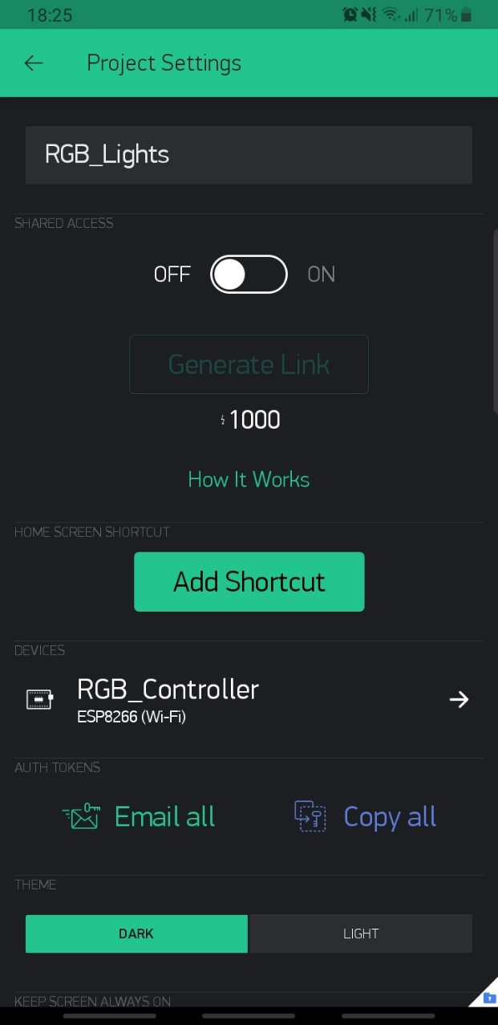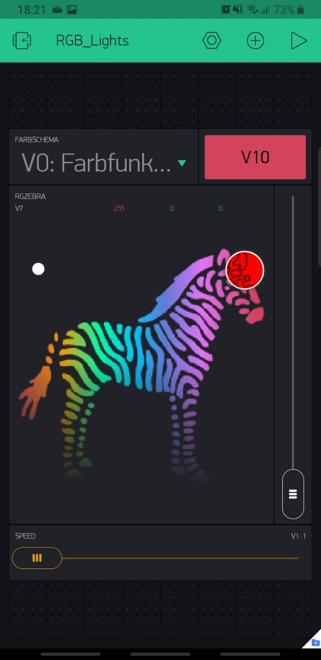

1. Click on “RGB_Controller”.

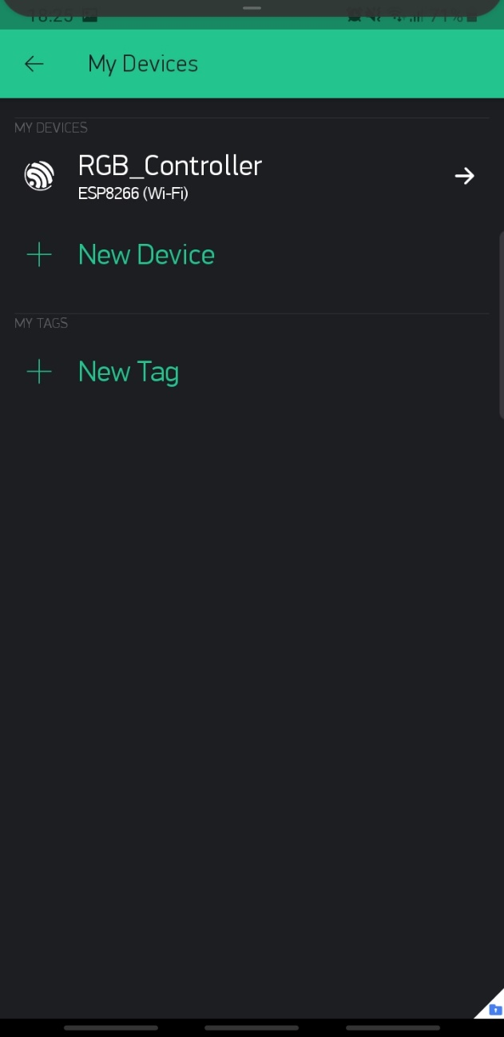

1. Click the Auth Token text. It will copy the token to your clipboard.

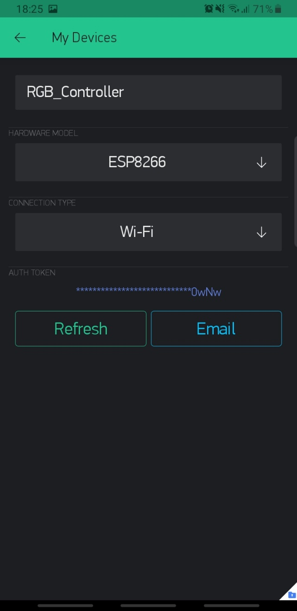

1. Take the lid off the RGB-Controller.
2. Supply the RGB-Controller with 12V via the power jack or the screw terminal.
3. 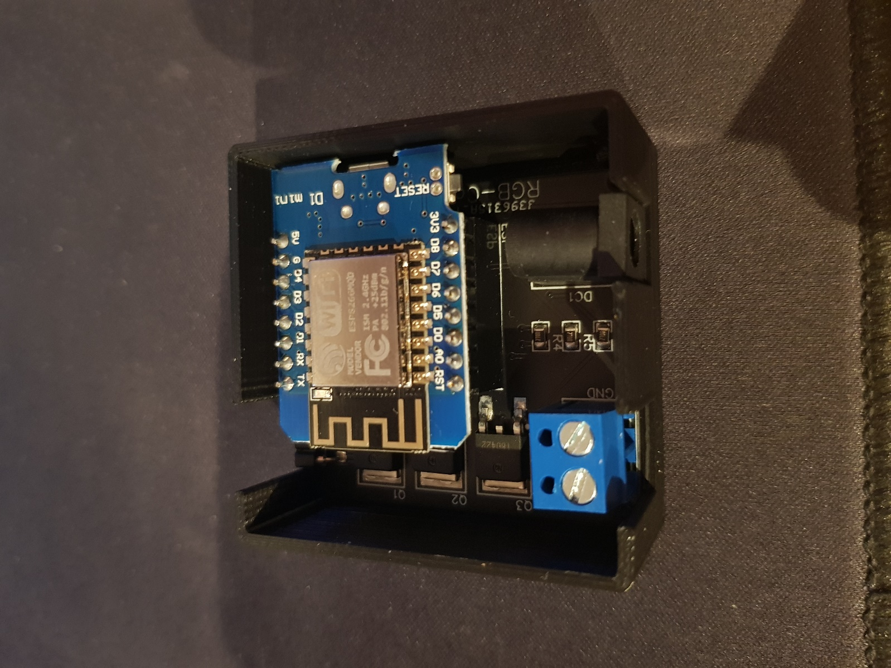Double-Click the “Reset” button.
4. 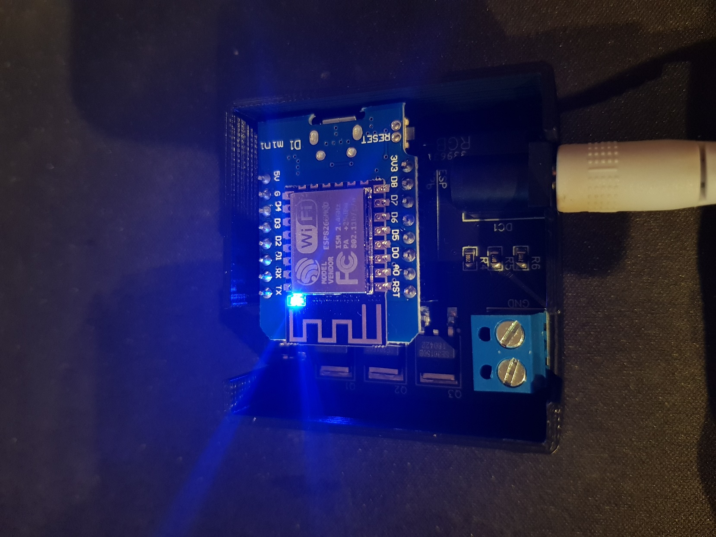Now a blue LED should be lit. If it doesn’t, try Double-Clicking the button again.
5. Now open the Wi-Fi settings on your phone and connect to the RGB Controller Wi-Fi.

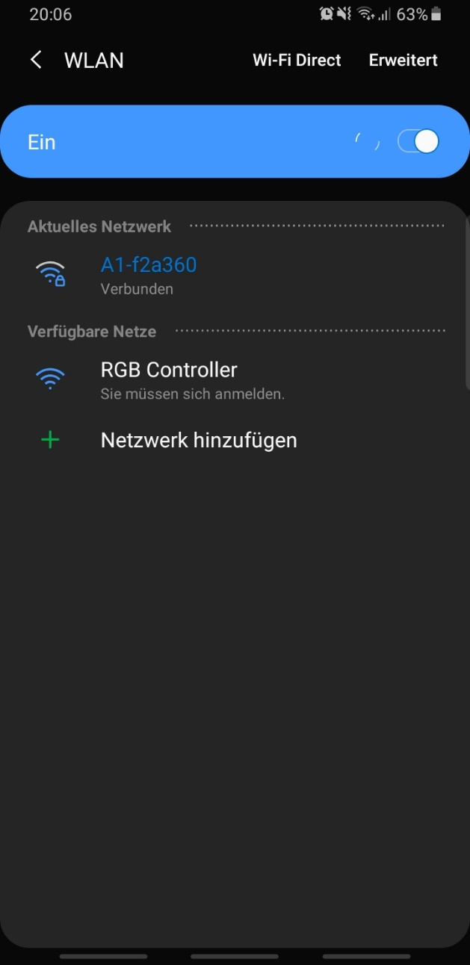

1. You will be redirected to a login page. Click your Wi-Fi name (1), enter the Password (2), click and hold on the “auth token” field to paste your auth token (3). Then press on the “Save” button (4).

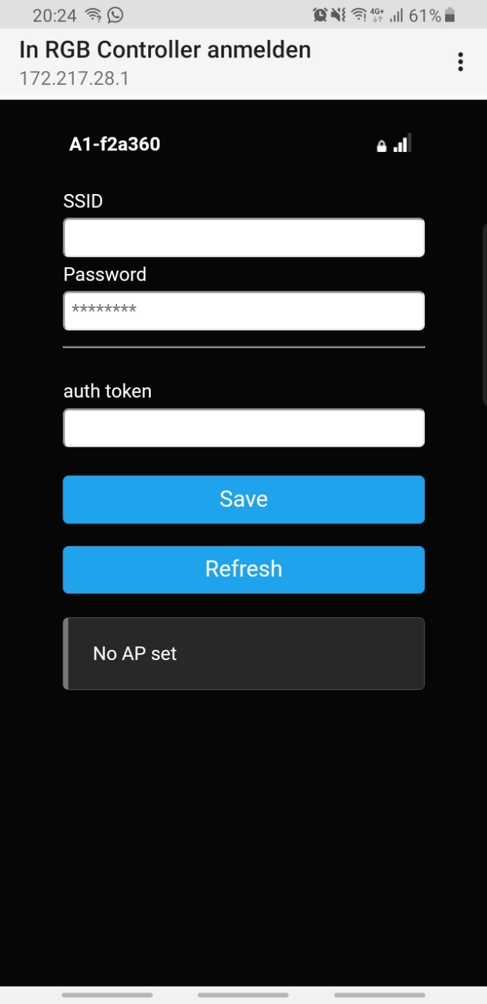

(1)

(2)

(3)

(4)

1. Now you should be automatically reconnected with your Wi-Fi, else you can do it manually.
2. You can now go back to the Blynk app and click the “Start” button

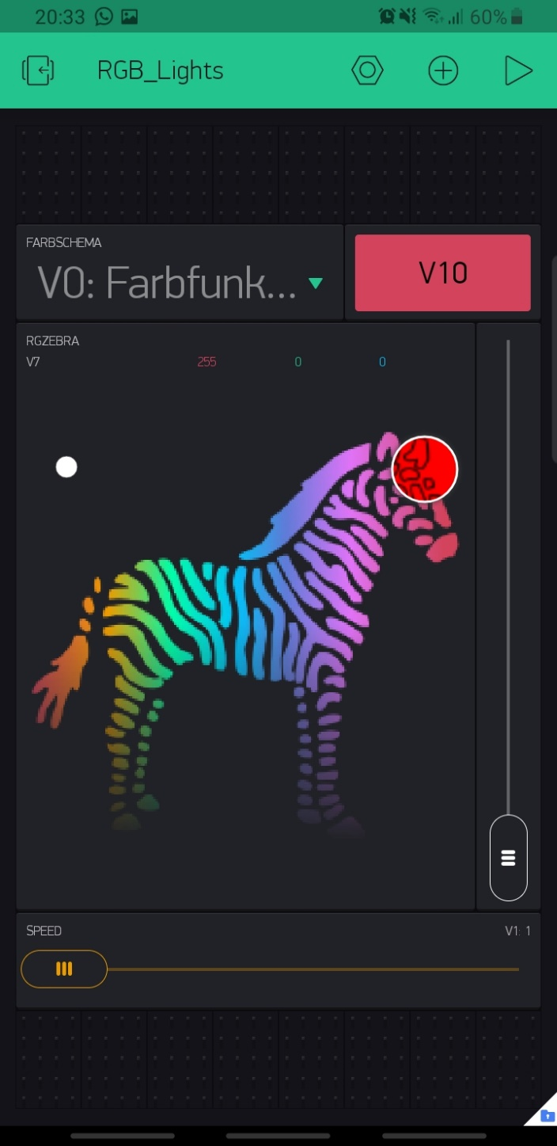

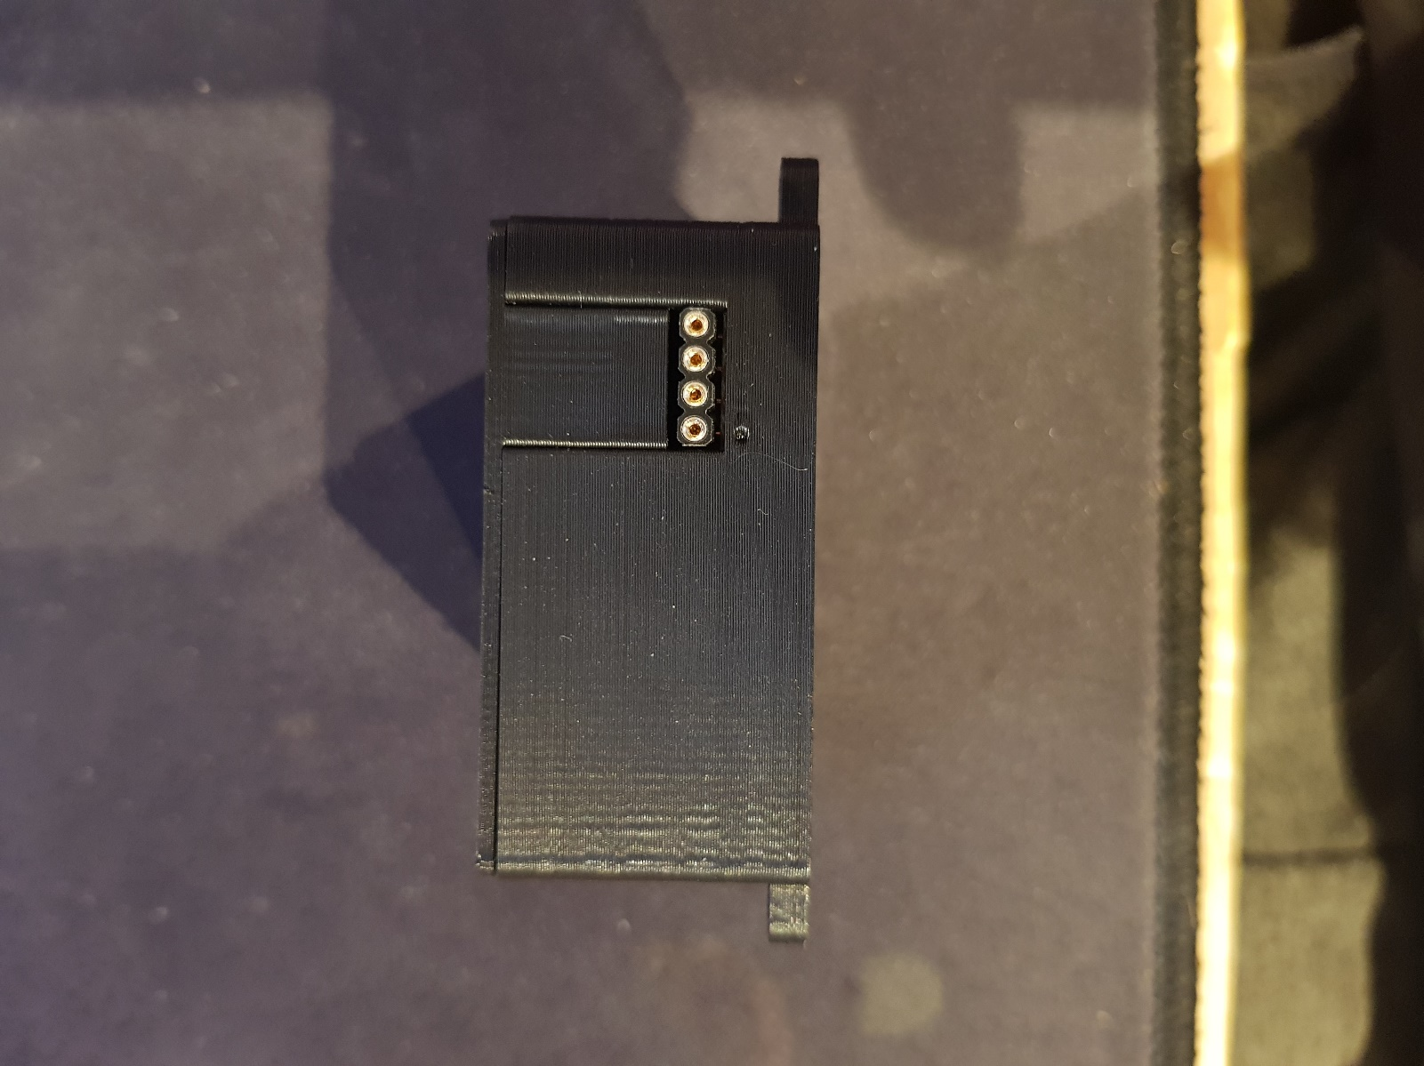

1. Now plug in the LEDs. Make sure you plug it in the right way so the 12V pin (the small Arrow) is aligned with the little dot on the case.
2. If the colors are wrong, check the order of your RGB-Strip and change the Colorcode (1) in the Wi-Fi Menu.

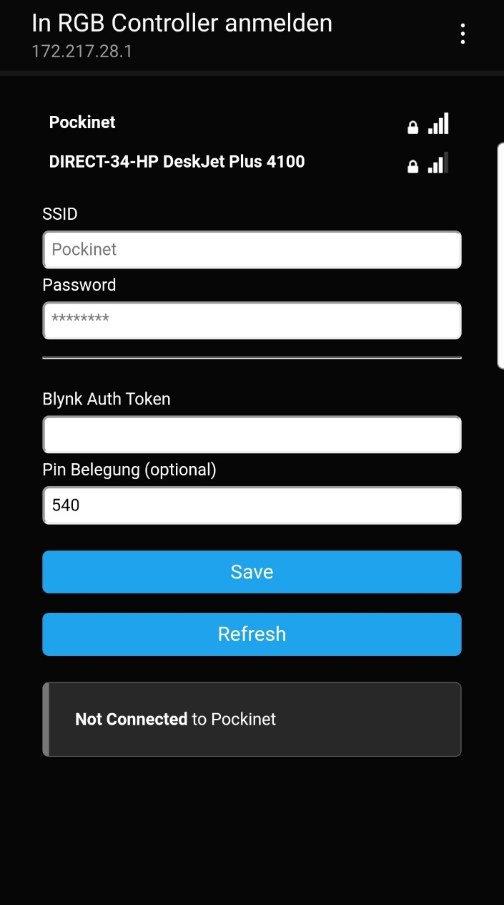





(1)

Pin Header +12V G R B

Colorcode 540

Pin Header +12V R G B

Colorcode 450

Pin Header +12V B G R

Colorcode 054

Pin Header +12V B R G

Colorcode 045

Pin Header +12V G B R

Colorcode 504

Pin Header +12V R B G

Colorcode 405