Coral Reef Health Assessment and Restoration Prioritisation
  - Baseline Ecological Survey Report: Unguja North and Mtwara, Tanzania
2026-05-12
Table of contents

Executive Summary
This report presents the findings of a baseline ecological survey conducted in March 2026 across seven coral reef sites in Unguja North and Mtwara, Tanzania. The assessment utilized four key metrics—benthic substrate composition, fish density, coral recruit density, and indicator invertebrate assemblages—to evaluate reef health and prioritize restoration efforts under the Bahari Yetu project.
Key findings indicate that Chamba Cha Kati (Mtwara) remains the healthiest site, with the highest hard coral cover (80.8%) and superior fish densities. Conversely, Chama Kangu and Mwamba Mrefu (Unguja North) were identified as critically degraded, characterized by high algal dominance (>75%) and low coral cover (<10%), signaling an urgent need for active restoration. The study confirms that Marine Managed Areas (MMAs) generally support higher coral-to-algae ratios and fish biomass, though high-quality reefs like Nusura and Viulu currently lack formal protection.
Restoration priorities are categorized into immediate, moderate, and maintenance tiers. Recommendations include active macroalgae removal and coral gardening for degraded sites, the establishment of new MMAs for healthy but unprotected reefs, and the implementation of biological controls (e.g., Crown-of-Thorns starfish removal) to ensure the long-term sustainability of Tanzania’s marine assets.

Acknowledgments
The TNC wish to express gratitude to the following individuals and organizations for their invaluable contributions to this assessment:
- Mtwara Seascape Team: Special thanks to the Mnazi Bay-Ruvuma Estuary Marine Park (MBREMP) leadership and technical staff, including Dr. Nedfredy Ngowo (In-charge), Davis Urio, Mussa Hamis, Amos Singo, and Mustapha Issa for their logistical support and ecological expertise. We also acknowledge the technical contributions of Masumbuko Semba (TNC), Pagu Julius (WCS), and The Nature Conservancy (TNC) team members Emmanuel Mpina, Edward Senkondo, and Glory Chagama.
- North Unguja Seascape Team: We are grateful for the expertise provided by Yassir Ali Haji (DMC Zanzibar), Hija Khamis Uled (And Beyond Mnemba), and Edward Paul (IMS). Significant technical support was also provided by Catherine Nduati (KEMFRI) and TNC staff members Joan Kawaka and John Komakoma.
- Local Government & Authorities: We thank Habiba (Fisheries Officer, Mtwara DC) and the District Administrative Secretary (DAS) office for their guidance on the strategic alignment of marine assets with the blue economy.
- Community Partners: Our sincere appreciation goes to the residents of Msangamkuu, Rivula, Msimbati, Mngoji, Mnazi, Mgao, and Nalingu. Their local knowledge and dedication to the Bahari Yetu project are fundamental to the success of these conservation initiatives.

Glossary of Terms
Term | Definition
Acanthaster planci | Crown-of-Thorns Starfish (COTs) — a corallivorous sea star known for population outbreaks that can devastate coral cover
Biomass | The total mass of organisms (typically fish) in a given area, used as a proxy for ecosystem productivity
CCA | Crustose Coralline Algae — calcified red algae that facilitate coral larval settlement
Coral Gardening | A two-step restoration method involving a nursery phase followed by transplantation to degraded reefs
GCRMN | Global Coral Reef Monitoring Network — the international standard for reef assessment protocols
MMA | Marine Managed Area — a broadly defined zone with regulated marine resource use
MPA | Marine Protected Area — a zone with regulated or prohibited extractive use
PIT | Point-Intercept Transect — a standardised benthic survey methodology
UVC | Underwater Visual Census — a standardised fish survey methodology
WIO | Western Indian Ocean — the biogeographic region encompassing Tanzania’s marine environment
Phase shift | Ecological transition from a coral-dominated to an algae-dominated reef state
Recruit | Juvenile coral colony with a maximum diameter of 5 cm or less
Trophic group | Functional feeding category used to classify fish assemblages
Allometric | Relating to the non-proportional growth relationship used in biomass estimation

1. Introduction

Coral reefs are among the most productive and biodiverse ecosystems on Earth, supporting approximately one quarter of all marine species and providing critical ecosystem services — including food security, coastal protection, and tourism revenue — to hundreds of millions of people globally (Wilkinson 2008; Burke et al. 2011). In the Western Indian Ocean (WIO), coral reefs are particularly important, sustaining the livelihoods of coastal communities that depend heavily on artisanal fisheries and reef-based tourism (Obura et al. 2017).
Tanzania’s coral reefs span the mainland coast and the islands of Zanzibar (Unguja and Pemba), forming part of the broader East African Coral Reef system — one of the world’s most significant reef complexes (McClanahan, Cinner, and Abunge 2014). Despite their ecological and socioeconomic value, Tanzanian reefs have experienced considerable decline over recent decades, driven by a combination of anthropogenic stressors including destructive fishing practices, coastal eutrophication, sedimentation, and the compounding effects of climate-driven coral bleaching events (Obura et al. 2016; McClanahan et al. 2020).

Marine Managed Areas (MMAs) have been established across Tanzania as a principal governance tool for coral reef conservation, encompassing both no-take zones and partially restricted-use zones (Rocliffe et al. 2014). However, the ecological effectiveness of these MMAs varies considerably depending on management capacity, community engagement, and enforcement (Cinner et al. 2016). Comparative assessment of reef condition within and outside MMA boundaries therefore provides critical insight into management effectiveness and guides targeted restoration planning.

This report presents findings from a systematic multi-metric reef health assessment conducted at seven sites across two regions: Unguja North (Chama Kangu, Mwamba Mrefu, Mayale, and Chumani) and Mtwara (Chamba Cha Kati, Nusura, and Viulu). The assessment evaluated four ecological metrics — benthic substrate composition, fish density, coral recruit density, and invertebrate assemblages — to: (i) characterise reef condition at each site; (ii) compare condition between MMA and non-MMA sites; and (iii) identify priority areas for active restoration intervention under the Bahari Yetu project.

2. Methodology

2.1 Study Area

The ecological assessment was conducted across seven distinct coral reef sites distributed between the northern coast of Unguja Island and the southern mainland region of Mtwara. These sites were strategically selected to represent a gradient of management regimes, including established Marine Managed Areas (MMAs) and open-access reefs. Note that while Mgao was initially selected, it was not surveyed due to unfavorable tidal conditions during the mission. The geographic distribution and spatial orientation of all study sites are illustrated in Figure 1 and Figure 2, respectively.
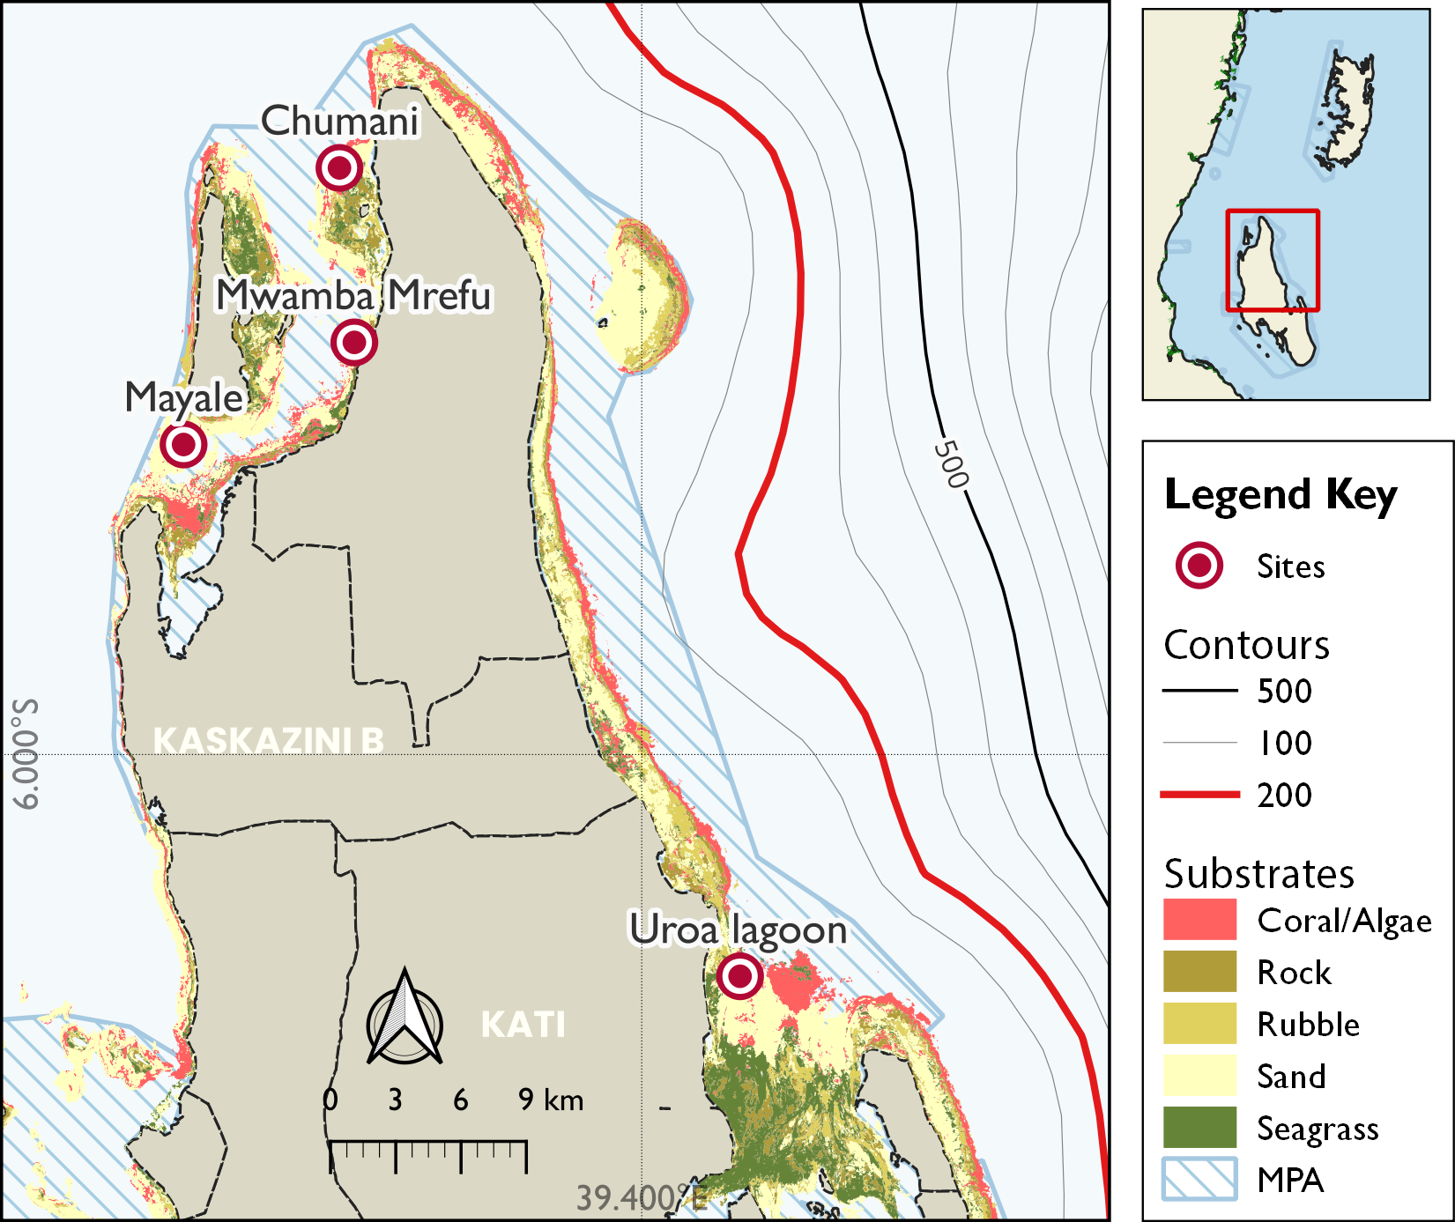
Figure 1: Distribution of survey site in Unguja North with spatial extent of the Marine Conservation Areas and key benthic habitats zonation.

2.1.1 Unguja North
Unguja North encompasses the northern coastline of Unguja Island, Zanzibar, characterised by fringing and patch reef systems with relatively shallow reef flats (Figure 1). This area is subject to substantial fishing pressure from surrounding communities. Of the four sites assessed, Fukuchani and Uroa fall within designated MMA boundaries, while Jongowe and Kendwa are located outside formal management areas (see Table 1).
Table 1: Geographic coordinates and management status of coral reef survey sites in Unguja North.
 |  |  |  | Coordinates
Location | Reef | Management | Exposure | Latitude | Longitude
Kendwa | Chumani |  |  | -5.75634 | 39.27444
Fukuchani | Mwamba Mrefu |  |  | -5.82883 | 39.28063
Jongowe | Mayale |  |  | -5.87126 | 39.20969
Uroa | Chama Kangu |  |  | -6.09220 | 39.44084

2.1.2 Mtwara
Mtwara is located in the southernmost coastal region of Tanzania (Figure 2), adjacent to the Mozambique border. The Mtwara coastline supports a diverse reef mosaic influenced by the Ruvuma River discharge and seasonal monsoon dynamics. Mnazi Bay — one of Tanzania’s oldest and best-studied marine protected areas — represents the primary MMA site for this region, while Msangamkuu is situated outside formal management structures (Table 2).
Table 2: Geographic coordinates and management status of coral reef survey sites in Mtwara region.
 |  |  |  | Coordinates
Location | Reef | Management | Exposure | Latitude | Longitude
MBREMP | Chamba Cha Kati | Core Zone | Sheltered | -10.31373 | 40.37449
Msanga Mkuu | Viulu | Open Access | Exposed | -10.19407 | 40.21902
Msanga Mkuu | Nusura | Open Access | Exposed | -10.22044 | 40.21319
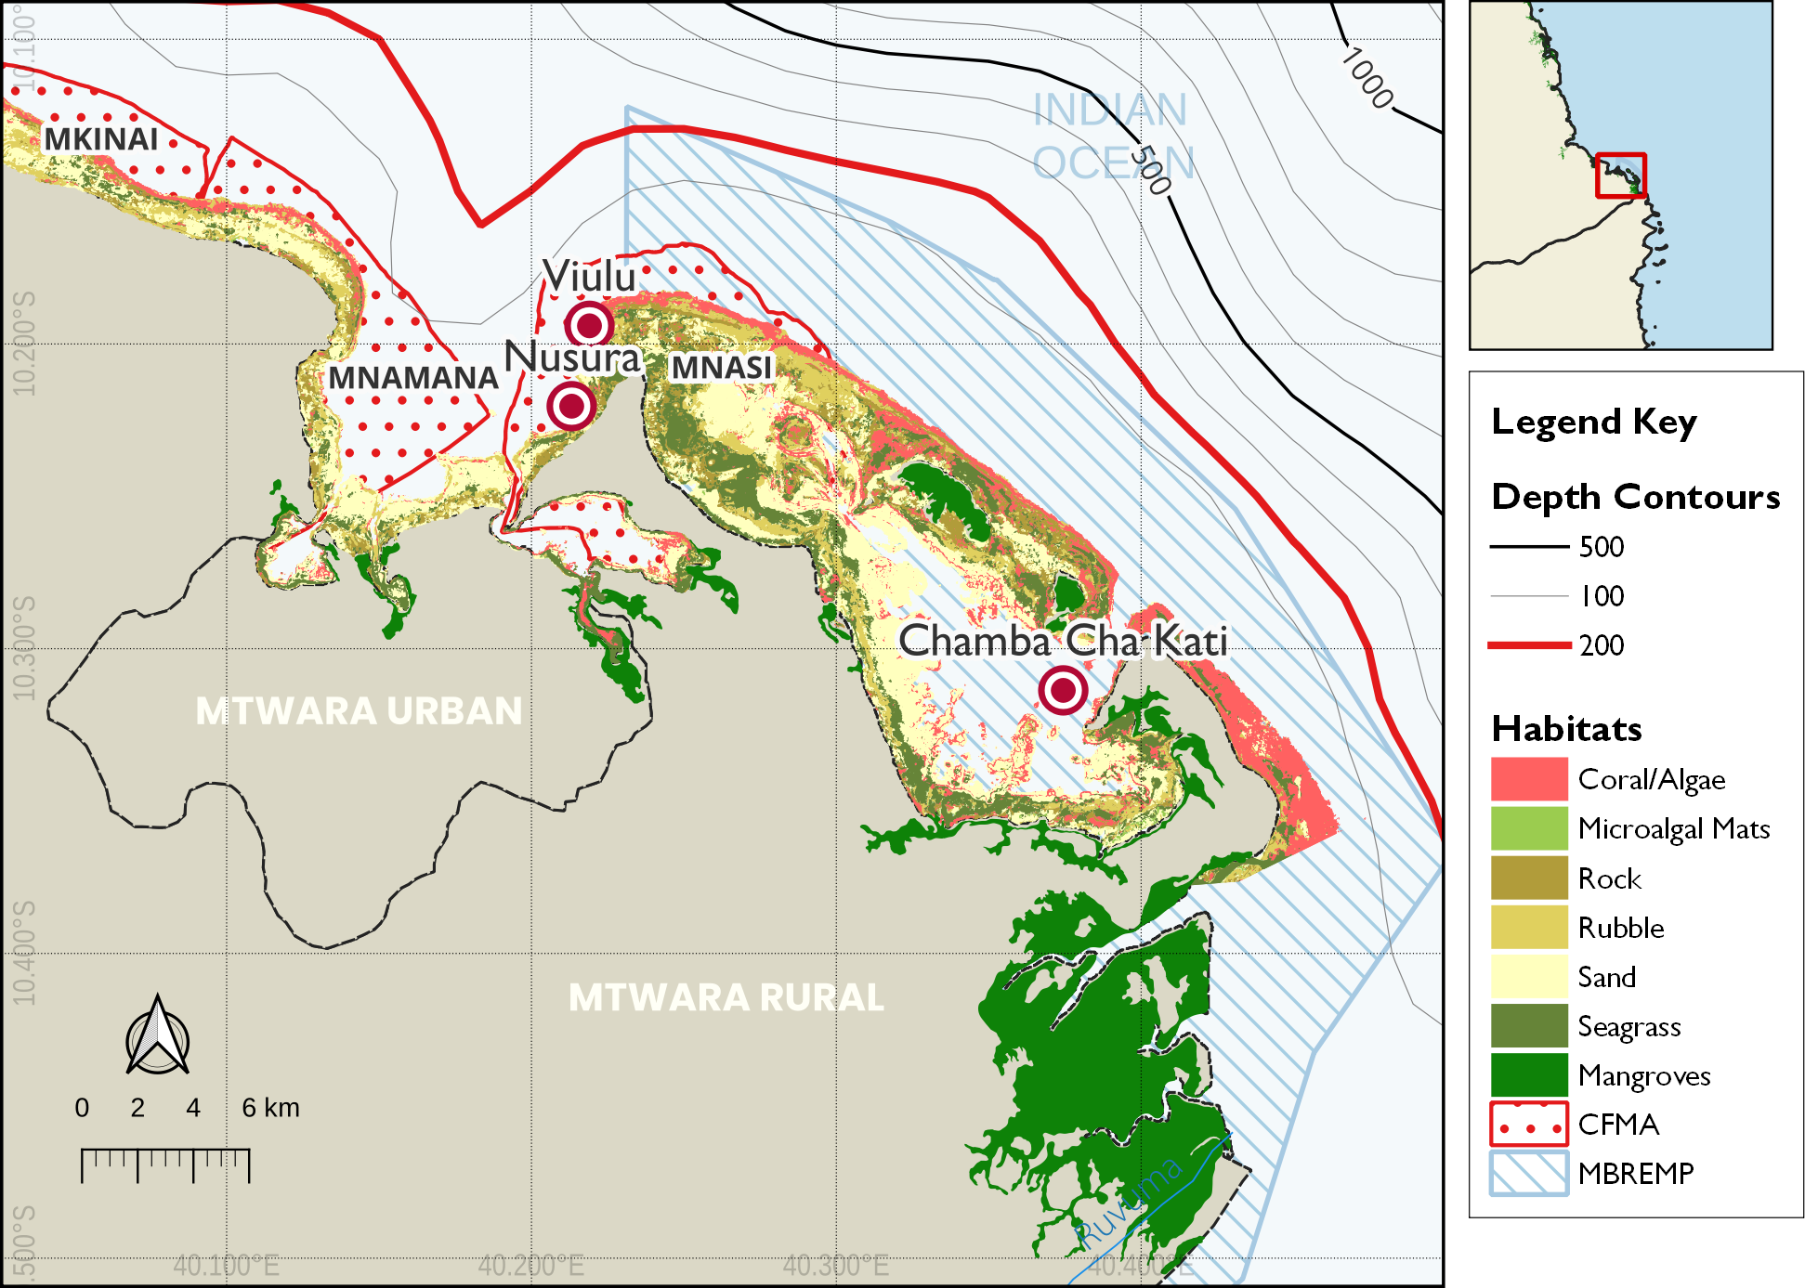
Figure 2: Distribution of survey site in Mtwara with spatial extent of the Mnazi Bay-Ruvuma Estuary Marine Park (MBREMP) showing the key benthic habitats zonation and proximity to the Ruvuma River mouth.

2.2 Survey Design

Ecological surveys were conducted between 16–24 March, 2026 following standardised reef health monitoring protocols (Hodgson et al. 2006; Wilson et al. 2020). Each site was assessed using replicated belt transects at two depth strata (shallow: 3–5 m; deep: 8–12 m), with three replicate transects per stratum per site (n = 6 transects per site). Site locations were recorded using GPS and mapped for repeatability in future monitoring rounds.

2.3 Data Processing

2.3.1 Benthic Substrate Assessment

Benthic cover was estimated using the Point-Intercept Transect (PIT) method (English, Wilkinson, and Baker 1997), where substrate categories were recorded at 0.5 m intervals along each 25 m transect tape, resulting in 50 data points per transect. These observations were classified according to the GCRMN scheme into seven primary categories: hard coral, soft coral, crustose coralline algae (CCA), algae (comprising both turf and macroalgae), rubble, sand, and other biota or substrate (e.g., rock, sponge). Finally, benthic cover estimates were derived by calculating the percentage of total points occupied by each category relative to the total number of points sampled per transect.
$$C_{i}=\left(\frac{n_{i}}{N}\right)×100 \left(1\right)$$
where $C_{i}$ is the percentage cover of substrate category $i$, $n_{i}$ is the number of points where category $i$ was recorded, and $N$ is the total number of points sampled per transect. Equation 1 was used to calculate the relative abundance of benthic components.

2.3.2 Fish Biomass Assessment

Fish biomass and density were estimated using underwater visual census (UVC) belt transects (50 m x 5 m). All fish species observed within the belt were identified to family level, counted, and their total length estimated to the nearest centimetre. Fish density was calculated as the number of individuals per unit area (individuals per 100 m²). Equation 2 was used to calculate the density of fish in an area.
$$D=\frac{N}{A}×100 \left(2\right)$$
where $D$ is density, $N$ is the count of individuals, and $A$ is the sampled area (250 m²). Equation 2 describes the standard calculation for fish density.
Biomass (kg/ha) was calculated from length-weight relationships derived from FishBase (Froese and Pauly 2023), applying species-specific allometric parameters. Equation 3 was used to calculate the biomass of fish per area.
$$W=a⋅L^{b} \left(3\right)$$
where $W$ is weight (g), $L$ is total length (cm), and $a$ and $b$ are species-specific constants. Equation 3 is used to estimate individual fish weight for biomass calculations. Fish assemblages were characterised by trophic group (herbivores, piscivores, invertivores, and omnivores).

2.3.3 Coral Recruit Assessment

Coral recruit density was assessed using 1 m² quadrats placed at 1 m intervals along each transect (25 quadrats per transect). All coral recruits less than or equal to 5 cm maximum diameter were counted and identified to genus level where possible (Babcock et al. 1992). Recruit density is expressed as recruits 100 m⁻² using Equation 4:
$$RD=\frac{∑n_{r}}{A}×100 \left(4\right)$$
where $RD$ is the recruit density (individuals per 100 m²), $n_{r}$ is the number of recruits counted, and $A$ is the total area sampled (m²).

2.3.4 Invertebrate Assessment

Key indicator invertebrates were quantified using visual belt transects measuring 25 m in length and 2 m in width, covering a total area of 50 m² per replicate. The survey focused on ecologically and commercially significant taxa, specifically sea urchins (Diadema spp., Echinometra spp., and Tripneustes spp.) which serve as primary algal grazers; sea cucumbers (Holothuria spp., Thelenota spp., and Actinopyga spp.) which act as essential nutrient cyclers; and giant clams (Tridacna spp.) which are indicators of harvesting pressure. Abundance data were standardized to density per unit area to allow for cross-site comparisons. The density for each taxon was calculated using Equation 5:
$$ID=\frac{∑n_{i}}{A}×100 \left(5\right)$$
where $ID$ represents the invertebrate density (individuals per 100 m²), $n_{i}$ is the total count of individuals for a specific taxon, and $A$ is the total area surveyed (m²). This standardization ensures that results are comparable with regional Western Indian Ocean (WIO) datasets.

2.4 Data Analysis, Visualization and Reporting
All data were analysed in R (v4.5.0; R Core Team (2024)). Site-level metrics are summarised as means +/- standard error (SE). Differences in reef metrics between were assessed using rstatix (Kassambara 2025). Figures were produced using the ggplot2 (Wickham 2016) and tidyplots (Engler 2025), maps using the sf package (Pebesma 2018) and QGIS (Muenchow, Schratz, and Brenning 2017), while tables were formatted using kableExtra (Zhu 2024) and gt (Iannone et al. 2025). This report was prepared using Quarto within the Positron IDE.

3. Results

3.1 Unguja North

3.1.1 Benthic Substrate Composition

Benthic substrate composition varied considerably among the four Unguja North sites (Table 3). Live hard coral cover was highest at Mayale (26.2%) and Chumani (23.8%), while the sites Mwamba Mrefu and Chama Kangu recorded significantly lower hard coral cover at 8.8% and 5.0% respectively. Algal dominance was most pronounced at Chama Kangu, with macroalgae (41.2%) and turf algae (35.0%) constituting the majority of the benthos, indicating a severe phase shift. Mwamba Mrefu also exhibited high macroalgal cover (32.5%), though it supported considerable soft coral communities (20.0%). Notably, Mayale was characterised by extensive sand cover (46.2%), while Chumani showed a diverse composition including 18.8% soft coral and 11.2% rubble. The major categories are shown in Figure 3.
Table 3: Percentage cover of benthic substrate across survey locations in Unguja North
 | Percentage Cover
Substrate | Chama Kangu | Chumani | Mayale | Mwamba Mrefu
Sand | 7.5 | 8.8 | 46.2 | 17.5
Live hard coral | 5.0 | 23.8 | 26.2 | 8.8
Turf algae | 35.0 | 33.8 | 12.5 | 3.8
Bare rock |  |  | 6.2
Dead coral | 2.5 | 3.8 | 2.5 | 12.5
Soft coral |  | 18.8 | 2.5 | 20.0
Coraline algae |  |  | 2.5
Macroalgae | 41.2 |  | 1.2 | 32.5
Rubble | 1.2 | 11.2 |  | 2.5
Seagrass | 7.5
Sponge |  |  |  | 2.5
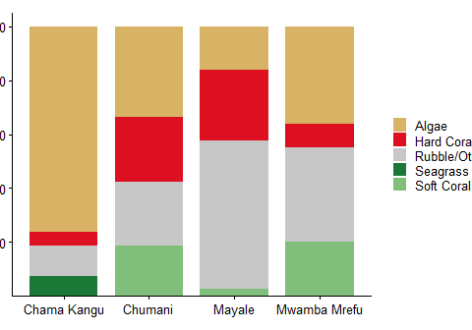
Figure 3: Major benthic substrate composition (% cover) at the four Unguja North sites.

3.1.2 Fish Biomass

Fish assemblages in Unguja North exhibited significant spatial variability in both density and composition (Table 4). Chama Kangu recorded the highest overall fish densities, dominated by Haemulidae (90.0 individuals per 100 m²) and Caesionidae (28.0 individuals per 100 m²). In contrast, Mwamba Mrefu showed much lower densities, with Pomacentridae (13.0 individuals per 100 m²) being the most prevalent group. Chumani was characterized by a high density of Lethrinidae (9.2 individuals per 100 m²), while Mayale supported a more even distribution of Lutjanidae (9.0 individuals per 100 m²) and Nemipteridae (4.0 individuals per 100 m²). These patterns suggest that while some sites maintain high abundance of schooling invertivores and planktivores, others like Mwamba Mrefu are significantly more depleted.
Table 4: Median fish density (individuals per 100 m²) by family across the surveyed reefs in Unguja North.
 | Fish Density (individuals per 100m2)
Family | Chama Kangu | Chumani | Mayale | Mwamba Mrefu
Haemulidae | 90.0 | 2.0 | - | 0.4
Caesionidae | 28.0 | - | - | -
Lutjanidae | 8.0 | 0.4 | 9.0 | -
Pomacentridae | 7.0 | 3.6 | 2.0 | 13.0
Holocentridae | 4.0 | - | - | -
Mullidae | 3.6 | 0.4 | 1.2 | 1.4
Siganidae | 3.6 | 1.2 | - | -
Aulostomidae | 2.4 | - | - | -
Scaridae | 2.4 | 1.0 | 2.8 | -
Zanclidae | 2.2 | - | - | -
Acanthuridae | 2.0 | 2.6 | 1.4 | -
Tetradontidae | 2.0 | 2.8 | 0.8 | -
Lethrinidae | 1.2 | 9.2 | 1.0 | -
Pomacanthidae | 1.2 | 2.4 | - | -
Labridae | 1.0 | 1.2 | 3.6 | 0.6
Kyphosidae | 0.8 | - | - | -
Chaetodontidae | 0.4 | 0.4 | 1.0 | 1.2
Serranidae | 0.4 | 0.4 | - | 0.4
Bleniidae | - | 0.8 | - | -
Centriscidae | - | - | 2.4 | -
Nemipteridae | - | - | 4.0 | -
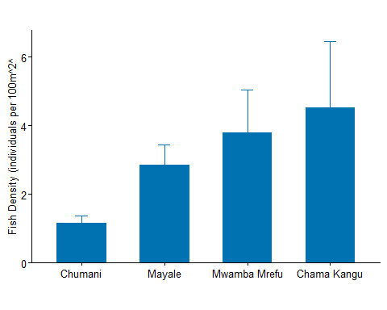
Figure 4: Median fish density (individuals per 100 m²) across the surveyed reefs in Unguja North.

3.1.3 Coral Recruits

Coral recruitment in Unguja North was dominated by Galaxea and Porites across most sites, with Chama Kangu exhibiting the highest overall recruit densities, particularly for Galaxea (250 ind. 100 m⁻²) and Fungia (200 ind. 100 m⁻²). Chumani and Mayale showed strong recruitment of Acropora and Fangia (200 ind. 100 m⁻² respectively), while Mwamba Mrefu recorded the highest density of Porites recruits (200 ind. 100 m⁻²). The presence of pioneer genera like Pocillopora and Millepora at Chumani suggests active recovery potential, whereas the absence of Acropora recruits at Mwamba Mrefu may indicate localized settlement limitations for branching coral species (see Figure 5).
Table 5: Recruit density (individuals per 100 m²) by family across the surveyed reefs in Unguja North.
 | Recruit Density (individuals per 100m2)
Family | Chama Kangu | Chumani | Mayale | Mwamba Mrefu
Galaxea | 250 | 100 | 100 | 100
Fungia | 200 | - | - | 100
Acropora | 100 | 200 | 100 | -
Fangia | 100 | - | 200 | -
Pavona | 100 | - | - | -
Porites | 100 | 100 | 150 | 200
Favia | - | 100 | - | -
Millepora | - | 200 | - | -
Pocillopora | - | 200 | - | -
Seriatopora | - | - | 150 | 100
Astreopora | - | - | - | 100
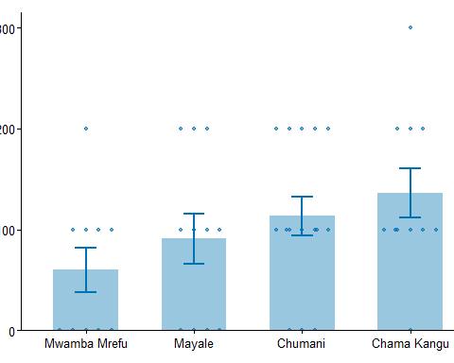
Figure 5: Median recruit density (individuals per 100 m²) across the surveyed reefs in Unguja North.

3.1.4 Invertebrate Assemblages

Invertebrate assemblages in Unguja North were heavily dominated by sea urchins (Table 6), particularly at Mayale, which recorded a density of 282 individuals per 100 m², significantly higher than Mwamba Mrefu (16 ind. 100 m⁻²) and Chumani (9 ind. 100 m⁻²). Other taxa were present in much lower abundances; blue starfish and white starfish were only recorded at Chumani (3 and 1 ind. 100 m⁻² respectively), while sea cucumbers were only observed at Chama Kangu (2 ind. 100 m⁻²). These low densities of high-value invertebrates like sea cucumbers across all sites reflect the persistent pressure of historical harvesting.
Table 6: Mean recruit density (individuals per 100 m²) by family across the surveyed reefs in Unguja. Values represent the median density observed across all transects per site.
 | Invertebrates (individuals per 100m2)
Family | Chama Kangu | Chumani | Mayale | Mwamba Mrefu
Sea Urchin | 1 | 9 | 282 | 16
Blue starfish | - | 3 | - | -
white starfish | - | 1 | - | -
Unspecified | 2 | - | - | -
sea cucumber | 2 | - | - | -
Figure 6: Invertebrate density (individuals per 100 m²) by taxon across reefs in Unguja North.

3.2 Mtwara

3.2.1 Benthic Substrate Composition

Detailed percentage cover for specific substrate categories in Mtwara is provided in Table 7. Chamba Cha Kati, located within the Mnazi Bay Marine Managed Area (MMA), displayed exceptional reef health with a hard coral cover of 80.8% and a low prevalence of fleshy algae (7.5%). This high coral-to-algae ratio suggests a resilient ecosystem state, likely contributed by the long-term management and enforcement within the Mnazi Bay–Ruvuma Estuary Marine Park (MBREMP).
Table 7: Benthic substrate composition across survey locations in Mtwara
 | Percentage Cover
Substrate | Chamba Cha Kati | Nusura | Viulu
Coralline | 5.5 | 8.8 | 7.1
Fleshy algae | 7.5 | 17.2 | 26.9
Hard Coral | 80.8 | 65.8 | 54.9
Sand | 3.0 | 12.8 | 7.6
Soft coral | 1.9 | 6.5 | 13.1
Sponge | 3.0 | - | 1.1
In contrast, sites situated outside the MBREMP showed varying degrees of composition (Figure 7); Nusura and Viulu recorded 65.8% and 54.9% hard coral cover respectively, with Viulu exhibiting a higher dominance of fleshy algae (26.9%) and soft coral (13.1%).
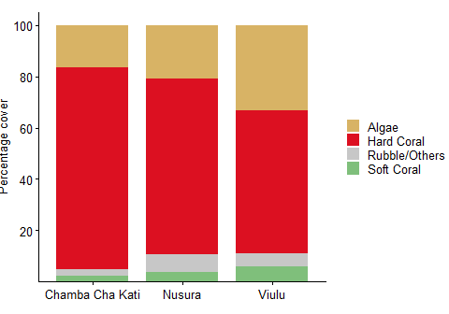
Figure 7: Major benthic substrate composition in sampled areas in Mtwara

3.2.2 Fish Biomass

Fish assemblages in Mtwara were characterized by high spatial variability in density and family composition (Figure 8). Chamba Cha Kati (Mnazi Bay) exhibited the highest overall fish densities, dominated by Pomacentridae (254.6 individuals per 100 m²), which was nearly ten times higher than densities recorded at Nusura (26.0) and Viulu (22.0) (Table 8).
Herbivorous families such as Scaridae and Acanthuridae were consistently present across all sites, with the highest Scaridae density at Chamba Cha Kati (11.0). In contrast, Viulu supported higher densities of Siganidae (4.4) and Mullidae (5.0) compared to other sites. While Chamba Cha Kati was unique in hosting families like Holocentridae and Balistidae, the non-MMA sites Nusura and Viulu supported higher densities of Lethrinidae and Pomacanthidae. These results indicate that while the protected Chamba Cha Kati reef maintains superior biomass and damselfish abundance, the surrounding reefs still support diverse functional groups essential for reef resilience.
Table 8: Mean fish density (individuals per 100 m²) by family across the surveyed reefs in Mtwara. Values represent the median density observed across all transects per site.
 | Fish Density (individuals per 100m2)
Family | Chamba Cha Kati | Nusura | Viulu
Pomacentridae | 254.6 | 26.0 | 22.0
Scaridae | 11.0 | 10.6 | 8.8
Labridae | 7.4 | 11.0 | 8.2
Acanthuridae | 5.0 | 3.6 | 3.4
Holocentridae | 3.8 | - | -
Chaetodontidae | 3.6 | 1.0 | 1.6
Mullidae | 1.6 | 3.6 | 5.0
Diodontidae | 1.2 | 1.2 | 1.6
Balistidae | 0.8 | - | -
Siganidae | 0.8 | - | 4.4
Fistularidae | 0.4 | - | -
Scorpaenidae | 0.4 | - | -
Lethrinidae | - | 2.0 | 2.4
Lutjanidae/Nemipteridae | - | 1.2 | 1.2
Others | - | 3.2 | -
Penguipedidae/Synodontidae | - | 1.0 | 0.6
Pomacanthidae | - | 1.8 | 2.8
Serranidae | - | 0.8 | 0.4
Pempheridae | - | - | 1.2
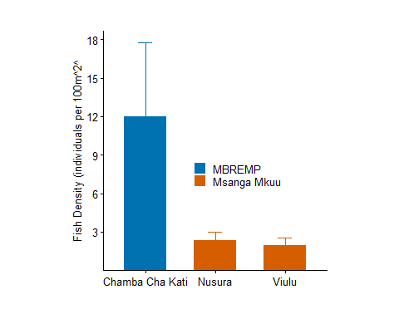
Figure 8: Median fish density (individuals per 100 m² +/- SE) across surveyed reefs in Mtwara. The dashed blue line represents the regional depletion threshold of 20 individuals per 100 m², indicating that most surveyed reefs currently sustain fish populations above critical depletion levels.

3.2.3 Coral Recruits

Coral recruitment in Mtwara was characterized by high taxonomic diversity and spatial variability across the three sites (Figure 9). Chamba Cha Kati (Mnazi Bay) exhibited strong recruitment of framework-building genera, particularly Acropora and Merulina (both at 500 ind. 100 m⁻²), alongside significant densities of Alveopora, Lobophyllia, and Porites (300 ind. 100 m⁻² each). In contrast, Nusura was dominated by massive Porites recruits (650 ind. 100 m⁻²), while Viulu showed the highest recruitment of Alveopora, Favia, and Astreopora (400 ind. 100 m⁻² each) (Table 9). The presence of specialized genera such as Gardineroseris and Plerogyra exclusively at Chamba Cha Kati, combined with high Acropora density, indicates a robust recovery potential within the MMA compared to the more opportunistic or stress-tolerant assemblages observed at the other sites.
Table 9: Recruit density (individuals per 100 m²) by family across the surveyed reefs in Mtwara. Values represent the median density observed across all transects per site.
 | Recruit Density (individuals per 100m2)
Family | Chamba Cha Kati | Nusura | Viulu
Acropora | 500 | 200 | 100
merulina | 500 | - | -
Alveopora | 300 | 100 | 400
Lobophyllia | 300 | 100 | 100
Millepora | 300 | - | 100
Porites(m) | 300 | 650 | 450
Fungia | 200 | 100 | 250
Gardineroseris | 200 | - | -
Pavona | 200 | 200 | 300
Plerogyra | 200 | - | -
Pocillopora | 200 | 100 | 100
Favia | 100 | 150 | 400
Favites | 100 | 200 | 300
Galaxea | 100 | 200 | 200
Halomitra | 100 | - | -
Herpolitha | 100 | - | -
Leptoseris | 100 | 100 | 100
Platygyra | 100 | 100 | 100
Seriatopora | 100 | - | -
Synarea | 100 | 300 | 200
Astreopora | - | 100 | 400
Echinopora | - | 100 | 300
Merullina | - | 100 | -
Pachyseris | - | 100 | -
Physogyra | - | 200 | -
Psammocoral | - | 100 | 100
Tubipora | - | 100 | -
Acanthastrea | - | - | 100
Hydnophora | - | - | 100
Psamocoral | - | - | 100
Stylophora | - | - | 250
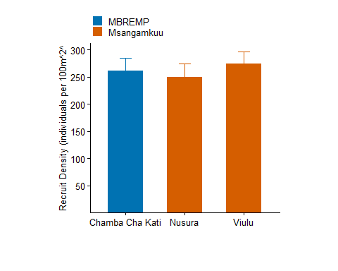
Figure 9: Median recruit density (individuals per 100 m² +/- SE) across surveyed reefs in Mtwara.

3.2.4 Invertebrate Assemblages

Indicator invertebrate densities in Mtwara varied significantly across the three surveyed reefs (Table 10). Viulu exhibited the highest overall densities for several key groups, including sea stars (900 ind. 100 m⁻²), urchins (1,150 ind. 100 m⁻²), and gastropods (800 ind. 100 m⁻²). Nusura showed moderate densities, notably supporting the highest recorded density of sea cucumbers (300 ind. 100 m⁻²). In contrast, Chamba Cha Kati generally recorded lower invertebrate abundances, although it maintained stable populations of bivalves (300 ind. 100 m⁻²) and octopuses (100 ind. 100 m⁻²). Notably, Crown-of-Thorns starfish (COTs), a significant coral predator, were recorded exclusively at Viulu (200 ind. 100 m⁻², See Figure 10), representing a localized threat to reef recovery.
Table 10: Invertebrate density (individuals per 100 m²) by family across the surveyed reefs in Mtwara.
 | Invertebrates (individuals per 100m2)
Family | Chamba Cha Kati | Nusura | Viulu
Sea star | 400 | 600 | 900
Urchin | 400 | 500 | 1,150
Bivalves | 300 | 350 | 500
Gastropods | 250 | 400 | 800
Sea cucumber | 150 | 300 | 200
Octopus | 100 | 100 | -
Worms | - | 300 | 450
COTs | - | - | 200
Figure 10: Invertebrate density (individuals per 100 m²) by taxon across reefs in Mnazi Bay and Msangamkuu.

4. Synthesis and Restoration Priorities

4.1 Ecological Condition Assessment
The conceptual framework in Figure 11 synthesises composite ecological condition scores (derived from the four assessed metrics) against governance and MMA effectiveness scores for all sites. This two-dimensional classification enables cross-regional comparison and restoration prioritisation.
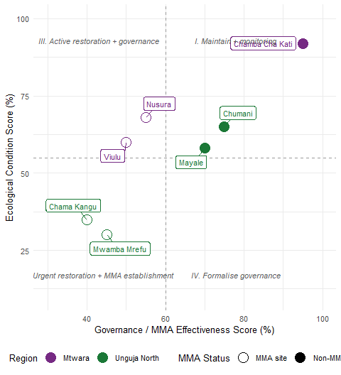
Figure 11: Conceptual restoration prioritisation framework. Sites are plotted by composite ecological condition score (y-axis; derived from benthic cover, fish biomass, recruit density, and invertebrate assemblages) against governance/MMA effectiveness score (x-axis). Dashed lines represent regional mean thresholds. Quadrant labels indicate recommended management actions.
Sites falling in the lower-left quadrant — Chama Kangu and Mwamba Mrefu — represent the highest restoration priority. Despite high recruit densities at Chama Kangu, the extreme algal dominance (>75%) and low coral cover indicate a persistent phase shift that requires active intervention. Chamba Cha Kati (Mnazi Bay) remains the regional benchmark for reef health, exhibiting the highest coral cover (80.8%) and fish biomass. Nusura and Viulu show moderate-to-high ecological resilience but lack formal protection, making them prime candidates for MMA establishment to safeguard their existing coral framework.

4.2 MMA Effectiveness

The assessment confirms that formal management significantly correlates with reef health. Chamba Cha Kati (Inside MBREMP) and Chumani/Mayale (Inside MCA) maintain higher coral-to-algae ratios compared to open-access sites. However, the high fish density at Chama Kangu (non-MMA) suggests that even degraded benthos can support high abundances of certain functional groups (e.g., Haemulidae), though these lack the biomass of larger predators found in protected zones. The presence of COTs at Viulu highlights that even relatively healthy non-MMA sites face acute biological threats that require managed responses.

4.3 Restoration Recommendations

Based on the assessment findings, a tiered restoration framework is recommended (see Table 11). Immediate interventions should focus on active coral gardening, macroalgae removal, and invertebrate restocking at the most degraded sites, paired with governance efforts to establish or strengthen MMA protections. Moderate-priority sites would benefit from targeted coral outplanting and enhanced surveillance, while maintenance-level monitoring is recommended for well-performing sites.
Table 11: Tiered restoration recommendations by site, prioritised by ecological condition and MMA governance status.
Priority | Site | Region | Key Issues | Recommended Actions
Immediate
 | Chama Kangu | Unguja North | Extreme algal dominance (76%); low coral cover (5%) | Active macroalgae removal; coral outplanting; MMA establishment
 | Mwamba Mrefu | Unguja North | High macroalgae; low coral cover (8.8%); low fish density | Artificial reef structures; herbivore protection; community management
Moderate
 | Viulu | Mtwara | Presence of COTs; high algal cover (26.9%); no formal protection | COTs removal program; formal MMA inclusion; monitoring
 | Nusura | Mtwara | High coral cover but lacks formal management; sea urchin dominance | Establishment of community-led no-take zone; urchin management
Maintenance
 | Mayale | Unguja North | High sand cover; high urchin density (282 ind/100m2) | Monitoring of urchin-driven bioerosion; maintain MCA patrols
 | Chumani | Unguja North | Moderate coral cover; low invertebrate diversity | Invertebrate restocking (sea cucumbers); maintain MCA patrols
 | Chamba Cha Kati | Mtwara | Excellent condition (80% coral); high fish biomass | Strict protection; use as regional donor site for coral fragments

4.4 Conclusions
This assessment provides a systematic multi-metric evaluation of reef health across Unguja North and Mtwara, establishing a baseline for the Bahari Yetu project. Key findings are as follows:
- Regional Benchmarks: Chamba Cha Kati (Mnazi Bay) represents the healthiest reef assessed, with over 80% hard coral cover and superior fish densities, serving as a critical reference site and potential larval source for regional recovery.
- Degradation Hotspots: Chama Kangu and Mwamba Mrefu in Unguja North are in a state of ecological crisis, characterized by severe phase shifts toward algal dominance (up to 76%) and critically low hard coral cover (<10%). These sites require urgent active restoration, including macroalgae removal and coral outplanting.
- Management Impact: The study confirms that formal protection within MMAs (e.g., MBREMP and North Unguja MCAs) significantly correlates with higher coral-to-algae ratios and fish biomass. However, high-quality reefs like Nusura and Viulu currently lack formal protection, making them vulnerable to future degradation.
- Trophic Imbalance: While fish densities are relatively stable, the severe depletion of high-value invertebrates like sea cucumbers and the localized presence of Crown-of-Thorns starfish at Viulu indicate significant harvesting pressure and emerging biological threats that require targeted management.
- Restoration Strategy: Restoration must be tiered; immediate active intervention is needed for degraded Unguja sites, while Mtwara efforts should focus on formalizing governance for healthy “outside” reefs and implementing biological controls (e.g., COTs removal) to maintain existing resilience.

References
Babcock, RC et al. 1992. “Reproduction and Recruitment of Corals: Comparisons Among the Caribbean, the Tropical Pacific, and the Red Sea.” Marine Ecology Progress Series 52: 109–25.
Burke, Lauretta, K Reytar, M Spalding, and A Perry. 2011. Reefs at Risk Revisited. World Resources Institute.
Cinner, Joshua E et al. 2016. “Bright Spots Among the World’s Coral Reefs.” Nature 535 (7612): 416–19.
Engler, Jan Broder. 2025. “Tidyplots Empowers Life Scientists with Easy Code-Based Data Visualization.” iMeta, e70018. https://doi.org/10.1002/imt2.70018.
English, S, C Wilkinson, and V Baker. 1997. Survey Manual for Tropical Marine Resources. Australian Institute of Marine Science.
Froese, Rainer, and Daniel Pauly. 2023. “FishBase.” 2023. www.fishbase.org.
Hodgson, G, J Hill, W Kiene, L Maun, J Mihaly, J Liebeler, C Shauka, and R Devel. 2006. Reef Check Instruction Manual: A Guide to Reef Check Coral Reef Monitoring. Reef Check Foundation.
Iannone, Richard, Joe Cheng, Barret Schloerke, Ellis Hughes, Alexandra Lauer, JooYoung Seo, Ken Brevoort, and Olivier Roy. 2025. Gt: Easily Create Presentation-Ready Display Tables. https://doi.org/10.32614/CRAN.package.gt.
Kassambara, Alboukadel. 2025. Rstatix: Pipe-Friendly Framework for Basic Statistical Tests. https://doi.org/10.32614/CRAN.package.rstatix.
McClanahan, Tim R et al. 2020. “Global Baselines and Benchmarks for Fish Biomass: Comparing Remote Reefs and Fisheries Closures.” Marine Ecology Progress Series 641: 153–67.
McClanahan, Tim R, Joshua E Cinner, and Caroline Abunge. 2014. “Perceived Benefits of Fisheries Management Restrictions in Madagascar.” Ecology and Society 19 (1).
Muenchow, Jannes, Patrick Schratz, and Alexander Brenning. 2017. “RQGIS: Integrating r with QGIS for Statistical Geocomputing.”
Obura, David et al. 2016. “Coral Mortality Dynamics on Reefs of the Western Indian Ocean.” Coral Reefs.
Obura, David, Mishal Gudka, J Abdouravi, S Ahamada, et al. 2017. “Coral Reef Status Report for the Western Indian Ocean.” Global Coral Reef Monitoring Network (GCRMN)/International Coral Reef Initiative (ICRI).
Pebesma, Edzer. 2018. “Simple Features for R: Standardized Support for Spatial Vector Data.” The R Journal 10 (1): 439–46. https://doi.org/10.32614/RJ-2018-009.
R Core Team. 2024. R: A Language and Environment for Statistical Computing. Vienna, Austria: R Foundation for Statistical Computing. https://www.R-project.org/.
Rocliffe, S, S Peabody, M Samoilys, and JP Hawkins. 2014. “Towards a Network of Locally Managed Marine Areas (LMMAs) in the Western Indian Ocean.” PLoS One 9 (7): e103000.
Wickham, Hadley. 2016. Ggplot2: Elegant Graphics for Data Analysis. Springer-Verlag New York. https://ggplot2.tidyverse.org.
Wilkinson, Clive. 2008. Status of Coral Reefs of the World: 2008. Global Coral Reef Monitoring Network; Reef; Rainforest Research Centre.
Wilson, JR et al. 2020. Monitoring Coral Reefs: A Guide for the Western Indian Ocean. CORDIO East Africa.
Zhu, Hao. 2024. kableExtra: Construct Complex Table with ’Kable’ and Pipe Syntax. https://CRAN.R-project.org/package=kableExtra.

