Coral Reef Assessment Report: Baseline Ecological Survey Report in Mtwara, Tanzania
2026-05-14
Table of contents

1. Introduction

2. Methods

2.1 Surveyed Sites and Geographic Coordinates
The coral reef assessment in Mtwara was conducted across a total of 8 survey sites, strategically selected to represent a range of reef conditions and management regimes within the region. These sites include Chamba Cha Kati, Chamba Cha Kati, Kieti, Matenga, Mmaluko, Rasmo, Viulu, and one additional location. Each site was categorized based on its location relative to Marine Management Areas (MMAs), with some sites located inside MMAs and others outside. This selection allows for comparative analysis of ecological conditions under different management contexts, providing insights into the effectiveness of conservation efforts and the status of coral reef ecosystems in Mtwara.
Table 1 provides a clear baseline overview of the coral reef assessment sites in Mtwara, listing site names, reef names, management status, and geographic coordinates. The table orients readers to the spatial distribution of locations sampled for benthic substrate, invertebrates, fish biomass, and recruits, and clarifies whether each site is inside or outside established marine management areas. This contextual information supports interpretation of the subsequent ecological analyses across the study region.
Table 1: Geographic coordinates and management status of coral reef survey sites in Mtwara region.
 |  |  | Coordinates
Area | Reef | Management | Latitude | Longitude
MBREMP | Chamba Cha Kati | Core Zone | -10.31373 | 40.37449
MBREMP | Matenga |  | -10.32315 | 40.36270
MBREMP | Kieti |  | -10.27417 | 40.34190
MBREMP | Inner Membelwa |  | -10.27402 | 40.34183
MBREMP | Rasmo |  | -10.34772 | 40.38065
Mgao | Mmaluko | Open Access | -10.10957 | 39.99297
Msanga Mkuu | Viulu |  | -10.19407 | 40.21902
Msanga Mkuu | Nusura |  | -10.22044 | 40.21319
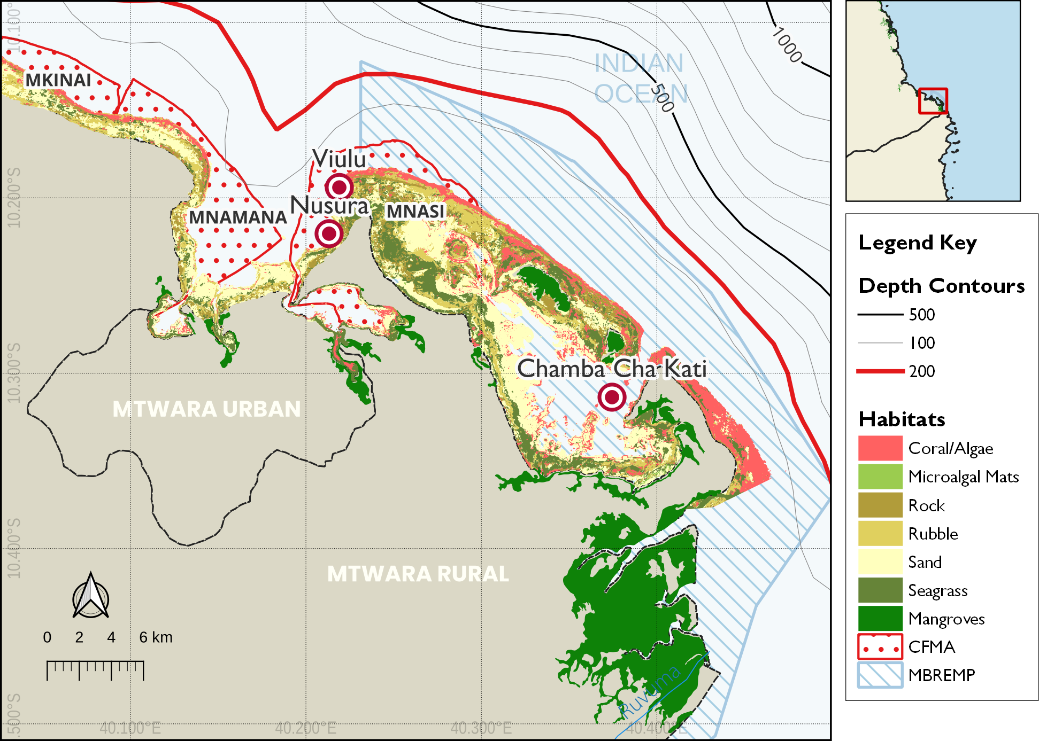
Figure 1: Distribution of survey site in Mtwara with spatial extent of the Mnazi Bay-Ruvuma Estuary Marine Park (MBREMP) showing the key benthic habitats zonation and proximity to the Ruvuma River mouth.

2.2 Survey Design

Ecological surveys were conducted between 16–24 March, 2026 following standardised reef health monitoring protocols (Hodgson et al. 2006; Wilson et al. 2020). Each site was assessed using replicated belt transects at two depth strata (shallow: 3–5 m; deep: 8–12 m), with three replicate transects per stratum per site (n = 6 transects per site). Site locations were recorded using GPS and mapped for repeatability in future monitoring rounds.

2.3 Data Processing

2.3.1 Benthic Substrate Assessment

Benthic cover was estimated using the Point-Intercept Transect (PIT) method (English, Wilkinson, and Baker 1997), where substrate categories were recorded at 0.5 m intervals along each 25 m transect tape, resulting in 50 data points per transect. These observations were classified according to the GCRMN scheme into seven primary categories: hard coral, soft coral, crustose coralline algae (CCA), algae (comprising both turf and macroalgae), rubble, sand, and other biota or substrate (e.g., rock, sponge). Finally, benthic cover estimates were derived by calculating the percentage of total points occupied by each category relative to the total number of points sampled per transect.
$$C_{i}=\left(\frac{n_{i}}{N}\right)×100 \left(1\right)$$
where $C_{i}$ is the percentage cover of substrate category $i$, $n_{i}$ is the number of points where category $i$ was recorded, and $N$ is the total number of points sampled per transect. Equation 1 was used to calculate the relative abundance of benthic components.

2.3.2 Fish Biomass Assessment

Fish biomass and density were estimated using underwater visual census (UVC) belt transects (50 m x 5 m). All fish species observed within the belt were identified to family level, counted, and their total length estimated to the nearest centimetre. Fish density was calculated as the number of individuals per unit area (individuals per 100 m²). Equation 2 was used to calculate the density of fish in an area.
$$D=\frac{N}{A}×100 \left(2\right)$$
where $D$ is density, $N$ is the count of individuals, and $A$ is the sampled area (250 m²). Equation 2 describes the standard calculation for fish density.
Biomass (kg/ha) was calculated from length-weight relationships derived from FishBase (Froese and Pauly 2023), applying species-specific allometric parameters. Equation 3 was used to calculate the biomass of fish per area.
$$W=a⋅L^{b} \left(3\right)$$
where $W$ is weight (g), $L$ is total length (cm), and $a$ and $b$ are species-specific constants. Equation 3 is used to estimate individual fish weight for biomass calculations. Fish assemblages were characterised by trophic group (herbivores, piscivores, invertivores, and omnivores).

2.3.3 Coral Recruit Assessment

Coral recruit density was assessed using 1 m² quadrats placed at 1 m intervals along each transect (25 quadrats per transect). All coral recruits less than or equal to 5 cm maximum diameter were counted and identified to genus level where possible (Babcock et al. 1992). Recruit density is expressed as recruits 100 m⁻² using Equation 4:
$$RD=\frac{∑n_{r}}{A}×100 \left(4\right)$$
where $RD$ is the recruit density (individuals per 100 m²), $n_{r}$ is the number of recruits counted, and $A$ is the total area sampled (m²).

2.3.4 Invertebrate Assessment

Key indicator invertebrates were quantified using visual belt transects measuring 25 m in length and 2 m in width, covering a total area of 50 m² per replicate. The survey focused on ecologically and commercially significant taxa, specifically sea urchins (Diadema spp., Echinometra spp., and Tripneustes spp.) which serve as primary algal grazers; sea cucumbers (Holothuria spp., Thelenota spp., and Actinopyga spp.) which act as essential nutrient cyclers; and giant clams (Tridacna spp.) which are indicators of harvesting pressure. Abundance data were standardized to density per unit area to allow for cross-site comparisons. The density for each taxon was calculated using Equation 5:
$$ID=\frac{∑n_{i}}{A}×100 \left(5\right)$$
where $ID$ represents the invertebrate density (individuals per 100 m²), $n_{i}$ is the total count of individuals for a specific taxon, and $A$ is the total area surveyed (m²). This standardization ensures that results are comparable with regional Western Indian Ocean (WIO) datasets.

2.4 Data Analysis, Visualization and Reporting
All data were analysed in R (v4.5.0; R Core Team (2024)). Site-level metrics are summarised as means +/- standard error (SE). Differences in reef metrics between were assessed using rstatix (Kassambara 2025). Figures were produced using the ggplot2 (Wickham 2016) and tidyplots (Engler 2025), maps using the sf package (Pebesma 2018) and QGIS (Muenchow, Schratz, and Brenning 2017), while tables were formatted using kableExtra (Zhu 2024) and gt (Iannone et al. 2025). This report was prepared using Quarto within the Positron IDE.

3. Results

3.1 Benthic Substrate Composition
The benthic community structure in Mtwara reflects a diverse coral reef ecosystem, with substrate composition varying significantly across the surveyed sites. At the site level, hard coral dominance was most pronounced at Chamba Cha Kati (80.8%), Matenga (80.6%), and Kieti (79.4%), as shown in Table 2. In contrast, Mmaluko exhibited a more heterogeneous composition with high coralline algae (43.9%) and sand (26.3%). Fleshy algae were most prevalent at Viulu (26.9%) and Mmaluko (23.8%), while seagrass was notably present only at Rasmo (22.5%) and Mmaluko (11.5%).
Table 2: Benthic substrate composition across survey locations in Mtwara
Substrate | Chamba Cha Kati | Inner Membelwa | Kieti | Matenga | Mmaluko | Nusura | Rasmo | Viulu
Coralline | 5.5 | 18.0 | 4.8 | 1.0 | 43.9 | 8.8 | 7.5 | 7.1
Fleshy algae | 7.5 | 5.7 | - | - | 23.8 | 17.2 | - | 26.9
Hard Coral | 80.8 | 41.5 | 79.4 | 80.6 | 43.9 | 65.8 | 63.5 | 54.9
Sand | 3.0 | 13.3 | 10.6 | 6.6 | 26.3 | 12.8 | 9.3 | 7.6
Soft coral | 1.9 | 2.1 | 8.4 | 2.3 | - | 6.5 | 7.0 | 13.1
Sponge | 3.0 | 3.0 | 2.0 | 4.0 | - | - | 7.2 | 1.1
Algal Turf | - | 33.0 | 14.0 | 6.1 | 12.6 | - | - | -
Calcareous | - | 6.5 | - | - | - | - | - | -
Seagrass | - | - | - | - | 11.5 | - | 22.5 | -
Statistical analysis of the benthic substrate reveals significant differences in reef composition based on management status (Table 3). As illustrated in Figure 2, sites located within Marine Management Areas (MMAs) exhibit significantly higher hard coral cover compared to outside areas ($p<0.001$), where algae and rubble dominate the landscape. Conversely, sites outside MMAs are characterized by significantly higher levels of algae ($p=0.001$) and rubble/other substrates ($p=0.036$). No significant differences were observed for seagrass or soft coral cover between the two management regimes.
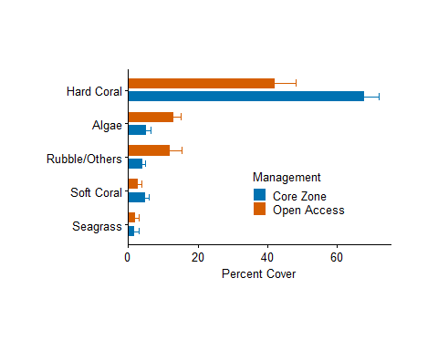
Figure 2: Benthic substrate composition across survey locations in Mtwara region, categorized by management status (Inside vs. Outside MMA).
Statistical analysis of the benthic substrate reveals significant differences in reef composition based on management status (Table 3). As illustrated in Figure 2, sites located within Marine Management Areas (MMAs) exhibit significantly higher hard coral cover compared to outside areas ($p<0.001$), where algae and rubble dominate the landscape. Conversely, sites outside MMAs are characterized by significantly higher levels of algae ($p=0.001$) and rubble/other substrates ($p=0.036$). No significant differences were observed for seagrass or soft coral cover between the two management regimes.
Table 3: Results of t-tests comparing percent cover of major benthic substrate categories between sites inside vs. outside marine management areas (MMAs) in Mtwara region.
 | Sample Size (N)
Category | Within | Outside | t-stat | p-value | Sig.
Algae | 108 | 70 | -3.32 | 0.001 | **
Hard Coral | 30 | 24 | 3.51 | 0.001 | **
Rubble/Others | 53 | 33 | -2.18 | 0.036 | *
Seagrass | 24 | 12 | -0.02 | 0.986 | ns
Soft Coral | 28 | 20 | 1.29 | 0.203 | ns

3.1.1 Fish Biomass

Fish assemblages in Mtwara were characterized by high spatial variability in density and family composition (Figure 3). Chamba Cha Kati (Mnazi Bay) exhibited the highest overall fish densities, dominated by Pomacentridae (254.6 individuals per 100 m²), which was nearly ten times higher than densities recorded at Nusura (26.0) and Viulu (22.0) (Table 4).
Herbivorous families such as Scaridae and Acanthuridae were consistently present across all sites, with the highest Scaridae density at Chamba Cha Kati (11.0). In contrast, Viulu supported higher densities of Siganidae (4.4) and Mullidae (5.0) compared to other sites. While Chamba Cha Kati was unique in hosting families like Holocentridae and Balistidae, the non-MMA sites Nusura and Viulu supported higher densities of Lethrinidae and Pomacanthidae. These results indicate that while the protected Chamba Cha Kati reef maintains superior biomass and damselfish abundance, the surrounding reefs still support diverse functional groups essential for reef resilience.
Table 4: Mean fish density (individuals per 100 m²) by family across the surveyed reefs in Mtwara. Values represent the median density observed across all transects per site.
 | Fish Density (individuals per 100m2)
Family | Chamba Cha Kati | Nusura | Viulu
Pomacentridae | 254.6 | 26.0 | 22.0
Scaridae | 11.0 | 10.6 | 8.8
Labridae | 7.4 | 11.0 | 8.2
Acanthuridae | 5.0 | 3.6 | 3.4
Holocentridae | 3.8 | - | -
Chaetodontidae | 3.6 | 1.0 | 1.6
Mullidae | 1.6 | 3.6 | 5.0
Diodontidae | 1.2 | 1.2 | 1.6
Balistidae | 0.8 | - | -
Siganidae | 0.8 | - | 4.4
Fistularidae | 0.4 | - | -
Scorpaenidae | 0.4 | - | -
Lethrinidae | - | 2.0 | 2.4
Lutjanidae/Nemipteridae | - | 1.2 | 1.2
Others | - | 3.2 | -
Penguipedidae/Synodontidae | - | 1.0 | 0.6
Pomacanthidae | - | 1.8 | 2.8
Serranidae | - | 0.8 | 0.4
Pempheridae | - | - | 1.2
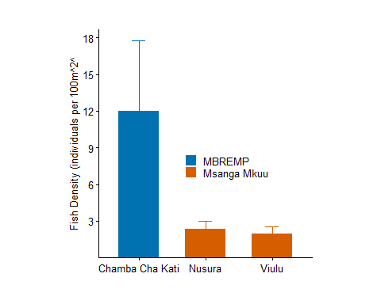
Figure 3: Median fish density (individuals per 100 m² +/- SE) across surveyed reefs in Mtwara. The dashed blue line represents the regional depletion threshold of 20 individuals per 100 m², indicating that most surveyed reefs currently sustain fish populations above critical depletion levels.

3.1.2 Coral Recruits

Coral recruitment in Mtwara was characterized by high taxonomic diversity and spatial variability across the three sites (Figure 4). Chamba Cha Kati (Mnazi Bay) exhibited strong recruitment of framework-building genera, particularly Acropora and Merulina (both at 500 ind. 100 m⁻²), alongside significant densities of Alveopora, Lobophyllia, and Porites (300 ind. 100 m⁻² each). In contrast, Nusura was dominated by massive Porites recruits (650 ind. 100 m⁻²), while Viulu showed the highest recruitment of Alveopora, Favia, and Astreopora (400 ind. 100 m⁻² each) (Table 5). The presence of specialized genera such as Gardineroseris and Plerogyra exclusively at Chamba Cha Kati, combined with high Acropora density, indicates a robust recovery potential within the MMA compared to the more opportunistic or stress-tolerant assemblages observed at the other sites.
Table 5: Recruit density (individuals per 100 m²) by family across the surveyed reefs in Mtwara. Values represent the median density observed across all transects per site.
 | Recruit Density (individuals per 100m2)
Family | Chamba Cha Kati | Inner Membelwa | Kieti | Matenga | Mmaluko | Nusura | Rasmo | Viulu
Acropora | 500 | 100 | 400 | 100 | 250 | 200 | 300 | 100
merulina | 500 | - | - | - | - | - | - | -
Alveopora | 300 | - | - | - | - | 100 | - | 400
Lobophyllia | 300 | 100 | - | 100 | 100 | 100 | 100 | 100
Millepora | 300 | 200 | - | - | - | - | 200 | 100
Porites(m) | 300 | - | 100 | 500 | 500 | 650 | 200 | 450
Fungia | 200 | 200 | 100 | 400 | - | 100 | 100 | 250
Gardineroseris | 200 | - | - | - | - | - | - | -
Pavona | 200 | 300 | 400 | 100 | 100 | 200 | 200 | 300
Plerogyra | 200 | - | - | 250 | - | - | - | -
Pocillopora | 200 | - | 150 | 100 | 100 | 100 | 400 | 100
Favia | 100 | 150 | - | 150 | 100 | 150 | 100 | 400
Favites | 100 | - | 100 | 250 | 100 | 200 | 100 | 300
Galaxea | 100 | 100 | 100 | 300 | 100 | 200 | 200 | 200
Halomitra | 100 | - | - | - | - | - | - | -
Herpolitha | 100 | - | - | - | - | - | - | -
Leptoseris | 100 | 300 | 200 | 200 | 100 | 100 | 100 | 100
Platygyra | 100 | - | - | - | 100 | 100 | - | 100
Seriatopora | 100 | 150 | 150 | 100 | - | - | 200 | -
Synarea | 100 | 400 | 250 | 100 | - | 300 | 100 | 200
Psammocoral | - | 300 | - | - | - | 100 | - | 100
Stylophora | - | 200 | 450 | 200 | - | - | - | 250
Echinopora | - | - | 100 | - | 100 | 100 | 150 | 300
Merulina | - | - | 100 | - | - | - | 100 | -
Astreopora | - | - | - | 100 | 100 | 100 | - | 400
Coscinaraea | - | - | - | 100 | - | - | 100 | -
Tubipora | - | - | - | 100 | - | 100 | - | -
Merullina | - | - | - | - | - | 100 | - | -
Pachyseris | - | - | - | - | - | 100 | - | -
Physogyra | - | - | - | - | - | 200 | - | -
Hydnophora | - | - | - | - | - | - | 100 | 100
Acanthastrea | - | - | - | - | - | - | - | 100
Psamocoral | - | - | - | - | - | - | - | 100
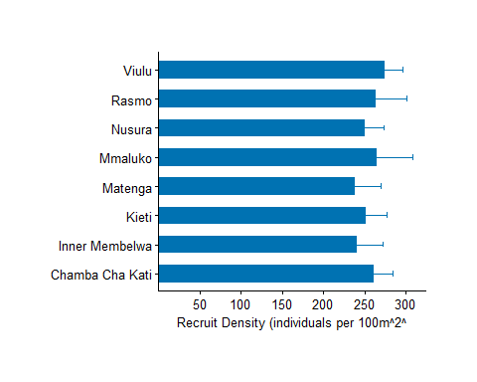
Figure 4: Median recruit density (individuals per 100 m² +/- SE) across surveyed reefs in Mtwara.

3.1.3 Invertebrate Assemblages

Indicator invertebrate densities in Mtwara varied significantly across the three surveyed reefs (Table 6). Viulu exhibited the highest overall densities for several key groups, including sea stars (900 ind. 100 m⁻²), urchins (1,150 ind. 100 m⁻²), and gastropods (800 ind. 100 m⁻²). Nusura showed moderate densities, notably supporting the highest recorded density of sea cucumbers (300 ind. 100 m⁻²). In contrast, Chamba Cha Kati generally recorded lower invertebrate abundances, although it maintained stable populations of bivalves (300 ind. 100 m⁻²) and octopuses (100 ind. 100 m⁻²). Notably, Crown-of-Thorns starfish (COTs), a significant coral predator, were recorded exclusively at Viulu (200 ind. 100 m⁻², See Figure 5), representing a localized threat to reef recovery.
Table 6: Invertebrate density (individuals per 100 m²) by family across the surveyed reefs in Mtwara.
Family | Chamba Cha Kati | Matenga | Membelwa | Mmaluko | Nusura | Rasmo | Viulu | kieti
Sea star | 400 | 300 | 200 | 650 | 600 | 650 | 900 | 400
Urchin | 400 | 400 | 250 | 250 | 500 | 300 | 1,150 | 500
Bivalves | 300 | 200 | 200 | - | 350 | 350 | 500 | 400
Gastropods | 250 | 300 | 400 | 400 | 400 | 300 | 800 | 600
Sea cucumber | 150 | 200 | 200 | 300 | 300 | 300 | 200 | 300
Octopus | 100 | - | - | - | 100 | 100 | - | 100
Worms | - | 200 | 250 | - | 300 | 150 | 450 | 300
COTs | - | - | - | - | - | - | 200 | 100
Figure 5: Invertebrate density (individuals per 100 m²) by taxon across reefs in Mnazi Bay and Msangamkuu.

4. References
Babcock, RC et al. 1992. “Reproduction and Recruitment of Corals: Comparisons Among the Caribbean, the Tropical Pacific, and the Red Sea.” Marine Ecology Progress Series 52: 109–25.
Engler, Jan Broder. 2025. “Tidyplots Empowers Life Scientists with Easy Code-Based Data Visualization.” iMeta, e70018. https://doi.org/10.1002/imt2.70018.
English, S, C Wilkinson, and V Baker. 1997. Survey Manual for Tropical Marine Resources. Australian Institute of Marine Science.
Froese, Rainer, and Daniel Pauly. 2023. “FishBase.” 2023. www.fishbase.org.
Hodgson, G, J Hill, W Kiene, L Maun, J Mihaly, J Liebeler, C Shauka, and R Devel. 2006. Reef Check Instruction Manual: A Guide to Reef Check Coral Reef Monitoring. Reef Check Foundation.
Iannone, Richard, Joe Cheng, Barret Schloerke, Ellis Hughes, Alexandra Lauer, JooYoung Seo, Ken Brevoort, and Olivier Roy. 2025. Gt: Easily Create Presentation-Ready Display Tables. https://doi.org/10.32614/CRAN.package.gt.
Kassambara, Alboukadel. 2025. Rstatix: Pipe-Friendly Framework for Basic Statistical Tests. https://doi.org/10.32614/CRAN.package.rstatix.
Muenchow, Jannes, Patrick Schratz, and Alexander Brenning. 2017. “RQGIS: Integrating r with QGIS for Statistical Geocomputing.”
Pebesma, Edzer. 2018. “Simple Features for R: Standardized Support for Spatial Vector Data.” The R Journal 10 (1): 439–46. https://doi.org/10.32614/RJ-2018-009.
R Core Team. 2024. R: A Language and Environment for Statistical Computing. Vienna, Austria: R Foundation for Statistical Computing. https://www.R-project.org/.
Wickham, Hadley. 2016. Ggplot2: Elegant Graphics for Data Analysis. Springer-Verlag New York. https://ggplot2.tidyverse.org.
Wilson, JR et al. 2020. Monitoring Coral Reefs: A Guide for the Western Indian Ocean. CORDIO East Africa.
Zhu, Hao. 2024. kableExtra: Construct Complex Table with ’Kable’ and Pipe Syntax. https://CRAN.R-project.org/package=kableExtra.

