Table of contents
Executive Summary 2
Acknowledgments 2
Glossary of Terms 3
1. Introduction 5
2. Methods 6
2.1 Surveyed Sites and Geographic Coordinates 6
2.1.1 Unguja North 6
2.1.2 Mtwara 7
2.2 Survey Design 9
2.3 Data Processing 9
2.3.1 Benthic Substrate Assessment 9
2.3.2 Fish Biomass Assessment 9
2.3.3 Coral Recruit Assessment 10
2.3.4 Invertebrate Assessment 10
2.4 Data Analysis, Visualization and Reporting 11
3. Results 11
3.1 Unguja North 11
3.1.1 Benthic Substrate Composition 11
3.1.2 Fish Biomass 12
3.1.3 Coral Recruits 14
3.1.4 Invertebrate Assemblages 16
3.2 Mtwara 17
3.2.1 Benthic Substrate Composition 17
3.2.2 Fish Biomass 18
3.2.3 Coral Recruits 20
3.2.4 Invertebrate Assemblages 22
4. Synthesis and Restoration Priorities 24
4.1 Ecological Condition Assessment 24
4.2 MMA Effectiveness 26
4.3 Restoration Recommendations 27
4.4 Conclusions 28
References 30

Executive Summary
This report presents the findings of a baseline ecological survey conducted in March 2026 across seven coral reef sites in Unguja North and Mtwara, Tanzania. The assessment utilized four key metrics—benthic substrate composition, fish density, coral recruit density, and indicator invertebrate assemblages—to evaluate reef health and prioritize restoration efforts under the Bahari Yetu project.
Key findings indicate that Chamba Cha Kati (Mtwara) remains the healthiest site, with the highest hard coral cover (80.8%) and superior fish densities. Conversely, Chama Kangu and Mwamba Mrefu (Unguja North) were identified as critically degraded, characterized by high algal dominance (>75%) and low coral cover (<10%), signaling an urgent need for active restoration. The study confirms that Marine Managed Areas (MMAs) generally support higher coral-to-algae ratios and fish biomass, though high-quality reefs like Nusura and Viulu currently lack formal protection.
Restoration priorities are categorized into immediate, moderate, and maintenance tiers. Recommendations include active macroalgae removal and coral gardening for degraded sites, the establishment of new MMAs for healthy but unprotected reefs, and the implementation of biological controls (e.g., Crown-of-Thorns starfish removal) to ensure the long-term sustainability of Tanzania’s marine assets.

Acknowledgments
The TNC wish to express gratitude to the following individuals and organizations for their invaluable contributions to this assessment:
- Mtwara Seascape Team: Special thanks to the Mnazi Bay-Ruvuma Estuary Marine Park (MBREMP) leadership and technical staff, including Dr. Nedfredy Ngowo (In-charge), Davis Urio, Mussa Hamis, Amos Singo, and Mustapha Issa for their logistical support and ecological expertise. We also acknowledge the technical contributions of Masumbuko Semba (TNC), Pagu Julius (WCS), and The Nature Conservancy (TNC) team members Emmanuel Mpina, Edward Senkondo, and Glory Chagama.
- North Unguja Seascape Team: We are grateful for the expertise provided by Yassir Ali Haji (DMC Zanzibar), Hija Khamis Uled (And Beyond Mnemba), and Edward Paul (IMS). Significant technical support was also provided by Catherine Nduati (KEMFRI) and TNC staff members Joan Kawaka and John Komakoma.
- Local Government & Authorities: We thank Habiba (Fisheries Officer, Mtwara DC) and the District Administrative Secretary (DAS) office for their guidance on the strategic alignment of marine assets with the blue economy.
- Community Partners: Our sincere appreciation goes to the residents of Msangamkuu, Rivula, Msimbati, Mngoji, Mnazi, Mgao, and Nalingu. Their local knowledge and dedication to the Bahari Yetu project are fundamental to the success of these conservation initiatives.

Glossary of Terms
Term | Definition
Acanthaster planci | Crown-of-Thorns Starfish (COTs) — a corallivorous sea star known for population outbreaks that can devastate coral cover
Biomass | The total mass of organisms (typically fish) in a given area, used as a proxy for ecosystem productivity
CCA | Crustose Coralline Algae — calcified red algae that facilitate coral larval settlement
Coral Gardening | A two-step restoration method involving a nursery phase followed by transplantation to degraded reefs
GCRMN | Global Coral Reef Monitoring Network — the international standard for reef assessment protocols
MMA | Marine Managed Area — a broadly defined zone with regulated marine resource use
MPA | Marine Protected Area — a zone with regulated or prohibited extractive use
PIT | Point-Intercept Transect — a standardised benthic survey methodology
UVC | Underwater Visual Census — a standardised fish survey methodology
WIO | Western Indian Ocean — the biogeographic region encompassing Tanzania’s marine environment
Phase shift | Ecological transition from a coral-dominated to an algae-dominated reef state
Recruit | Juvenile coral colony with a maximum diameter of 5 cm or less
Trophic group | Functional feeding category used to classify fish assemblages
Allometric | Relating to the non-proportional growth relationship used in biomass estimation

1. Introduction
Coral reefs are among the most productive and biodiverse ecosystems on Earth, supporting approximately one quarter of all marine species and providing critical ecosystem services — including food security, coastal protection, and tourism revenue — to hundreds of millions of people globally (Wilkinson 2008; Burke et al. 2011). In the Western Indian Ocean (WIO), coral reefs are particularly important, sustaining the livelihoods of coastal communities that depend heavily on artisanal fisheries and reef-based tourism (Obura et al. 2017).
Tanzania’s coral reefs span the mainland coast and the islands of Zanzibar (Unguja and Pemba), forming part of the broader East African Coral Reef system — one of the world’s most significant reef complexes (McClanahan, Cinner, and Abunge 2014). Despite their ecological and socioeconomic value, Tanzanian reefs have experienced considerable decline over recent decades, driven by a combination of anthropogenic stressors including destructive fishing practices, coastal eutrophication, sedimentation, and the compounding effects of climate-driven coral bleaching events (Obura et al. 2016; McClanahan et al. 2020).

Marine Managed Areas (MMAs) have been established across Tanzania as a principal governance tool for coral reef conservation, encompassing both no-take zones and partially restricted-use zones (Rocliffe et al. 2014). However, the ecological effectiveness of these MMAs varies considerably depending on management capacity, community engagement, and enforcement (Cinner et al. 2016). Comparative assessment of reef condition within and outside MMA boundaries therefore provides critical insight into management effectiveness and guides targeted restoration planning.

This report presents findings from a systematic multi-metric reef health assessment conducted at twelve sites across two regions: Unguja North (Chama Kangu, Mwamba Mrefu, Mayale, and Chumani) and Mtwara (Chamba Cha Kati, Inner Membelwa, Matenga, Kieti, Rasmo, Viulu, Nusura, and Mmaluko). The assessment evaluated four ecological metrics — benthic substrate composition, fish density, coral recruit density, and invertebrate assemblages — to:
- Characterize reef condition at each site;
- Compare condition between MMA and non-MMA sites; and
- Identify priority areas for active restoration intervention under the Bahari Yetu project.

2. Methods

2.1 Surveyed Sites and Geographic Coordinates

2.1.1 Unguja North
Unguja North encompasses the northern coastline of Unguja Island, Zanzibar, characterised by fringing and patch reef systems with relatively shallow reef flats (Figure 1). This area is subject to substantial fishing pressure from surrounding communities. Of the four sites assessed, Fukuchani and Uroa fall within designated MMA boundaries, while Jongowe and Kendwa are located outside formal management areas (see Table 1).
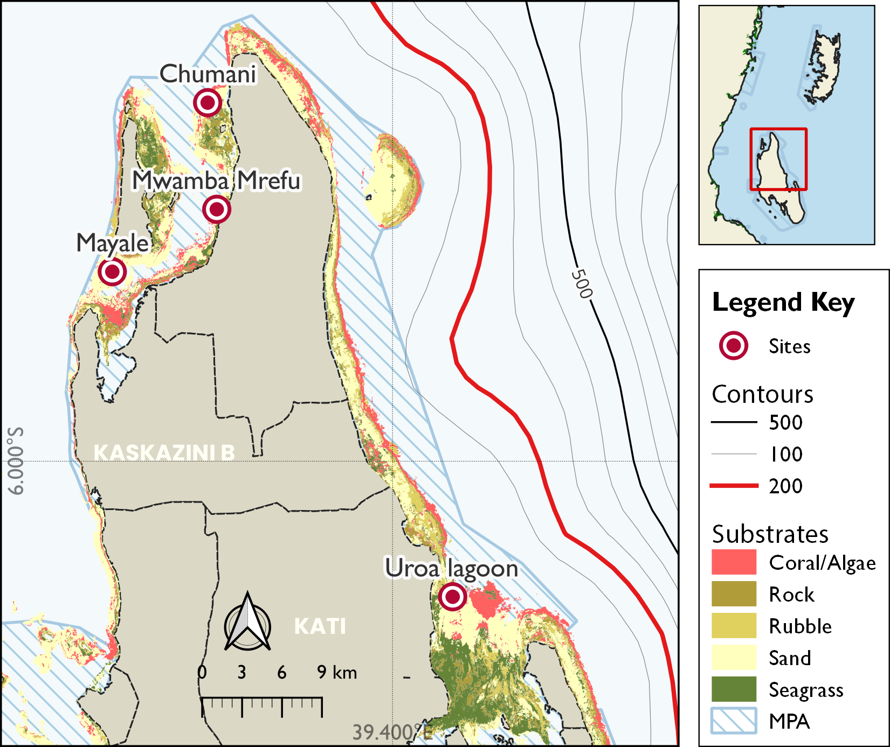
Figure 1: Distribution of survey site in Unguja North with spatial extent of the Marine Conservation Areas and key benthic habitats zonation.
Table Table 1 summarises the surveyed reef sites in Unguja North, including site and reef identifiers, management status, and geographic coordinates. By indicating whether each site is located inside or outside designated marine management areas, the table provides essential spatial context for benthic substrate, invertebrate, fish biomass, and coral recruit sampling. This framework supports interpretation of the ecological patterns observed across Unguja North.
Table 1: Geographic coordinates and management status of coral reef survey sites in Unguja North.
Area | Reef | Management | Latitude | Longitude
Kendwa | Chumani |  | -5.75634 | 39.27444
Fukuchani | Mwamba Mrefu |  | -5.82883 | 39.28063
Jongowe | Mayale |  | -5.87126 | 39.20969
Uroa | Chama Kangu |  | -6.09220 | 39.44084

2.1.2 Mtwara
The coral reef assessment in Mtwara was conducted across a total of 8 survey sites, strategically selected to represent a range of reef conditions and management regimes within the region. These sites include Chamba Cha Kati, Inner Membelwa, Matenga, Kieti, Rasmo, Viulu, Nusura, and Mmaluko (Figure 2). Each site was categorized based on its location relative to Marine Management Areas (MMAs), with some sites located inside MMAs and others outside. This selection allows for comparative analysis of ecological conditions under different management contexts, providing insights into the effectiveness of conservation efforts and the status of coral reef ecosystems in Mtwara.
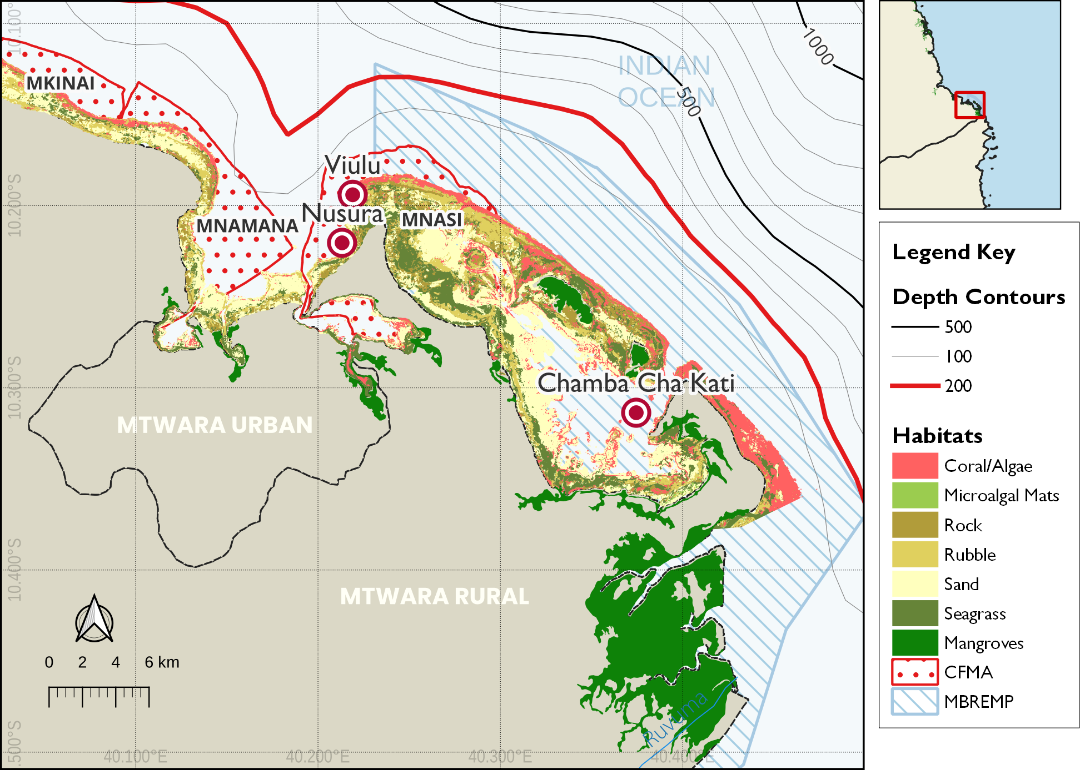
Figure 2: Distribution of survey site in Mtwara with spatial extent of the Mnazi Bay-Ruvuma Estuary Marine Park (MBREMP) showing the key benthic habitats zonation and proximity to the Ruvuma River mouth.
Table 2 provides a clear baseline overview of the coral reef assessment sites in Mtwara, listing site names, reef names, management status, and geographic coordinates. The table orients readers to the spatial distribution of locations sampled for benthic substrate, invertebrates, fish biomass, and recruits, and clarifies whether each site is inside or outside established marine management areas. This contextual information supports interpretation of the subsequent ecological analyses across the study region.
Table 2: Geographic coordinates and management status of coral reef survey sites in Mtwara region.
 |  |  | Coordinates
Area | Reef | Management | Latitude | Longitude
MBREMP | Chamba Cha Kati | Core Zone | -10.31373 | 40.37449
MBREMP | Matenga |  | -10.32315 | 40.36270
MBREMP | Kieti |  | -10.27417 | 40.34190
MBREMP | Inner Membelwa |  | -10.27402 | 40.34183
MBREMP | Rasmo |  | -10.34772 | 40.38065
Mgao | Mmaluko | Open Access | -10.10957 | 39.99297
Msanga Mkuu | Viulu |  | -10.19407 | 40.21902
Msanga Mkuu | Nusura |  | -10.22044 | 40.21319

2.2 Survey Design

Ecological surveys were conducted between 16–24 March, 2026 following standardised reef health monitoring protocols (Hodgson et al. 2006; Wilson et al. 2020). Each site was assessed using replicated belt transects at two depth strata (shallow: 3–5 m; deep: 8–12 m), with three replicate transects per stratum per site (n = 6 transects per site). Site locations were recorded using GPS and mapped for repeatability in future monitoring rounds.

2.3 Data Processing

2.3.1 Benthic Substrate Assessment

Benthic cover was estimated using the Point-Intercept Transect (PIT) method (English, Wilkinson, and Baker 1997), where substrate categories were recorded at 0.5 m intervals along each 25 m transect tape, resulting in 50 data points per transect. These observations were classified according to the GCRMN scheme into seven primary categories: hard coral, soft coral, crustose coralline algae (CCA), algae (comprising both turf and macroalgae), rubble, sand, and other biota or substrate (e.g., rock, sponge). Finally, benthic cover estimates were derived by calculating the percentage of total points occupied by each category relative to the total number of points sampled per transect.
$$C_{i}\text{=}\left(\frac{n_{i}}{N}\right)×100\left(1\right)$$
where $C_{i}$ is the percentage cover of substrate category $i$, $n_{i}$ is the number of points where category $i$ was recorded, and $N$ is the total number of points sampled per transect. Equation 1 was used to calculate the relative abundance of benthic components.

2.3.2 Fish Biomass Assessment

Fish biomass and density were estimated using underwater visual census (UVC) belt transects (50 m x 5 m). All fish species observed within the belt were identified to family level, counted, and their total length estimated to the nearest centimetre. Fish density was calculated as the number of individuals per unit area (individuals per 100 m²). Equation 2 was used to calculate the density of fish in an area.
$$D\text{=}\frac{N}{A}×100\left(2\right)$$
where $D$ is density, $N$ is the count of individuals, and $A$ is the sampled area (250 m²). Equation 2 describes the standard calculation for fish density.
Biomass (kg/ha) was calculated from length-weight relationships derived from FishBase (Froese and Pauly 2023), applying species-specific allometric parameters. Equation 3 was used to calculate the biomass of fish per area.
$$W\text{=}a⋅L^{b}\left(3\right)$$
where $W$ is weight (g), $L$ is total length (cm), and $a$ and $b$ are species-specific constants. Equation 3 is used to estimate individual fish weight for biomass calculations. Fish assemblages were characterised by trophic group (herbivores, piscivores, invertivores, and omnivores).

2.3.3 Coral Recruit Assessment

Coral recruit density was assessed using 1 m² quadrats placed at 1 m intervals along each transect (25 quadrats per transect). All coral recruits less than or equal to 5 cm maximum diameter were counted and identified to genus level where possible (Babcock et al. 1992). Recruit density is expressed as recruits 100 m⁻² using Equation 4:
$$RD\text{=}\frac{∑n_{r}}{A}×100\left(4\right)$$
where $RD$ is the recruit density (individuals per 100 m²), $n_{r}$ is the number of recruits counted, and $A$ is the total area sampled (m²).

2.3.4 Invertebrate Assessment

Key indicator invertebrates were quantified using visual belt transects measuring 25 m in length and 2 m in width, covering a total area of 50 m² per replicate. The survey focused on ecologically and commercially significant taxa, specifically sea urchins (Diadema spp., Echinometra spp., and Tripneustes spp.) which serve as primary algal grazers; sea cucumbers (Holothuria spp., Thelenota spp., and Actinopyga spp.) which act as essential nutrient cyclers; and giant clams (Tridacna spp.) which are indicators of harvesting pressure. Abundance data were standardized to density per unit area to allow for cross-site comparisons. The density for each taxon was calculated using Equation 5:
$$ID\text{=}\frac{∑n_{i}}{A}×100\left(5\right)$$
where $ID$ represents the invertebrate density (individuals per 100 m²), $n_{i}$ is the total count of individuals for a specific taxon, and $A$ is the total area surveyed (m²). This standardization ensures that results are comparable with regional Western Indian Ocean (WIO) datasets.

2.4 Data Analysis, Visualization and Reporting
All data were analysed in R (v4.5.0; R Core Team (2024)). Site-level metrics are summarised as means +/- standard error (SE). Differences in reef metrics between were assessed using rstatix (Kassambara 2025). Figures were produced using the ggplot2 (Wickham 2016) and tidyplots (Engler 2025), maps using the sf package (Pebesma 2018) and QGIS (Muenchow, Schratz, and Brenning 2017), while tables were formatted using kableExtra (Zhu 2024) and gt (Iannone et al. 2025). This report was prepared using Quarto within the Positron IDE.

3. Results

3.1 Unguja North

3.1.1 Benthic Substrate Composition

Benthic substrate composition varied considerably among the four Unguja North sites (Table 3). Live hard coral cover was highest at Mayale (26.2%) and Chumani (23.8%), while the sites Mwamba Mrefu and Chama Kangu recorded significantly lower hard coral cover at 8.8% and 5.0% respectively. Algal dominance was most pronounced at Chama Kangu, with macroalgae (41.2%) and turf algae (35.0%) constituting the majority of the benthos, indicating a severe phase shift. Mwamba Mrefu also exhibited high macroalgal cover (32.5%), though it supported considerable soft coral communities (20.0%). Notably, Mayale was characterised by extensive sand cover (46.2%), while Chumani showed a diverse composition including 18.8% soft coral and 11.2% rubble. The major categories are shown in Figure 3.
Table 3: Percentage cover of benthic substrate across survey locations in Unguja North
Substrate | Chama Kangu | Chumani | Mayale | Mwamba Mrefu
Sand | 7.5 | 8.8 | 46.2 | 17.5
Live hard coral | 5.0 | 23.8 | 26.2 | 8.8
Turf algae | 35.0 | 33.8 | 12.5 | 3.8
Bare rock |  |  | 6.2
Dead coral | 2.5 | 3.8 | 2.5 | 12.5
Soft coral |  | 18.8 | 2.5 | 20.0
Coraline algae |  |  | 2.5
Macroalgae | 41.2 |  | 1.2 | 32.5
Rubble | 1.2 | 11.2 |  | 2.5
Seagrass | 7.5
Sponge |  |  |  | 2.5
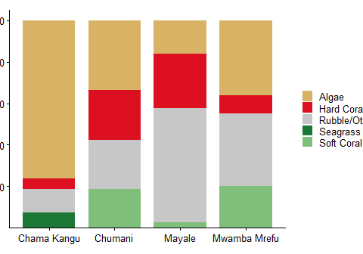
Figure 3: Major benthic substrate composition (% cover) at the four Unguja North sites.

3.1.2 Fish Biomass

Fish assemblages in Unguja North exhibited significant spatial variability in both density and composition (Table 4). Chama Kangu recorded the highest overall fish densities, dominated by Haemulidae (90.0 individuals per 100 m²) and Caesionidae (28.0 individuals per 100 m²). In contrast, Mwamba Mrefu showed much lower densities, with Pomacentridae (13.0 individuals per 100 m²) being the most prevalent group. Chumani was characterized by a high density of Lethrinidae (9.2 individuals per 100 m²), while Mayale supported a more even distribution of Lutjanidae (9.0 individuals per 100 m²) and Nemipteridae (4.0 individuals per 100 m²). These patterns suggest that while some sites maintain high abundance of schooling invertivores and planktivores, others like Mwamba Mrefu are significantly more depleted.
Table 4: Median fish density (individuals per 100 m²) by family across the surveyed reefs in Unguja North.
Family | Chama Kangu | Chumani | Mayale | Mwamba Mrefu
Haemulidae | 90.0 | 2.0 | - | 0.4
Caesionidae | 28.0 | - | - | -
Lutjanidae | 8.0 | 0.4 | 9.0 | -
Pomacentridae | 7.0 | 3.6 | 2.0 | 13.0
Holocentridae | 4.0 | - | - | -
Mullidae | 3.6 | 0.4 | 1.2 | 1.4
Siganidae | 3.6 | 1.2 | - | -
Aulostomidae | 2.4 | - | - | -
Scaridae | 2.4 | 1.0 | 2.8 | -
Zanclidae | 2.2 | - | - | -
Acanthuridae | 2.0 | 2.6 | 1.4 | -
Tetradontidae | 2.0 | 2.8 | 0.8 | -
Lethrinidae | 1.2 | 9.2 | 1.0 | -
Pomacanthidae | 1.2 | 2.4 | - | -
Labridae | 1.0 | 1.2 | 3.6 | 0.6
Kyphosidae | 0.8 | - | - | -
Chaetodontidae | 0.4 | 0.4 | 1.0 | 1.2
Serranidae | 0.4 | 0.4 | - | 0.4
Bleniidae | - | 0.8 | - | -
Centriscidae | - | - | 2.4 | -
Nemipteridae | - | - | 4.0 | -
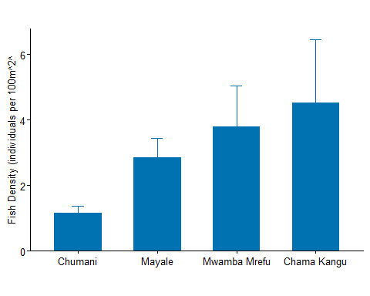
Figure 4: Median fish density (individuals per 100 m²) across the surveyed reefs in Unguja North.

3.1.3 Coral Recruits

Coral recruitment in Unguja North was dominated by Galaxea and Porites across most sites, with Chama Kangu exhibiting the highest overall recruit densities, particularly for Galaxea (250 ind. 100 m⁻²) and Fungia (200 ind. 100 m⁻²). Chumani and Mayale showed strong recruitment of Acropora and Fangia (200 ind. 100 m⁻² respectively), while Mwamba Mrefu recorded the highest density of Porites recruits (200 ind. 100 m⁻²). The presence of pioneer genera like Pocillopora and Millepora at Chumani suggests active recovery potential, whereas the absence of Acropora recruits at Mwamba Mrefu may indicate localized settlement limitations for branching coral species (see Figure 5).
Table 5: Recruit density (individuals per 100 m²) by family across the surveyed reefs in Unguja North.
 | Recruit Density (individuals per 100m2)
Family | Chama Kangu | Chumani | Mayale | Mwamba Mrefu
Galaxea | 250 | 100 | 100 | 100
Fungia | 200 | - | - | 100
Acropora | 100 | 200 | 100 | -
Fangia | 100 | - | 200 | -
Pavona | 100 | - | - | -
Porites | 100 | 100 | 150 | 200
Favia | - | 100 | - | -
Millepora | - | 200 | - | -
Pocillopora | - | 200 | - | -
Seriatopora | - | - | 150 | 100
Astreopora | - | - | - | 100
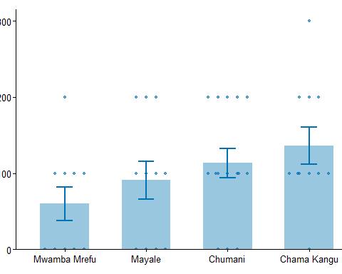
Figure 5: Median recruit density (individuals per 100 m²) across the surveyed reefs in Unguja North.

3.1.4 Invertebrate Assemblages

Invertebrate assemblages in Unguja North were heavily dominated by sea urchins (Table 6), particularly at Mayale, which recorded a density of 282 individuals per 100 m², significantly higher than Mwamba Mrefu (16 ind. 100 m⁻²) and Chumani (9 ind. 100 m⁻²). Other taxa were present in much lower abundances; blue starfish and white starfish were only recorded at Chumani (3 and 1 ind. 100 m⁻² respectively), while sea cucumbers were only observed at Chama Kangu (2 ind. 100 m⁻²). These low densities of high-value invertebrates like sea cucumbers across all sites reflect the persistent pressure of historical harvesting.
Table 6: Mean recruit density (individuals per 100 m²) by family across the surveyed reefs in Unguja. Values represent the median density observed across all transects per site.
Family | Chama Kangu | Chumani | Mayale | Mwamba Mrefu
Sea Urchin | 1 | 9 | 282 | 16
Blue starfish | - | 3 | - | -
white starfish | - | 1 | - | -
Unspecified | 2 | - | - | -
sea cucumber | 2 | - | - | -
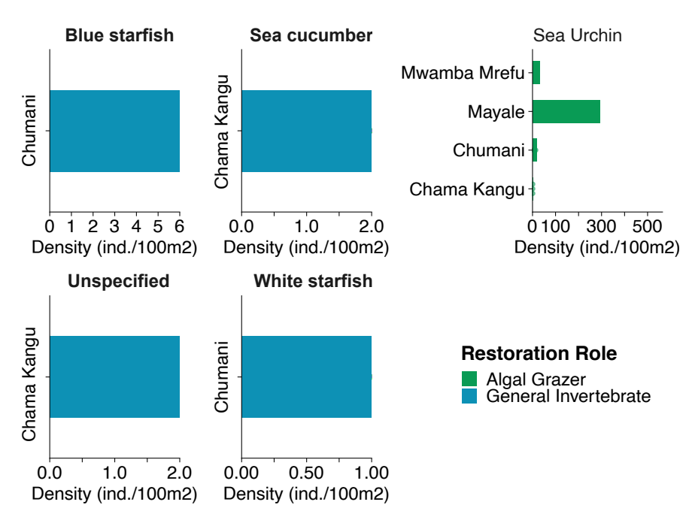
Figure 6: Invertebrate density (individuals per 100 m²) by taxon across reefs in Unguja North.

3.2 Mtwara

3.2.1 Benthic Substrate Composition
The benthic community structure in Mtwara reflects a diverse coral reef ecosystem, with substrate composition varying significantly across the surveyed sites. At the site level, hard coral dominance was most pronounced at Chamba Cha Kati (80.8%), Matenga (80.6%), and Kieti (79.4%), as shown in Table 7. In contrast, Mmaluko exhibited a more heterogeneous composition with high coralline algae (43.9%) and sand (26.3%). Fleshy algae were most prevalent at Viulu (26.9%) and Mmaluko (23.8%), while seagrass was notably present only at Rasmo (22.5%) and Mmaluko (11.5%).
Table 7: Benthic substrate composition across survey locations in Mtwara
Substrate | Chamba Cha Kati | Membelwa | Matenga | Kieti | Rasmo | Viulu | Nusura | Mmaluko
Coralline | 5.5 | 18.0 | 1.0 | 4.8 | 7.5 | 7.1 | 8.8 | 43.9
Fleshy algae | 7.5 | 5.7 | - | - | - | 26.9 | 17.2 | 23.8
Hard Coral | 80.8 | 41.5 | 80.6 | 79.4 | 63.5 | 54.9 | 65.8 | 43.9
Sand | 3.0 | 13.3 | 6.6 | 10.6 | 9.3 | 7.6 | 12.8 | 26.3
Soft coral | 1.9 | 2.1 | 2.3 | 8.4 | 7.0 | 13.1 | 6.5 | -
Sponge | 3.0 | 3.0 | 4.0 | 2.0 | 7.2 | 1.1 | - | -
Algal Turf | - | 33.0 | 6.1 | 14.0 | - | - | - | 12.6
Calcareous | - | 6.5 | - | - | - | - | - | -
Seagrass | - | - | - | - | 22.5 | - | - | 11.5
Statistical analysis of the benthic substrate reveals significant differences in reef composition based on management status (Table 8). As illustrated in Figure 7, sites located within Marine Management Areas (MMAs) exhibit significantly higher hard coral cover compared to outside areas ($p\text{<}0.001$), where algae and rubble dominate the landscape. Conversely, sites outside MMAs are characterized by significantly higher levels of algae ($p\text{=}0.001$) and rubble/other substrates ($p\text{=}0.036$). No significant differences were observed for seagrass or soft coral cover between the two management regimes.
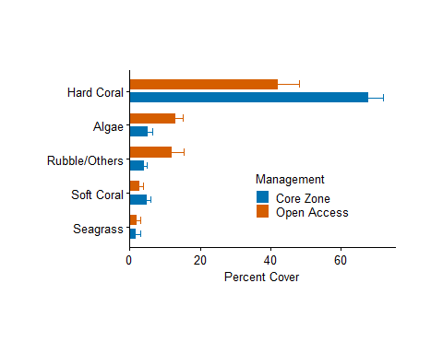
Figure 7: Benthic substrate composition across survey locations in Mtwara region, categorized by management status (Inside vs. Outside MMA).
Table 8: Results of t-tests comparing percent cover of major benthic substrate categories between sites inside vs. outside marine management areas (MMAs) in Mtwara region.
 | Sample Size (N)
Category | Within | Outside | t-stat | p-value | Sig.
Algae | 108 | 70 | -3.32 | 0.001 | **
Hard Coral | 30 | 24 | 3.51 | 0.001 | **
Rubble/Others | 53 | 33 | -2.18 | 0.036 | *
Seagrass | 24 | 12 | -0.02 | 0.986 | ns
Soft Coral | 28 | 20 | 1.29 | 0.203 | ns

3.2.2 Fish Biomass

Fish assemblages across Mtwara reefs showed pronounced spatial variability in density and family composition (Figure 8). Chamba Cha Kati (Mnazi Bay) recorded the highest fish densities overall, with Pomacentridae dominating at 254.6 individuals per 100 m² — nearly ten times the densities observed at Nusura (26.0) and Viulu (22.0) (Table 9). Herbivorous families, including Scaridae and Acanthuridae, were present across all surveyed sites, with Scaridae density peaking at Chamba Cha Kati (11.0 ind. 100 m⁻²). Viulu stood out for comparatively higher densities of Siganidae (4.4) and Mullidae (5.0). Families such as Holocentridae and Balistidae were recorded exclusively at Chamba Cha Kati, while the unprotected reefs at Nusura and Viulu maintained higher densities of Lethrinidae and Pomacanthidae. These patterns suggest that although the protected reef at Chamba Cha Kati has greater overall fish biomass and damselfish abundance, the adjacent unprotected reefs continue to support functionally diverse assemblages that are important for broader reef resilience.
Table 9: Mean fish density (individuals per 100 m²) by family across the surveyed reefs in Mtwara. Values represent the median density observed across all transects per site.
 | Fish Density (individuals per 100m2)
Family | Chamba Cha Kati | Nusura | Viulu
Pomacentridae | 254.6 | 26.0 | 22.0
Scaridae | 11.0 | 10.6 | 8.8
Labridae | 7.4 | 11.0 | 8.2
Acanthuridae | 5.0 | 3.6 | 3.4
Holocentridae | 3.8 | - | -
Chaetodontidae | 3.6 | 1.0 | 1.6
Mullidae | 1.6 | 3.6 | 5.0
Diodontidae | 1.2 | 1.2 | 1.6
Balistidae | 0.8 | - | -
Siganidae | 0.8 | - | 4.4
Fistularidae | 0.4 | - | -
Scorpaenidae | 0.4 | - | -
Lethrinidae | - | 2.0 | 2.4
Lutjanidae/Nemipteridae | - | 1.2 | 1.2
Others | - | 3.2 | -
Penguipedidae/Synodontidae | - | 1.0 | 0.6
Pomacanthidae | - | 1.8 | 2.8
Serranidae | - | 0.8 | 0.4
Pempheridae | - | - | 1.2
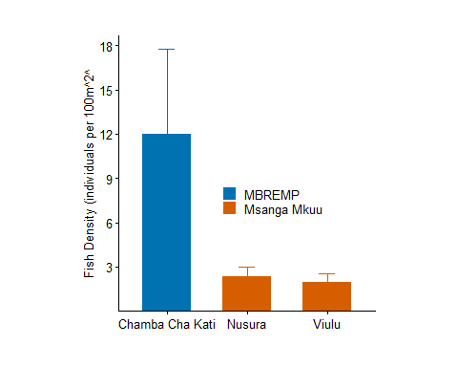
Figure 8: Median fish density (individuals per 100 m² +/- SE) across surveyed reefs in Mtwara. The dashed blue line represents the regional depletion threshold of 20 individuals per 100 m², indicating that most surveyed reefs currently sustain fish populations above critical depletion levels.

3.2.3 Coral Recruits

Coral recruitment across Mtwara reefs revealed considerable taxonomic diversity and spatial heterogeneity among the eight surveyed sites (Figure 9). At Chamba Cha Kati, recruitment was dominated by framework-building genera, with Acropora and Merulina each reaching densities of 500 ind. 100 m⁻², and Alveopora, Lobophyllia, and Millepora contributing equally at 300 ind. 100 m⁻². Nusura stood out for its exceptionally high Porites recruit density (650 ind. 100 m⁻²), a pattern typical of reefs recovering from disturbance, where massive corals tend to dominate early successional stages. At Viulu and Kieti, recruitment was broadly distributed across Alveopora, Favia, and Stylophora (400–450 ind. 100 m⁻²), suggesting relatively stable and diverse recruitment assemblages. The occurrence of specialist genera — Gardineroseris, Halomitra, and Herpolitha — exclusively at Chamba Cha Kati, alongside consistently elevated Acropora densities at Kieti (400 ind. 100 m⁻²), points to meaningful recovery potential across the study region (Table 10).
Table 10: Recruit density (individuals per 100 m²) by family across the surveyed reefs in Mtwara. Values represent the median density observed across all transects per site.
 | Recruit Density (individuals per 100m2)
Family | Chamba Cha Kati | Membelwa | Matenga | Kieti | Rasmo | Viulu | Nusura | Mmaluko
Acropora | 500 | 100 | 100 | 400 | 300 | 100 | 200 | 250
merulina | 500 | - | - | - | - | - | - | -
Alveopora | 300 | - | - | - | - | 400 | 100 | -
Lobophyllia | 300 | 100 | 100 | - | 100 | 100 | 100 | 100
Millepora | 300 | 200 | - | - | 200 | 100 | - | -
Porites(m) | 300 | - | 500 | 100 | 200 | 450 | 650 | 500
Fungia | 200 | 200 | 400 | 100 | 100 | 250 | 100 | -
Gardineroseris | 200 | - | - | - | - | - | - | -
Pavona | 200 | 300 | 100 | 400 | 200 | 300 | 200 | 100
Plerogyra | 200 | - | 250 | - | - | - | - | -
Pocillopora | 200 | - | 100 | 150 | 400 | 100 | 100 | 100
Favia | 100 | 150 | 150 | - | 100 | 400 | 150 | 100
Favites | 100 | - | 250 | 100 | 100 | 300 | 200 | 100
Galaxea | 100 | 100 | 300 | 100 | 200 | 200 | 200 | 100
Halomitra | 100 | - | - | - | - | - | - | -
Herpolitha | 100 | - | - | - | - | - | - | -
Leptoseris | 100 | 300 | 200 | 200 | 100 | 100 | 100 | 100
Platygyra | 100 | - | - | - | - | 100 | 100 | 100
Seriatopora | 100 | 150 | 100 | 150 | 200 | - | - | -
Synarea | 100 | 400 | 100 | 250 | 100 | 200 | 300 | -
Psammocoral | - | 300 | - | - | - | 100 | 100 | -
Stylophora | - | 200 | 200 | 450 | - | 250 | - | -
Echinopora | - | - | - | 100 | 150 | 300 | 100 | 100
Merulina | - | - | - | 100 | 100 | - | - | -
Astreopora | - | - | 100 | - | - | 400 | 100 | 100
Coscinaraea | - | - | 100 | - | 100 | - | - | -
Tubipora | - | - | 100 | - | - | - | 100 | -
Merullina | - | - | - | - | - | - | 100 | -
Pachyseris | - | - | - | - | - | - | 100 | -
Physogyra | - | - | - | - | - | - | 200 | -
Hydnophora | - | - | - | - | 100 | 100 | - | -
Acanthastrea | - | - | - | - | - | 100 | - | -
Psamocoral | - | - | - | - | - | 100 | - | -
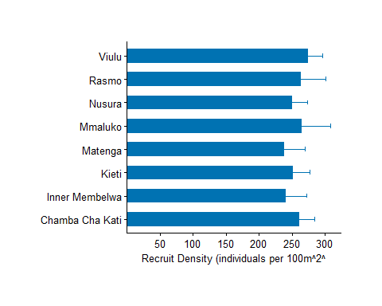
Figure 9: Median recruit density (individuals per 100 m² +/- SE) across surveyed reefs in Mtwara.

3.2.4 Invertebrate Assemblages

Indicator invertebrate densities in Mtwara varied significantly across the eight surveyed reefs (Table 11). Viulu exhibited the highest overall densities for several key groups, including sea stars (900 ind. 100 m⁻²), urchins (1,150 ind. 100 m⁻²), and gastropods (800 ind. 100 m⁻²). High densities were also observed at Rasmo (650 sea stars) and Kieti (600 gastropods). Nusura, Rasmo, and Mmaluko supported the highest recorded densities of sea cucumbers (300 ind. 100 m⁻²). In contrast, Chamba Cha Kati and Membelwa generally recorded lower invertebrate abundances, though Chamba Cha Kati maintained stable populations of bivalves (300 ind. 100 m⁻²). Notably, Crown-of-Thorns starfish (COTs), a significant coral predator, were recorded at Viulu (200 ind. 100 m⁻²) and Kieti (100 ind. 100 m⁻², See Figure 10), representing localized threats to reef recovery.
Table 11: Invertebrate density (individuals per 100 m²) by family across the surveyed reefs in Mtwara.
Family | Chamba Cha Kati | Membelwa | Matenga | Kieti | Rasmo | Viulu | Nusura | Mmaluko
Sea star | 400 | 200 | 300 | 400 | 650 | 900 | 600 | 650
Urchin | 400 | 250 | 400 | 500 | 300 | 1,150 | 500 | 250
Bivalves | 300 | 200 | 200 | 400 | 350 | 500 | 350 | -
Gastropods | 250 | 400 | 300 | 600 | 300 | 800 | 400 | 400
Sea cucumber | 150 | 200 | 200 | 300 | 300 | 200 | 300 | 300
Octopus | 100 | - | - | 100 | 100 | - | 100 | -
Worms | - | 250 | 200 | 300 | 150 | 450 | 300 | -
COTs | - | - | - | 100 | - | 200 | - | -
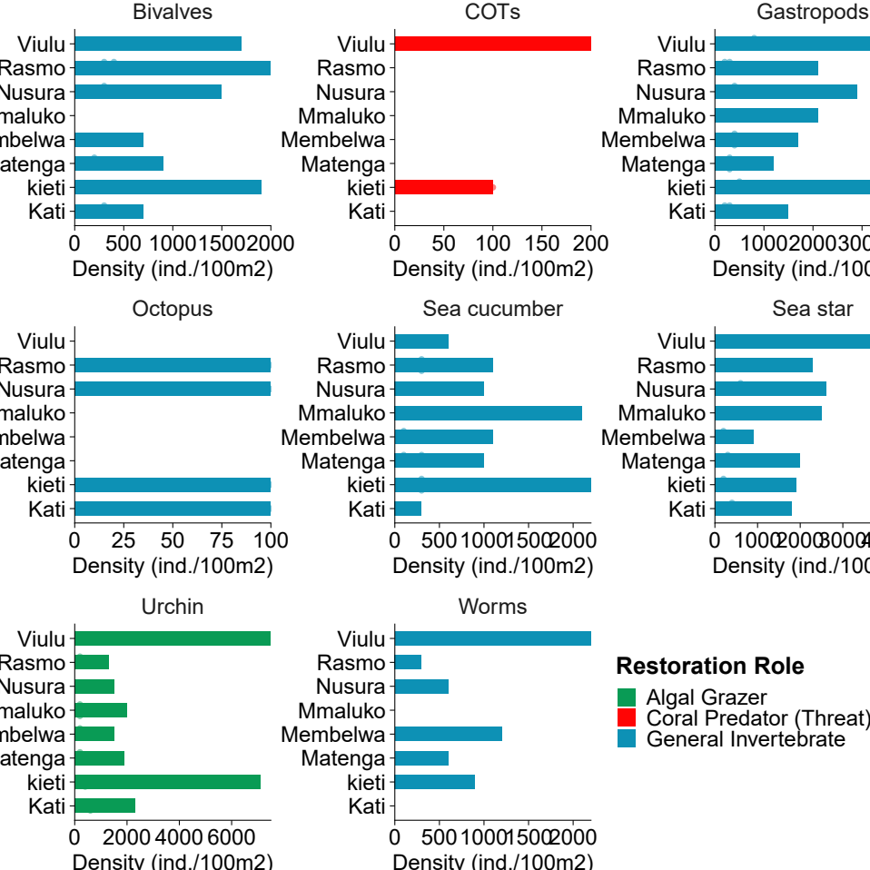
Figure 10: Invertebrate density (individuals per 100 m²) by taxon across reefs in Mnazi Bay and Msangamkuu.

4. Synthesis and Restoration Priorities

4.1 Ecological Condition Assessment
The conceptual restoration prioritisation framework shown in Figure 11 integrates ecological condition and governance performance into a single decision tool for site-level planning. By plotting each reef against these two dimensions, the framework clarifies not only where ecological decline is most severe, but also where institutional capacity is strong enough to support recovery actions. This dual-lens approach improves prioritisation by distinguishing ecological need from management readiness, helping practitioners allocate limited resources more strategically across Unguja North and Mtwara.
The framework classifies sites into four management tiers with clear operational implications. Tier I (Maintain and Monitor) includes high-performing reefs where current governance is functioning and the priority is to preserve gains through compliance and long-term monitoring. Tier II (Urgent Restoration and MMA Establishment) captures sites with poor ecological condition and weak governance, requiring immediate intervention alongside formal management strengthening. Tier III (Active Restoration and Governance) represents ecologically degraded reefs that already have some governance structures in place, where restoration can be accelerated through improved enforcement and co-management. Tier IV (Formalise Governance) includes comparatively healthy but unprotected reefs, where proactive legal and institutional designation is needed to prevent future decline and lock in existing resilience.
As illustrated in Figure 11, sites falling in the lower-left quadrant — Chama Kangu and Mwamba Mrefu in Unguja North, and Mmaluko in Mtwara — represent the highest restoration priority. Despite high recruit densities at Chama Kangu, extreme algal dominance ($\text{>}75\text{\%}$) and very low coral cover indicate a persistent phase shift that requires active intervention. In Mtwara, Chamba Cha Kati remains the regional benchmark for reef health, and together with Inner Membelwa, Matenga, and Kieti, forms a high-condition cluster where maintenance and compliance should be prioritized. Nusura and Viulu show moderate-to-high ecological resilience but weaker governance, while Rasmo sits near the management threshold; these sites are strong candidates for formal MMA establishment and strengthened co-management to safeguard existing coral framework and recovery potential.
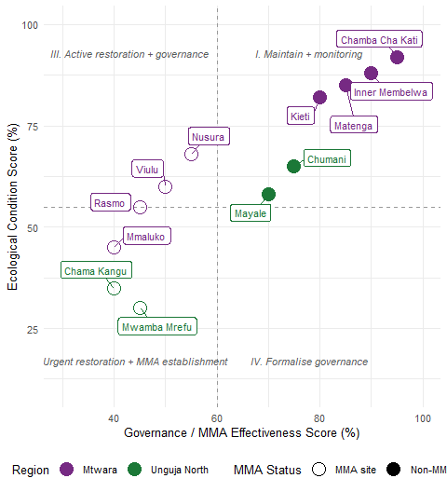
Figure 11: Conceptual restoration prioritisation framework. Sites are plotted by composite ecological condition score (y-axis; derived from benthic cover, fish biomass, recruit density, and invertebrate assemblages) against governance/MMA effectiveness score (x-axis). Dashed lines represent regional mean thresholds. Quadrant labels indicate recommended management actions.

4.2 MMA Effectiveness

The assessment confirms that formal management is strongly associated with better reef condition in Mtwara. Protected reefs—Chamba Cha Kati, Inner Membelwa, Matenga, and Kieti (inside MBREMP)—generally maintain higher hard coral cover and more favorable coral-to-algae ratios than open-access reefs. Outside formal management, Nusura and Viulu retain moderate ecological value but show weaker governance signals, while Rasmo and Mmaluko indicate greater vulnerability through lower overall condition and higher non-coral substrate dominance. Notably, Crown-of-Thorns starfish (COTs) were recorded at Viulu and Kieti, highlighting ongoing biological pressure that requires targeted surveillance and rapid-response control, including at sites with otherwise strong recovery potential.

4.3 Restoration Recommendations

Based on the assessment findings, a tiered restoration framework is recommended to address the varying levels of degradation and management needs across the regions (see Table 12). Immediate priority is assigned to the most critically degraded sites in Unguja North, specifically Chama Kangu and Mwamba Mrefu. Chama Kangu exhibits extreme algal dominance (76%) and minimal coral cover (5%), necessitating active macroalgae removal and coral outplanting alongside formal MMA establishment. Similarly, Mwamba Mrefu suffers from high macroalgae and low fish density, requiring the deployment of artificial reef structures and community-led herbivore protection. In Mtwara, moderate-priority sites like Viulu and Kieti face biological threats from Crown-of-Thorns starfish (COTs) and lack formal protection; these areas require COTs removal programs and inclusion into formal management frameworks to prevent further decline.
Sites categorized for maintenance represent high-quality habitats that serve as ecological anchors for the region. Chamba Cha Kati, Matenga, and Inner Membelwa in Mtwara all maintain exceptional hard coral cover (~80%), requiring strict enforcement and routine monitoring to safeguard their status as regional donor sites for coral fragments. In Unguja North, Mayale and Chumani show moderate resilience but face specific pressures such as high sea urchin-driven bioerosion (282 ind/100m²) and low invertebrate diversity. Recommendations for these sites focus on maintaining MCA patrols, invertebrate restocking—particularly sea cucumbers—and strengthening local co-management to reduce localized stressors. This tiered approach ensures that resources are strategically allocated between urgent active recovery and the long-term preservation of existing marine assets.
Table 12: Tiered restoration recommendations by site, prioritised by ecological condition and MMA governance status in Unguja North and Mtwara.
Priority | Site | Region | Key Issues | Recommended Actions
Immediate | Chama Kangu | Unguja North | Extreme algal dominance (76%); low coral cover (5%) | Active macroalgae removal; coral outplanting; MMA establishment
 | Mwamba Mrefu |  | High macroalgae; low coral cover (8.8%); low fish density | Artificial reef structures; herbivore protection; community management
Moderate | Viulu | Mtwara | Presence of COTs; high algal cover (26.9%); no formal protection | COTs removal program; formal MMA inclusion; monitoring
 | Nusura |  | High coral cover but lacks formal management; sea urchin dominance | Establishment of community-led no-take zone; urchin management
 | Kieti |  | Moderate algal pressure; COTs observed; no formal protection | Targeted COTs surveillance/removal; herbivore protection; MMA inclusion
 | Rasmo |  | High sea star density; elevated sea cucumber densities; outside MMA | Strengthen local compliance; protect key herbivores; targeted monitoring
Maintenance | Mayale | Unguja North | High sand cover; high urchin density (282 ind/100m2) | Monitoring of urchin-driven bioerosion; maintain MCA patrols
 | Chumani |  | Moderate coral cover; low invertebrate diversity | Invertebrate restocking (sea cucumbers); maintain MCA patrols
 | Chamba Cha Kati | Mtwara | Excellent condition (80% coral); high fish biomass | Strict protection; use as regional donor site for coral fragments
 | Inner Membelwa |  | High ecological condition but requires sustained enforcement | Maintain strict enforcement; long-term coral and fish monitoring
 | Matenga |  | High hard coral cover (~80%); maintain recovery trajectory | Routine ecological monitoring; protect herbivores; maintain compliance
 | Mmaluko |  | Mixed benthic condition; elevated fleshy/coralline algae and seagrass | Reduce local stressors; targeted coral outplanting; strengthen co-management

4.4 Conclusions
This assessment provides an integrated, multi-metric baseline of reef condition across Unguja North and Mtwara under the Bahari Yetu project. Key findings are:
- Reference reefs: Chamba Cha Kati remains the strongest benchmark site, with consistently high hard coral cover (about 80%), high fish density, and broad recruit diversity. In Mtwara, Matenga, Kieti, and Inner Membelwa also show strong ecological condition and function as key maintenance sites.
- Critical degradation hotspots: Chama Kangu and Mwamba Mrefu (Unguja North) remain the highest-priority restoration sites, with very low hard coral cover and strong algal dominance, indicating persistent phase-shifted states requiring active intervention.
- Management effects are evident: Sites inside MMAs show significantly higher hard coral cover and lower algal/rubble dominance than outside sites, reinforcing the ecological value of formal management. At the same time, non-MMA reefs such as Nusura and Viulu still retain important ecological value and should be prioritized for strengthened governance.
- Recruitment and recovery potential: Coral recruitment is substantial but spatially uneven. Chamba Cha Kati and Kieti show strong framework-builder recruitment (including Acropora), while Nusura is dominated by high Porites recruitment, indicating differing recovery trajectories among sites.
- Emerging invertebrate risks and restoration pathway: Invertebrate assemblages show marked site variability, with localized Crown-of-Thorns occurrence (notably Viulu and Kieti) and continued pressure on high-value taxa. A tiered strategy is supported: immediate active restoration in degraded Unguja reefs, targeted threat control and governance expansion in moderate-priority Mtwara reefs, and strict protection/monitoring of high-condition benchmark reefs.

References
Babcock, RC et al. 1992. “Reproduction and Recruitment of Corals: Comparisons Among the Caribbean, the Tropical Pacific, and the Red Sea.” Marine Ecology Progress Series 52: 109–25.
Burke, Lauretta, K Reytar, M Spalding, and A Perry. 2011. Reefs at Risk Revisited. World Resources Institute.
Cinner, Joshua E et al. 2016. “Bright Spots Among the World’s Coral Reefs.” Nature 535 (7612): 416–19.
Engler, Jan Broder. 2025. “Tidyplots Empowers Life Scientists with Easy Code-Based Data Visualization.” iMeta, e70018. https://doi.org/10.1002/imt2.70018.
English, S, C Wilkinson, and V Baker. 1997. Survey Manual for Tropical Marine Resources. Australian Institute of Marine Science.
Froese, Rainer, and Daniel Pauly. 2023. “FishBase.” 2023. www.fishbase.org.
Hodgson, G, J Hill, W Kiene, L Maun, J Mihaly, J Liebeler, C Shauka, and R Devel. 2006. Reef Check Instruction Manual: A Guide to Reef Check Coral Reef Monitoring. Reef Check Foundation.
Iannone, Richard, Joe Cheng, Barret Schloerke, Ellis Hughes, Alexandra Lauer, JooYoung Seo, Ken Brevoort, and Olivier Roy. 2025. Gt: Easily Create Presentation-Ready Display Tables. https://doi.org/10.32614/CRAN.package.gt.
Kassambara, Alboukadel. 2025. Rstatix: Pipe-Friendly Framework for Basic Statistical Tests. https://doi.org/10.32614/CRAN.package.rstatix.
McClanahan, Tim R et al. 2020. “Global Baselines and Benchmarks for Fish Biomass: Comparing Remote Reefs and Fisheries Closures.” Marine Ecology Progress Series 641: 153–67.
McClanahan, Tim R, Joshua E Cinner, and Caroline Abunge. 2014. “Perceived Benefits of Fisheries Management Restrictions in Madagascar.” Ecology and Society 19 (1).
Muenchow, Jannes, Patrick Schratz, and Alexander Brenning. 2017. “RQGIS: Integrating r with QGIS for Statistical Geocomputing.”
Obura, David et al. 2016. “Coral Mortality Dynamics on Reefs of the Western Indian Ocean.” Coral Reefs.
Obura, David, Mishal Gudka, J Abdouravi, S Ahamada, et al. 2017. “Coral Reef Status Report for the Western Indian Ocean.” Global Coral Reef Monitoring Network (GCRMN)/International Coral Reef Initiative (ICRI).
Pebesma, Edzer. 2018. “Simple Features for R: Standardized Support for Spatial Vector Data.” The R Journal 10 (1): 439–46. https://doi.org/10.32614/RJ-2018-009.
R Core Team. 2024. R: A Language and Environment for Statistical Computing. Vienna, Austria: R Foundation for Statistical Computing. https://www.R-project.org/.
Rocliffe, S, S Peabody, M Samoilys, and JP Hawkins. 2014. “Towards a Network of Locally Managed Marine Areas (LMMAs) in the Western Indian Ocean.” PLoS One 9 (7): e103000.
Wickham, Hadley. 2016. Ggplot2: Elegant Graphics for Data Analysis. Springer-Verlag New York. https://ggplot2.tidyverse.org.
Wilkinson, Clive. 2008. Status of Coral Reefs of the World: 2008. Global Coral Reef Monitoring Network; Reef; Rainforest Research Centre.
Wilson, JR et al. 2020. Monitoring Coral Reefs: A Guide for the Western Indian Ocean. CORDIO East Africa.
Zhu, Hao. 2024. kableExtra: Construct Complex Table with ’Kable’ and Pipe Syntax. https://CRAN.R-project.org/package=kableExtra.

