Research Results

Ian Nyeme

July 29, 2018

setting working directory

setwd("E:/Data Manipulation/Ian Nyeme/")

required packages

require(haven)

## Loading required package: haven

require(tidyverse)

## Loading required package: tidyverse

## -- Attaching packages ----------------------------------------------------------------------- tidyverse 1.2.1 --

## v ggplot2 3.0.0.9000 v purrr 0.2.5   
## v tibble 1.4.2 v dplyr 0.7.6   
## v tidyr 0.8.1 v stringr 1.3.1   
## v readr 1.1.1 v forcats 0.3.0

## -- Conflicts -------------------------------------------------------------------------- tidyverse_conflicts() --  
## x dplyr::filter() masks stats::filter()  
## x dplyr::lag() masks stats::lag()

require(lubridate)

## Loading required package: lubridate

##   
## Attaching package: 'lubridate'

## The following object is masked from 'package:base':  
##   
## date

read the questionnaire file

# read the file  
db = read_csv("Questionnaire_response_29072018.csv")

## Warning: Missing column names filled in: 'X8' [8], 'X59' [59], 'X60' [60],  
## 'X61' [61]

## Warning: Duplicated column names deduplicated: 'TPS does not ensure cost  
## certainty to the owner?' => 'TPS does not ensure cost certainty to the  
## owner?_1' [23], 'Completion date is not rigid' => 'Completion date is  
## not rigid_1' [24], 'Stipulated price is not rigid' => 'Stipulated price  
## is not rigid_1' [25], 'Design should be completed before tendering' =>  
## 'Design should be completed before tendering_1' [26], 'Cost overrun due  
## to new design and specification' => 'Cost overrun due to new design and  
## specification_1' [27], 'Cost overrun due to quantities and variation of  
## price factors' => 'Cost overrun due to quantities and variation of price  
## factors_1' [28], 'Responsibility of design is vested to the Client' =>  
## 'Responsibility of design is vested to the Client_1' [29], 'Design changes  
## impact price' => 'Design changes impact price_1' [30], 'Dispute occur  
## between the owner and Contractor' => 'Dispute occur between the owner and  
## Contractor_1' [31]

## Parsed with column specification:  
## cols(  
## .default = col_integer(),  
## Timestamp = col_character(),  
## `Which category below define you?` = col_character(),  
## `What is your age group among the listed below?` = col_character(),  
## `Have you ever used Design & Build in any of your projects?` = col_character(),  
## `In what form have you used the Design and Build?` = col_character(),  
## `What is your current job position?` = col_character(),  
## `For how long have you been in this job position?` = col_character(),  
## X8 = col_character(),  
## `Any other comments you would like to make to ensure cost escalation is eliminated or reduced by using D&B Procurement System in roadworks in Tanzania:` = col_character()  
## )

## See spec(...) for full column specifications.

# remove unwanted columns  
db = db[,-c(8,59:61)]

check the column structure

glimpse(db)

## Observations: 55  
## Variables: 57  
## $ Timestamp <chr> ...  
## $ `Which category below define you?` <chr> ...  
## $ `What is your age group among the listed below?` <chr> ...  
## $ `Have you ever used Design & Build in any of your projects?` <chr> ...  
## $ `In what form have you used the Design and Build?` <chr> ...  
## $ `What is your current job position?` <chr> ...  
## $ `For how long have you been in this job position?` <chr> ...  
## $ `It provides single point of contact between the Client and Contractor hence ensure the efficient utilization of resources on projects` <int> ...  
## $ `It ensures certainty of final project cost to be high` <int> ...  
## $ `It ensures project management efficiency is improved due to improved communication` <int> ...  
## $ `It increases effectiveness and efficiency as the structure of the organization is simple` <int> ...  
## $ `It ensures the designing and construction risks are transferred to the Contractor hence improve performance standards` <int> ...  
## $ `TPS does not ensure cost certainty to the owner?` <int> ...  
## $ `Completion date is not rigid` <int> ...  
## $ `Stipulated price is not rigid` <int> ...  
## $ `Design should be completed before tendering` <int> ...  
## $ `Cost overrun due to new design and specification` <int> ...  
## $ `Cost overrun due to quantities and variation of price factors` <int> ...  
## $ `Responsibility of design is vested to the Client` <int> ...  
## $ `Design changes impact price` <int> ...  
## $ `Dispute occur between the owner and Contractor` <int> ...  
## $ `TPS does not ensure cost certainty to the owner?_1` <int> ...  
## $ `Completion date is not rigid_1` <int> ...  
## $ `Stipulated price is not rigid_1` <int> ...  
## $ `Design should be completed before tendering_1` <int> ...  
## $ `Cost overrun due to new design and specification_1` <int> ...  
## $ `Cost overrun due to quantities and variation of price factors_1` <int> ...  
## $ `Responsibility of design is vested to the Client_1` <int> ...  
## $ `Design changes impact price_1` <int> ...  
## $ `Dispute occur between the owner and Contractor_1` <int> ...  
## $ `Lack of design expertise` <int> ...  
## $ `Lack of interest from owners` <int> ...  
## $ `Lack of suitable organisation structure` <int> ...  
## $ `Lack of Design and Build specialist` <int> ...  
## $ `Lack of design-build experience` <int> ...  
## $ `Unfamiliarity of owners` <int> ...  
## $ `Lack of support from local government` <int> ...  
## $ `Lack of competent design-builders` <int> ...  
## $ `Uncertainty of design-build contract` <int> ...  
## $ `Higher risk of design-build projects` <int> ...  
## $ `Lack of qualification regulations` <int> ...  
## $ `Effectiveness of design-build projects` <int> ...  
## $ `Difficulty in writing design-build request for proposals` <int> ...  
## $ `Lack of Contractor selection methods` <int> ...  
## $ `Higher Contract price of design-build projects` <int> ...  
## $ `Conflict with existing bidding law` <int> ...  
## $ `Coordination with Subcontractor` <int> ...  
## $ `Lack of specified subcontractors` <int> ...  
## $ `Fixed Construction cost from the beginning of the project` <int> ...  
## $ `Cost is minimized due to shortening of project duration by engaging D&B Contractor during design stage.` <int> ...  
## $ `Fixed schedule due to absence of design errors, design omission` <int> ...  
## $ `Schedule reduction and promote fast-tracking.` <int> ...  
## $ `Claims are reduced since design errors and omission are responsibility of the Contractor.` <int> ...  
## $ `Promote constructability and innovations as it inject the Contractor knowledge from designing stage.` <int> ...  
## $ `Quick delivery method as it allows the overlapping of Design and Construction process.` <int> ...  
## $ `Design errors are minimized hence no increase in project cost` <int> ...  
## $ `Any other comments you would like to make to ensure cost escalation is eliminated or reduced by using D&B Procurement System in roadworks in Tanzania:` <chr> ...

db$`Which category below define you?`%>%table()%>%barplot()

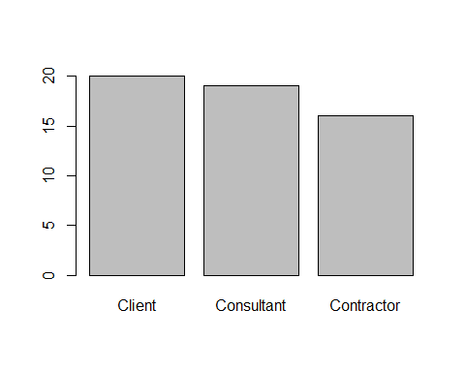

You are trying to address the number of respondents and whether they have ever used the design and building

# ggplot(data = db, aes(x =`Which category below define you?`), col = 1)+geom_bar(fill = "grey80", col = "black")+theme_bw()  
  
ggplot(data = db, aes(x =`Which category below define you?`,   
 fill = `Have you ever used Design & Build in any of your projects?` ),   
 col = 1)+  
 geom_bar()+theme_bw()+  
 scale_fill_discrete(name = NULL)+  
 labs(x = NULL, y = "Number of Respondents")+  
 theme(legend.position = c(.9,.9),  
 legend.background = element_rect(colour = 1))

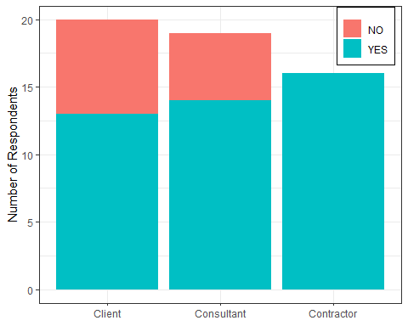

table(db$`Which category below define you?`, db$`Have you ever used Design & Build in any of your projects?`)

##   
## NO YES  
## Client 7 13  
## Consultant 5 14  
## Contractor 0 16

table(db$`Which category below define you?`, db$`Have you ever used Design & Build in any of your projects?`)%>%as.matrix()%>%prop.table()

##   
## NO YES  
## Client 0.12727273 0.23636364  
## Consultant 0.09090909 0.25454545  
## Contractor 0.00000000 0.29090909

table(db$`Which category below define you?`, db$`Have you ever used Design & Build in any of your projects?`)%>%as.matrix()%>%prop.test()

## Warning in prop.test(.): Chi-squared approximation may be incorrect

##   
## 3-sample test for equality of proportions without continuity  
## correction  
##   
## data: .  
## X-squared = 6.7277, df = 2, p-value = 0.0346  
## alternative hypothesis: two.sided  
## sample estimates:  
## prop 1 prop 2 prop 3   
## 0.3500000 0.2631579 0.0000000