Research Results

Ian Nyeme

July 29, 2018

## R version

The analysis was done in R environmet using version 3.4.4 released on 2018-03-15, which can be download [here](http://cran.us.r-project.org/). The scripts work with this version or later

setting working directory

setwd("E:/Data Manipulation/Ian Nyeme/")

required packages

require(haven)

## Loading required package: haven

require(tidyverse)

## Loading required package: tidyverse

## -- Attaching packages ------------------------------------------------------------------ tidyverse 1.2.1 --

## v ggplot2 3.0.0.9000 v purrr 0.2.5   
## v tibble 1.4.2 v dplyr 0.7.6   
## v tidyr 0.8.1 v stringr 1.3.1   
## v readr 1.1.1 v forcats 0.3.0

## -- Conflicts --------------------------------------------------------------------- tidyverse_conflicts() --  
## x dplyr::filter() masks stats::filter()  
## x dplyr::lag() masks stats::lag()

require(lubridate)

## Loading required package: lubridate

##   
## Attaching package: 'lubridate'

## The following object is masked from 'package:base':  
##   
## date

require(ggsci)

## Loading required package: ggsci

require(RColorBrewer)

## Loading required package: RColorBrewer

read the questionnaire file

# read the file  
db = read_csv("Questionnaire_response_04082018.csv")

## Warning: Missing column names filled in: 'X8' [8], 'X59' [59], 'X60' [60],  
## 'X61' [61]

## Warning: Duplicated column names deduplicated: 'TPS does not ensure cost  
## certainty to the owner?' => 'TPS does not ensure cost certainty to the  
## owner?_1' [23], 'Completion date is not rigid' => 'Completion date is  
## not rigid_1' [24], 'Stipulated price is not rigid' => 'Stipulated price  
## is not rigid_1' [25], 'Design should be completed before tendering' =>  
## 'Design should be completed before tendering_1' [26], 'Cost overrun due  
## to new design and specification' => 'Cost overrun due to new design and  
## specification_1' [27], 'Cost overrun due to quantities and variation of  
## price factors' => 'Cost overrun due to quantities and variation of price  
## factors_1' [28], 'Responsibility of design is vested to the Client' =>  
## 'Responsibility of design is vested to the Client_1' [29], 'Design changes  
## impact price' => 'Design changes impact price_1' [30], 'Dispute occur  
## between the owner and Contractor' => 'Dispute occur between the owner and  
## Contractor_1' [31]

## Parsed with column specification:  
## cols(  
## .default = col_integer(),  
## Timestamp = col_character(),  
## `Which category below define you?` = col_character(),  
## `What is your age group among the listed below?` = col_character(),  
## `Have you ever used Design & Build in any of your projects?` = col_character(),  
## `In what form have you used the Design and Build?` = col_character(),  
## `5. What is your current job position?` = col_character(),  
## `For how long have you been in this job position?` = col_character(),  
## X8 = col_character(),  
## `Any other comments you would like to make to ensure cost escalation is eliminated or reduced by using D&B Procurement System in roadworks in Tanzania:` = col_character()  
## )

## See spec(...) for full column specifications.

# remove unwanted columns  
db = db[,-c(8,59:61)]  
  
# da = db%>%select(-c('X8', 'X59','X60', 'X61'))  
# rm(list = setdiff(ls(), "db"))  
  
code1 = c("Strongly Disagree", "Disagree", "Agree", "Strongly Agree")  
code2 = c("Very low", "Low", "Moderate", "High", "Very High")

check the structure of the data frame and change the variable names into questions

glimpse(db)

## Observations: 55  
## Variables: 57  
## $ Timestamp <chr> ...  
## $ `Which category below define you?` <chr> ...  
## $ `What is your age group among the listed below?` <chr> ...  
## $ `Have you ever used Design & Build in any of your projects?` <chr> ...  
## $ `In what form have you used the Design and Build?` <chr> ...  
## $ `5. What is your current job position?` <chr> ...  
## $ `For how long have you been in this job position?` <chr> ...  
## $ `It provides single point of contact between the Client and Contractor hence ensure the efficient utilization of resources on projects` <int> ...  
## $ `It ensures certainty of final project cost to be high` <int> ...  
## $ `It ensures project management efficiency is improved due to improved communication` <int> ...  
## $ `It increases effectiveness and efficiency as the structure of the organization is simple` <int> ...  
## $ `It ensures the designing and construction risks are transferred to the Contractor hence improve performance standards` <int> ...  
## $ `TPS does not ensure cost certainty to the owner?` <int> ...  
## $ `Completion date is not rigid` <int> ...  
## $ `Stipulated price is not rigid` <int> ...  
## $ `Design should be completed before tendering` <int> ...  
## $ `Cost overrun due to new design and specification` <int> ...  
## $ `Cost overrun due to quantities and variation of price factors` <int> ...  
## $ `Responsibility of design is vested to the Client` <int> ...  
## $ `Design changes impact price` <int> ...  
## $ `Dispute occur between the owner and Contractor` <int> ...  
## $ `TPS does not ensure cost certainty to the owner?_1` <int> ...  
## $ `Completion date is not rigid_1` <int> ...  
## $ `Stipulated price is not rigid_1` <int> ...  
## $ `Design should be completed before tendering_1` <int> ...  
## $ `Cost overrun due to new design and specification_1` <int> ...  
## $ `Cost overrun due to quantities and variation of price factors_1` <int> ...  
## $ `Responsibility of design is vested to the Client_1` <int> ...  
## $ `Design changes impact price_1` <int> ...  
## $ `Dispute occur between the owner and Contractor_1` <int> ...  
## $ `Lack of design expertise` <int> ...  
## $ `Lack of interest from owners` <int> ...  
## $ `Lack of suitable organisation structure` <int> ...  
## $ `Lack of Design and Build specialist` <int> ...  
## $ `Lack of design-build experience` <int> ...  
## $ `Unfamiliarity of owners` <int> ...  
## $ `Lack of support from local government` <int> ...  
## $ `Lack of competent design-builders` <int> ...  
## $ `Uncertainty of design-build contract` <int> ...  
## $ `Higher risk of design-build projects` <int> ...  
## $ `Lack of qualification regulations` <int> ...  
## $ `Effectiveness of design-build projects` <int> ...  
## $ `Difficulty in writing design-build request for proposals` <int> ...  
## $ `Lack of Contractor selection methods` <int> ...  
## $ `Higher Contract price of design-build projects` <int> ...  
## $ `Conflict with existing bidding law` <int> ...  
## $ `Coordination with Subcontractor` <int> ...  
## $ `Lack of specified subcontractors` <int> ...  
## $ `Fixed Construction cost from the beginning of the project` <int> ...  
## $ `Cost is minimized due to shortening of project duration by engaging D&B Contractor during design stage.` <int> ...  
## $ `Fixed schedule due to absence of design errors, design omission` <int> ...  
## $ `Schedule reduction and promote fast-tracking.` <int> ...  
## $ `Claims are reduced since design errors and omission are responsibility of the Contractor.` <int> ...  
## $ `Promote constructability and innovations as it inject the Contractor knowledge from designing stage.` <int> ...  
## $ `Quick delivery method as it allows the overlapping of Design and Construction process.` <int> ...  
## $ `Design errors are minimized hence no increase in project cost` <int> ...  
## $ `Any other comments you would like to make to ensure cost escalation is eliminated or reduced by using D&B Procurement System in roadworks in Tanzania:` <chr> ...

variable.names = names(db)  
  
names(db) = rep(paste("q",1:57, sep = ""))  
  
index = data_frame(variable.names, names(db))%>%select(question = `names(db)`, long.question = variable.names)

db%>%select(q4, q2)%>%table()

## q2  
## q4 Client Consultant Contractor  
## NO 7 5 0  
## YES 13 14 16

db%>%select(q4, q2)%>%table()%>%barplot(col = 2:3)

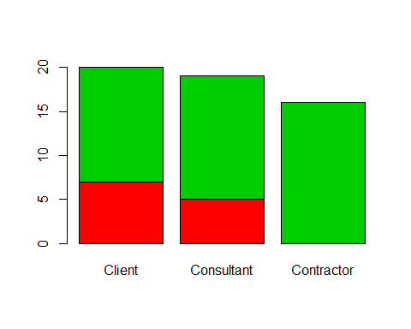

db%>%select(q4, q2)%>%table()%>%prop.table()

## q2  
## q4 Client Consultant Contractor  
## NO 0.12727273 0.09090909 0.00000000  
## YES 0.23636364 0.25454545 0.29090909

db%>%select(q2, q4)%>%table()%>%as.matrix()%>%prop.test()

## Warning in prop.test(.): Chi-squared approximation may be incorrect

##   
## 3-sample test for equality of proportions without continuity  
## correction  
##   
## data: .  
## X-squared = 6.7277, df = 2, p-value = 0.0346  
## alternative hypothesis: two.sided  
## sample estimates:  
## prop 1 prop 2 prop 3   
## 0.3500000 0.2631579 0.0000000

## Objectives

### First objective:

To determine if design and build contract can improve project performance on roadworks in Tanzania

db$q2 = as.factor(db$q2)  
  
#plot for question 8  
ggplot(data = db, aes(x = q8, fill = q2))+  
 geom_bar(col = 1)+  
 scale_x_discrete(limits = code1)+  
 # scale_fill_discrete(name = "Respondents")+  
 # scale_fill_brewer(name = "Respondents",palette = "Dark2")+  
 # scale_fill_jco(name = "Respondents")+  
 scale_fill_viridis_d(name = "Respondents")+  
 scale_y_continuous(breaks = seq(0,40,5))+  
 theme_bw()+  
 theme(legend.position = c(0.9,0.85),   
 legend.background = element_rect(colour = "black"),  
 panel.grid.minor.y = element_blank())+  
 labs(x = NULL, y = "Number of Respondents",   
 subtitle = " Does it provides single point of contact between the Client and Contractor hence ensure the efficient \nutilization of resources on projects?")

## Warning: Removed 1 rows containing non-finite values (stat_count).

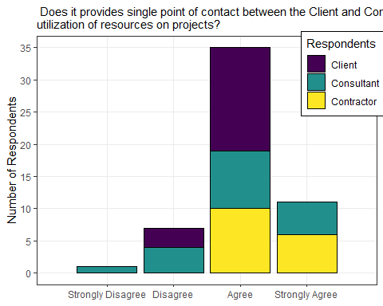

#plot for question 8  
ggplot(data = db, aes(x = q9, fill = q2))+  
 geom_bar(col = 1)+  
 scale_x_discrete(limits = code1)+  
 # scale_fill_discrete(name = "Respondents")+  
 # scale_fill_brewer(name = "Respondents",palette = "Dark2")+  
 # scale_fill_jco(name = "Respondents")+  
 scale_fill_viridis_d(name = "Respondents")+  
 scale_y_continuous(breaks = seq(0,25,5))+  
 theme_bw()+  
 theme(legend.position = c(0.9,0.85),   
 legend.background = element_rect(colour = "black"),  
 panel.grid.minor.y = element_blank())+  
 labs(x = NULL, y = "Number of Respondents",   
 subtitle = "It ensures certainty of final project cost to be high")

## Warning: Removed 1 rows containing non-finite values (stat_count).

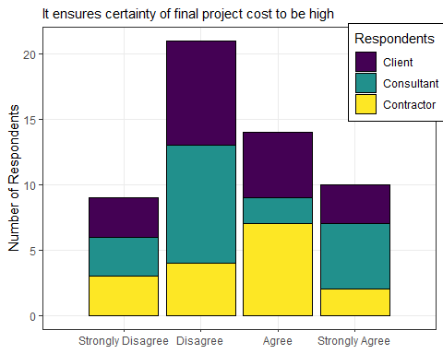

#plot for question 8  
ggplot(data = db, aes(x = q10, fill = q2))+  
 geom_bar(col = 1)+  
 scale_x_discrete(limits = code1)+  
 # scale_fill_discrete(name = "Respondents")+  
 # scale_fill_brewer(name = "Respondents",palette = "Dark2")+  
 # scale_fill_jco(name = "Respondents")+  
 scale_fill_viridis_d(name = "Respondents")+  
 scale_y_continuous(breaks = seq(0,35,6))+  
 theme_bw()+  
 theme(legend.position = c(0.9,0.85),   
 legend.background = element_rect(colour = "black"),  
 panel.grid.minor.y = element_blank())+  
 labs(x = NULL, y = "Number of Respondents",   
 subtitle = "It ensures project management efficiency is improved due to improved communication")

## Warning: Removed 1 rows containing non-finite values (stat_count).

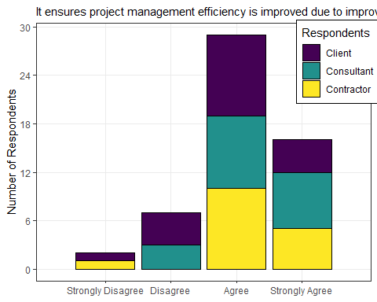

#plot for question 8  
ggplot(data = db, aes(x = q11, fill = q2))+  
 geom_bar(col = 1)+  
 scale_x_discrete(limits = code1)+  
 # scale_fill_discrete(name = "Respondents")+  
 # scale_fill_brewer(name = "Respondents",palette = "Dark2")+  
 # scale_fill_jco(name = "Respondents")+  
 scale_fill_viridis_d(name = "Respondents")+  
 scale_y_continuous(breaks = seq(0,30,5))+  
 theme_bw()+  
 theme(legend.position = c(0.9,0.85),   
 legend.background = element_rect(colour = "black"),  
 panel.grid.minor.y = element_blank())+  
 labs(x = NULL, y = "Number of Respondents",   
 subtitle = "It increases effectiveness and efficiency as the structure of the organization is simple")

## Warning: Removed 2 rows containing non-finite values (stat_count).

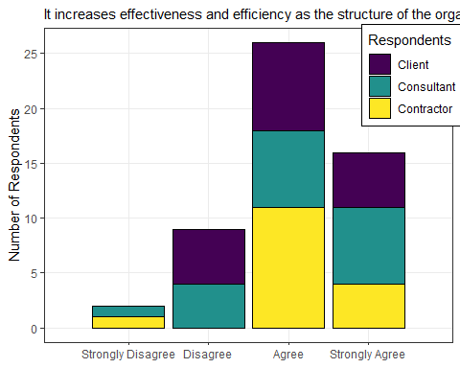

#plot for question 8  
ggplot(data = db, aes(x = q12, fill = q2))+  
 geom_bar(col = 1)+  
 scale_x_discrete(limits = code1)+  
 # scale_fill_discrete(name = "Respondents")+  
 # scale_fill_brewer(name = "Respondents",palette = "Dark2")+  
 # scale_fill_jco(name = "Respondents")+  
 scale_fill_viridis_d(name = "Respondents")+  
 scale_y_continuous(breaks = seq(0,25,6))+  
 theme_bw()+  
 theme(legend.position = c(0.1,0.85),   
 legend.background = element_rect(colour = "black"),  
 panel.grid.minor.y = element_blank())+  
 labs(x = NULL, y = "Number of Respondents",   
 subtitle = "It ensures the designing and construction risks are transferred to the Contractor hence improve performance \nstandards")

## Warning: Removed 1 rows containing non-finite values (stat_count).

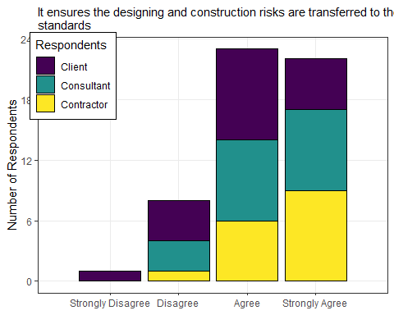

### Second objective:

1. To investigate the current challenges caused by *traditional procurement system* on roadwork projects in Tanzania

#plot for question 8  
ggplot(data = db%>%mutate(q13 = replace(q13,q13==5,4)),   
 aes(x = q13, fill = q2))+  
 geom_bar(col = 1)+  
 scale_x_discrete(limits = code1)+  
 # scale_fill_discrete(name = "Respondents")+  
 # scale_fill_brewer(name = "Respondents",palette = "Dark2")+  
 # scale_fill_jco(name = "Respondents")+  
 scale_fill_viridis_d(name = "Respondents")+  
 # scale_y_continuous(breaks = seq(0,25,6))+  
 theme_bw()+  
 theme(legend.position = c(0.1,0.85),   
 legend.background = element_rect(colour = "black"),  
 panel.grid.minor.y = element_blank())+  
 labs(x = NULL, y = "Number of Respondents",   
 subtitle = "TPS does not ensure cost certainty to the owner?")

## Warning: Removed 1 rows containing non-finite values (stat_count).

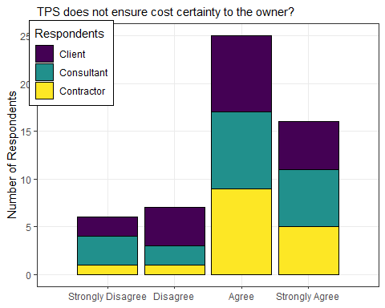

#plot for question 8  
ggplot(data = db%>%mutate(q14 = replace(q14,q14==5,4)),   
 aes(x = q14, fill = q2))+  
 geom_bar(col = 1)+  
 scale_x_discrete(limits = code1)+  
 # scale_fill_discrete(name = "Respondents")+  
 # scale_fill_brewer(name = "Respondents",palette = "Dark2")+  
 # scale_fill_jco(name = "Respondents")+  
 scale_fill_viridis_d(name = "Respondents")+  
 # scale_y_continuous(breaks = seq(0,25,6))+  
 theme_bw()+  
 theme(legend.position = c(0.1,0.85),   
 legend.background = element_rect(colour = "black"),  
 panel.grid.minor.y = element_blank())+  
 labs(x = NULL, y = "Number of Respondents",   
 subtitle = "Completion date is not rigid")

## Warning: Removed 2 rows containing non-finite values (stat_count).

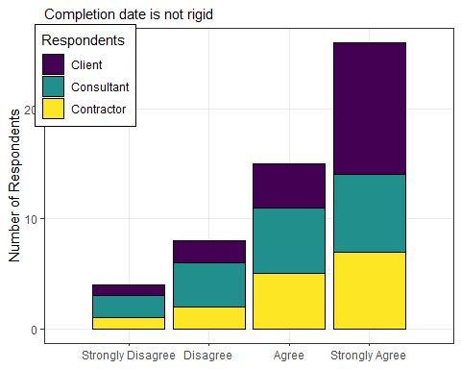

#plot for question 8  
ggplot(data = db%>%mutate(q15 = replace(q15,q15==5,4)),   
 aes(x = q15, fill = q2))+  
 geom_bar(col = 1)+  
 scale_x_discrete(limits = code1)+  
 # scale_fill_discrete(name = "Respondents")+  
 # scale_fill_brewer(name = "Respondents",palette = "Dark2")+  
 # scale_fill_jco(name = "Respondents")+  
 scale_fill_viridis_d(name = "Respondents")+  
 # scale_y_continuous(breaks = seq(0,25,6))+  
 theme_bw()+  
 theme(legend.position = c(0.1,0.85),   
 legend.background = element_rect(colour = "black"),  
 panel.grid.minor.y = element_blank())+  
 labs(x = NULL, y = "Number of Respondents",   
 subtitle = "Stipulated price is not rigid")

## Warning: Removed 1 rows containing non-finite values (stat_count).

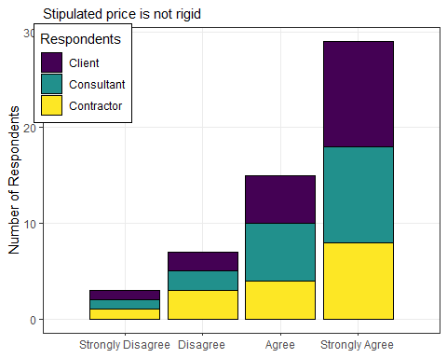

#plot for question 8  
ggplot(data = db%>%mutate(q16 = replace(q16,q16==5,4)),   
 aes(x = q16, fill = q2))+  
 geom_bar(col = 1)+  
 scale_x_discrete(limits = code1)+  
 # scale_fill_discrete(name = "Respondents")+  
 # scale_fill_brewer(name = "Respondents",palette = "Dark2")+  
 # scale_fill_jco(name = "Respondents")+  
 scale_fill_viridis_d(name = "Respondents")+  
 # scale_y_continuous(breaks = seq(0,25,6))+  
 theme_bw()+  
 theme(legend.position = c(0.1,0.85),   
 legend.background = element_rect(colour = "black"),  
 panel.grid.minor.y = element_blank())+  
 labs(x = NULL, y = "Number of Respondents",   
 subtitle = "Design should be completed before tendering")

## Warning: Removed 2 rows containing non-finite values (stat_count).

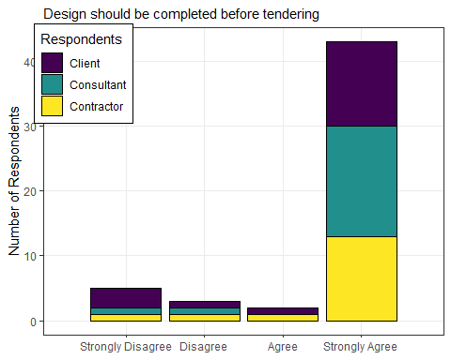

#plot for question 17  
ggplot(data = db%>%mutate(q17 = replace(q17,q17==5,4)),   
 aes(x = q17, fill = q2))+  
 geom_bar(col = 1)+  
 scale_x_discrete(limits = code1)+  
 # scale_fill_discrete(name = "Respondents")+  
 # scale_fill_brewer(name = "Respondents",palette = "Dark2")+  
 # scale_fill_jco(name = "Respondents")+  
 scale_fill_viridis_d(name = "Respondents")+  
 # scale_y_continuous(breaks = seq(0,25,6))+  
 theme_bw()+  
 theme(legend.position = c(0.1,0.85),   
 legend.background = element_rect(colour = "black"),  
 panel.grid.minor.y = element_blank())+  
 labs(x = NULL, y = "Number of Respondents",   
 subtitle = "Cost overrun due to new design and specification")

## Warning: Removed 1 rows containing non-finite values (stat_count).

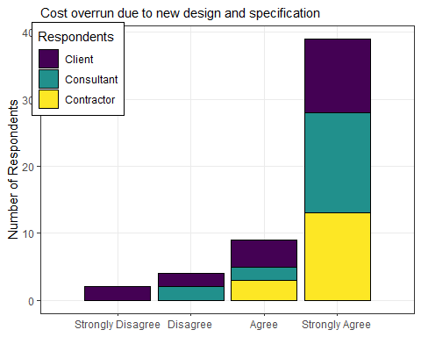

#plot for question 18  
ggplot(data = db%>%mutate(q18 = replace(q18,q18==5,4)),   
 aes(x = q18, fill = q2))+  
 geom_bar(col = 1)+  
 scale_x_discrete(limits = code1)+  
 # scale_fill_discrete(name = "Respondents")+  
 # scale_fill_brewer(name = "Respondents",palette = "Dark2")+  
 # scale_fill_jco(name = "Respondents")+  
 scale_fill_viridis_d(name = "Respondents")+  
 # scale_y_continuous(breaks = seq(0,25,6))+  
 theme_bw()+  
 theme(legend.position = c(0.1,0.85),   
 legend.background = element_rect(colour = "black"),  
 panel.grid.minor.y = element_blank())+  
 labs(x = NULL, y = "Number of Respondents",   
 subtitle = "Cost overrun due to quantities and variation of price factors")

## Warning: Removed 2 rows containing non-finite values (stat_count).

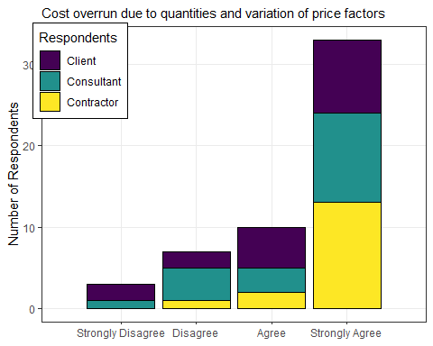

#plot for question 19  
ggplot(data = db%>%mutate(q19 = replace(q19,q19==5,4)),   
 aes(x = q19, fill = q2))+  
 geom_bar(col = 1)+  
 scale_x_discrete(limits = code1)+  
 # scale_fill_discrete(name = "Respondents")+  
 # scale_fill_brewer(name = "Respondents",palette = "Dark2")+  
 # scale_fill_jco(name = "Respondents")+  
 scale_fill_viridis_d(name = "Respondents")+  
 # scale_y_continuous(breaks = seq(0,25,6))+  
 theme_bw()+  
 theme(legend.position = c(0.1,0.85),   
 legend.background = element_rect(colour = "black"),  
 panel.grid.minor.y = element_blank())+  
 labs(x = NULL, y = "Number of Respondents",   
 subtitle = index[19,2])

## Warning: Removed 1 rows containing non-finite values (stat_count).

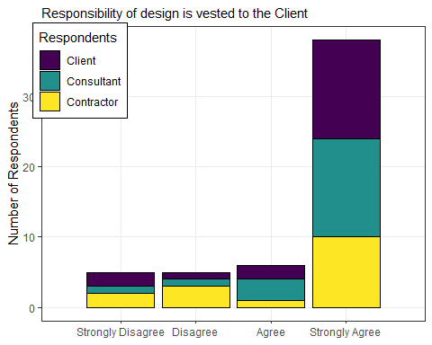

#plot for question 20  
ggplot(data = db%>%mutate(q20 = replace(q20,q20==5,4)),   
 aes(x = q20, fill = q2))+  
 geom_bar(col = 1)+  
 scale_x_discrete(limits = code1)+  
 # scale_fill_discrete(name = "Respondents")+  
 # scale_fill_brewer(name = "Respondents",palette = "Dark2")+  
 # scale_fill_jco(name = "Respondents")+  
 scale_fill_viridis_d(name = "Respondents")+  
 # scale_y_continuous(breaks = seq(0,25,6))+  
 theme_bw()+  
 theme(legend.position = c(0.1,0.85),   
 legend.background = element_rect(colour = "black"),  
 panel.grid.minor.y = element_blank())+  
 labs(x = NULL, y = "Number of Respondents",   
 subtitle = index[20,2])

## Warning: Removed 2 rows containing non-finite values (stat_count).

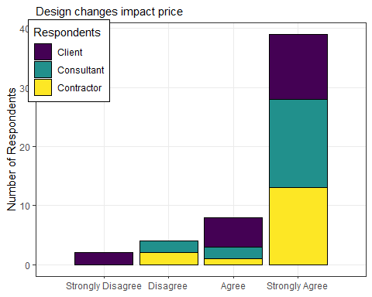

#plot for question 21  
ggplot(data = db%>%mutate(q21 = replace(q21,q21==5,4)),   
 aes(x = q21, fill = q2))+  
 geom_bar(col = 1)+  
 scale_x_discrete(limits = code1)+  
 # scale_fill_discrete(name = "Respondents")+  
 # scale_fill_brewer(name = "Respondents",palette = "Dark2")+  
 # scale_fill_jco(name = "Respondents")+  
 scale_fill_viridis_d(name = "Respondents")+  
 # scale_y_continuous(breaks = seq(0,25,6))+  
 theme_bw()+  
 theme(legend.position = c(0.1,0.85),   
 legend.background = element_rect(colour = "black"),  
 panel.grid.minor.y = element_blank())+  
 labs(x = NULL, y = "Number of Respondents",   
 subtitle = index[21,2])

## Warning: Removed 1 rows containing non-finite values (stat_count).

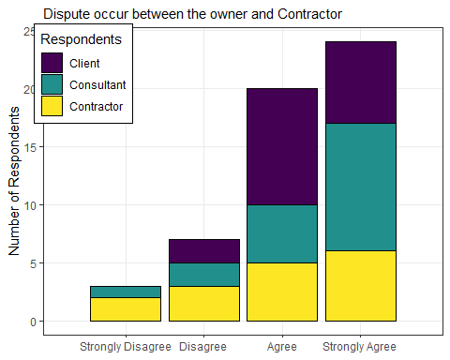

### Third objective:

1. To investigate the challanges that hinder the client to move from traditional procurement to designa build

#plot for question 22  
ggplot(data = db%>%mutate(q22 = replace(q22,q22==5,4)),   
 aes(x = q22, fill = q2))+  
 geom_bar(col = 1)+  
 scale_x_discrete(limits = code1)+  
 # scale_fill_discrete(name = "Respondents")+  
 # scale_fill_brewer(name = "Respondents",palette = "Dark2")+  
 # scale_fill_jco(name = "Respondents")+  
 scale_fill_viridis_d(name = "Respondents")+  
 # scale_y_continuous(breaks = seq(0,25,6))+  
 theme_bw()+  
 theme(legend.position = c(0.1,0.85),   
 legend.background = element_rect(colour = "black"),  
 panel.grid.minor.y = element_blank())+  
 labs(x = NULL, y = "Number of Respondents",   
 subtitle = index[22,2])

## Warning: Removed 4 rows containing non-finite values (stat_count).

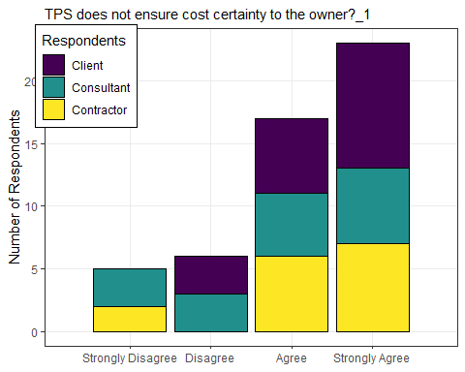

### Fourth objective:

1. To suggest ways of which design abuild can be used to reduce or eliminate current cost escalation on roadworks projects in tanzania

## Hypotheses

1. Design and Build contract will not improve project performance on roadwork projects in Tanzania
2. Traditional procurement does not contribute to poor performance on roadwork projects in Tanzania
3. There no are challenges that hinder the client to move from traditional procurement system to desing and build contract