Research Results

Ian Nyeme

July 29, 2018

## R version

The analysis was done in R environmet using version 3.4.4 released on 2018-03-15, which can be download [here](http://cran.us.r-project.org/). The scripts work with this version or later

setting working directory

required packages

read the questionnaire file

## Warning: Missing column names filled in: 'X8' [8], 'X59' [59], 'X60' [60],  
## 'X61' [61]

## Warning: Duplicated column names deduplicated: 'TPS does not ensure cost  
## certainty to the owner?' => 'TPS does not ensure cost certainty to the  
## owner?_1' [23], 'Completion date is not rigid' => 'Completion date is  
## not rigid_1' [24], 'Stipulated price is not rigid' => 'Stipulated price  
## is not rigid_1' [25], 'Design should be completed before tendering' =>  
## 'Design should be completed before tendering_1' [26], 'Cost overrun due  
## to new design and specification' => 'Cost overrun due to new design and  
## specification_1' [27], 'Cost overrun due to quantities and variation of  
## price factors' => 'Cost overrun due to quantities and variation of price  
## factors_1' [28], 'Responsibility of design is vested to the Client' =>  
## 'Responsibility of design is vested to the Client_1' [29], 'Design changes  
## impact price' => 'Design changes impact price_1' [30], 'Dispute occur  
## between the owner and Contractor' => 'Dispute occur between the owner and  
## Contractor_1' [31]

## Parsed with column specification:  
## cols(  
## .default = col_integer(),  
## Timestamp = col_character(),  
## `Which category below define you?` = col_character(),  
## `What is your age group among the listed below?` = col_character(),  
## `Have you ever used Design & Build in any of your projects?` = col_character(),  
## `In what form have you used the Design and Build?` = col_character(),  
## `5. What is your current job position?` = col_character(),  
## `For how long have you been in this job position?` = col_character(),  
## X8 = col_character(),  
## `Any other comments you would like to make to ensure cost escalation is eliminated or reduced by using D&B Procurement System in roadworks in Tanzania:` = col_character()  
## )

## See spec(...) for full column specifications.

check the structure of the data frame and change the variable names into questions

## Objectives

### First objective:

To determine if design and build contract can improve project performance on roadworks in Tanzania

Table 1:

|  |  |  |
| --- | --- | --- |
| Age.group | count | Percentage |
| 31-35 | 23 | 41.82 |
| 36-40 | 10 | 18.18 |
| 41-45 | 6 | 10.91 |
| Above 45 | 10 | 18.18 |
| Below 31 | 6 | 10.91 |

## Warning: Removed 1 rows containing non-finite values (stat_count).

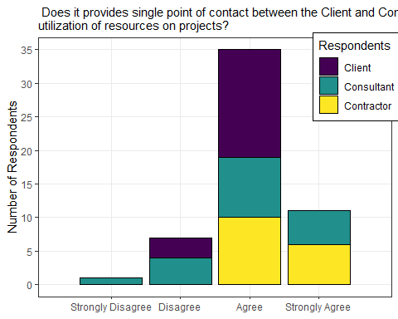

## Warning: Removed 1 rows containing non-finite values (stat_count).

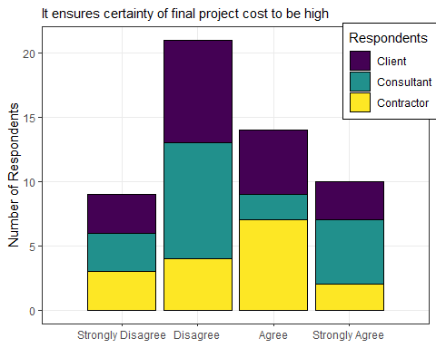

## Warning: Removed 1 rows containing non-finite values (stat_count).

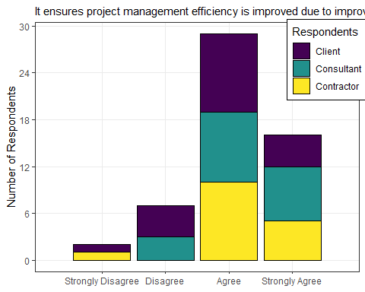

## Warning: Removed 2 rows containing non-finite values (stat_count).

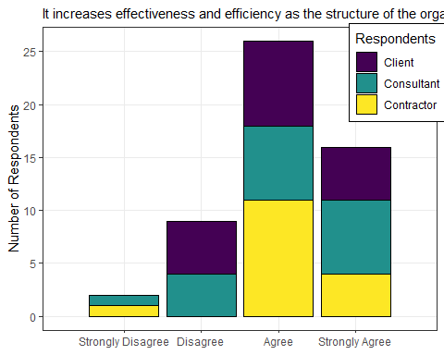

## Warning: Removed 1 rows containing non-finite values (stat_count).

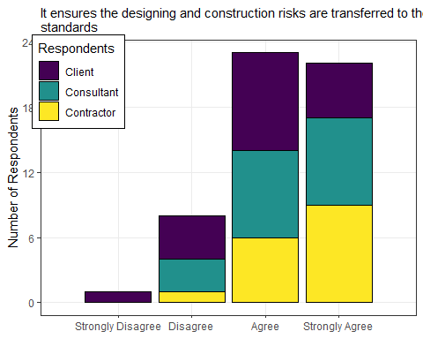

### Second objective:

1. To investigate the current challenges caused by *traditional procurement system* on roadwork projects in Tanzania

## Warning: Removed 1 rows containing non-finite values (stat_count).

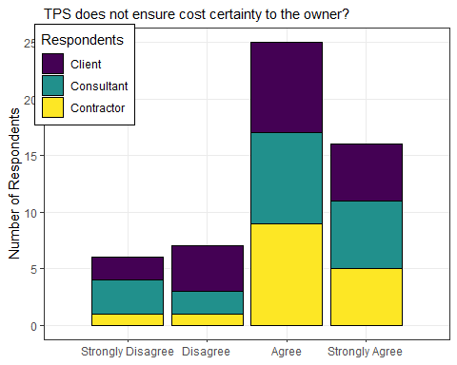

## Warning: Removed 2 rows containing non-finite values (stat_count).

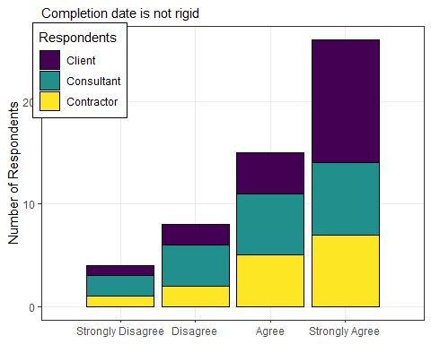

## Warning: Removed 1 rows containing non-finite values (stat_count).

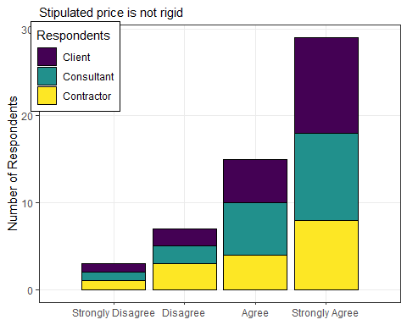

## Warning: Removed 2 rows containing non-finite values (stat_count).

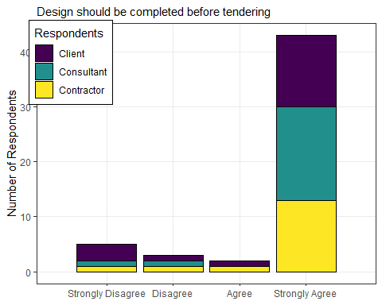

## Warning: Removed 1 rows containing non-finite values (stat_count).

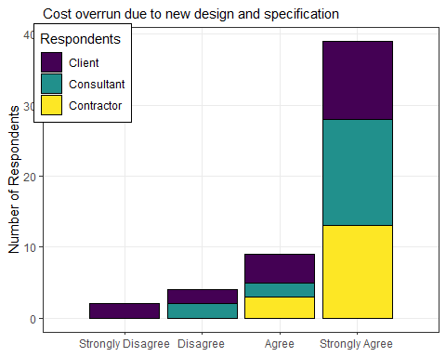

## Warning: Removed 2 rows containing non-finite values (stat_count).

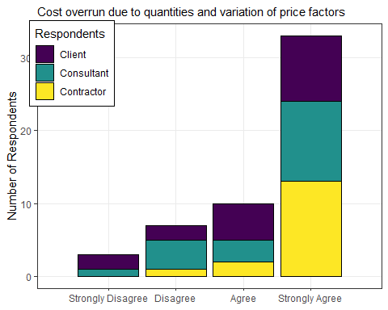

## Warning: Removed 1 rows containing non-finite values (stat_count).

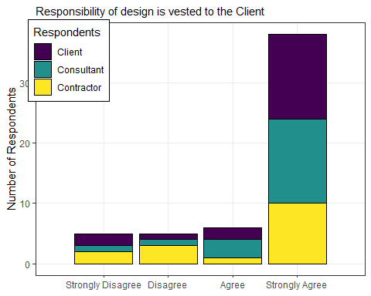

## Warning: Removed 2 rows containing non-finite values (stat_count).

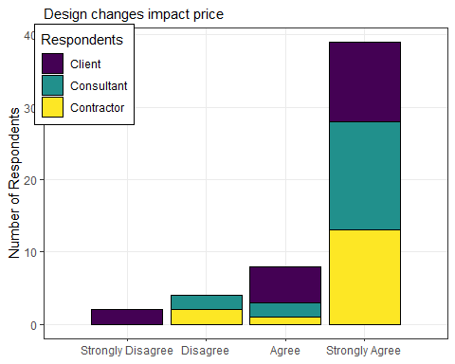

## Warning: Removed 1 rows containing non-finite values (stat_count).

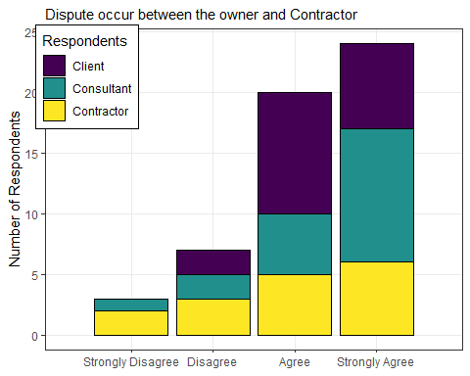

### Third objective:

1. To investigate the challanges that hinder the client to move from traditional procurement to designa build

## Warning: Removed 4 rows containing non-finite values (stat_count).

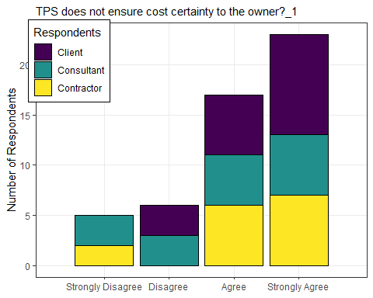

## Warning: Removed 4 rows containing non-finite values (stat_count).

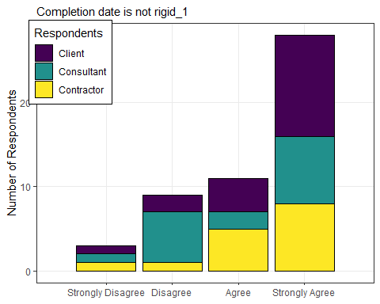

## Warning: Removed 5 rows containing non-finite values (stat_count).

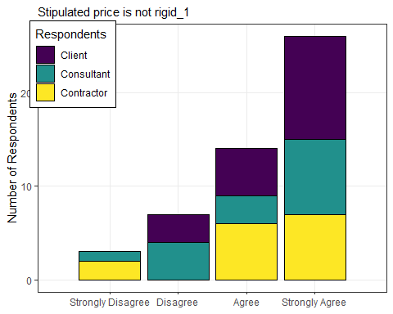

## Warning: Removed 7 rows containing non-finite values (stat_count).

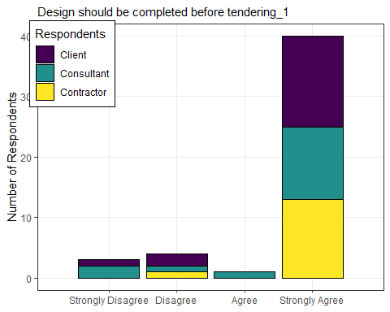

## Warning: Removed 5 rows containing non-finite values (stat_count).

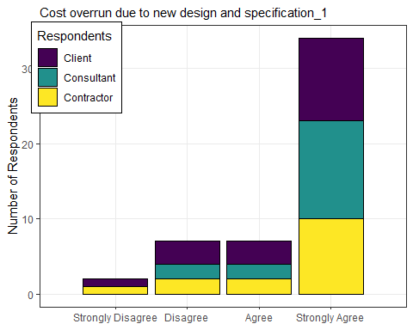

## Warning: Removed 5 rows containing non-finite values (stat_count).

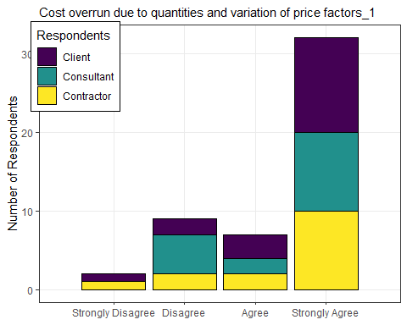

## Warning: Removed 4 rows containing non-finite values (stat_count).

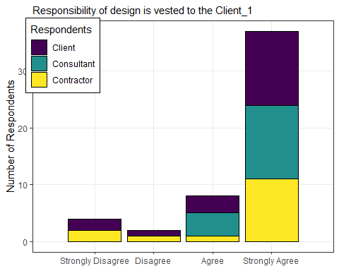

## Warning: Removed 4 rows containing non-finite values (stat_count).



## Warning: Removed 4 rows containing non-finite values (stat_count).

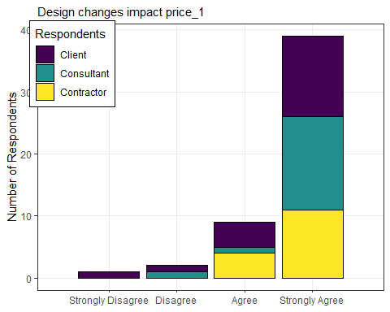

## Warning: Removed 4 rows containing non-finite values (stat_count).

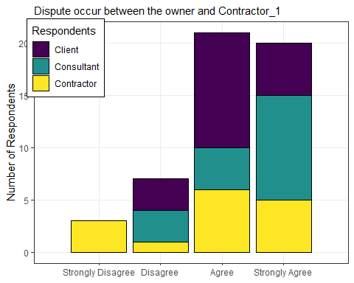

## Warning: Removed 3 rows containing missing values (position_stack).

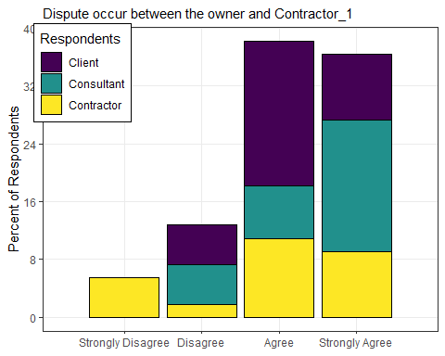

## Warning: Removed 2 rows containing non-finite values (stat_count).

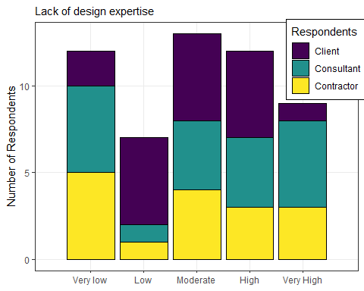

## Warning: Removed 1 rows containing missing values (position_stack).

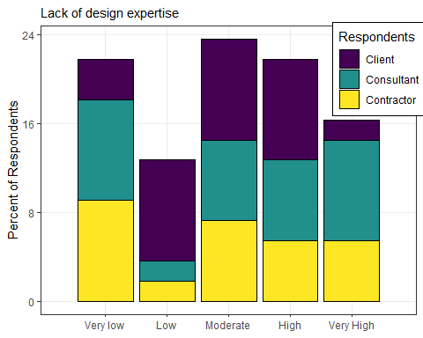

## Warning: Removed 2 rows containing non-finite values (stat_count).

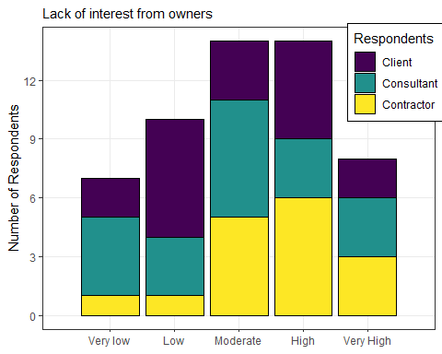

## Warning: Removed 1 rows containing missing values (position_stack).

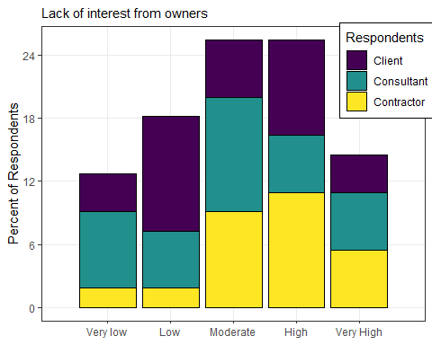

## Warning: Removed 2 rows containing non-finite values (stat_count).

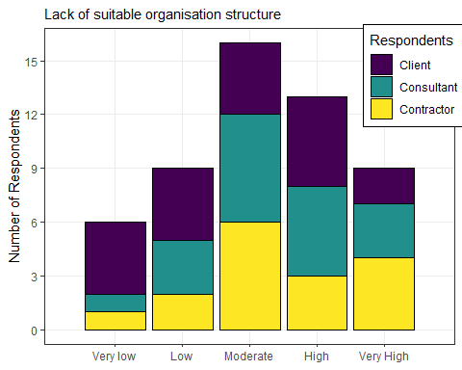

## Warning: Removed 2 rows containing missing values (position_stack).

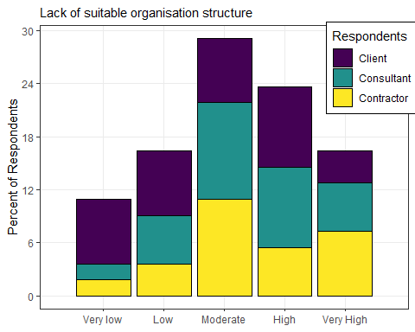

## Warning: Removed 1 rows containing non-finite values (stat_count).

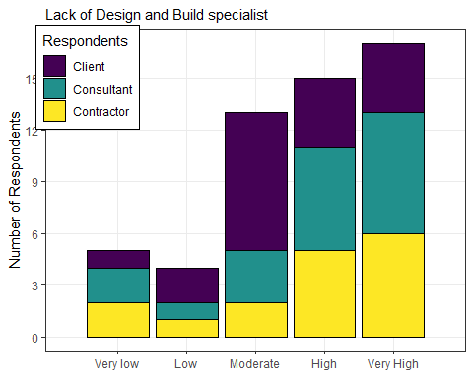

## Warning: Removed 1 rows containing missing values (position_stack).

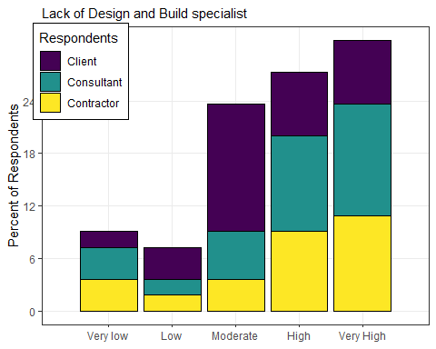

## Warning: Removed 1 rows containing non-finite values (stat_count).

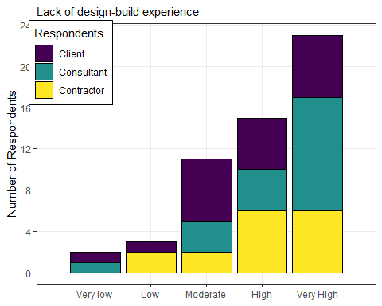

## Warning: Removed 1 rows containing missing values (position_stack).

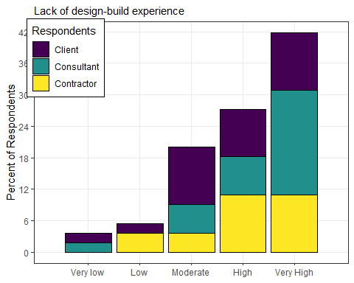

## Warning: Removed 1 rows containing non-finite values (stat_count).

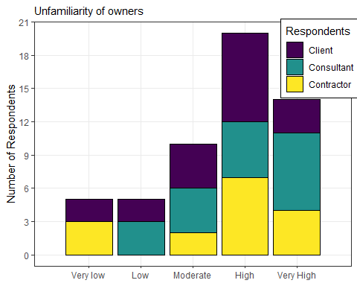

## Warning: Removed 1 rows containing missing values (position_stack).

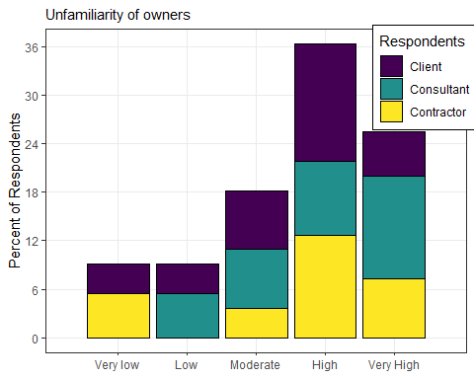

## Warning: Removed 1 rows containing non-finite values (stat_count).

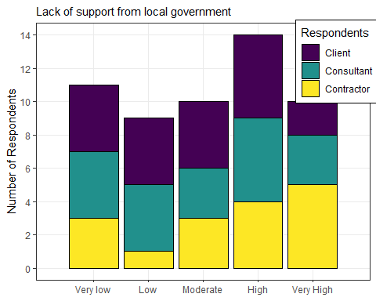

## Warning: Removed 1 rows containing missing values (position_stack).

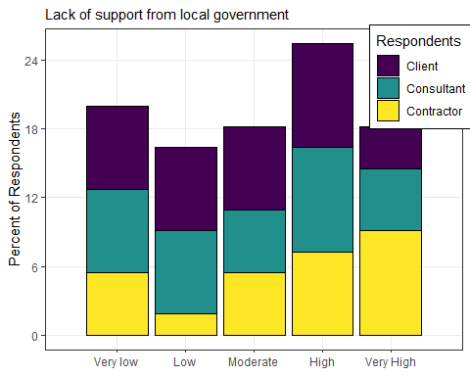

## Warning: Removed 2 rows containing non-finite values (stat_count).

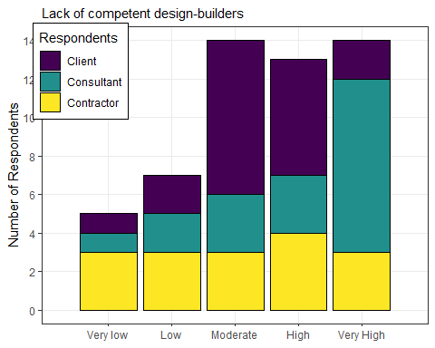

## Warning: Removed 2 rows containing missing values (position_stack).

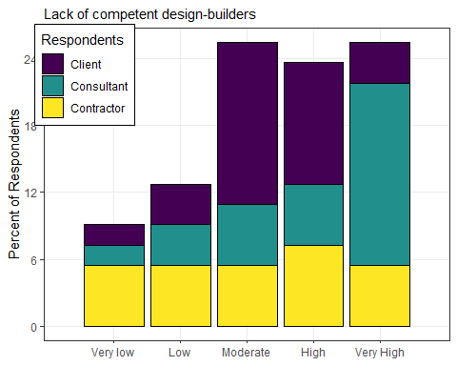

## Warning: Removed 3 rows containing non-finite values (stat_count).

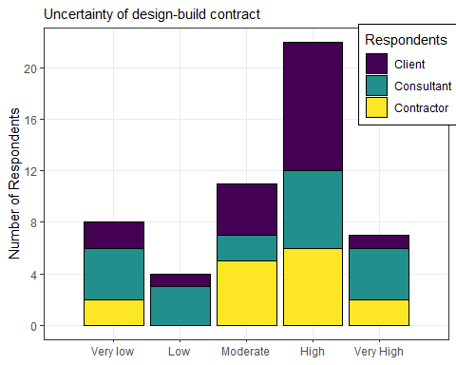

## Warning: Removed 2 rows containing missing values (position_stack).

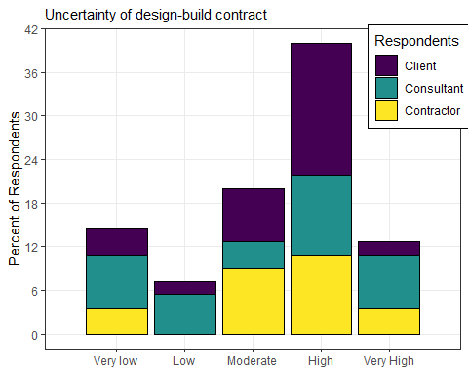

## Warning: Removed 1 rows containing non-finite values (stat_count).

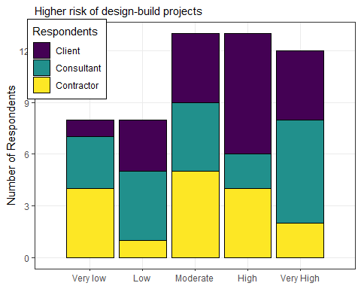

## Warning: Removed 1 rows containing missing values (position_stack).

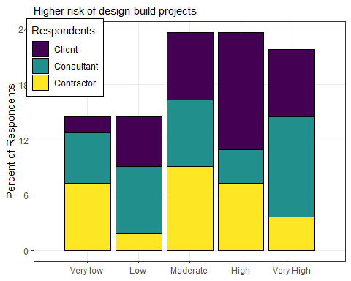

## Warning: Removed 2 rows containing non-finite values (stat_count).

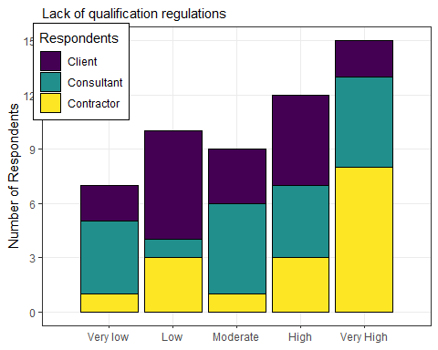

## Warning: Removed 1 rows containing missing values (position_stack).

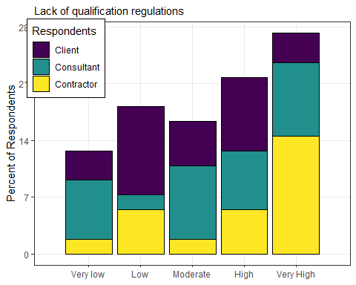

## Warning: Removed 1 rows containing non-finite values (stat_count).

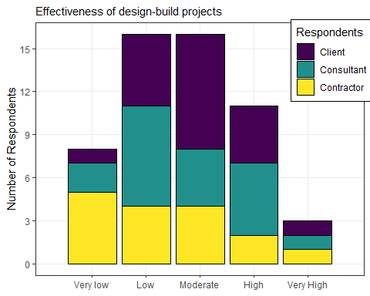

## Warning: Removed 1 rows containing missing values (position_stack).

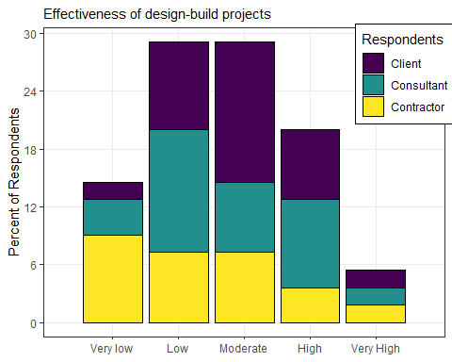

## Warning: Removed 2 rows containing non-finite values (stat_count).

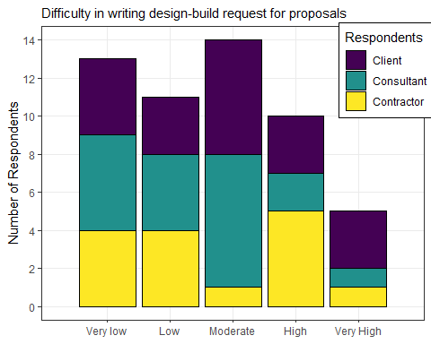

## Warning: Removed 2 rows containing missing values (position_stack).

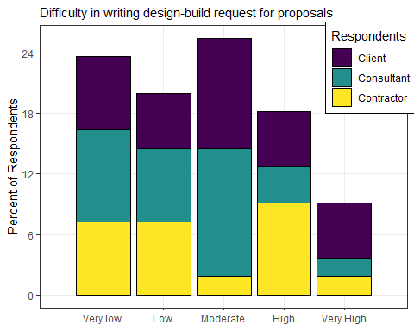

## Warning: Removed 2 rows containing non-finite values (stat_count).

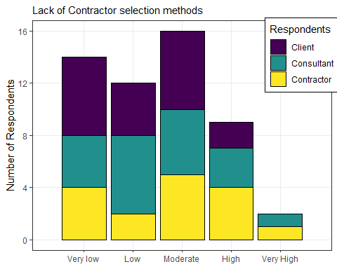

## Warning: Removed 1 rows containing missing values (position_stack).

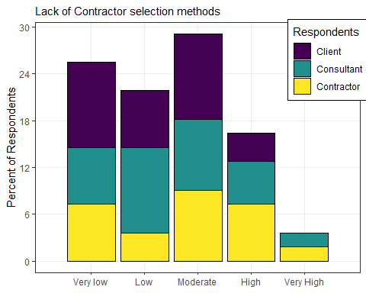

## Warning: Removed 1 rows containing non-finite values (stat_count).

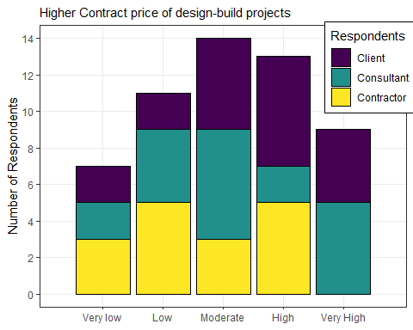

## Warning: Removed 1 rows containing missing values (position_stack).

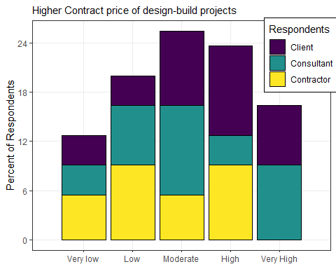

## Warning: Removed 3 rows containing non-finite values (stat_count).

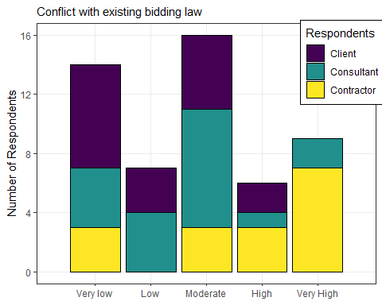

## Warning: Removed 1 rows containing missing values (position_stack).

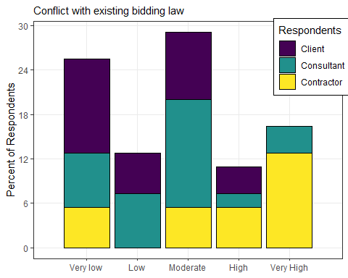

## Warning: Removed 2 rows containing non-finite values (stat_count).

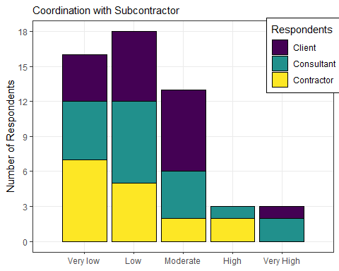

## Warning: Removed 1 rows containing missing values (position_stack).

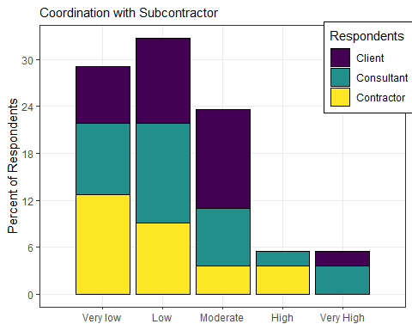

## Warning: Removed 2 rows containing non-finite values (stat_count).

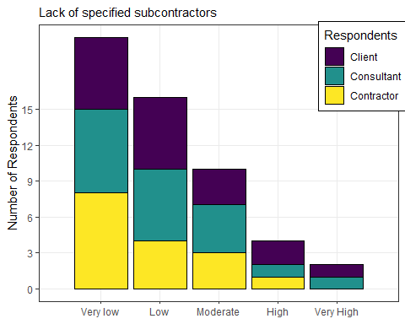

## Warning: Removed 1 rows containing missing values (position_stack).

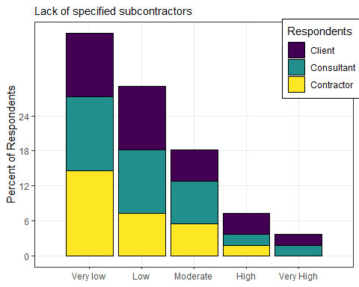

### Fourth objective:

1. To suggest ways of which design abuild can be used to reduce or eliminate current cost escalation on roadworks projects in tanzania

## Warning: Removed 1 rows containing non-finite values (stat_count).

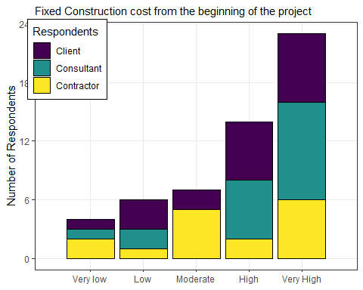

## Warning: Removed 1 rows containing missing values (position_stack).

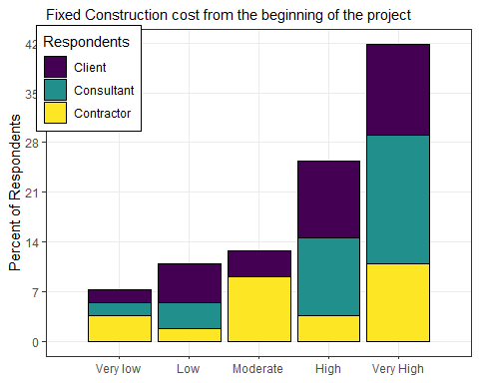

## Warning: Removed 1 rows containing non-finite values (stat_count).

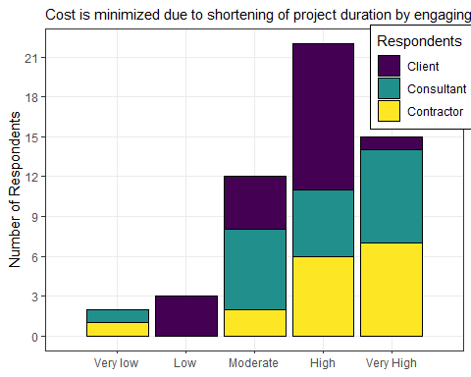

## Warning: Removed 1 rows containing missing values (position_stack).

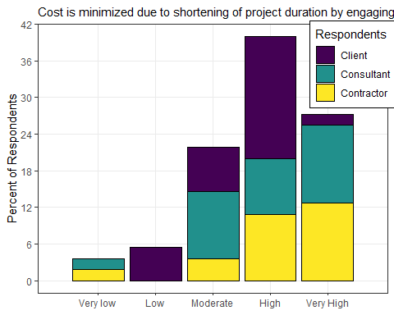

## Warning: Removed 1 rows containing non-finite values (stat_count).

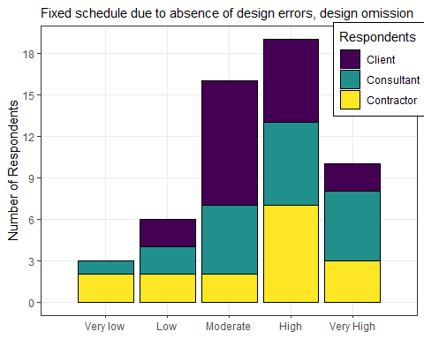

## Warning: Removed 1 rows containing missing values (position_stack).

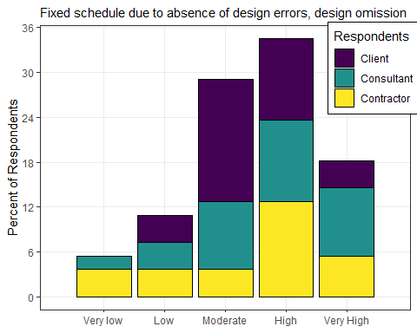

## Warning: Removed 2 rows containing non-finite values (stat_count).

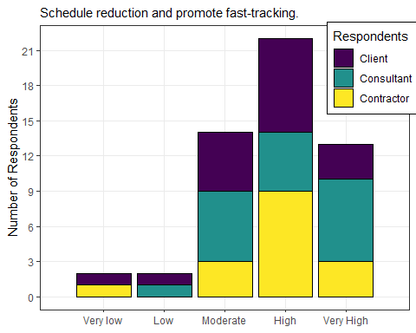

## Warning: Removed 1 rows containing missing values (position_stack).

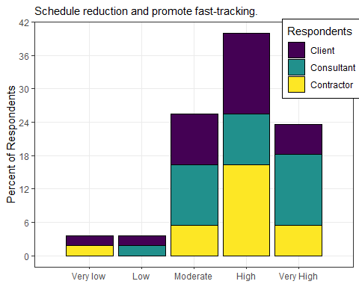

## Warning: Removed 1 rows containing non-finite values (stat_count).

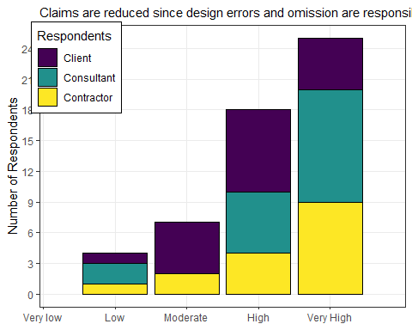

## Warning: Removed 1 rows containing missing values (position_stack).

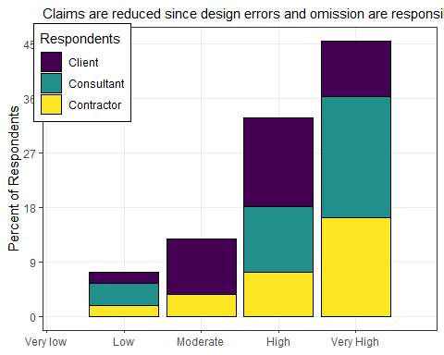

## Warning: Removed 1 rows containing non-finite values (stat_count).

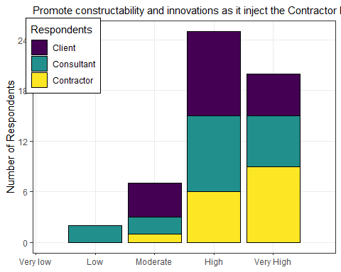

## Warning: Removed 1 rows containing missing values (position_stack).

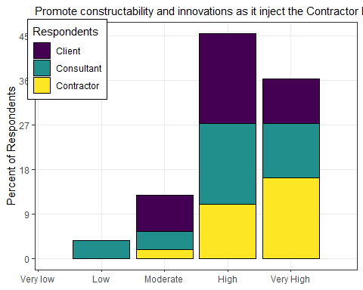

## Warning: Removed 1 rows containing non-finite values (stat_count).

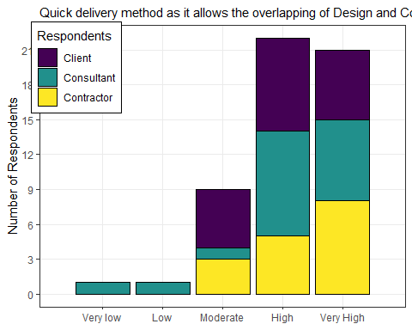

## Warning: Removed 1 rows containing missing values (position_stack).

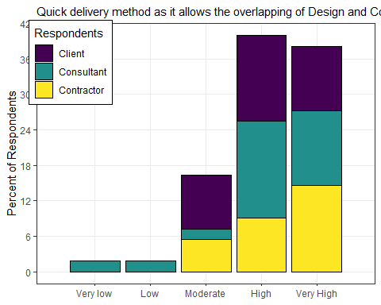

### plot for question 56

## Warning: Removed 1 rows containing non-finite values (stat_count).

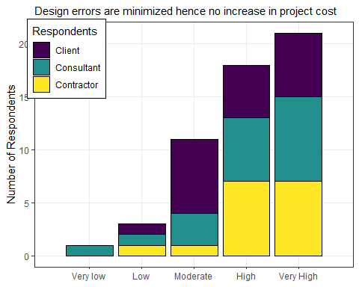

## Warning: Removed 1 rows containing missing values (position_stack).

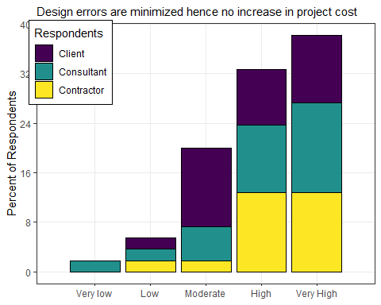

## Hypotheses

1. Design and Build contract will not improve project performance on roadwork projects in Tanzania
2. Traditional procurement does not contribute to poor performance on roadwork projects in Tanzania
3. There no are challenges that hinder the client to move from traditional procurement system to desing and build contract