Growth, mortality and stock status of Octopus cyanea
Monthly length frequency data from different fishing grounds (namely Jibondo and Bwejuu in Mafia and Songosongo and Somanga in Kilwa) were grouped into classes of 2 cm intervals mantle length. Length-frequency data were used to calculate the von Bertalanffy growth (VBG) function (K) and the asymptotic length (L∞) by model progression analysis whereas ELEFAN 1 within the FiSAT program (Gayanilo et al., 2003) was employed. The growth performance index (Φ) was calculated according to Pauly and Munro (1984). The index was compared with estimates obtained by other authors to facilitate the intra and interspecific comparison of the growth performance. The annual instantaneous rate of total mortality (Z) was calculated from the length converted catch curves (Gayanilo and Pauly 1997). Annual instantaneous rate of natural mortality (M) was estimated from the empirical equation according to Pauly’s empirical relationship: Log M = 0.0066 - 0.279 Log L + 0.6543LogK + 0.4634LogT; where L = length expressed in cm, T = mean annual environmental water temperature in ºC (for this study it was 27.5ºC) and M = natural mortality (Pauly 1980). The reliability of M was ascertained by estimating M/K ratio according to Beverton and Holt (1957). Fishing mortality (F) was obtained by subtracting M from Z while the exploitation rate (E) was derived from F/Z (Appeldoom 1988).
A selectivity curve was used to derive values of the sizes at capture at a probability of 0.5 (Lc50) and the size at which fish were fully recruited to the fishery (L100). Length structured virtual population analysis (VPA) was used to obtain fishing mortalities per length class. Pauly and Soriano (1980) equation was used to predict the effects of increasing the existing mean size at first capture (Lc50) to that at which yield per recruit would be maximized (Lmax). The stock status was evaluated by comparing estimates of fishing mortality rate with target (Fopt) and limit (Flimit) biological reference point (BRPs) which were defined as Fopt = 0.5M and Flimit =2M/3 (Petterson 1992). Relative yield per recruit (Y/R) and relative biomass per recruit (B/R) values as a function of E were determined from the estimated growth parameters and probability of capture by length according to Sparre and Venema (1998).

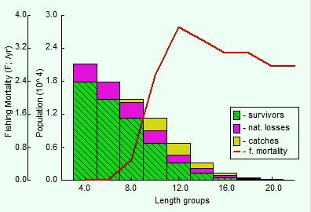

Figure: VPA for Jibondo Mafia
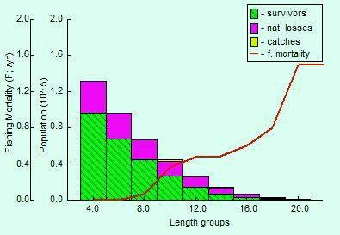
Figure: VPA for Bwejuu Mafia
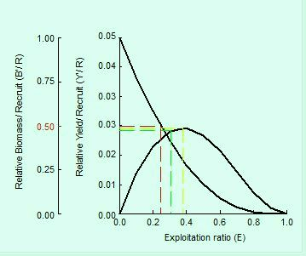
Figure: Relative biomass per recruit (B/R) and relative yield per recruit ( Y/R) for Bwejuu Mafia

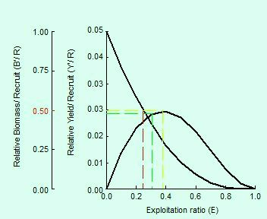
Figure: Relative biomass per recruit (B/R) and relative yield per recruit ( Y/R) for Jibondo Mafia

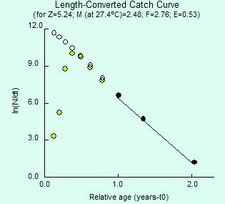
Figure: Mortality parameters for Jibondo Mafia (The black circles calculated the Z through the least square linear regression while blank circles represented the points either not fully recruited or very close to L∞)

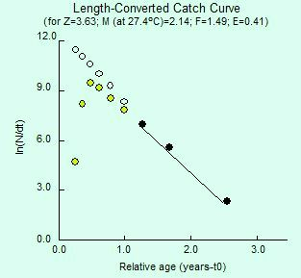
Figure: Mortality parameters for Bwejuu Mafia (The black circles calculated the Z through the least square linear regression while blank circles represented the points either not fully recruited or very close to L∞)

RESULTS
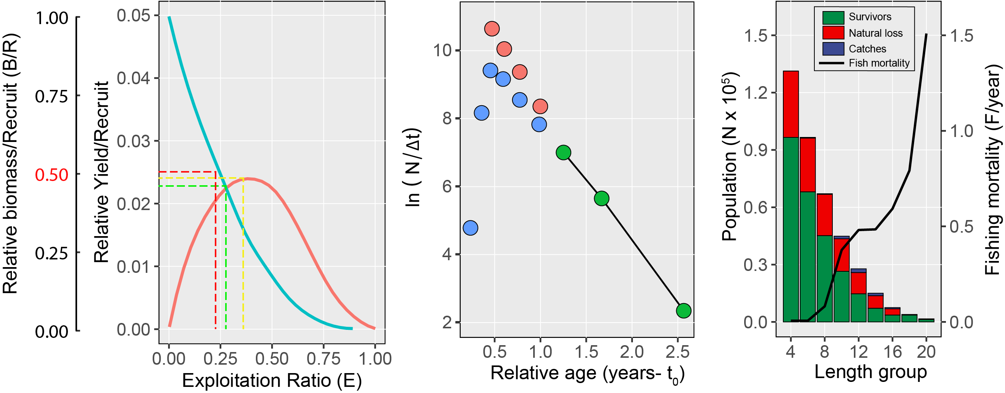
Figure 1: bwejuu
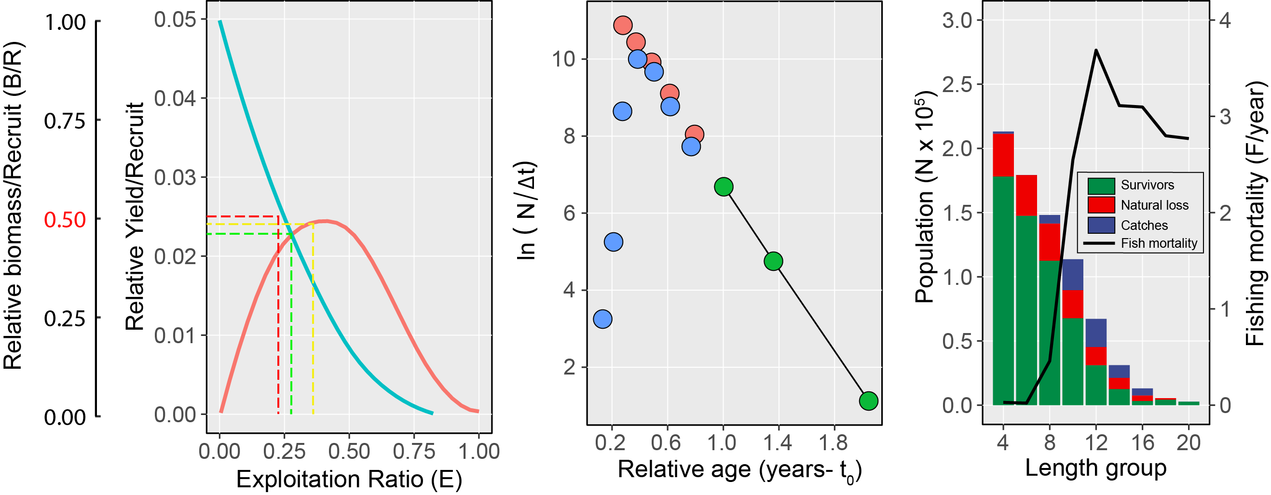
Figure 2: jibondo

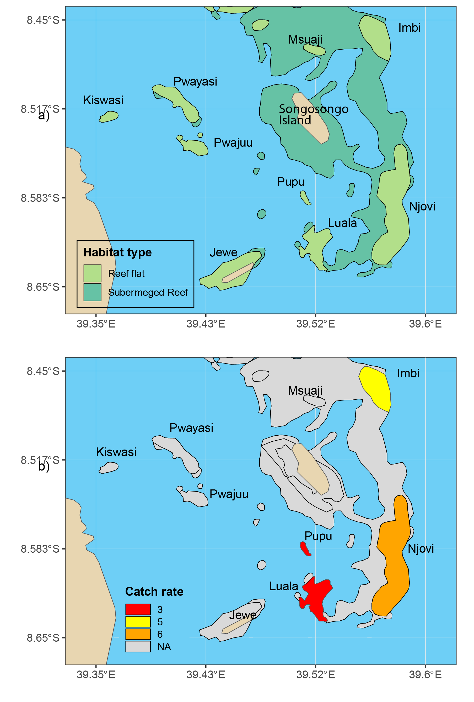
Figure : Songosongo
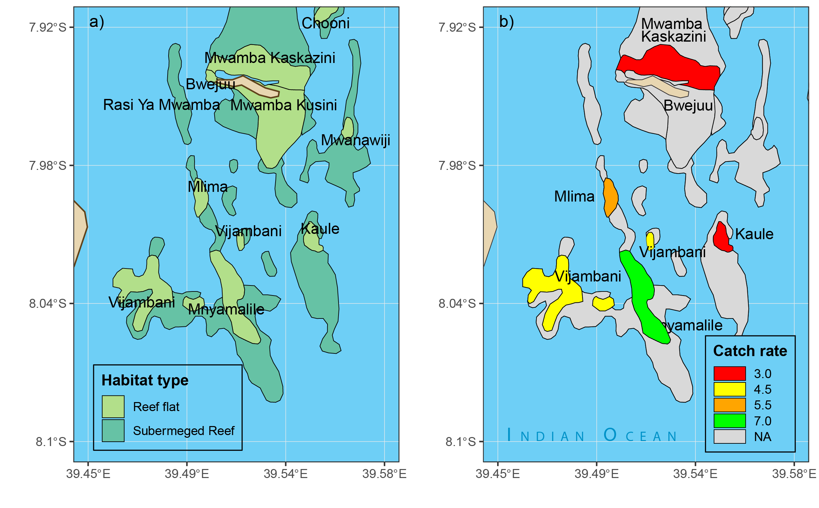
Figure : Bwejuu
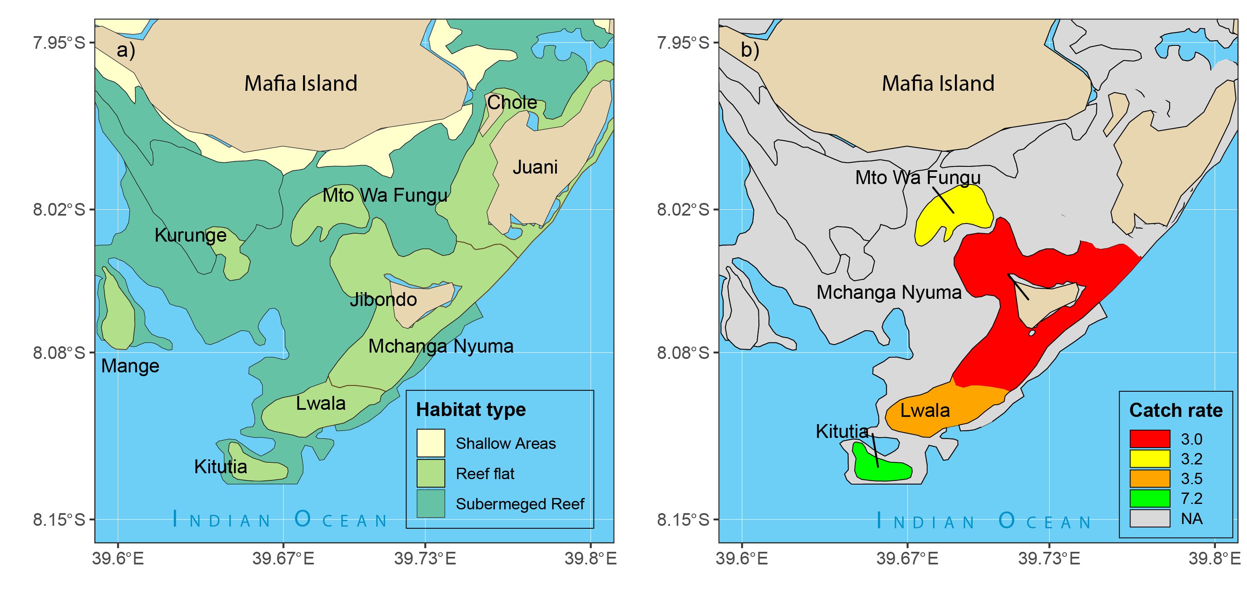
Figure : Jibondo
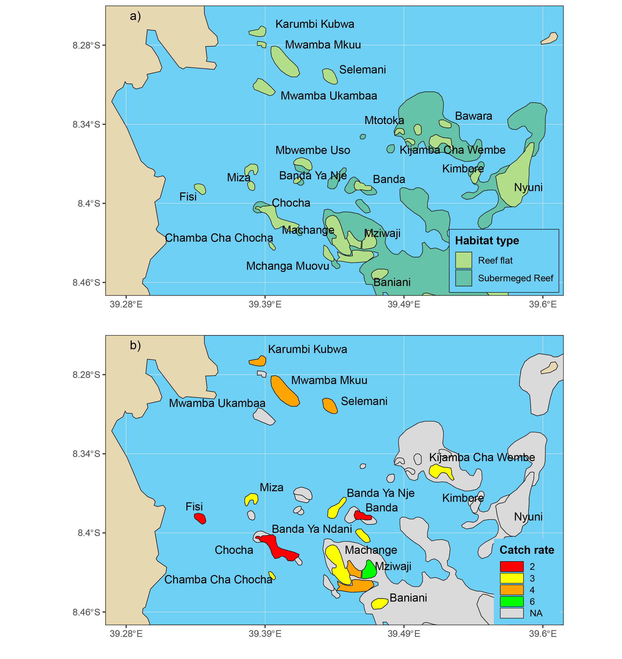
Figure : Somanga

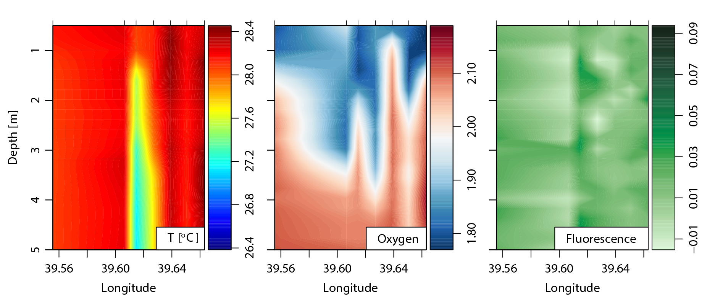
Figure : hydrographic section from Chooni to Mange reef in Mafia

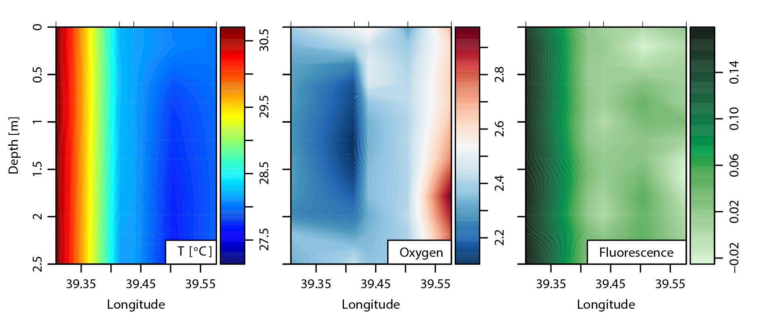
Figure : hydrographic section from fisi to Njovi reef

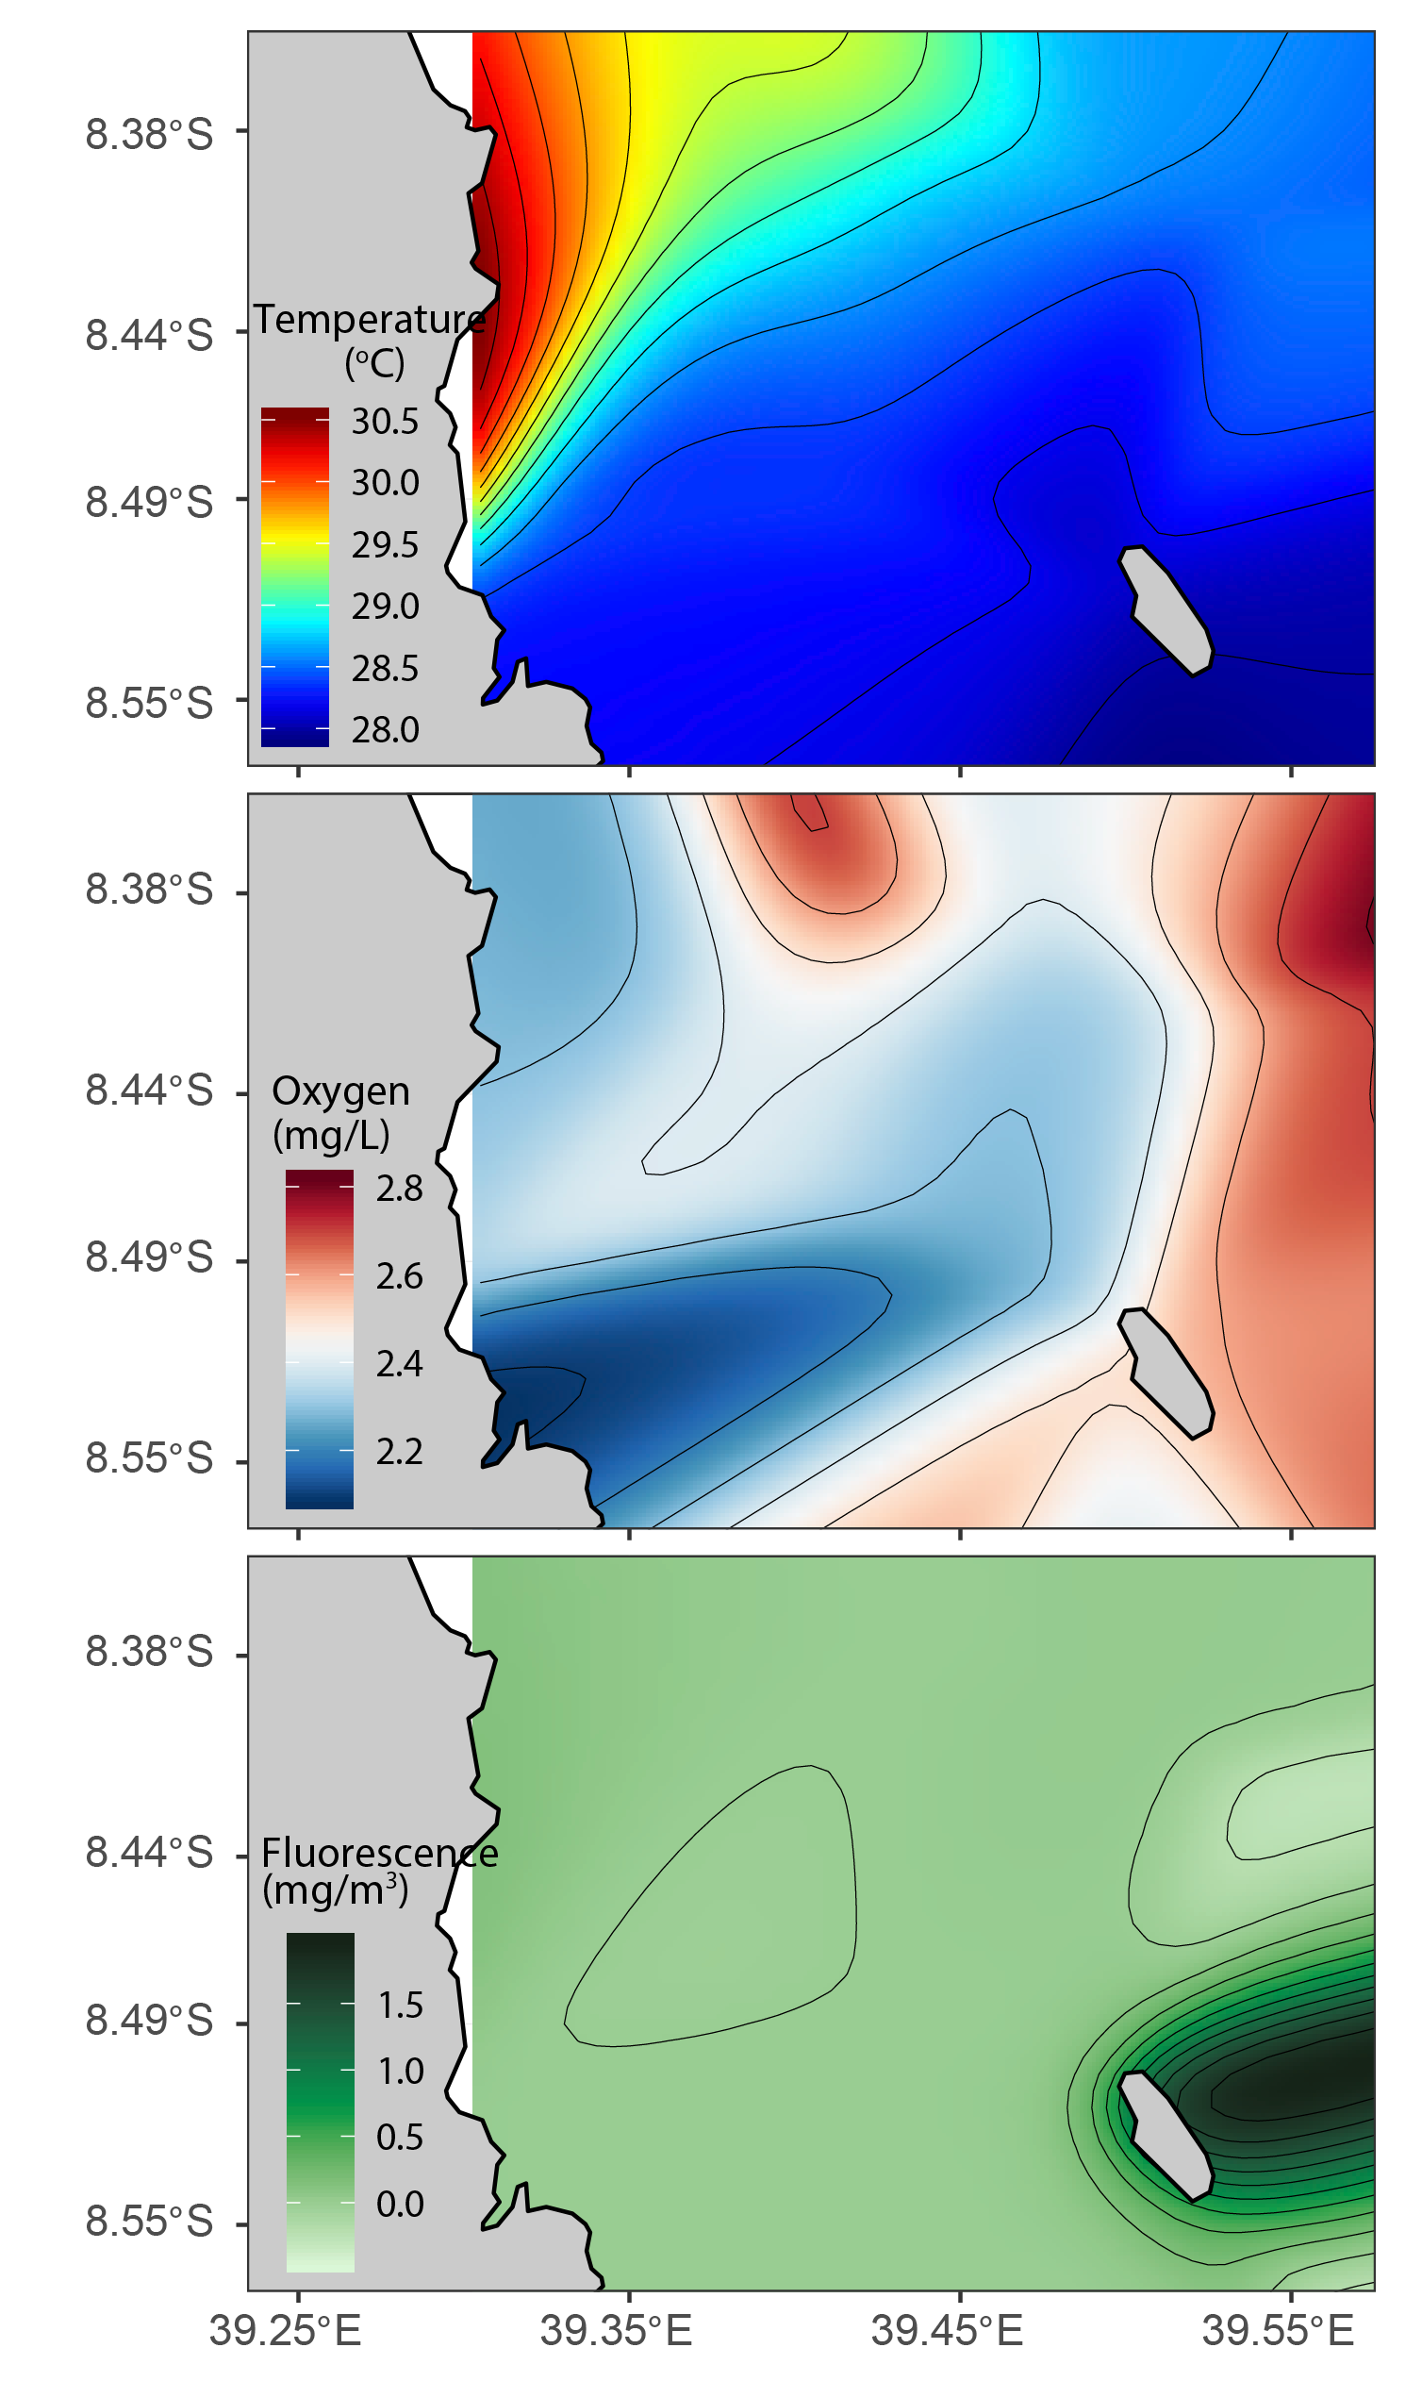
Figure : environmental variables in Kilwa

