STUDY AREA

The study area lay within longitude 39.10 oE and 40.20 oE and latitude 8.7 oS and 7.4 oS (Figure 1). The area has vast shallow inshore areas with depth below 20 meters, which is dominated with corals, sand and seagrasses habitats. The climate of the area is influenced by the monsoon wind system, where the northeast (NE) monsoon blows from December to April, and the southeast (SE) monsoon blows from June to October (Figure 2). These reverse with seasons—they blow northerly during the SE and southerly during the SE monsoon season (Semba et al., in press). The seasonal reverse of these winds influence climatic and oceanic conditions, including the air temperature that ranges from 20 to 32 °C, and the sea surface temperature that ranges from 25 to 31 °C (Bryceson et al., 2006).

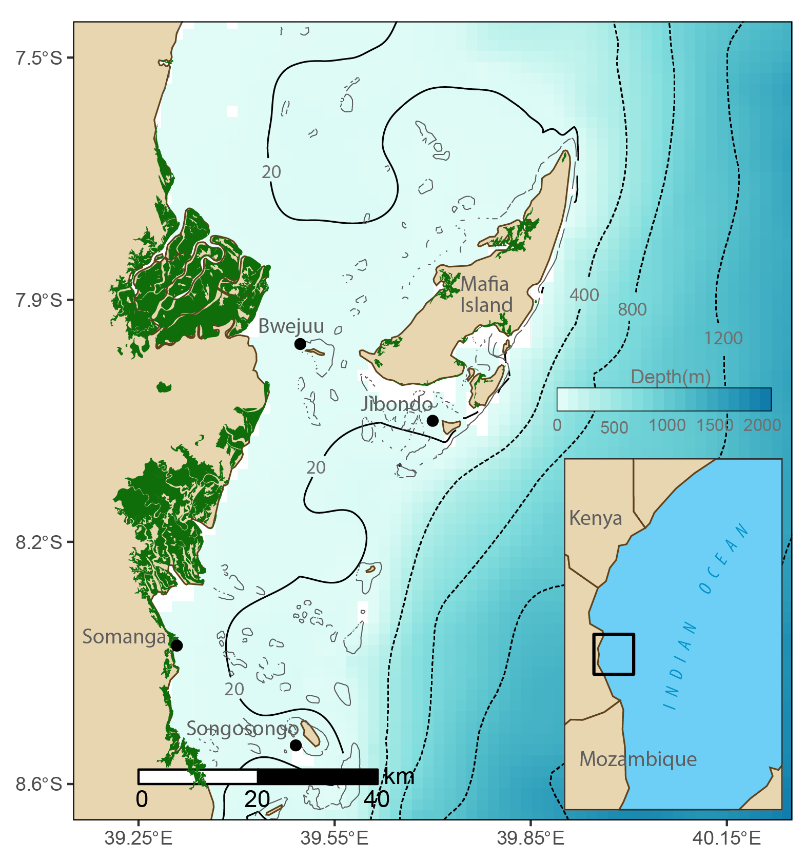

Figure 1: Map showing the study area for octopus fishery. An inset is the map of showing the location of the study area along the coast of Tanzania. The solid line is the isobaths at 20 meter and the dotted lines are isobar at 400, 800 and 1200 meter.

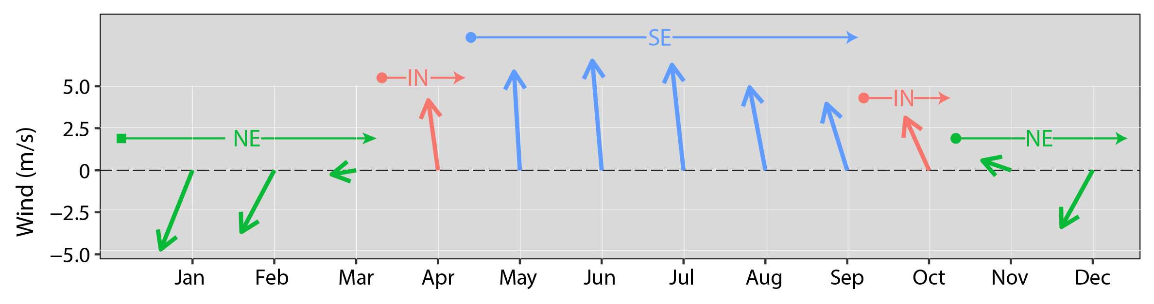

Figure 2: Speed and direction of winds during the northeast (NE), southeast (SE) and inter-monsoon (IN) seasons for the areas around Mafia and Kilwa Districts. Source: Semba et al., 2018

**MAPPING OF OCTOPUS REEFS**

The study mapped reefs commonly used for octopus fishery in four selected sites of Somanga and Songosongo in Kilwa District and Bwejuu and Songosongo Island in Mafia District. The reefs were surveyed and the reef’s boundary was recorded with a handheld GPS (Geographical Position System) device at an accuracy of ±1.5m.

**Environmental Data**

The environmental variables within the reefs were measured in November and December 2018 with a CTD (conductivity, temperature, depth) instrument. Sea-Bird SBE19plus version 2.6.3.104 used has sensors for temperature, conductivity oxygen and fluorescence. In each reef surveyed, a profile of was measured, and for reefs with shallow water (flat reefs)—that the boat could not reach, CTD instrument was lowered for the adjacent water that are relatively deep enough but close to the reef. Because the CTD cast were lowered manually using rope, we ensured that the downcast descent at relatively low speed of about one meter per minute ((~1m/minute). In each cast, the geographical location (longitude, latitude, and time) were marked.

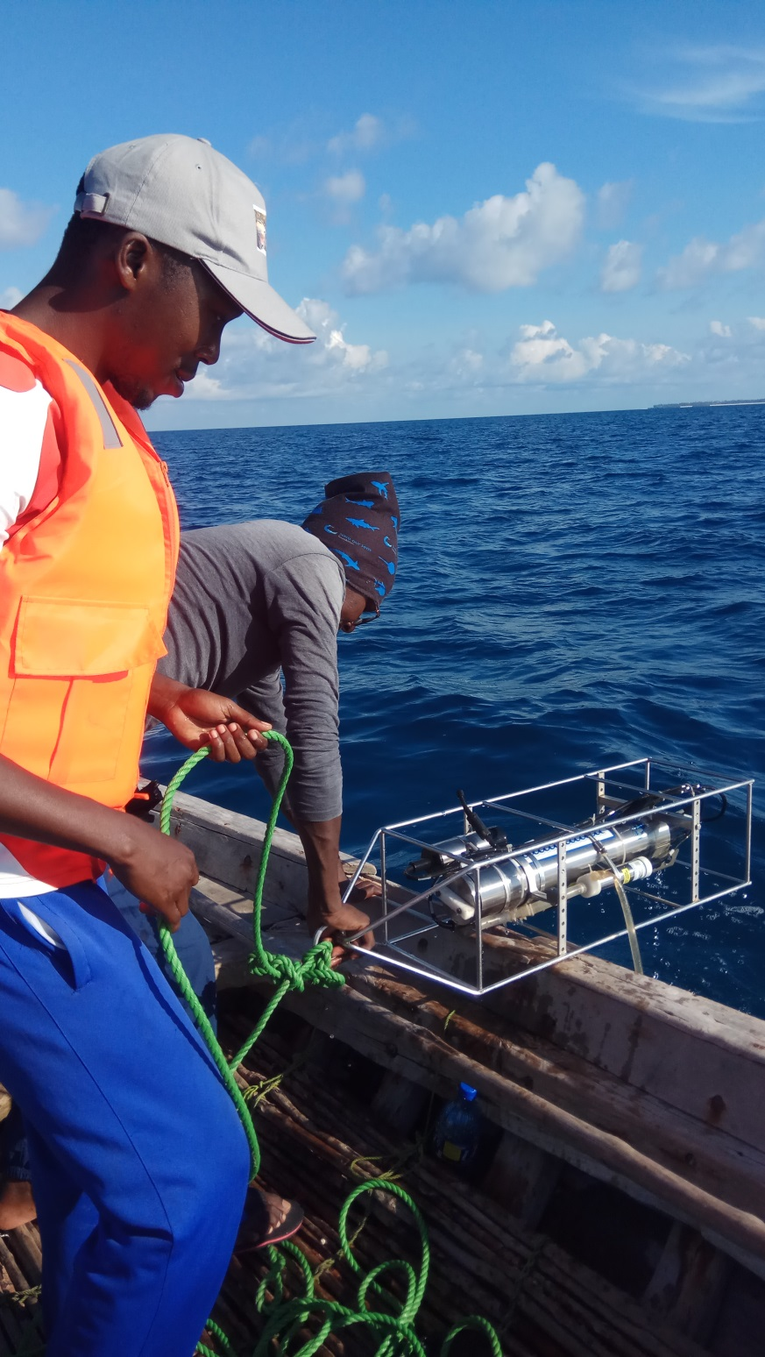

Figure 3. Retrieving the CTD instrument lowered on water of reefs in Bwejuu Island

**DATA PROCESSING and Analysis**

**Delineation of reef’s boundary area**

Using the reference points of the geographical location recorded during the survey, the boundary of each reef was created. The longitude and latitude locations from a handheld GPS device were downloaded and exported into R. Once in R, the file was converted to simple feature and create boundary of each reef. For reefs that were not captured during the survey, the boundary feature created was superimposed on basemap using mapview package and traced the other reefs visible on the mapservice with the mapedit package. The digitized reefs were cross-checked and verified their accuracy using the openCPN, which contains vector nautical charts used for navigation. Once the reef’s boundary was delineated, the Octopus catches were merged to the respective reef and mapped their mean catch rate.

**Environmental variables**

Binary number measured for CTD (conductivity, temperature, depth) cast were first converted to scientific unit and added the geographical position of each cast that were recorded with the handheld GPS. Because of the high frequency measurement of CTD profile, the depth for all the CTD casts were aligned to standard pressure from the surface to the maximum depth with an interval of 25 cm. Because of the unreliability of the upcast profiles, only downcast profiles were considered in the analysis. Because the CTD instrument could not measure salinity direct, the measured profile of conductivity, temperature and pressure for each cast was used to calculate the salinity based on International Thermodynamic Equation Of Seawater – 2010 (TEOS-10) (McDougall 2011). The cast were then used to create hydrographic sections and isosurface–to show vertical and spatial variations of temperature, oxygen and fluorescence.

**RESULTS SUMMARY**

Figure 4b show the mean catch rate of octopus for some reefs around Bwejuu. Most of the reefs with cpue are located in the southern side of the Bwejuu Island with varied CPUE. Kaule and Mwamba Kaskazini reefs had the lowest catch rate of 3 kg/fisher followed by submerged reefs of Dima and Mnyamalile (Vijambani) and the highest catch rate of above 7 kg/fisher at Mnyamalile. Figure 5b show the mean catch rate of octopus for some reefs around Jibondo. Like Bwejuu, commonly reefs used for octopus fishery in Jibondo, are located in the southern side of the island with varied CPUE. Mchanganyuma reef had the lowest catch rate of 3 kg/fisher followed by Mto wa Fungu and Lwala reefs and the highest catch rate of about 7.2 kg/fisher was found at Kitutia. Figure 7b show the mean catch rate of octopus for some reefs around Somanga. Ulike other sites, Somanga has more reefs scattered around the area. The reefs are found on the south-east of Somanga village (Figure 7a). The mean catch rate for Somanga reefs varied from 2 kg/fisher at Fisi, Chocha and Banda reefs to 6 kg/fisher at Mziwaji. Most reef located north-east of Somanga have similar mean catch rate of about 4 kg/fisher. Figure 6b show the mean catch rate of octopus for some reefs around Songosongo. The island of Songosongo is surrounded by reefs (Figure 6a), but commonly used reefs for octopus fishery are located on the south and east side of the island. Njovi Reef dominated the mean catch rate at Songosongo with 6kg/fisher followed by Imbi (~5 kg/fisher). Pupu and Luala reefs had the lowest catch rate of about 3 kg/fisher.

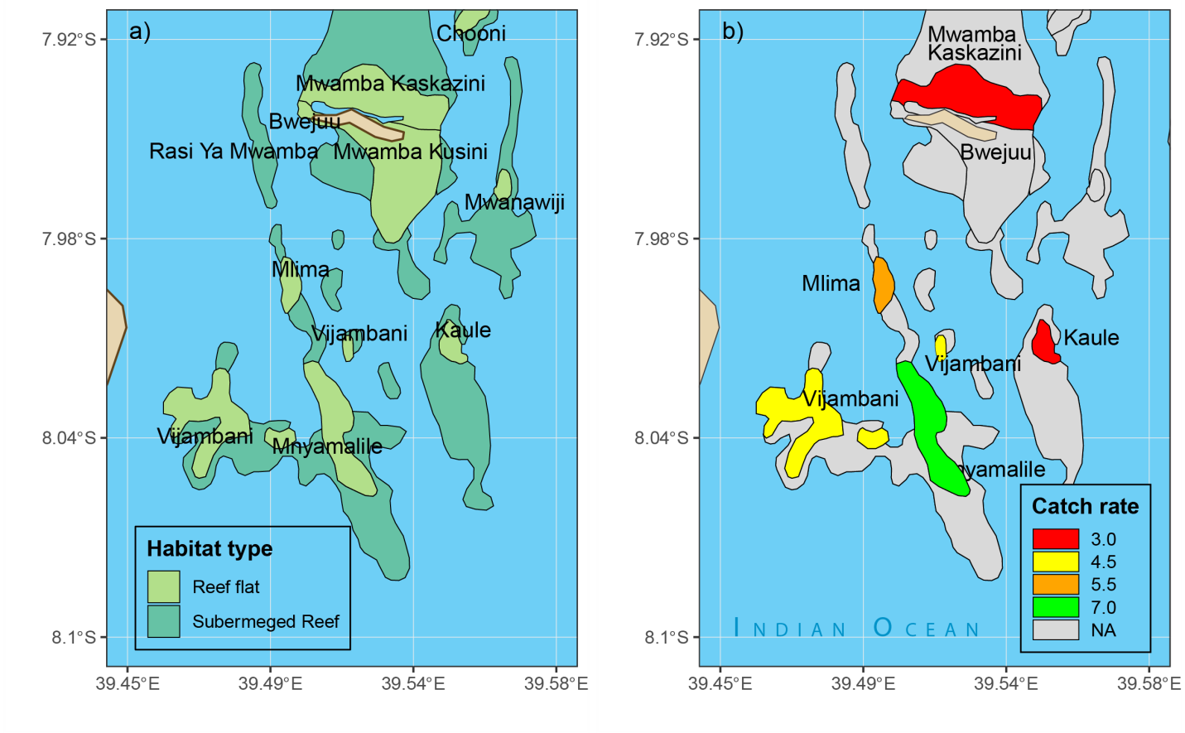

Figure 4: spatial distribution of a) reefs and b) CPUE from reefs commonly used for octopus fishery around Bwejuu.

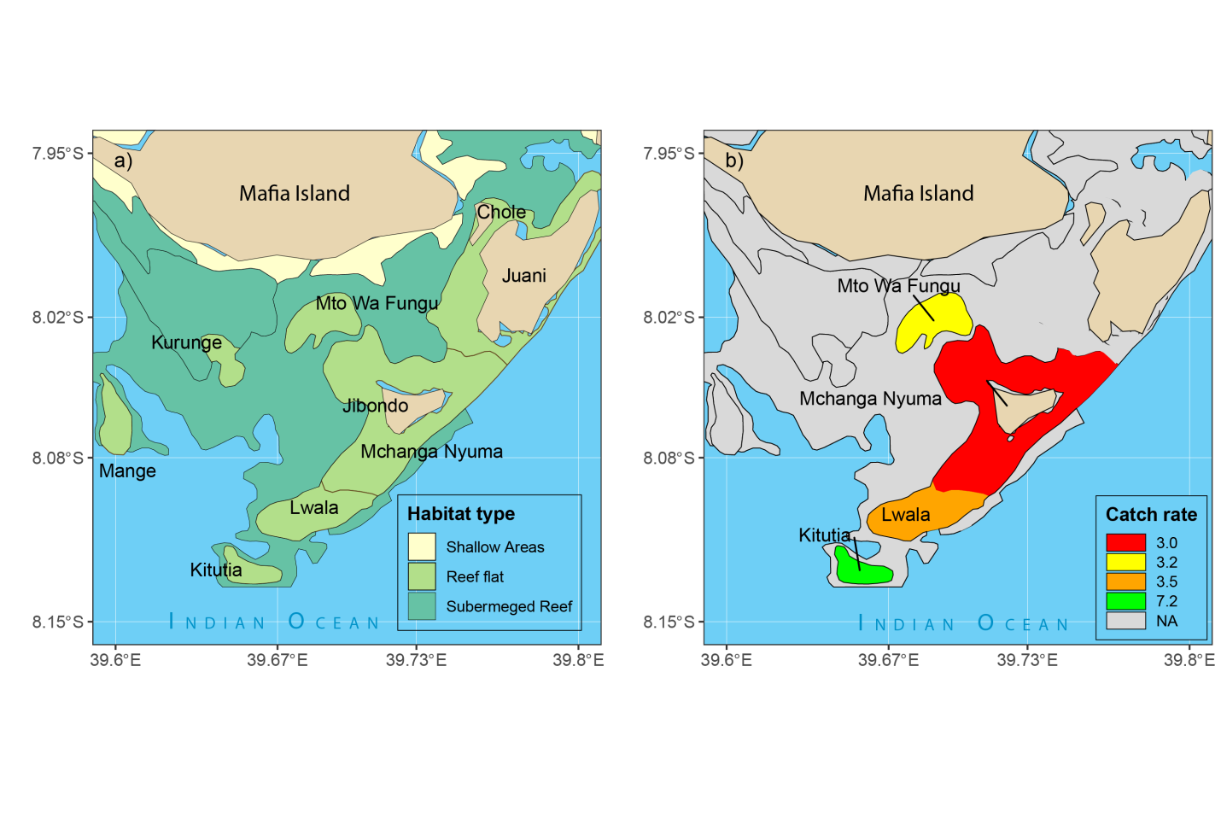Figure 5: spatial distribution of a) reefs and b) CPUE from reefs commonly used for octopus fishery around Bwejuu.Jibondo

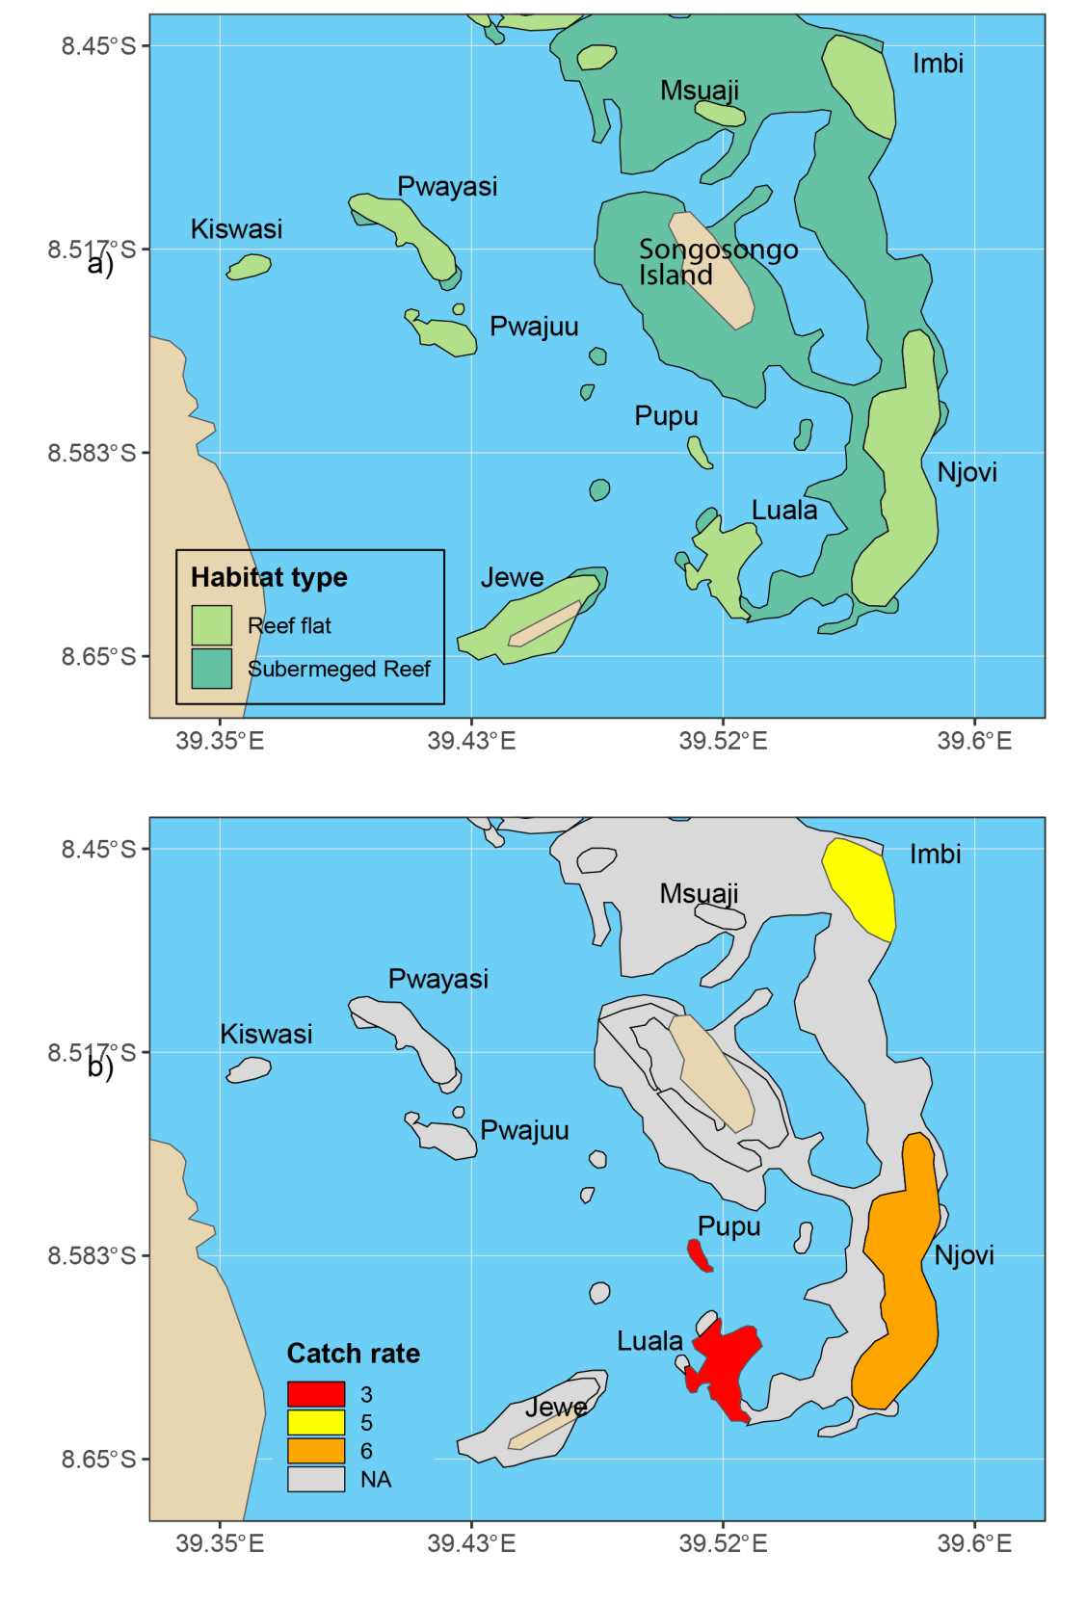

Figure 6: spatial distribution of a) reefs and b) CPUE from reefs commonly used for octopus fishery around Songosongo.

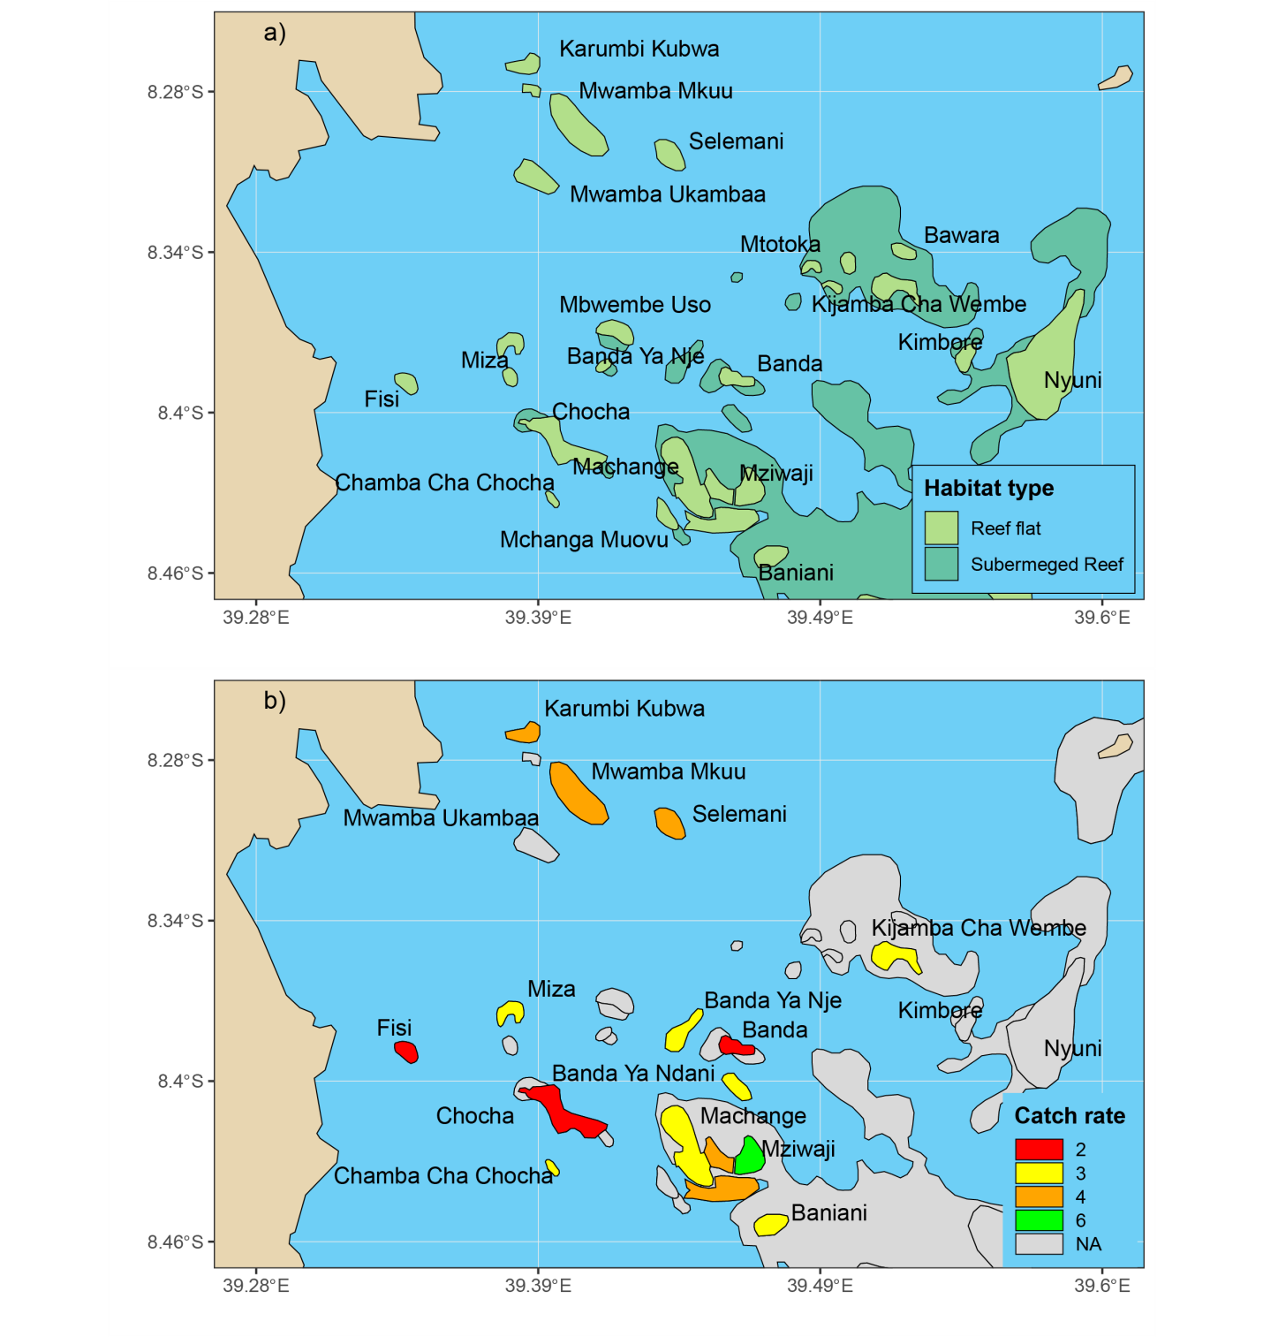

Figure 8: spatial distribution of a) reefs and b) CPUE from reefs commonly used for octopus fishery around Somanga

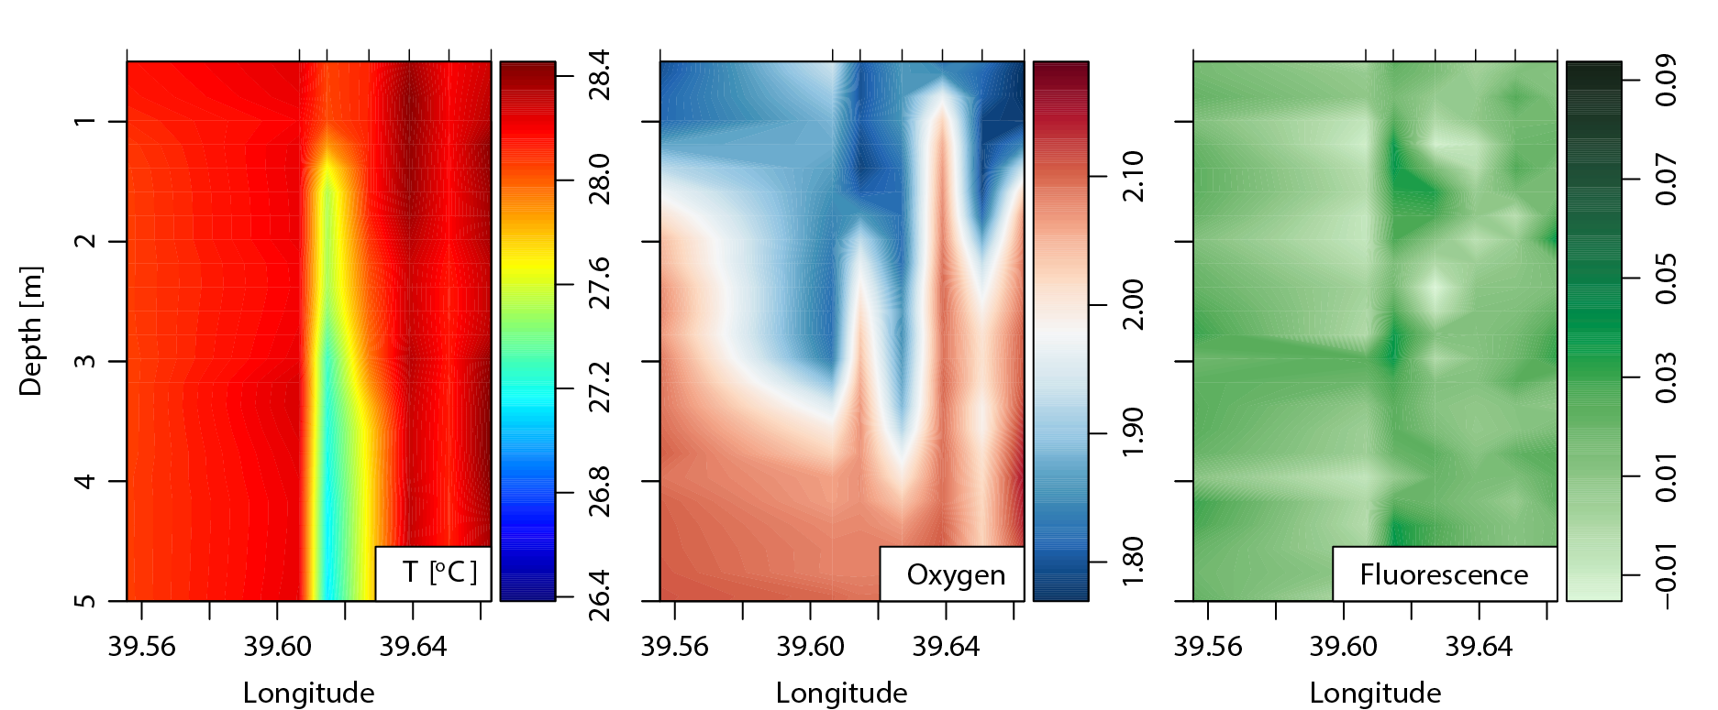

Figure 9: hydrographic section from Chooni to Mange reef in Mafia

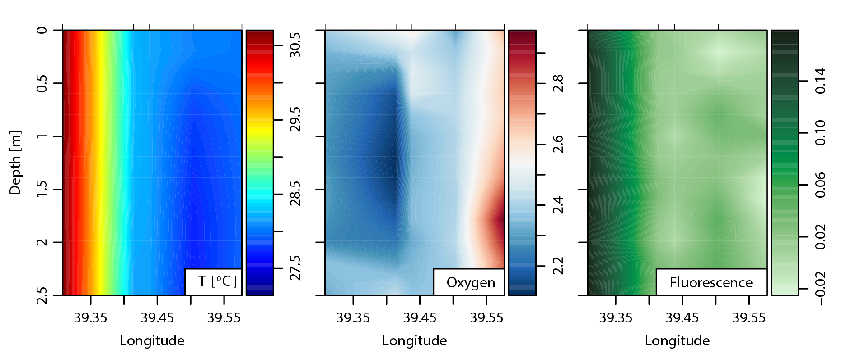

Figure 10: hydrographic section from fisi to Njovi reef

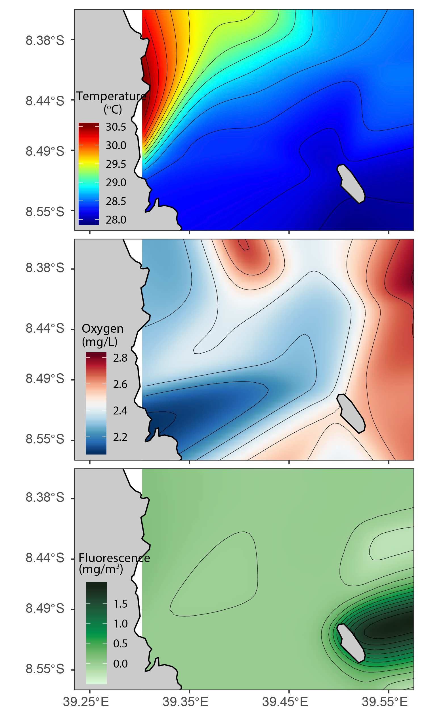

Figure 11: spatial distribution of environmental variables of surface water at around Somnaga and Songosongo reefs.

Discussion

The Rufiji, Mafia and Kilwa seascape ……

Mean CPUE from the reefs around Somanga ranged between 2-6 Kg/fisher as compared to 3-6 Kg/fisher for Songosongo, 3-7 Kg/fisher for Bwejuu and 3-7.2 Kg/fisher for Jibondo. Results also showed Somanga site to have habitat which differ with the rest of sites. It has many reefs for octopus fishing as compared to the rest of sites but the reefs are very scattered and comprised of less complex habitat. In other sites reefs are relatively connected and they comprised of more complex habitats. Complex habitat refers to the presence of reefs flats which are connected by large part of the submerged reefs, this complexity and heterogeneity nature of the reefs allow the habitat to support different ecological niches which in turn guarantee food availability for octopus. Nevertheless environmental variables showed area around Somanga to experience high temperature which recorded to reach a maximum of 30.50C which was not recorded at any other site. This high temperature is detrimental to the growth of octopus around (ref). The presence of less complex habitat and high temperature at Somanga might be a reason for the lowest CPUE of about 2 Kg/fisher to be recorded at this site (mean size also needed). Habitats at Songosongo looks to be very productive as compared to other sites, this was evident by the presence of more stable and low SST and high fluorescence (indicator of Chl-a) especially around Njovi reef. Apart from being more productive Njovi reef is also closed seasonally to allow replenish of its stock. Signal of being more productive and practice of seasonal closure could be a reason for high CPUE at Songosongo to be recorded from Njovi reef. Moreover, extremely high CPUE of about 7.2 Kg/fisher was recorded at Jibondo from Kitutia reef, this is probably due to the fact that, this reef is within the MIMP where by any fishing is not allowed except for women and children who practiced foot fishing. So octopus within this area are subjected to less fishing pressure which allow them to grow to bigger sizes (mean size also needed to support this). Nevertheless, all reefs from which high CPUE was recorded, there is a management measure which is dedicated for that particular reef, for instance Njovi reef at Sonosongo, Kilwa there is seasonal closure while Kitutia reef at Jibondo, Mafia fall under the no-take zone, but curious enough Mnyamalile at Bwejuu, Mafia also recorded high CPUE while there is no any management measure which is particularly intended for this reef. So high CPUE from this reef was probably due to few octopus fishers at Bwejuu sites (To be supported by the data of no. of fishers). However, in all sites the lowest CPUEs were recorded from the reefs which are very close to the corresponding sites, this is probably due to the fact that, these reefs are easily to be accessed by the octopus fishers, so they are subjected to high fishing pressure.

McDougall, T. J. a. B., P.M. (2011). Getting started with TEOS‑10 and the Gibbs Seawater (GSW) Oceanographic Toolbox, SCOR/IAPSO**:** 28.