**4 digits – year**

Treated = (work_horizon_change_minimum > 0)

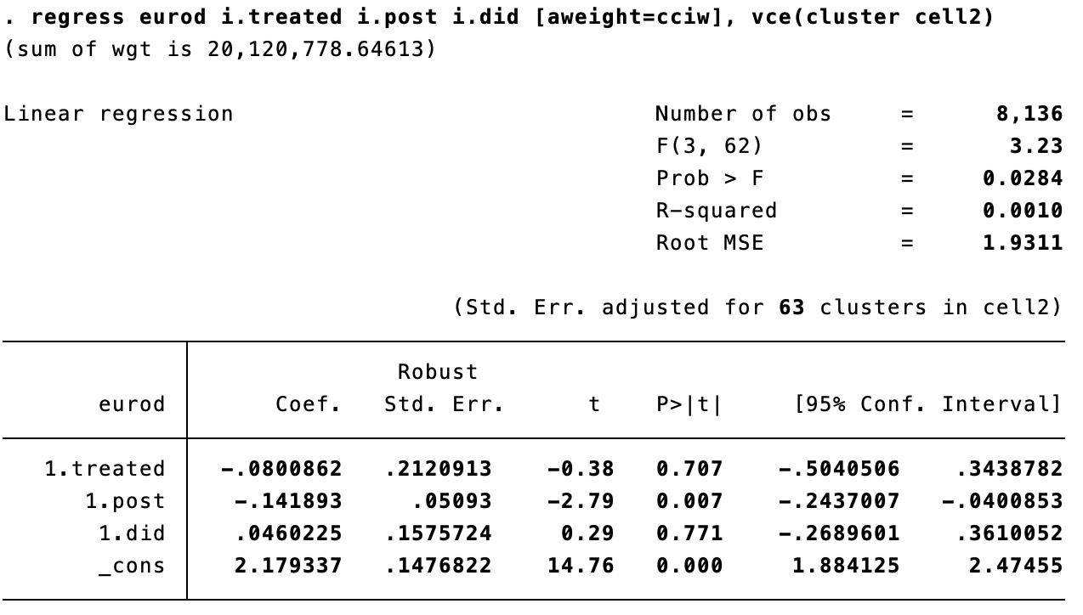

Treated = (work_horizon_change_minimum > 0)

Only countries present in both waves

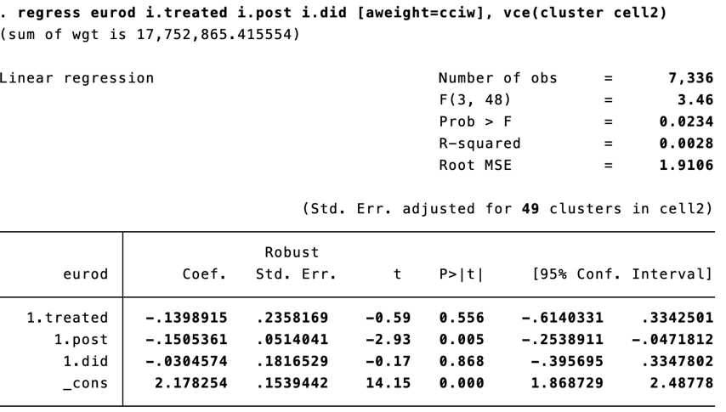

Treated = (work_horizon_change_minimum > 0)

Balanced sample

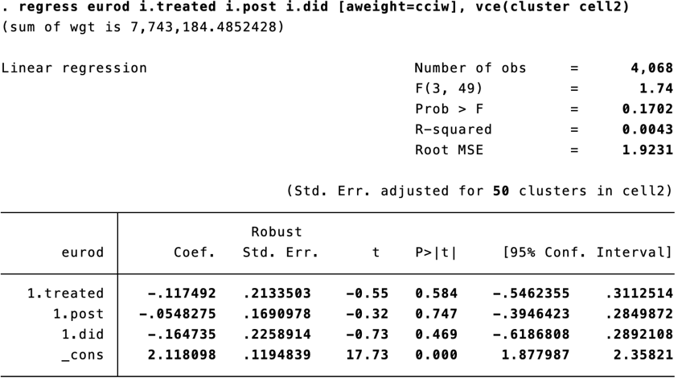

Treated = (work_horizon_change_minimum > 0)

Balanced sample

Longitudinal weights

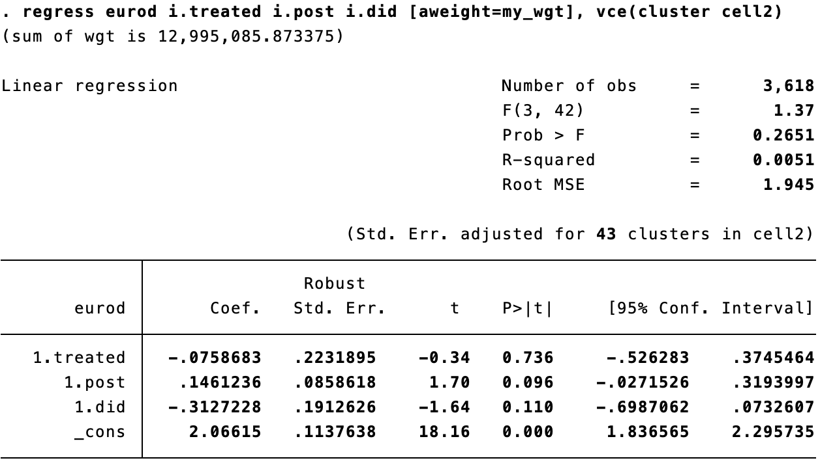

Treated = (work_horizon_change_minimum > 0)

With controls

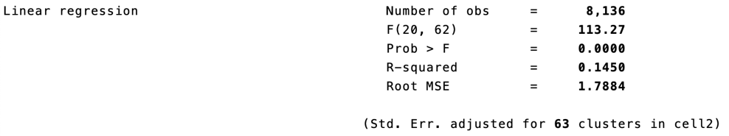

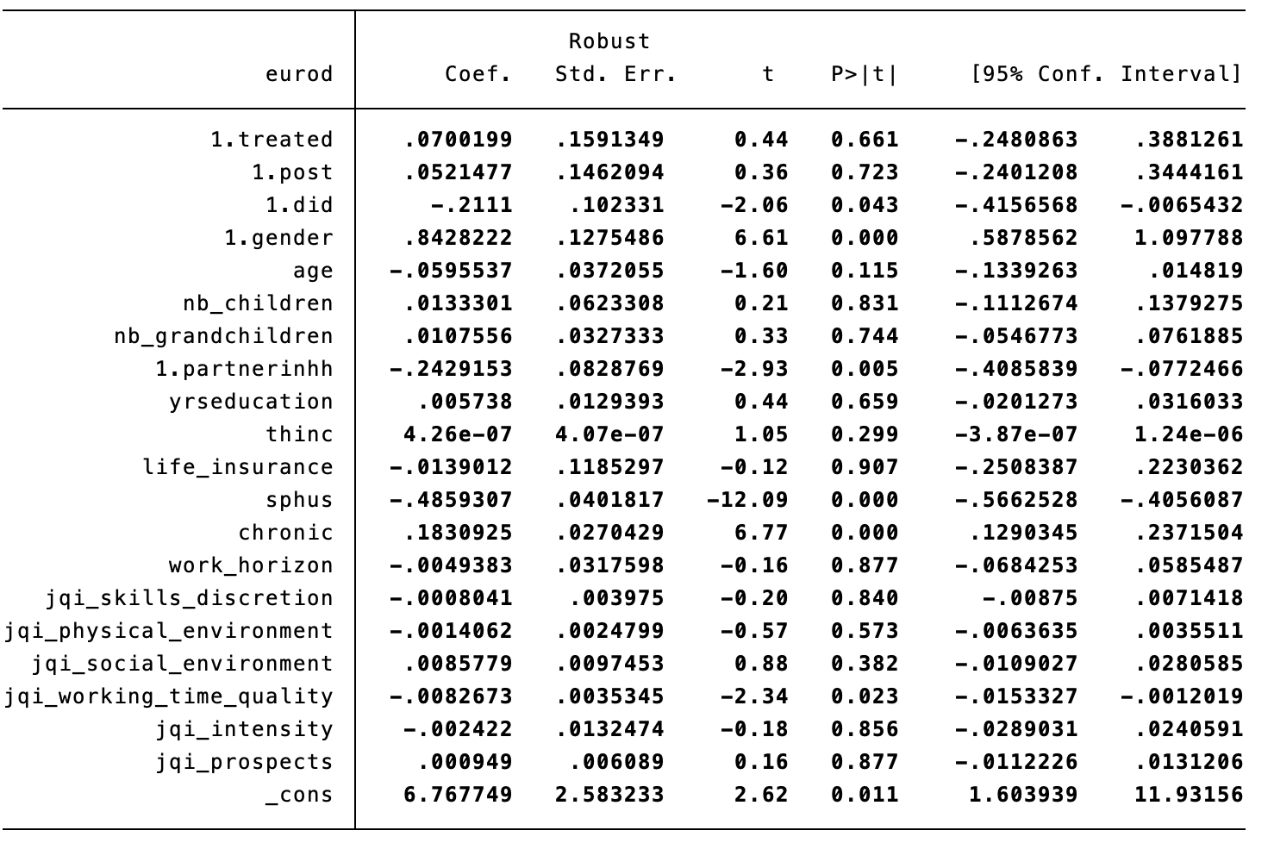

Treated = (work_horizon_change_minimum > 0)

With controls

Only countries present in both waves

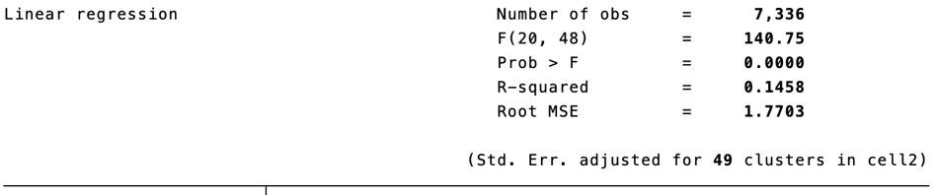

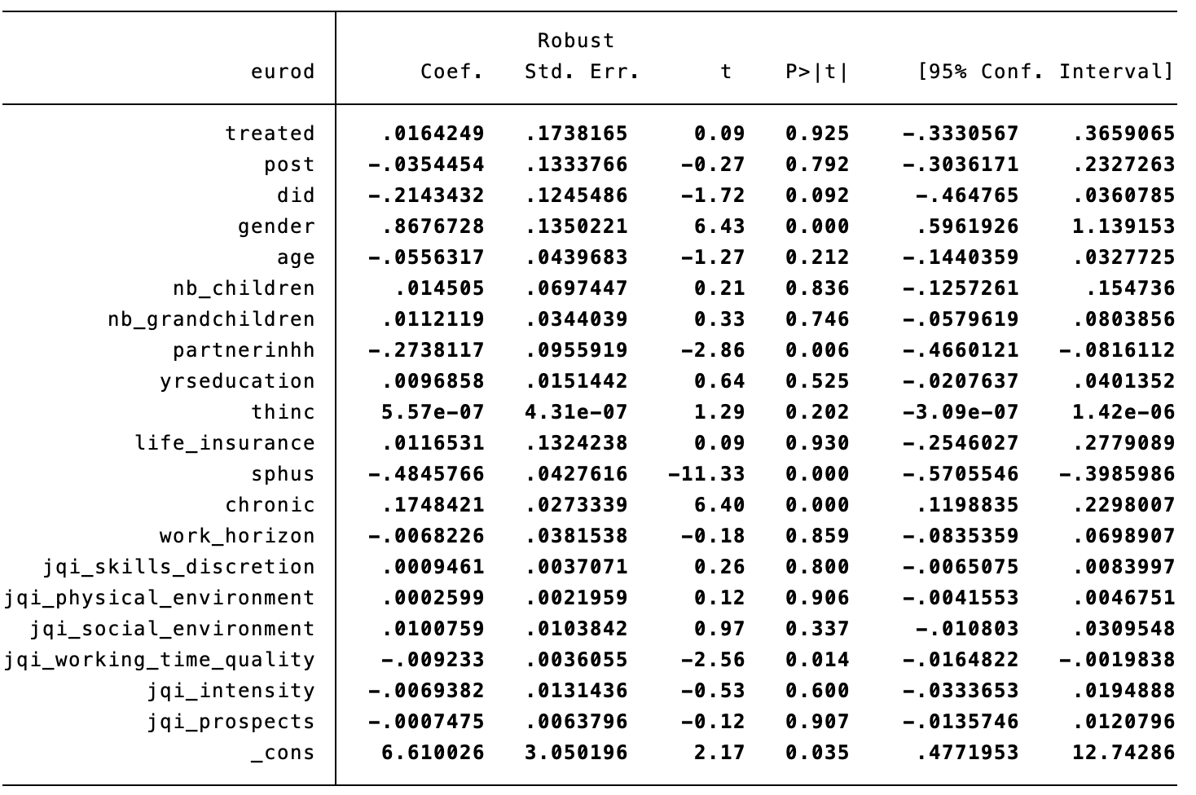

Treated = (work_horizon_change_minimum > 0)

With controls

Balanced sample

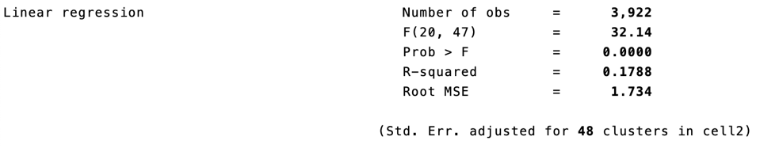

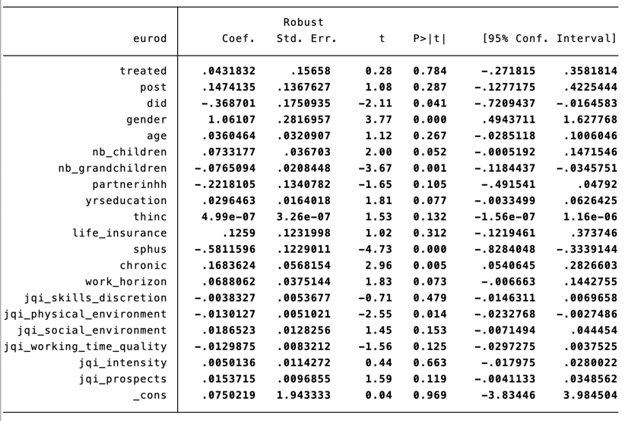

Treated = (work_horizon_change_minimum > 1)

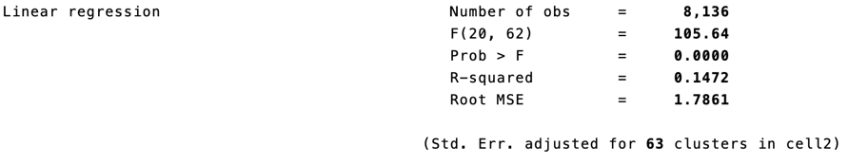

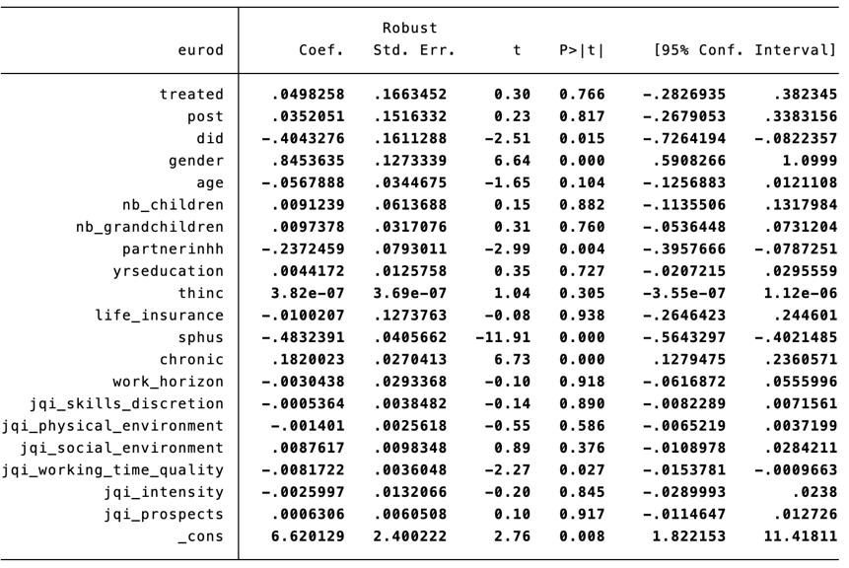

Treated = (work_horizon_change_minimum > 1)

Only countries present in both waves

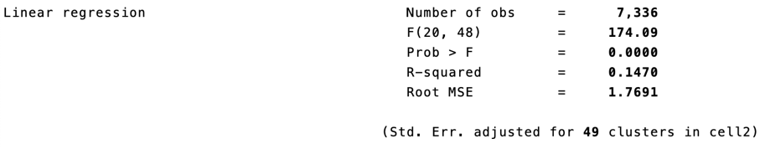

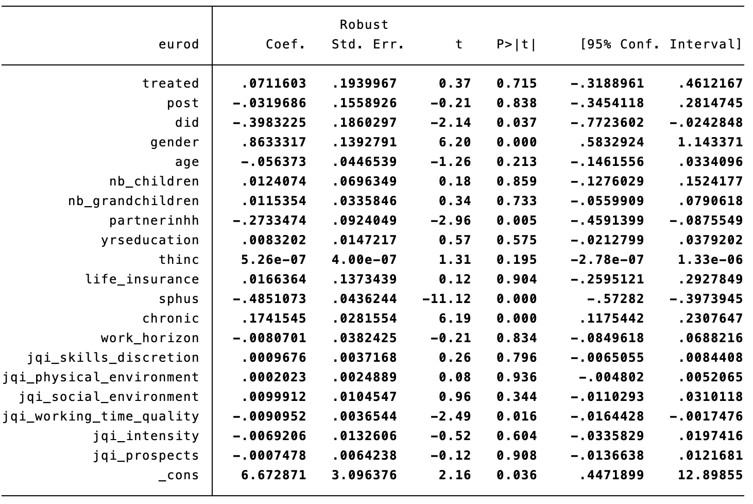

Treated = (work_horizon_change_minimum > 1)

Balanced sample

