Bugs found during testing

**Title**: Required fields should be marked with asterisks

**Repro step**s:

1. Open web application
2. Click on Register Link on the top

**ER**: As all fields are required programmatically, they should be with asterisks

**AR**: No asterisks shown.

**Screenshot**:

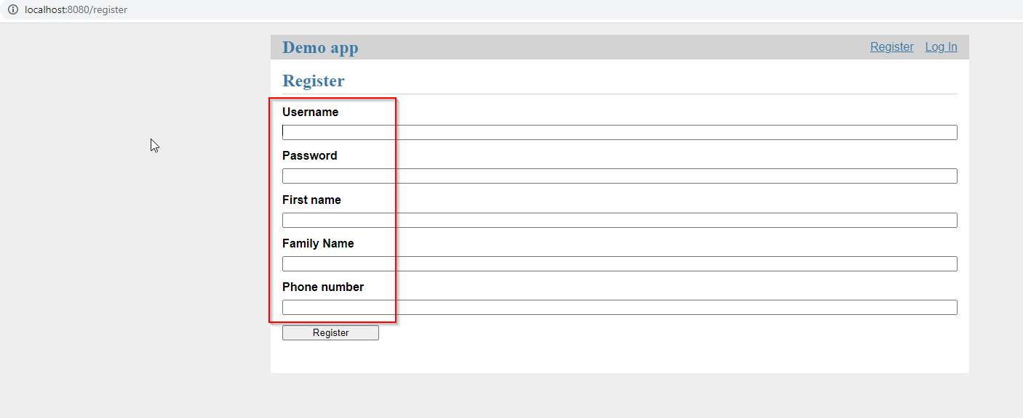

**Title**: “Family Name” field should be renamed to “Last name” on the registration form

**Repro step**s:

1. Open web application
2. Click on Register Link on the top

**ER**: Registration form should match User information

**AR**: “Family Name” on Registration form, “Last name” on User information table

**Screenshots**:

Registration form:

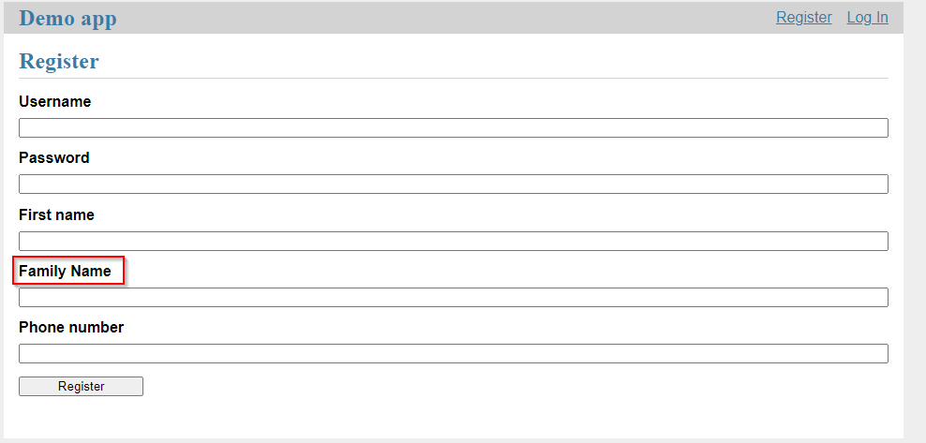

User Info:

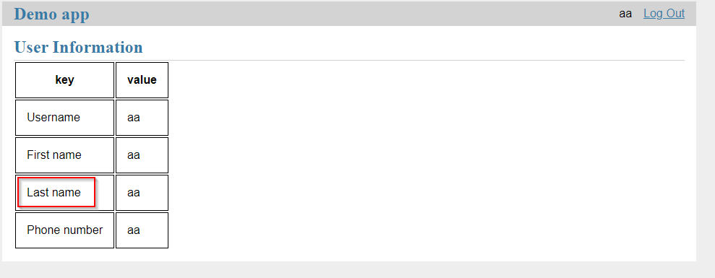

**Title**: User info cannot be updated with API

**Repro step**s:

1. Run application
2. Create a user with UI
3. Invoke PUT request for updating the user info

**ER**: The user information is updated

**AR**: The application returns 500 error code (might be connected to Python version)

**Logs**:

*[2021-08-17 20:03:46,038] ERROR in app: Exception on /api/users/SergeyMoskalev [PUT]*

*Traceback (most recent call last):*

*File "c:\users\moskalev.sergey\appdata\local\programs\python\python37-32\lib\site-packages\flask\app.py", line 2292, in wsgi_app*

*response = self.full_dispatch_request()*

*File "c:\users\moskalev.sergey\appdata\local\programs\python\python37-32\lib\site-packages\flask\app.py", line 1815, in full_dispatch_request*

*rv = self.handle_user_exception(e)*

*File "c:\users\moskalev.sergey\appdata\local\programs\python\python37-32\lib\site-packages\flask\app.py", line 1718, in handle_user_exception*

*reraise(exc_type, exc_value, tb)*

*File "c:\users\moskalev.sergey\appdata\local\programs\python\python37-32\lib\site-packages\flask\_compat.py", line 35, in reraise*

*raise value*

*File "c:\users\moskalev.sergey\appdata\local\programs\python\python37-32\lib\site-packages\flask\app.py", line 1813, in full_dispatch_request*

*rv = self.dispatch_request()*

*File "c:\users\moskalev.sergey\appdata\local\programs\python\python37-32\lib\site-packages\flask\app.py", line 1799, in dispatch_request*

*return self.view_functions[rule.endpoint](**req.view_args)*

*File "C:\SignantHealthTask\Flasky-master\demo_app\api.py", line 46, in wrapped_call*

*return call(*args, **kwargs)*

*File "C:\SignantHealthTask\Flasky-master\demo_app\api.py", line 79, in username*

*return put_specific_user(username, request)*

*File "C:\SignantHealthTask\Flasky-master\demo_app\api.py", line 90, in put_specific_user*

*for key, value in data.iteritems():*

*AttributeError: 'dict' object has no attribute 'iteritems'*