Neo4J

|  |  |
| --- | --- |
| 制作小组 | BIG DATA GROUP |
| 制作日期 | 2018.11.02 |

Contents

Neo4J 3

1.About Neo4J 3

2.Neo4J Install 3

2.1.Install JDK 3

2.2.Download installment file 3

2.3.Unzip file 3

2.4.Start server 3

2.5. Chrome server 4

2.6.Test database 4

2.7.Others 5

3.Python Neo4j 6

# Neo4J

# 1.About Neo4J

Neo4j is the world’s leading **Graph Database**. It is a **high performance** graph store with all the features expected of a mature and robust database, like a friendly query language and ACID transactions. The programmer works with a **flexible network structure of nodes and relationships** rather than static tables — yet enjoys all the benefits of enterprise-quality database. For many applications, Neo4j offers orders of **magnitude performance** benefits compared to relational DBs.

# 2.Neo4J Install

## 2.1.Install JDK

First install JKD8 in system.

## 2.2.Download installment file

Here is Neo4j official download website:

<https://neo4j.com/download-center/>

Noted(download the community edition for windows: [Neo4j 3.4.9 (zip)](https://go.neo4j.com/download-thanks.html?edition=community&release=3.4.9&flavour=winzip))

## 2.3.Unzip file

Unzip the downloaded file ….zip to local file, Here is my file location: **path**:C:\Users\Public\software\noe4j\neo4j-community-3.4.9

Then add System Environment Variables: name: NEO4J_HOME, value: **path;** Add a variable to path**: %NEO4J_HOME%/bin. Ok.**

## 2.4.Start server

Open a terminal, enter to the noe4j local file **path/bin,** code this:

**neo4j.bat console**

Then will see that service is started.

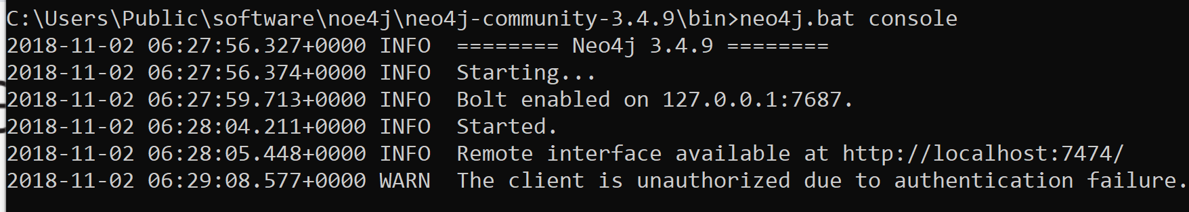

## 2.5. Chrome server

Open chrome, use this URI:

**localhost:7474**

You will have to enter the **password: neo4j** (After that, reset password)

Then you will see this website:

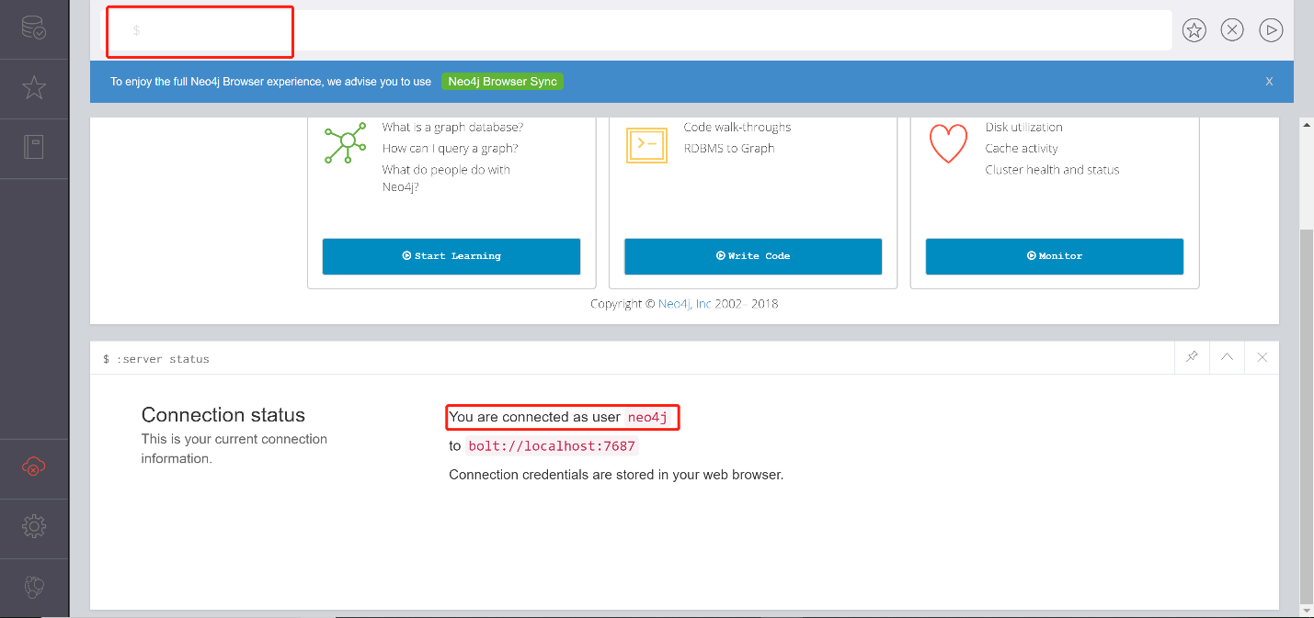

## 2.6.Test database

Create one node:

**create (lgq:Person {name: 'lugq', hobit:'reading', sex:'male', work:'accenture'});**

Create another node:

**create (liu:Person {name: 'liu', hobit:'shopping', sex:'female', work:'hp', like:'money'});**

Link them(create relation between each other):

**create (lgq) -[:LOVES]->(liu), (liu)-[:LOVES]->(lgq);**

Get the relation result graph:

**match(x:Person)-[:LOVES]-(y) where x.name = 'lugq' return x, y;**

Result:

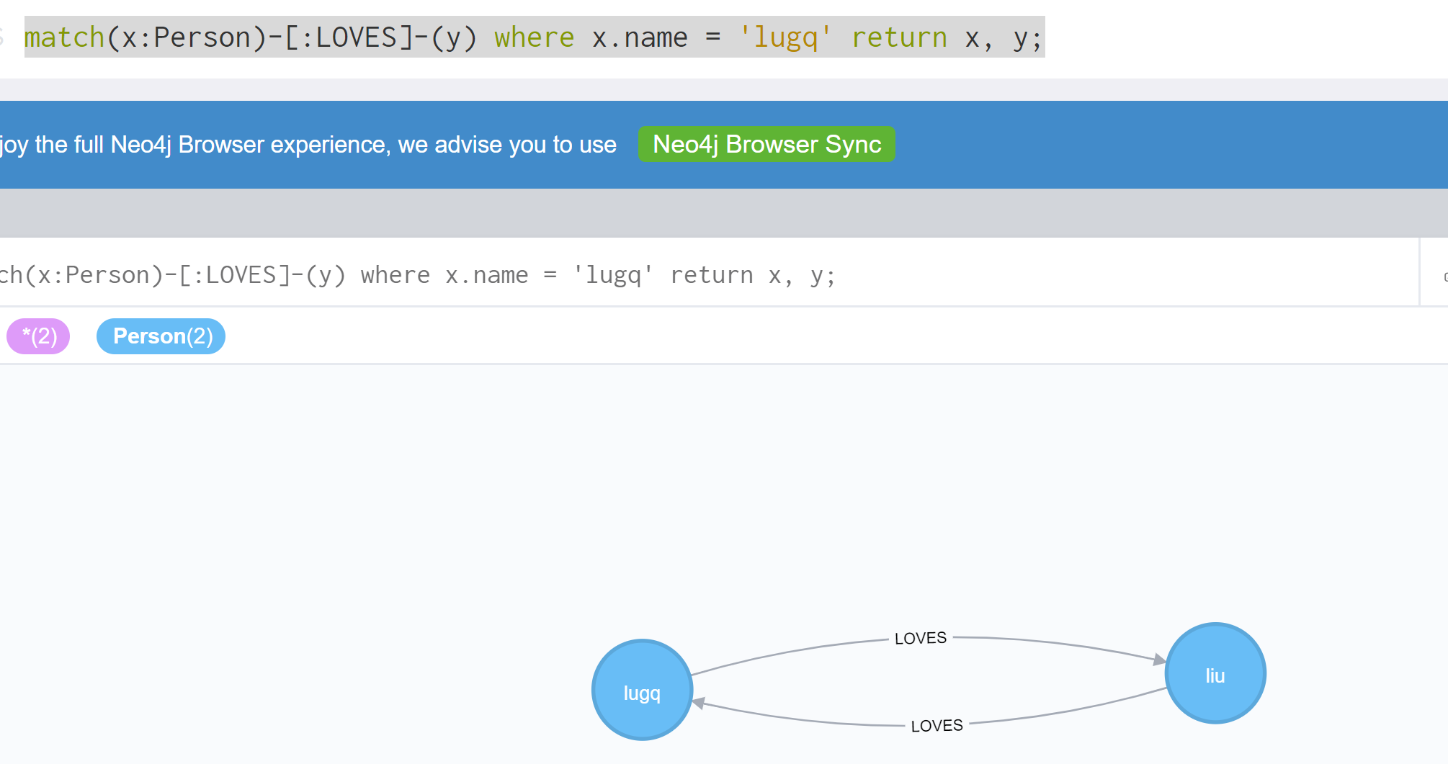

## 2.7.Others

There are many others information about the graph, such as properties, nodes .etc. In chrome, we can also see that:

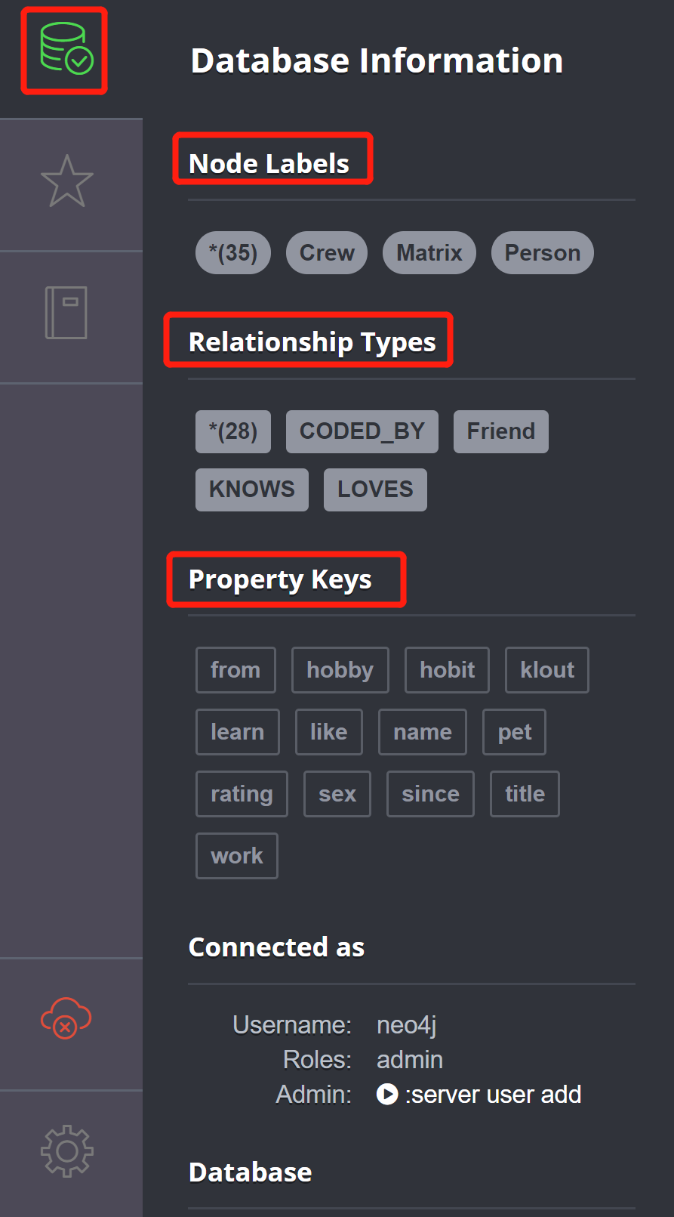

# 3.Python Neo4j

We can also use python to create nodes, relations or something others.

First install python neo4j, code this:

**pip install neo4j**

Here is some example code:

# -*- coding:utf-8 -*-

from neo4j.v1 import GraphDatabase

uri = 'bolt:loalhost:7687'

driver = GraphDatabase.driver(uri, auth=('neo4j', '123lug'))

def submit(sent):

with driver.session() as sess:

with sess.begin_transaction() as tx:

tx.run(sent)

cypher = """

match(x:Person)-[:LOVES]-(y) where x.name = 'lugq' return x, y

"""

# start to commit

submit(cypher)

print('Finished submit jobs!')