Can You Say that Again?
A Real-World API and Data Exercise

At this point, you are familiar with both the Java API and the Karel API. The Java API is the set of classes that are included with the Java Development Environment. The Karel API included all the classes needed to work in the Karel environment.

So, what’s an API anyway?
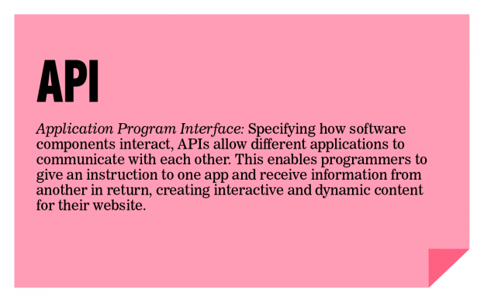
Read more about APIs and why they are so useful at: http://readwrite.com/2013/09/19/api-defined.

We are going to use an API which allows us to interact with Twitter. With just a few lines of code, we can access our personal tweets as well as the public tweets of others. And we can do much more!

Part I – Connect and Tweet
We decided to use the Twitter4j API which can be found at http://twitter4j.org. Click on JavaDoc.

There are a few housekeeping items to be tackled before you can use Twitter from your program. Steps 1-3 are required and steps 4-10 will make your life with this assignment much, much easier.

- Copy the Twitter-students folder from the R: drive.

- Once the folder is on your personal drive, you’ll notice a lib folder containing a twitter4j-core-4.0.2.jar file. You will need to set the classpath in jGrasp to lib\twitter4j-core-4.0.2.jar.

- You should also notice a twitter4jproperties file. This file holds the credentials in order for you to access Twitter data. The file currently holds some default values which grant you read-only access to Twitter. While this is enough for you to complete the assignment, it does not allow for multiple students to use the credentials at the same time. You may encounter a run-time error that states there is a rate limit issue if you using the credentials at the same time as other students. (This will probably work fine if you are coding at 5am.) To avoid this error, you should consider making your own Twitter account.

- To make your own Twitter account, visit www.twitter.com and sign up. While you have to provide a valid email address as you will need to use it for verification, feel free to use a non-real username. You must add a mobile phone number to your Twitter profile in order to make a developer account later. You can also delete the account once the assignment is over, if desired.

- Now that you have a Twitter account, you’ll need to visit http://apps.twitter.com to set up the permissions to allow a non-Twitter app (your Java program) to access Twitter.

- Select Create New App and fill in the first three fields of Application Details:
  - Name: <Name your project>
  - Description: Learning to Work with APIs
  - Website: <Anything you want that starts with an http://>

- Agree to the Developer Agreement.

- If you want to be able to tweet out from your Java program, then visit the Permissions tab and select Read and Write. Leave Read Only if you do not wish to have write access.

- Retrieve the four keys you will need for the twitter4j.properties file and edit that file:
- Go to My Applications
- Click on the application you made
- Go to Keys and Access Tokens
- Click on Create My Access Token
- Copy the four keys from the Twitter webpage. (Note: for unknown reasons, the names don’t exactly match. The Consumer Key is the API key and the ConsumerSecret is the APISecret.) Paste the four new keys into your twitter4j.properties file in your folder.
oauth.consumerKey=
oauth.consumerSecret=
oauth.accessToken=
oauth.accessTokenSecret=

- Let's see if you can tweet from your Java program! Type this code into your Twitter_Driver in the setUpAndTweet() method:

twitter.updateStatus("I just tweeted from my Java program! #APCSRocks @TJColonials Thanks @cscheerleader!");

Part II – Most Common Word
You will access the last 2,000 tweets of a person’s twitter handle (this can be your own, someone you know, or a public figure) and determine the most common word they use. To do this, you will need to grab a user’s most recent 2,000 tweets, store individual words in a data structure of your choice, and then write an algorithm to determine the most common term. Since it would not be interesting to count “the”, “a”, “and”, or similarly all-too common words, you need to remove those too-common words. Fortunately, we put those too-common words in the file commonWords.txt. Remove those too-common words from the tweeter’s list of words before determining the tweeter’s most commonly used word. Note: you will need multiple data structures for this assignment – at least one must be an ArrayList.

Once you have all the tweets in a list, you need to determine the most common word. For consistency sake, we created a list of too-common words you should remove from your collection of individual words. We also recommend removing any words starting with the @ symbol since that’s not always interesting. You might find yourself wanting to do things like remove punctuation and sort words. You’ve done that before in other programs. Don’t recreate that code, go grab it and reuse!

Sample run

Enter Twitter handle (without the @ symbol, type done to quit) --> taylorswift13
Count = 147 out of the last 1998 tweets.
The most common word from @taylorswift13 is: love
Enter Twitter handle (without the @ symbol, type done to quit) --> NASA
Count = 267 out of the last 1999 tweets.
The most common word from @NASA is: #yearinspace
Enter Twitter handle (without the @ symbol, type done to quit) --> KDTrey5
Count = 129 out of the last 1995 tweets.
The most common word from @KDTrey5 is: lol
Enter Twitter handle (without the @ symbol, type done to quit) --> BillNye
Count = 199 out of the last 1492 tweets.
The most common word from @BillNye is: science
Enter Twitter handle (without the @ symbol, type done to quit) --> done

Part III
Team up with a partner and brainstorm something interesting you can do with Twitter. You have the JavaDocs as a resource (http://twitter4j.org/oldjavadocs/4.0.2/index.html) and you can find some sample code at http://twitter4j.org/en/code-examples.html.

Here are some ideas:

- Filter your home timeline (these are all the tweets from people you follow) to avoid a particular term. For instance, if you are an Android fan, you could filter out all tweets with Apple in them.
- Count the number of tweets originating from your zip code that contain the word “flu”.
- Send tweets every 10 minutes to your friend on his/her birthday. Use a timer, of course.
- Search for tweets: (a) created in the last week, (b) that contained the term "dolphins" (aka Miami Dolphins), and (c) were sent from a location within a 10 mile radius of Ms. Galanos' house. Her sample code reports the time, username, and the actual tweet. The sample code for this can be found in the sampleInvestigate method.

