ELEVATE-LNP: Empty Lipid Nanoparticle Enabled Validation and AI-Guided Therapeutic Evaluation for Efficient Formulation Optimization for mRNA Delivery
Mingzhi Yu^{1†}, Luhan Wang^{1†}, Timothy Elliott¹, Xianqing Wang², Allen Mathew¹, Bei Qiu², Liang Yao², Wenxin Wang², Nan Zhang^{1*}

1. Centre of Micro/Nano Manufacturing Technology (MNMT-Dublin), School of Mechanical & Materials Engineering, University College Dublin, D04 V1W8, Ireland.
2. Charles Institute of Dermatology, School of Medicine, University College Dublin, D04 V1W8, Dublin, Ireland.
†These authors contributed equally: Mingzhi Yu, Luhan Wang.

*Corresponding author. E-mail: nan.zhang@ucd.ie

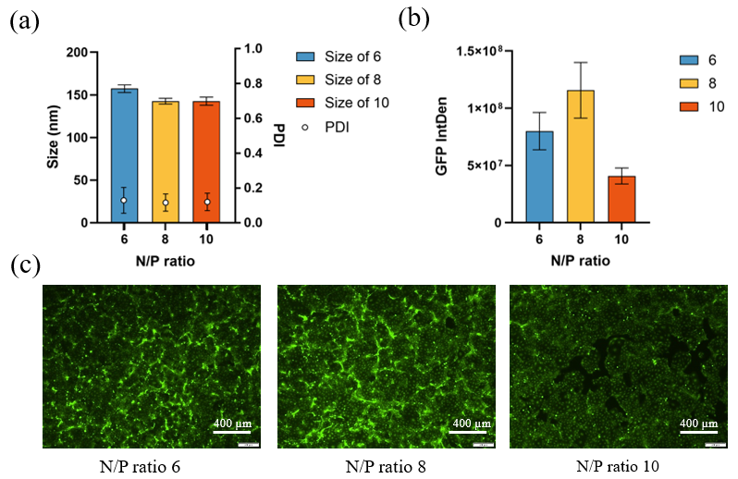
Fig. S1 Preliminary optimization of N/P ratio for GFP mRNA-loaded LNPs.
GFP mRNA-loaded LNPs were prepared at N/P ratios of 6, 8, and 10 to evaluate the influence of N/P ratio on LNP physicochemical properties and transfection performance. (a) Particle size and PDI of LNPs prepared at different N/P ratios. LNPs prepared at N/P 6 showed a larger particle size, whereas N/P 8 and N/P 10 resulted in smaller and comparable particle sizes. (b) Quantification of GFP fluorescence intensity (GFP IntDen) in cells transfected with LNPs prepared at different N/P ratios. N/P 8 produced the highest GFP signal among the tested conditions. (c) Representative fluorescence microscopy images of GFP expression after transfection with LNPs prepared at N/P ratios of 6, 8, and 10.

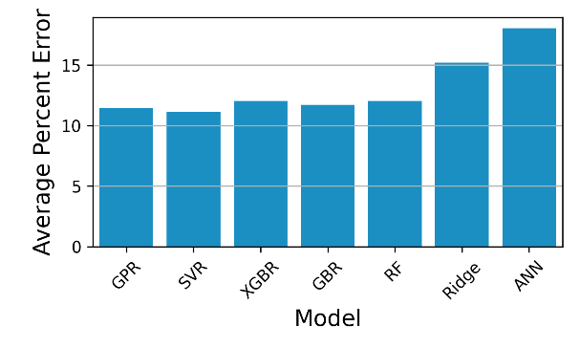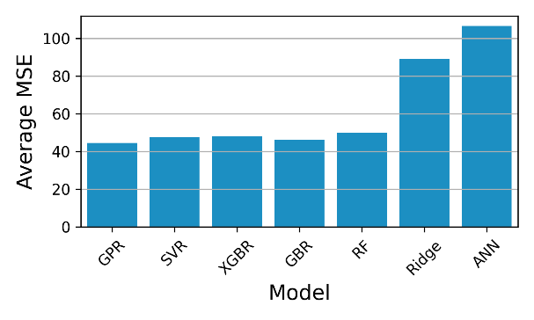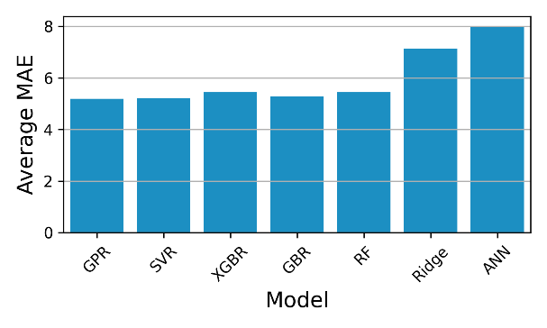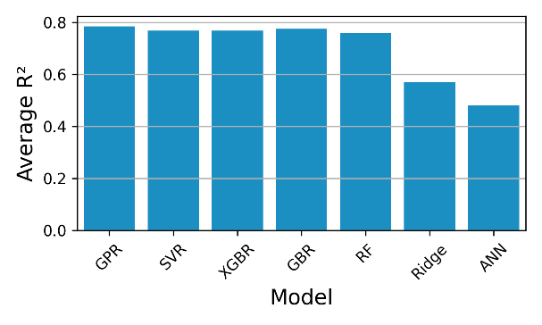
Fig S2. Percent error, MSE, MAE and average R² for nested cross-validation for size

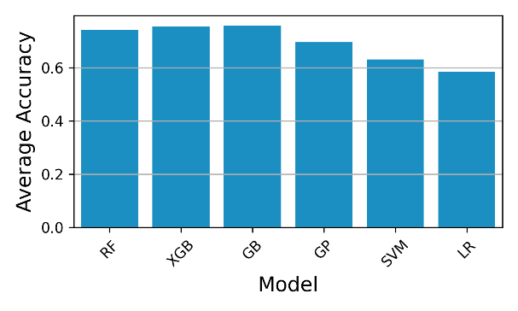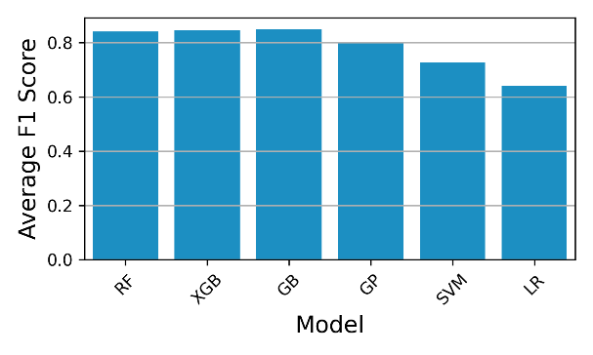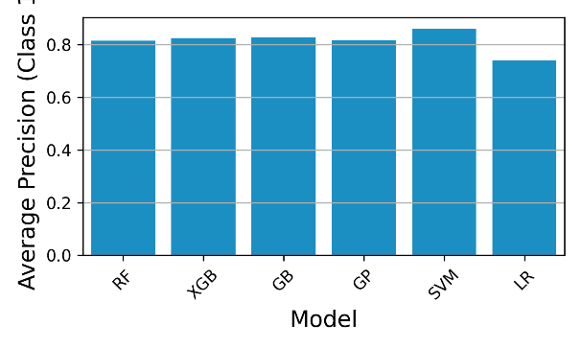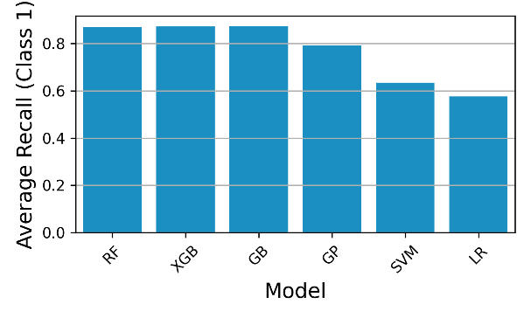
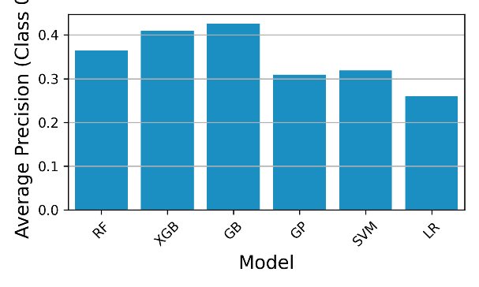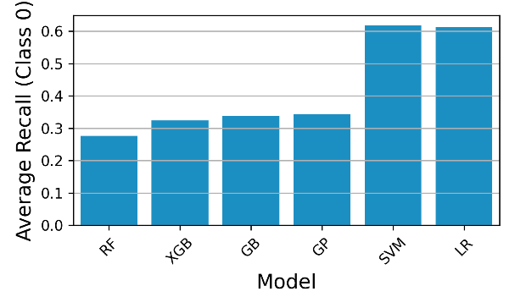
Figure S3. Accuracy, F1 score, precision and recall for nested cross-validation for PDI

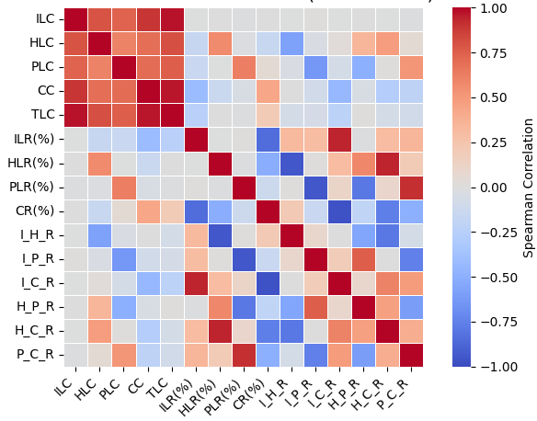
Fig. S4 Spearman correlation matrix of formulation features in relation to LNP size and PDI.

Fig. S5 Experimental validation of model-selected formulations with GFP mRNA. (a) The size and PDI of 100 GFP mRNA–loaded formulations; (b) EE of the same formulations; (c) GFP fluorescence intensity (GFP intDen) in CFBE cells 48 h post-transfection; (d) Cell viability of CFBE cells after transfection with the corresponding formulations.

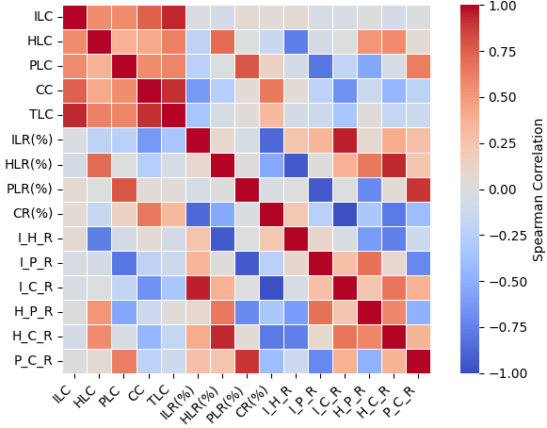
Fig. S6 Spearman correlation matrix of formulation features in relation to transfection efficiency.

Table. S1 Six lead formulations selected for CFTR mRNA encapsulation and Western blot validation
No. | ILT | HLT | ILC | ILR | HLP | PLR | CR
1 | SM-102 | DOPC | 0.0025 | 40 | 16 | 0.5 | 43.5
2 | SM-102 | DOPC | 0.0055 | 44 | 16 | 0.5 | 39.5
3 | SM-102 | DOPC | 0.004 | 40 | 16 | 0.5 | 43.5
4 | SM-102 | DSPC | 0.01 | 48 | 16 | 0.5 | 35.5
5 | SM-102 | DSPC | 0.01 | 52 | 16 | 0.5 | 31.5
6 | SM-102 | DSPC | 0.0085 | 48 | 16 | 0.5 | 35.5

Table. S2 Best parameters for different ML models of nested cross-validation for size
 | Best Parameters | Frequency
GPR | {'alpha': 0.1, 'kernel': '1**2 * RationalQuadratic(alpha=1, length_scale=1)', 'n_restarts_optimizer': 0, 'normalize_y': True} | 25
SVR | {'C': 10, 'degree': 3, 'epsilon': 1.0, 'kernel': 'rbf'} | 61
XGBR | {'colsample_bytree': 1.0, 'learning_rate': 0.01, 'max_depth': 5.0, 'min_child_weight': 4.0, 'n_estimators': 200.0, 'subsample': 0.8} | 29
GBR | {'learning_rate': 0.01, 'max_depth': 3.0, 'min_samples_leaf': 4.0, 'min_samples_split': 10.0, 'n_estimators': 400.0, 'subsample': 0.8} | 18
RF | {'max_depth': 5, 'min_samples_leaf': 4, 'min_samples_split': 2, 'n_estimators': 200} | 19
Ridge | {'alpha': 100} | 99
ANN | {'batch_size': 16.0, 'lr': 0.001, 'max_epochs': 100.0, 'module__hidden_size': 128.0} | 30

Table. S3 Best parameters for different ML models of nested cross-validation for PDI
 | Best Parameters | Frequency
GP | {"kernel": "1**2 * RBF(length_scale=1)"} | 200
SVM | {"C": 0.1, "gamma": "auto", "kernel": "rbf"} | 114
XGB | {"colsample_bytree": 0.8, "gamma": 0.1, "learning_rate": 0.1, "max_depth": 5.0, "min_child_weight": 5.0, "n_estimators": 200.0, "subsample": 0.8} | 18
GB | {"learning_rate": 0.1, "max_depth": 3.0, "min_samples_leaf": 4.0, "min_samples_split": 2.0, "n_estimators": 200.0} | 26
RF | {"max_depth": 10.0, "min_samples_leaf": 1.0, "min_samples_split": 2.0, "n_estimators": 200.0} | 32
LR | {"C": 0.0001, "penalty": "l2", "solver": "lbfgs"} | 90

Table. S4 Best parameters for different ML models of nested cross-validation for transfection efficiency
 | Best Parameters | Frequency
GPR | {'alpha': 0.1, 'kernel': '1**2 * RationalQuadratic(alpha=2, length_scale=1)', 'n_restarts_optimizer': 0, 'normalize_y': True} | 51
SVR | {'C': 10, 'epsilon': 0.1, 'kernel': 'rbf'} | 99
XGBR | {'colsample_bytree': 0.8, 'learning_rate': 0.1, 'max_depth': 3.0, 'min_child_weight': 1.0, 'n_estimators': 100.0, 'subsample': 0.8} | 89
GBR | {'learning_rate': 0.1, 'max_depth': 5.0, 'min_samples_leaf': 1.0, 'min_samples_split': 2.0, 'n_estimators': 100.0, 'subsample': 0.8} | 42
RF | {'max_depth': 5, 'min_samples_leaf': 1, 'min_samples_split': 2, 'n_estimators': 50} | 30
Ridge | {'alpha': 1} | 92

