Software Requirements Specification
for
<CS321 Project 1: Phone Voice Messaging System>
Version 1.0 approved
Prepared by <Luhang Sun>
Colby College
October 2021
Table of Contents
Table of Contents ii
1. Introduction 1
1.1 Purpose 1
1.2 Intended Audience and Reading Suggestions 1
1.3 Product Scope 1
1.4 References 1
2. Overall Description 1
2.1 Product Perspective 1
2.2 Product Functions 3
2.3 User Classes and Characteristics 3
3. System Features 5
3.1 Access Account 5
3.2 Retrieving Message 5
3.3 Deleting Message 6
3.4 Leaving a Message 6

Introduction

Purpose
The purpose of this document is present a detailed description of the Phone Messaging System. It will explain the purpose and features of the system, the interfaces of the system, and what the system will do. This document is intended for both stakeholders and the developers of the system.

Intended Audience and Reading Suggestions
<Describe the different types of reader that the document is intended for, such as developers, project managers, marketing staff, users, testers, and documentation writers. Describe what the rest of this SRS contains and how it is organized. Suggest a sequence for reading the document, beginning with the overview sections and proceeding through the sections that are most pertinent to each reader type.>

Product Scope
This system is a simple phone voice messaging system. It acts as an answering service for an organization-wide phone system. This system is defined in software scope only with the assumption that the hardware for the phone system, dialing, and message recording are in place.

The phone voice messaging system primarily serves as an add-on for standard organization-wise dialing system and provides internal users with the options to leave messages when the receiver fails to pick-up the call in a timely manner.

References
Used SRS Example – Web App posted on Moodle as a reference when composing this document.

Overall Description

Product Perspective
The voice messaging system has 2 end users and a server. The organization’s internal user is the main customer of the system and is given access to functions such as dial, leave messages, access account, and retrieving messages. The admin user of the organization manages all the internal user’s account and is given the power to change perspectives of the accounts. The phone system server manages all the information of user accounts. Below is a use case diagram for the entire system.
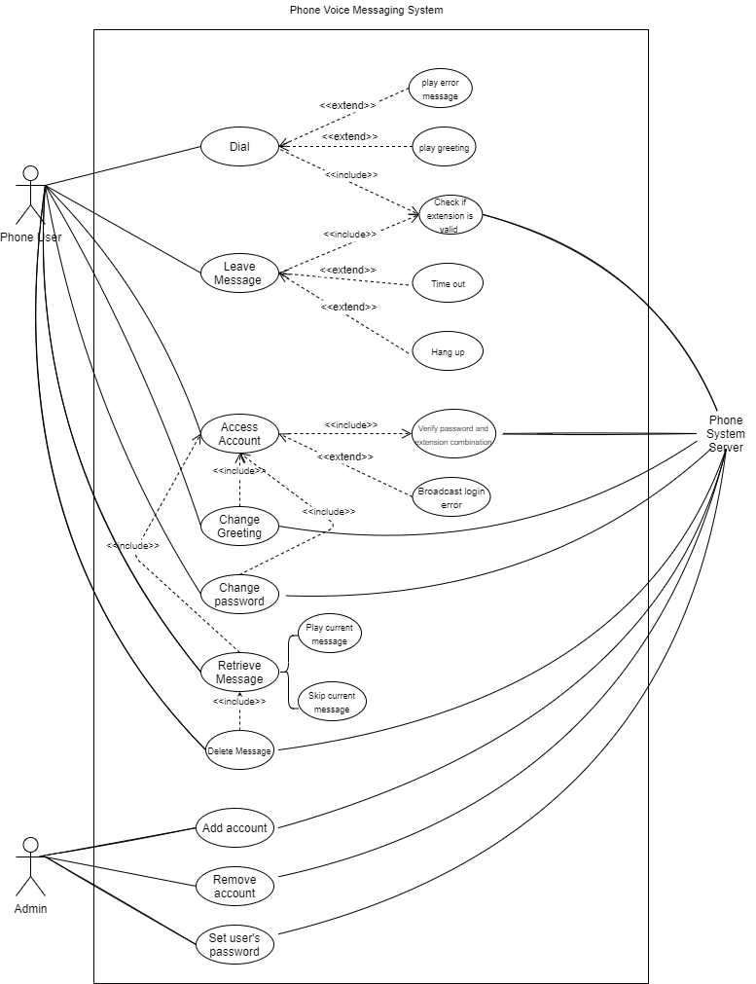

Product Functions

Accessing an Account
Users will have access to their own accounts through their extension number and the correct password. After the system validate the extension and password, the user will be able to retrieve messages from the account, change the greeting played when a caller reaches with voice messaging, and change account settings.

Retrieving Messages
After the user access their account and select the message retrieving option, they can:
- play the current message
- delete the current message
- skip the current message.

After the selection is processed, the next message is played or an acknowledgement of the action is given. This repeats until all messages are played in the order that they are received. At any time, the caller may hang up. After all new messages are played, the saved messages are played in the order in which they are saved.

Deleting Messages
While the user retrieves their message, they will have the option (press 2) to delete the current message. Then the next message will be displayed, and the process repeats until the end of the message list, in which case the user menu will be restated.

Leaving a message
The user needs to enter a valid, active extension that is not their own. If the receiver does not pick up the call in-time, the connection will enter the voice messaging system and asks the user to leave a message by talking. To finish leaving the message, the user either hangs the phone, or a timeout in number of second.

Admin use case
The admin of the organization will have the access to view and manage each user’s account in the organization, including adding or removing accounts and setting a user’s password.

User Classes and Characteristics
The class PhoneSystem is the highest-level object class that includes the list of accounts in the organization, the dialing and recording option, and a set of interface functions such as pick up, hang up, ring, set, connections, etc.
A connection object is activated after a certain number of rings without a pickup from the account owner. The connection class contains the caller and receiver extension and the functions of playing greeting message and accessing account. The connection class belongs to the PhoneSystem class as it is created there and will be deleted after when not needed.
During connection, message objects will be created, but the relationship between the two class is aggregation because after the connection is dropped, messages will still exist in the system. The PhoneSystem class is dependent on the account class, which contains an extension, a password, and a greeting specifications set by the account owner. The account class is inherited by three types of account: active user account, active admin account, and inactive account. An active account object has active as its states attribute, a list of messages received, and a greeting setting, along with a change password function. The active admin account has function to add and remove accounts, and change password of other accounts.
The class diagram of the entire system is shown below.
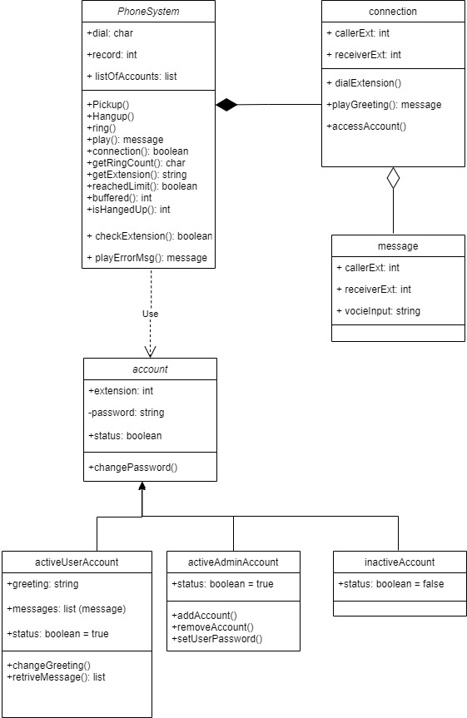

System Features

Access Account
3.1.1 Description and Priority
This feature involves the end user to dial the extension of their own account, or 8888 from their own phone, and enters the password, which is validated by the phone server.
High priority.
3.1.2 Stimulus/Response Sequences
1. The user enters the extension of their account, or 8888 if calling from their own phone
2. The user selects the option “access an account” by pressing #
3. The user is asked for a password
4. The user enters the password
5. The user will enter their account and access the options of retrieving messages, changing greeting and changing password.
3.1.3 Functional Requirements
REQ-1: at step 1) in 4.1.2, the security system checks if the extension and the password is a correct combination. If the combination is not correct, return a message “The password/the extention is not correct” and ask the user to reenter.

Retrieving Message
3.2.1 Description and Priority
This feature allows the users to access the list of messages received by their account, with the option of deleting, skipping and playing the messages.
High priority.
3.2.2 Stimulus/Response Sequences
1. The user access their account.
2. The user press 1 to retrieve the message.
3. The first message is displayed on the phone
4. The user has to select from 3 options:
a.Press 1 to play the current message
b. Press 2 to delete the current message
c. Press 3 to skip the current message
5. An acknowledgement of the action is given.
6. The next message is played and the user is given the option again and repeat 3) until all the new messages are played.

3.2.3 Functional Requirements
REQ-1: messages will be shown in the order they are received. After all new messages are played, the saved messages will be played per user’s selection repeated from 3)

Deleting Message
3.3.1 Description and Priority
This feature allows the users to delete a message.
Medium priority.
3.3.2 Stimulus/Response Sequences
1. The user access their account.
2. The user press 1 to retrieve the message.
3. The first message is displayed on the phone
4. The user press 2 to delete the current message.
5. An acknowledgement of the action is given.
6. The next message is played

3.3.3 Functional Requirements
REQ-1: messages will be shown in the order they are received. If there are no messages left, the user options menu will be restated.

Leaving a Message
3.4.1 Description and Priority
This feature allows the users to leave a message to another user when dialing.
High priority.
3.4.2 Stimulus/Response Sequences
1. The user enters an extension
2. The receiver rings, if no pick up within 4 rings, the phone asks the user to leave a message by talking.
3. The user either hangs the phone, or a timeout in number of second, to end the message.

3.4.3 Functional Requirements
REQ-1: If the extension is the phone’s extension, return a message “You can’t leave a message to yourself”.
REQ-1: The system also checks if the extension is valid. If not, there will not be a connection set up and the caller’s system will return to its initial state.

