Hello this is our report from last 2 weeks. Our site is about puppy adoption.

At the beginning we started from doing simple header.



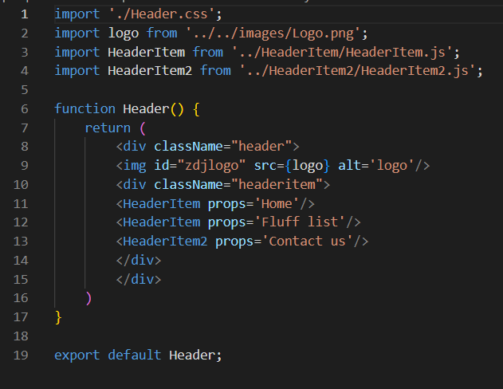

With some css

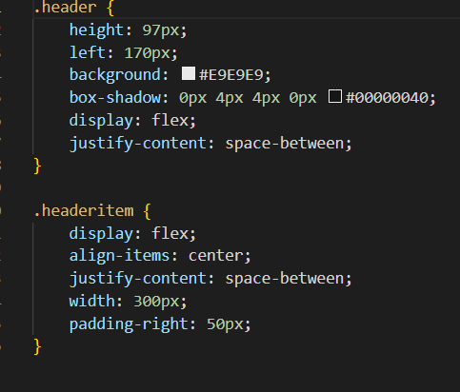

Next we add 2 cute photos



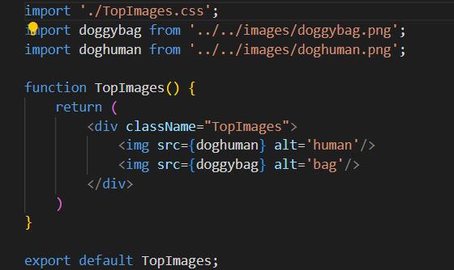

Next we had some fun with adding components and this is result:

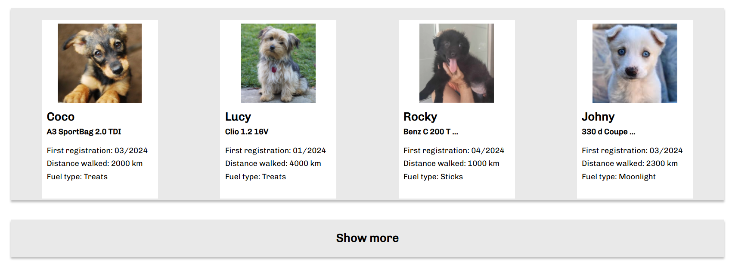

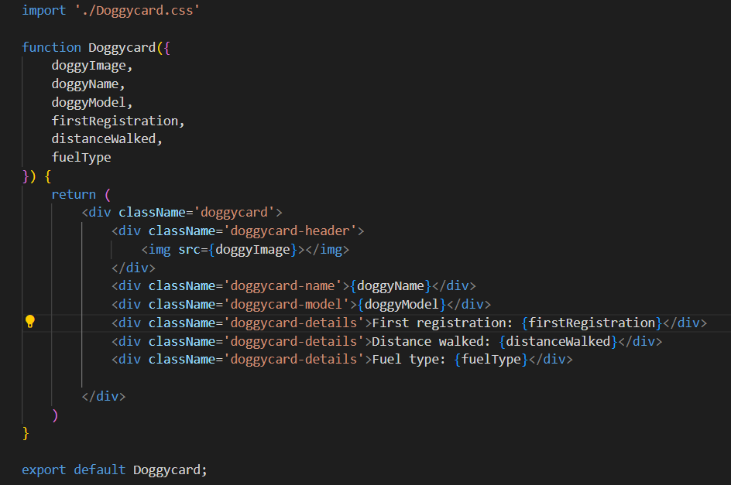

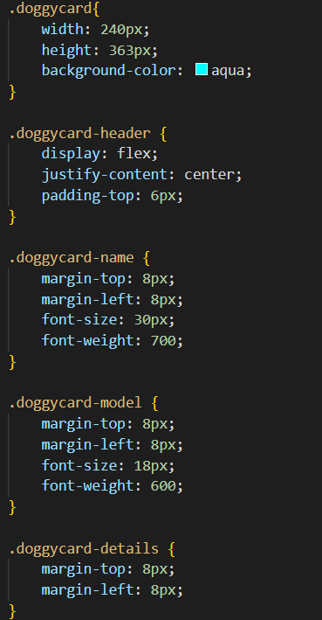

Next we did cool banner with puppy’s biography 😊

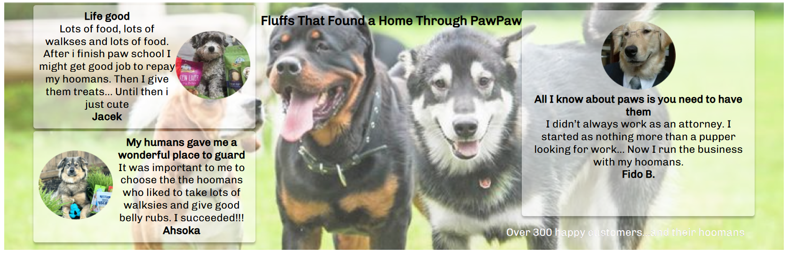

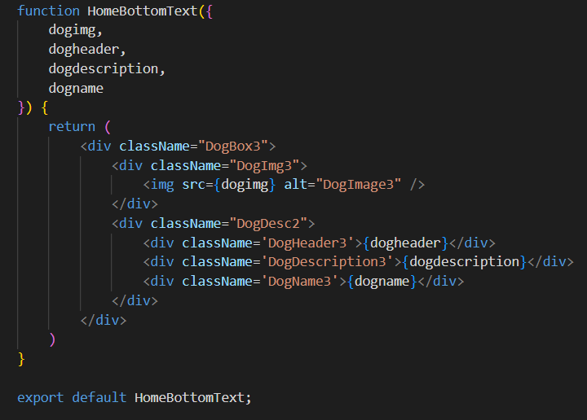

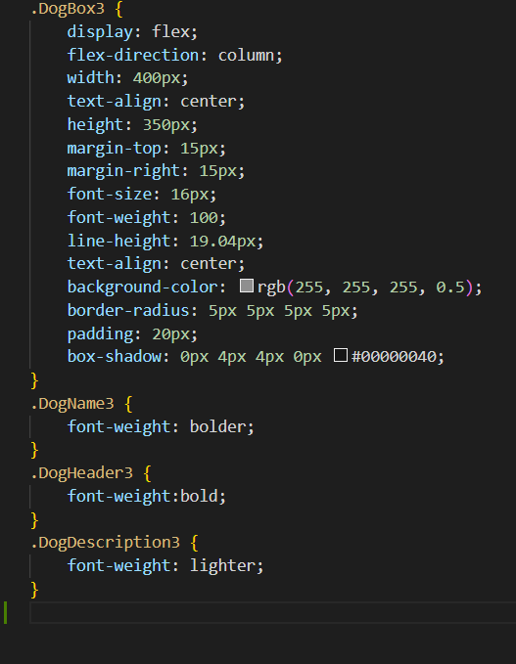

Then we did cool form with cool and handsome doggy (cool)

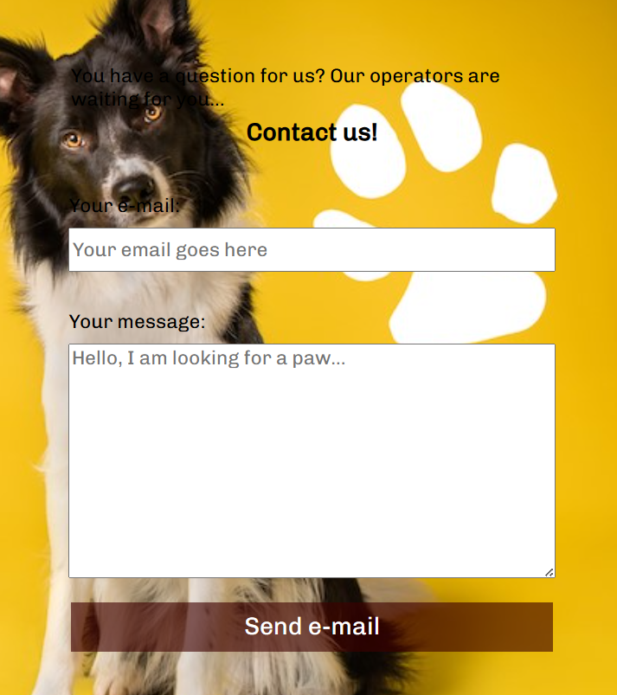

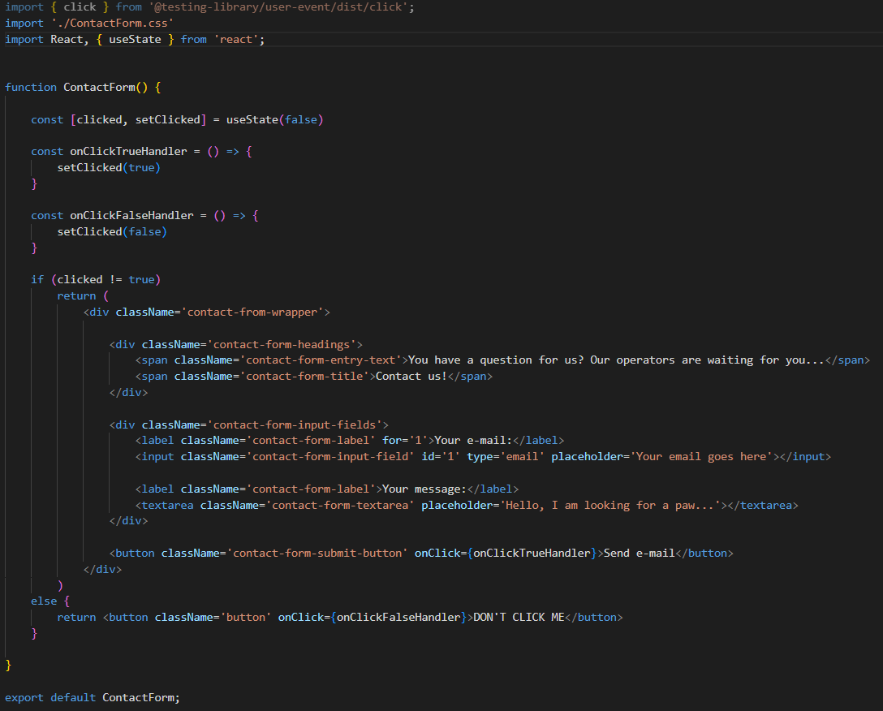

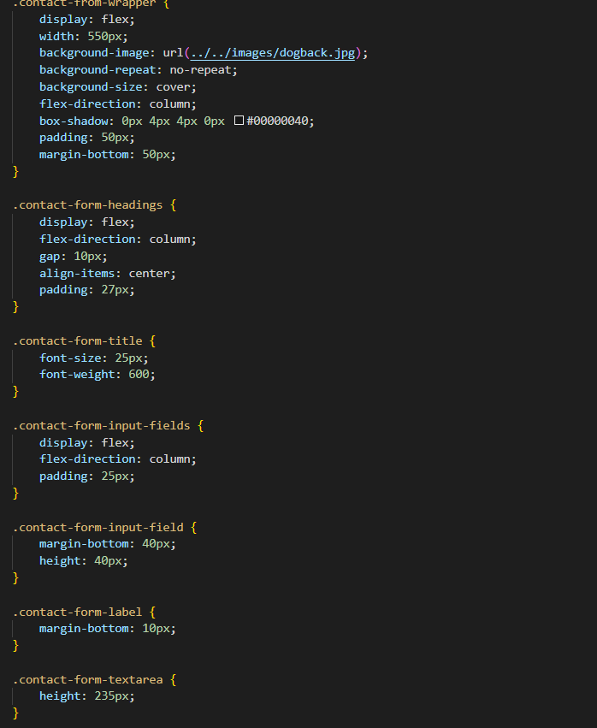

Finally we end by doing footer

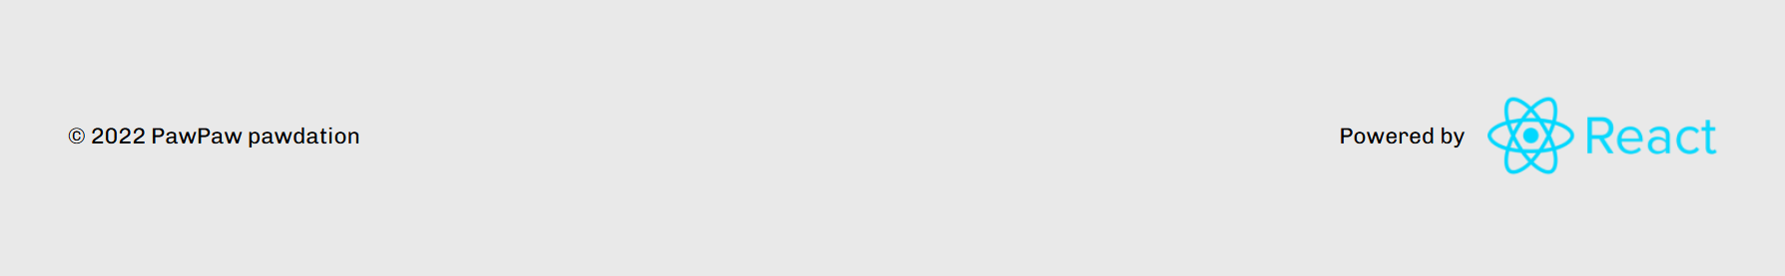

And that’s it. We learnt some react. Also we improved our skills in HTML, JS, and CSS.

It was cool adventure



Greetings from Kamil, Mateusz and Kacper from Tarnoszyn