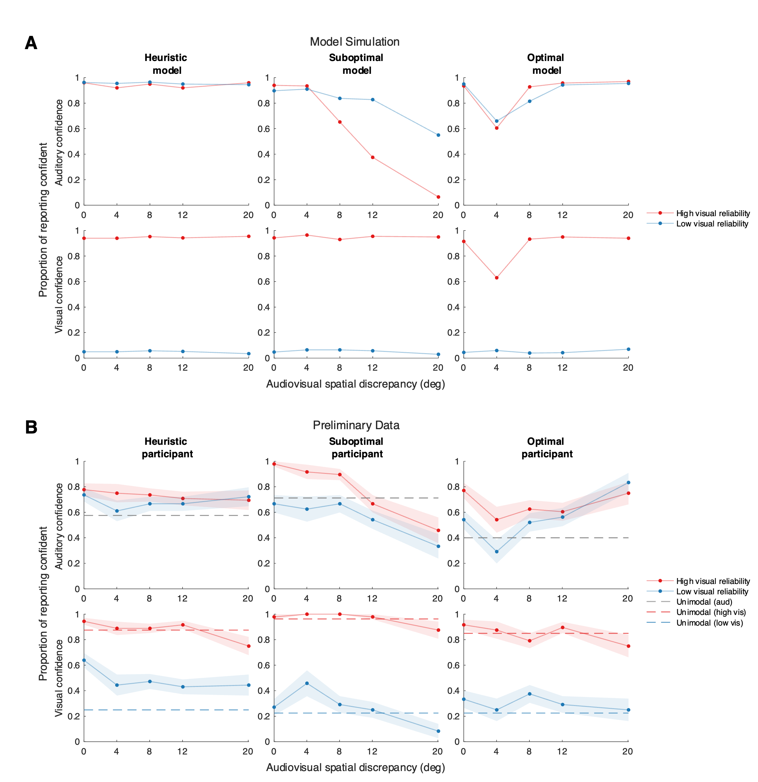

Figure 1. (A) Model simulation of auditory and visual confidence reports for the heuristic, suboptimal, and optimal models as a function of audiovisual spatial discrepancy and visual stimulus reliability. The heuristic model maintains a constant confidence level for auditory estimates, unaffected by audiovisual discrepancies, due to its sole reliance on auditory reliability. The suboptimal model shows monotonically decreasing auditory confidence as spatial discrepancy increases, attributed to an increasing probability of selecting the separate-causes scenario with greater variance. The optimal model yields a non-monotonic confidence trend, dipping at moderate discrepancies at which the model determines that both causal scenarios are approximately equally probable, analogous to a similar trend in the model's estimate of the variance of the posterior distribution of auditory location. (B) Preliminary data for three distinct participants, each aligning with the qualitative predictions of the respective models.