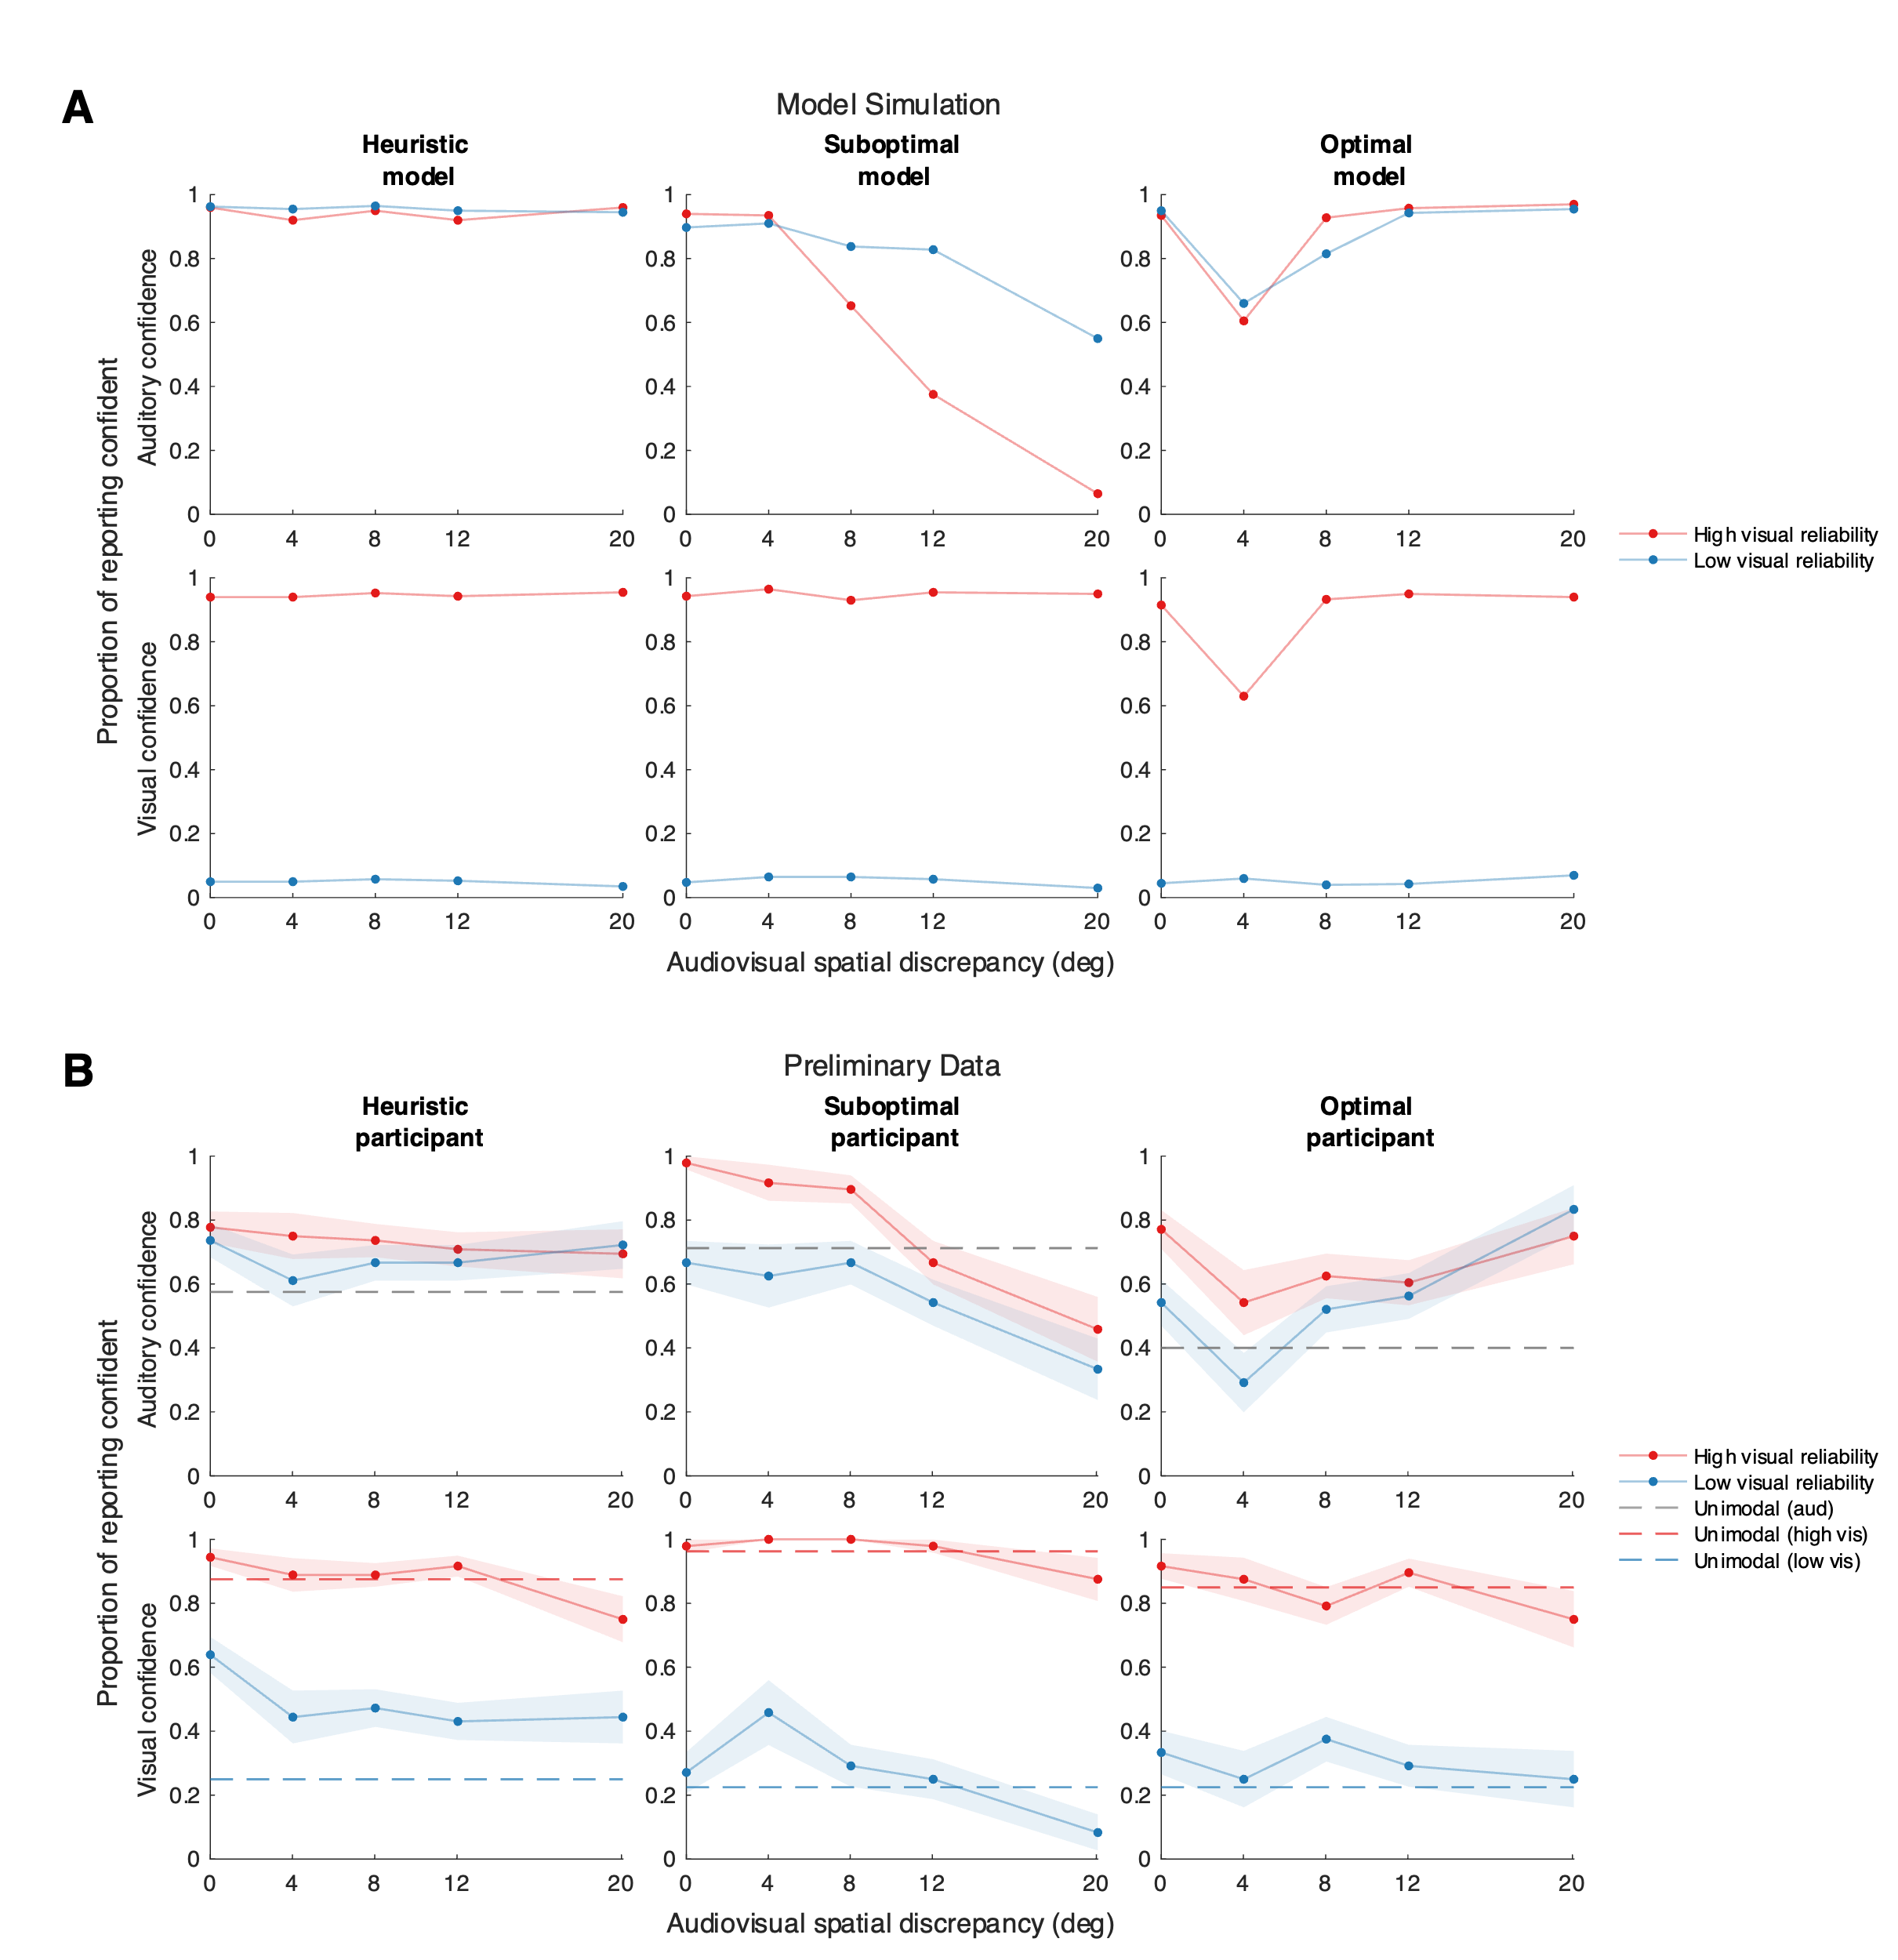

(A) Model simulation of confidence report. Three models make qualitatively different predictions on the auditory and visual confidence reports, modulated by audiovisual spatial discrepancy and visual stimulus reliability. (B) Preliminary data of three participants. The confidence reports of three participants are [], corresponding to the prediction of each model.