# BAB III ROTASI

## Pengertian dan Persamaan Rotasi

### Pengertian Rotasi

Rotasi atau perputaran suatu bangun geometri adalah proses memutar bangun geometri terhadap titik dan radius tertentu.

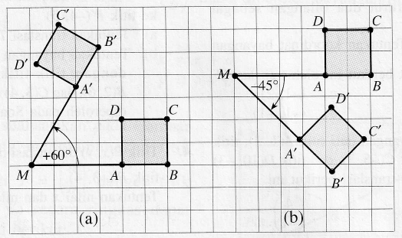

**Gambar 3.1** Ilustrasi Refleksi pada bangun geometri

### Persamaan Umum Rotasi

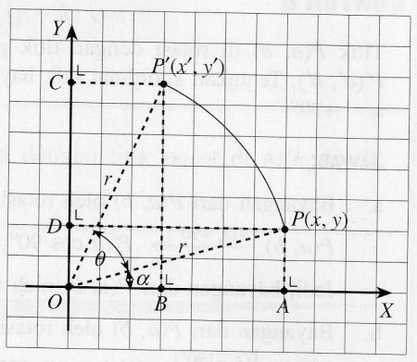

**Gambar 3.2** Refleksi Umum

Misalkan *P* terletak pada bidang kartesius dengan koordinat (*x*, *y*), ditulis *P*(*x*,*y*). Jika *P*(*x*,*y*) dirotasikan sejauh θ (dalam ukuran derajat atau radian) dengan titik pusat rotasi O(0,0) maka diperoleh bayangan titik titik *P*’ dengan koordinat (*x*’, *y*’) dapat dituliskan sebagai berikut:



dimana,



## Rotasi pada objek geometri

### Rotasi Titik

Jika titik *P* yang memiliki koordinat (*x*, *y*) diRotasikan , akan dihasilkan titik *P*’ dengan koordinat (*x*’, *y*’). Bayangan titik *P* oleh beberapa jenis rotasi disajikan pada Tabel 3.1 berikut:

**Tabel 3.1.** Daftar Rotasi Titik dari berbagai Jenis Rotasi

|  |  |  |  |  |
| --- | --- | --- | --- | --- |
| **No** | **Jenis Rotasi** | **Titik Asal** | **Titik Bayangan** | **Matriks** |
| 1 | atau | (*x*, *y*) | (-*y*, *x*) |  |
| 2 | atau | (*x*, *y*) | (*y*, *-x*) |  |
| 3 |  | (*x*, *y*) | …. | …. |
| 4 |  | (*x*, *y*) | …. | …. |

Contoh 3.1:

Tentukan bayangan dari titik *P*(1,4) oleh rotasi 

Penyelesaian:





Alternatif:



Dengan demikian bayangan titik *P*(1,4) oleh rotasi adalah *P*(-4,1)

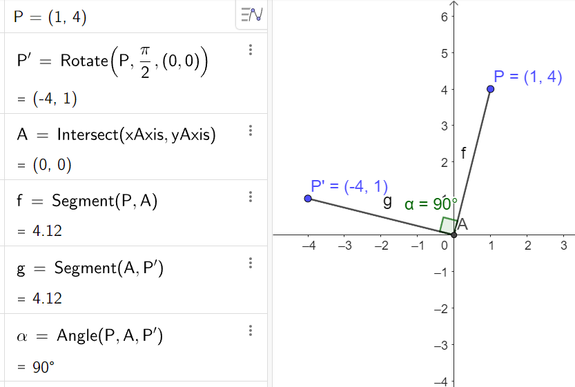

**Gambar 3.3** Rotasi Titik P(1,4) oleh R[O,90o]

### Rotasi Garis dan Kurva

Video provides a powerful way to help you prove your point. When you click Online Video, you can paste in the embed code for the video you want to add. You can also type a keyword to search online for the video that best fits your document.

To make your document look professionally produced, Word provides header, footer, cover page, and text box designs that complement each other. For example, you can add a matching cover page, header, and sidebar. Click Insert and then choose the elements you want from the different galleries.

### Rotasi Bidang

Video provides a powerful way to help you prove your point. When you click Online Video, you can paste in the embed code for the video you want to add. You can also type a keyword to search online for the video that best fits your document.

To make your document look professionally produced, Word provides header, footer, cover page, and text box designs that complement each other. For example, you can add a matching cover page, header, and sidebar. Click Insert and then choose the elements you want from the different galleries.

## Komposisi Rotasi

Video provides a powerful way to help you prove your point. When you click Online Video, you can paste in the embed code for the video you want to add. You can also type a keyword to search online for the video that best fits your document.

To make your document look professionally produced, Word provides header, footer, cover page, and text box designs that complement each other. For example, you can add a matching cover page, header, and sidebar. Click Insert and then choose the elements you want from the different galleries.