Avazu Native Ad SDK Setup for Android

|  |  |  |  |
| --- | --- | --- | --- |
| Date | Version | Description | Developer |
| 2017.03.27 | V2.2.5 | Improve Appwall | Hongwu Lu |
|  |  |  |  |
|  |  |  |  |

Content

1.Introduction 3

1.1 SDK Introduction 3

1.2 Compabability 3

2. Configuration 3

2.1 Traffic Source ID 3

2.2 Import Appwall SDK 3

2.3 Proguard configuration 4

3. Show App Market 4

3.1 Intialize SDK 4

3.2 Configration 5

3.3 Preload market data 7

3.4 Start App Market 7



1.Introduction

1.1 SDK Introduction

* This SDK provide you simple API to show APP martet to end users, and help app developers to get revenue from the user’s download and install.

1.2 Compabability

Suport Android 2.2 & API Level > 8

2. Configuration

2.1 Traffic Source ID

Make sure you have registered on Avazu APX, and got valid SDK traffic source ID. You may consult your AM for this.

2.2 Import Appwall SDK

List：

* avazu_common-<version>.aar
* avazu_appwall-<version>.aar

1. Copy aar files to your project:

* Copy avazu_common-<version>.aar and avazu_appwall-<version>.aar to the libs folder of your project，and compile it in gradle.
* Add below dependencies on your build.gradle：

compile 'com.google.code.gson:gson:2.8.0'

compile(name: avazu_common-<version>, ext: 'aar')

compile(name: avazu_appwall-<version>, ext: 'aar')

compile 'com.google.android.gms:play-services-ads:8.1.0' // Admob ad. If you don’t want show admob ad on App Wall, just ignore it.

Note：

1. If you need Facebook ad，please make sure you have AudienceNetwork.jar in you libs.

2.3 Proguard configuration

Add below rules in you proguard config：

// AVAZU appwall

-keep class nativesdk.ad.adsdk.** {*;}

-dontwarn nativesdk.ad.adsdk.**

-keep class nativesdk.ad.adsdkcore.** {*;}

-dontwarn nativesdk.ad.adsdkcore.**

3. Show App Market

We can show App Market by Activity or Fragment. The UI is like below ：

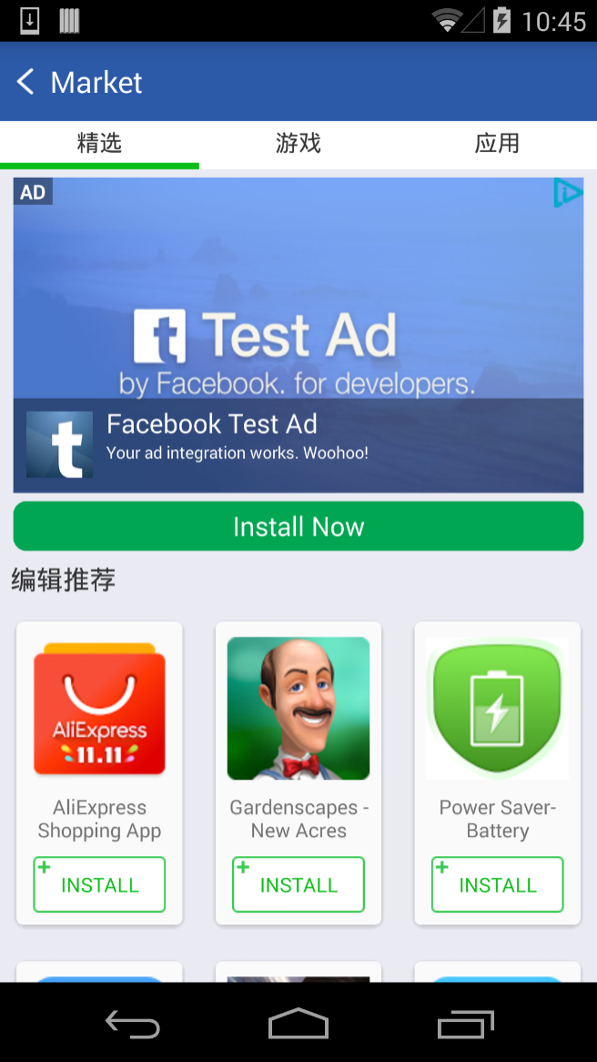

3.1 Intialize SDK

Call below method in your Application.onCreate：

|  |
| --- |
| Adsdk.initialize(Context context, String marketSourceId); |

Parameter：

* context: Application Context
* marketSourceId: Traffic Source Id

3.2 Configration

You can customize App Market according to your product requirement:

1. Set market name：

|  |
| --- |
| public static void setAppMarketName(Context context, String name) |

Parameter：

* context: Application context
* name: the name of your App Markte page

If not set , the default value is ：“Market”

2. Create shortcut of AppMarket

|  |
| --- |
| public static void createMarketShortcut  (Context context, Bitmap marketIcon, String marketName) |

Parameter：

* context: Application Context
* marketIcon: icon of market
* marketName: Name of market

3. Config App Market style:

|  |
| --- |
| public static void setMarketStyle  (Context context, HashMap<String, Integer> marketStyle) |

Parameter：

* context: Application context
* marketStyle : support to config below style. If set to 0 or not set, mean default value：
* TITLE_BACKGROUND_COLOR
* TITLE_TEXT_COLOR
* TITLE_BAR_HEIGHT
* TABLE_BACKGROUND_COLOR
* TABLE_TEXT_COLOR
* TABLE_BAR_HEIGHT
* TABLE_INDICATOR_COLOR
* DK_BUTTON_BACKGROUND_COLOR
* DK_BUTTON_TEXT_COLOR
* INSTALL_TEXT_BACKGROUND_DRAWABLE
* INSTALL_TEXT_COLOR
* WALL_STATUS_COLOR
* WALL_NAVIGATION_COLOR
* BACK_BUTTON_DRAWABLE
* APPWALL_BACKGROUND_COLOR
* SUBTITLE_TEXT_COLOR
* AD_TITLE_TEXT_COLOR
* AD_DESCRIPTION_TEXT_COLOR

Example：

|  |
| --- |
| Protected void onCreate(Bundle savedInstanceState) {  Adsdk.initialize(this);  setMarketStyle();  }  private void setMarketStyle() {  marketStyle.put(Constants.MarketStyle.TITLE_BACKGROUND_COLOR, R.color.white);  marketStyle.put(Constants.MarketStyle.TITLE_TEXT_COLOR, R.color.gray);  marketStyle.put(Constants.MarketStyle.TABLE_BACKGROUND_COLOR, R.color.white);  marketStyle.put(Constants.MarketStyle.TABLE_TEXT_COLOR, R.color.gray);  marketStyle.put(Constants.MarketStyle.DK_BUTTON_BACKGROUND_COLOR, R.color.black);  marketStyle.put(Constants.MarketStyle.DK_BUTTON_TEXT_COLOR, R.color.white);  marketStyle.put(Constants.MarketStyle.INSTALL_TEXT_BACKGROUND_DRAWABLE,  R.drawable.apx_appwall_adress_button_type1);  marketStyle.put(Constants.MarketStyle.INSTALL_TEXT_COLOR, R.color.gray);  marketStyle.put(Constants.MarketStyle.BACK_BUTTON_DRAWABLE, R.drawable.apx_appwall_adrss_ic_back);  marketStyle.put(Constants.MarketStyle.WALL_STATUS_COLOR, 0);  marketStyle.put(Constants.MarketStyle.WALL_NAVIGATION_COLOR, 0);  marketStyle.put(Constants.MarketStyle.APPWALL_BACKGROUND_COLOR, R.color.white);  marketStyle.put(Constants.MarketStyle.TITLE_BAR_HEIGHT, 0);  marketStyle.put(Constants.MarketStyle.TABLE_BAR_HEIGHT, 0);  marketStyle.put(Constants.MarketStyle.TABLE_INDICATOR_COLOR, R.color.light_gray);  marketStyle.put(Constants.MarketStyle.SUBTITLE_TEXT_COLOR, R.color.gray);  marketStyle.put(Constants.MarketStyle.AD_TITLE_TEXT_COLOR, R.color.gray);  marketStyle.put(Constants.MarketStyle.AD_DESCRIPTION_TEXT_COLOR, R.color.light_gray);  AdSdk.setMarketStyle(this, marketStyle);  } |

3.3 Preload market data

In order to optimize AD fill and launch speed of market，**strongly suggest developers to preload appwall data. It will have benefit on revenue**：

|  |
| --- |
| public static void preloadMarketData (Context context) |

Parameter：

* context: ApplicationContext

Example：

|  |
| --- |
| @Override  protected void onResume() {  super.onResume();  preloadMarketWall();  }  private void preloadMarketWall() {  AdSdk.enableFacebookAdInMarket(MainActivity.this, "your-fb-id"); // 若无，不添加  AdSdk.enableAdmobInMarket(MainActivity.this, "your-ad-id"); // 若无，不添加  AdSdk.preloadMarketData(this.getApplicationContext());  } |

3.4 Start App Market

We can launch App Marktet via Activity or Fragment

1. Launch with Activity：

|  |
| --- |
| public static void showAppMarket(Context context) |

2. Launch with Fragment：

Call below API at first:

|  |
| --- |
| public static void setMarketFragmentMode(Context context, boolean isFragmentMode) |

Parameter：

* context: Appliction Context
* isFragmentMode: true for fragment mode

Use below method to get fragment instance when you need

|  |
| --- |
| Fragment fr = new FeatureFragment(); |