Report on Discriminatory PointNet & PointNet++ Models

Summary
- Overview of datasets used and processing techniques.
- Exploration on discriminatory PointNet and PointNet++ model that are used in generative point cloud model. Results and comparison to literature.
- Next steps.

1 Datasets
All preprocessing steps are detailed in the README file from the GitHub repository.

ModelNet [1]
The dataset used is the ModelNet40_Normal_Resampled, the dataset features 40 classes with 9843 instances for training and 2468 instances for testing from ModelNet40. All models have normal annotations and are resampled to have uniform point density. Normal annotations can be dropped during dataset loading to only train the model on three coordinates (x, y, z). 10 classes can also be selected out to form ModelNet10. Data can be downloaded from Kaggle. The original datasets and aligned version can be downloaded from official website.
ModelNet40_Normal_Resampled
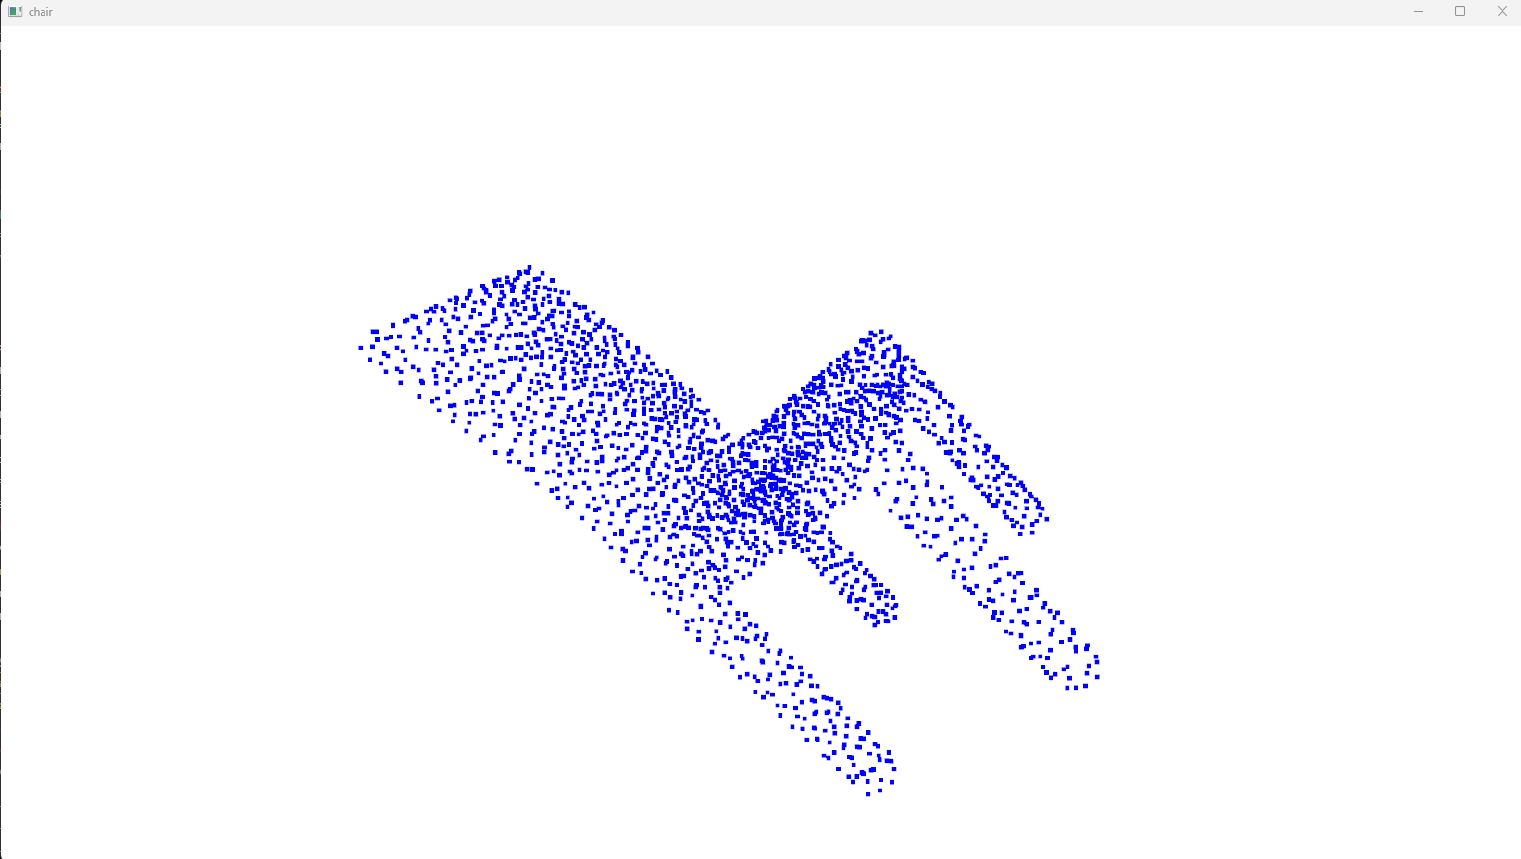 | 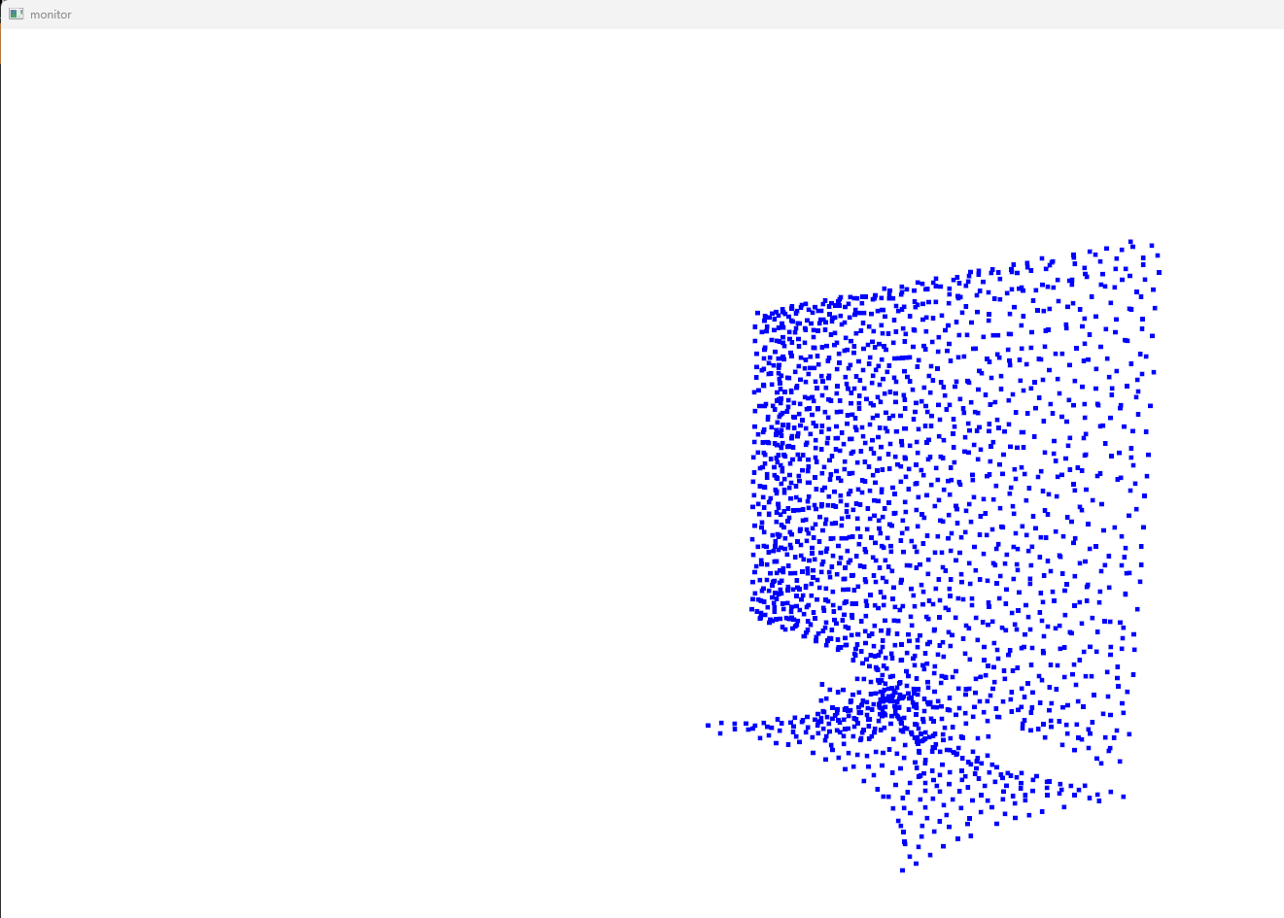

During the first run, it will take longer to preprocess data (around 60 minutes for both train and test at 2048 points), the generated .dat files will be used in subsequent runs to reduce overhead from processing.
ShapeNetCore [2]
The dataset used is the shapenetcore_partanno_segmentation_benchmark_v0_normal, the dataset features 16 classes with 12137 instances for training and 2874 instances for testing. All models have normal annotations. Normal annotations can be dropped during dataset loading to only train the model on three coordinates (x, y, z). Data can be downloaded from Kaggle.
shapenetcore_partanno_segmentation_benchmark_v0_normal
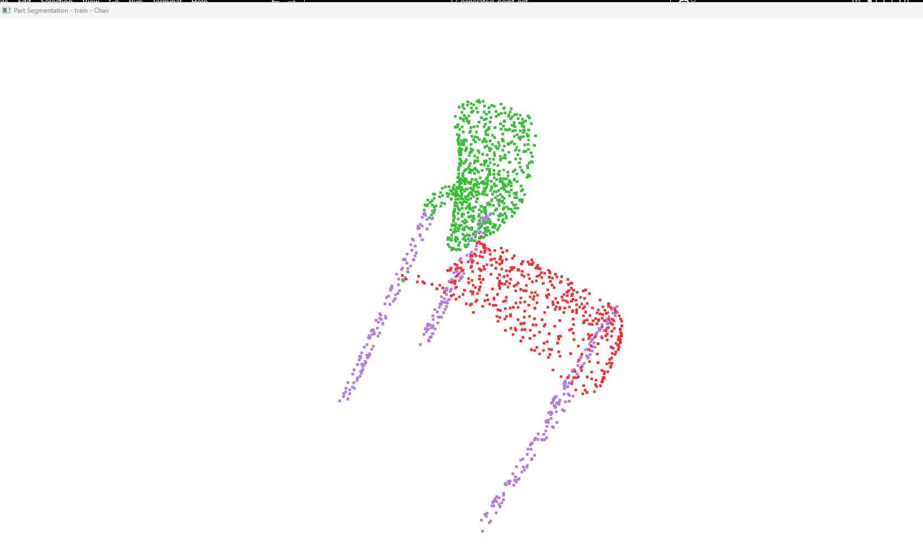 | 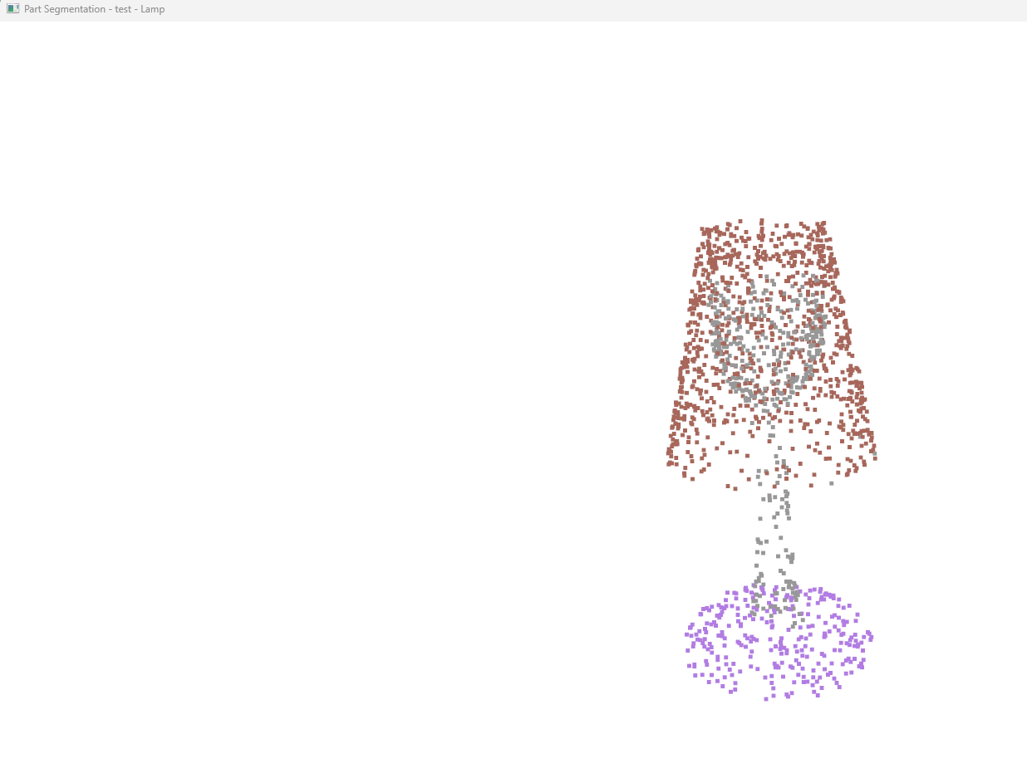

Stanford Large-Scale Indoor Spaces 3D Dataset (S3DIS) [3]
The dataset used is Stanford3dDataset_v1.2_Aligned_Version, the dataset consists of five large-scale indoor areas from three different buildings, each covering approximately 1900, 450, 1700, 870 and 1100 square meters (total of 6020 square meters). The areas have diverse architectural style and appearance, they include mainly office areas, educational and exhibition spaces, and conference rooms, personal offices, restrooms, open spaces, lobbies, stairways, and hallways, etc. Data can be downloaded after filling up the Google Form.
Stanford3dDataset_v1.2_Aligned_Version
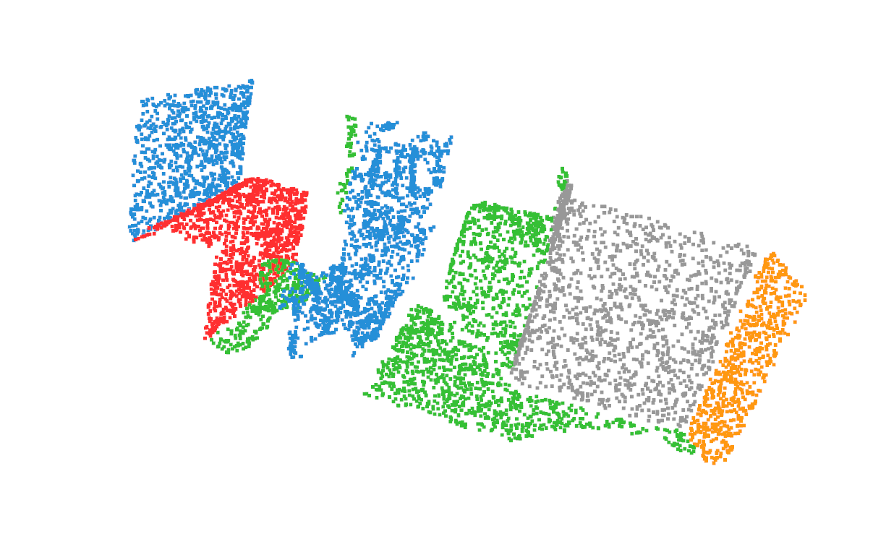 | 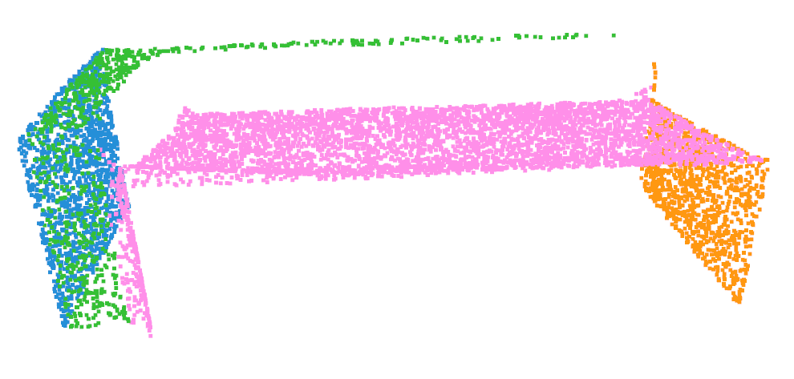

More samples are at appendix (j).

2 PointNet & PointNet++
Results
The PointNet [4] and PointNet++ MSG (multi-scale grouping) [5] are trained for 50 epoch only with 2048 points and batch size of 32. Plot of test accuracy against time at appendix (a) and appendix (b). Trained model weights at appendix (c).

- Classification on ModelNet10, logs at appendix (d)
Model | Details | Accuracy (%)
PointNet | PyTorch, only xyz | 92.78
 | PyTorch, with normal | 94.18
PointNet++ (MSG) | PyTorch, only xyz | 93.68
 | PyTorch, with normal | 94.61

- Classification on ModelNet40, logs at appendix (d)
Model | Details | Accuracy (%)
PointNet | Paper | 89.20
 | PyTorch, only xyz | 88.94
 | PyTorch, with normal | 90.38
PointNet++ (MSG) | Paper | 90.70
 | PyTorch, only xyz | 92.07
 | PyTorch, with normal | 92.34

- Part Segmentation on ShapeNetCore, logs at appendix (e)
Model | Details | Instance Avg IoU | Class Avg IoU
PointNet | Paper | 83.70 | 80.40
 | PyTorch, only xyz | 83.26 | 78.25
 | PyTorch, with normal | 83.93 | 80.46
PointNet++ (MSG) | Paper | 85.10 | 81.90
 | PyTorch, only xyz | 84.79 | 81.14
 | PyTorch, with normal | 85.13 | 82.16

- Semantic Segmentation on S3DIS, logs at appendix (f).
Model | Details | Overall Acc | Class Avg IoU
PointNet | Paper | 78.62 | 47.71
 | PyTorch | 79.79 | 43.03
PointNet++ (MSG) | Paper | N/A | N/A
 | PyTorch | 82.57 | 55.57

Sample outputs
Sample outputs can be found at appendix (g), appendix (h) and appendix (i).

Conclusion
Learning and exploration of the discriminative point cloud models are important because generative point cloud models are derived from [6] or contain encoder module that make use of discriminative model layers [7,8]. This is due to the properties 3D point cloud data – unordered, interaction among points, and invariance under transformation [1]. Therefore, a discriminative model that can reliably extract features from 3D point cloud data is crucial for the success of generating accurate and detailed point cloud data. Below is an example of semantic segmentation output from PointNet and PointNet++. It can be seen that PointNet++ can more reliably capture details of the scene and output correct semantic segmentation labels.

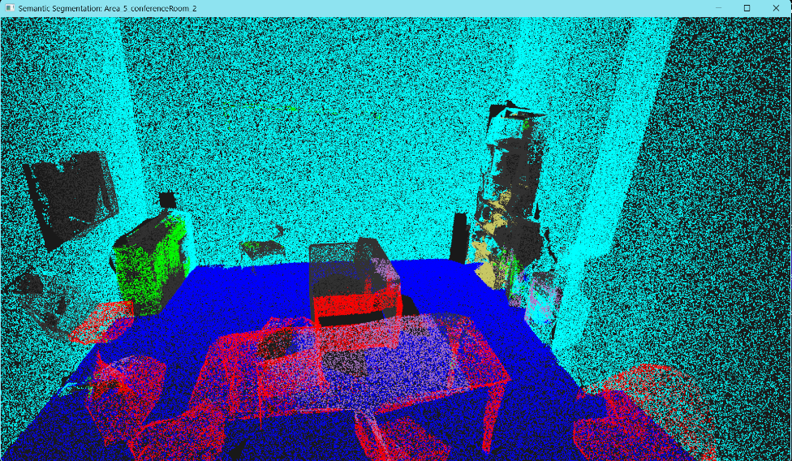
Figure 1: Semantic segmentation by PointNet of test Area 5 Conference Room 2
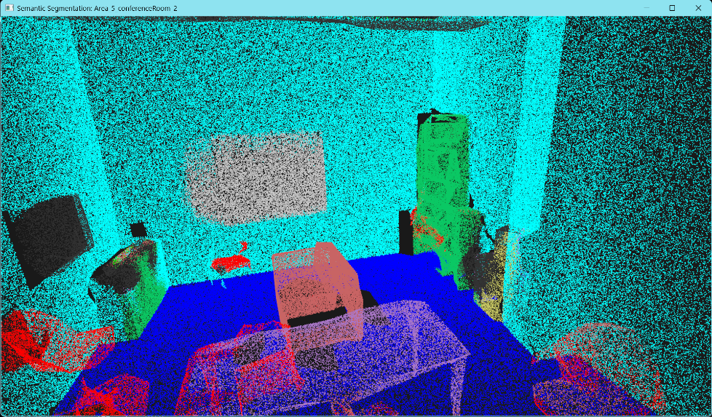
Figure 2: Semantic Segmentation by PointNet++ of test Area 5 Conference Room 2
This difference is due to the new techniques used in PointNet++, multi-scale grouping (MSG). By performing sampling (using farthest point sampling), grouping (of points within a Euclidean space of the point) and applying PointNet layer repetitively, it can progressively abstract larger and larger local regions. This improvement gained by applying different model architecture motivates further exploration into newer discriminative point cloud model architectures to form the generative point cloud model.

3 Next Steps
- Learning and experimenting with Generative PointNet [6].
- Obtaining and preprocessing scene (rural terrain and electrical transmission system) [12], indoor space [10,11], structures (exterior architectural structures) [13] datasets. List of 177 3D point cloud datasets for industry-specific applications [14].
- Exploring transformers in 3D point cloud models [9].
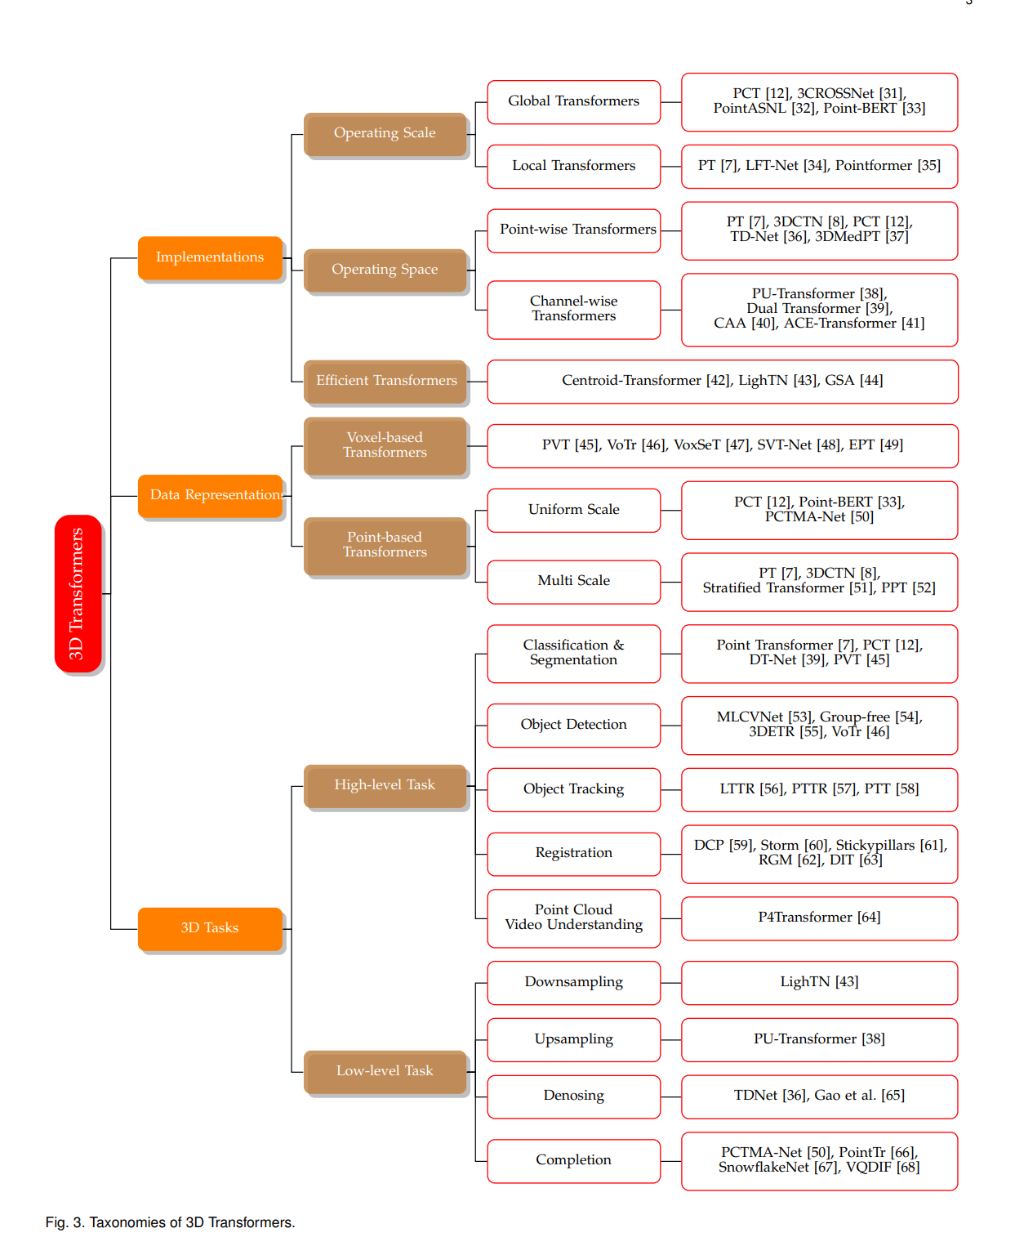

References
[1] Z. Wu et al., “3D ShapeNets: A Deep Representation for Volumetric Shapes,” arXiv:1406.5670 [cs], Apr. 2015, Available: https://arxiv.org/abs/1406.5670
[2] L. Yi et al., “A scalable active framework for region annotation in 3D shape collections,” ACM Transactions on Graphics, vol. 35, no. 6, pp. 1–12, Nov. 2016, doi: https://doi.org/10.1145/2980179.2980238
[3] I. Armeni et al., “3D Semantic Parsing of Large-Scale Indoor Spaces,” IEEE Xplore, Jun. 01, 2016. https://ieeexplore.ieee.org/document/7780539 (accessed Dec. 14, 2021).
[4] C. R. Qi, H. Su, K. Mo, and Guibas, Leonidas J, “PointNet: Deep Learning on Point Sets for 3D Classification and Segmentation,” arXiv.org, 2016. https://arxiv.org/abs/1612.00593
[5] C. R. Qi, L. Yi, H. Su, and Guibas, Leonidas J, “PointNet++: Deep Hierarchical Feature Learning on Point Sets in a Metric Space,” arXiv.org, 2017. https://arxiv.org/abs/1706.02413
[6] J. Xie, Y. Xu, Z. Zheng, S.-C. Zhu, and Y. N. Wu, “Generative PointNet: Deep Energy-Based Learning on Unordered Point Sets for 3D Generation, Reconstruction and Classification,” arXiv.org, 2020. https://arxiv.org/abs/2004.01301
[7] P. Achlioptas, O. Diamanti, I. Mitliagkas, and L. Guibas, “Learning Representations and Generative Models for 3D Point Clouds,” arXiv:1707.02392 [cs], Jun. 2018, Available: https://arxiv.org/abs/1707.02392
[8] G. Yang, X. Huang, Z. Hao, M.-Y. Liu, S. Belongie, and B. Hariharan, “PointFlow: 3D Point Cloud Generation with Continuous Normalizing Flows,” arXiv.org, 2019. https://arxiv.org/abs/1906.12320
‌[9] D. Lu, Q. Xie, M. Wei, K. Gao, L. Xu, and J. Li, “Transformers in 3D Point Clouds: A Survey,” arXiv.org, 2022. https://arxiv.org/abs/2205.07417
[10] “ScanNet,” ScanNet. http://www.scan-net.org/
‌[11] J. Walczak, “InLUT3D: Challenging real indoor dataset for point cloud analysis,” arXiv.org, 2024. https://arxiv.org/abs/2408.03338v1
‌[12] D. Lavado, C. Soares, A. Micheletti, R. Santos, A. Coelho, and J. Santos, “TS40K: a 3D Point Cloud Dataset of Rural Terrain and Electrical Transmission System,” arXiv.org, 2024. https://arxiv.org/abs/2405.13989v1
‌[13] K. L. Cheung and C. C. Lee, “ARCH2S: Dataset, Benchmark and Challenges for Learning Exterior Architectural Structures from Point Clouds,” arXiv.org, 2024. https://arxiv.org/abs/2406.01337v1
[14] Brett, “Master List of 177 Leading 3D Point Cloud Datasets for Industry-Specific Applications,” iMerit, Nov. 28, 2024. https://imerit.net/blog/master-list-of-177-leading-3d-point-cloud-datasets-for-industry-specific-applications/
‌

Appendix

PointNet Training
ModelNet10
Only xyz | With normal
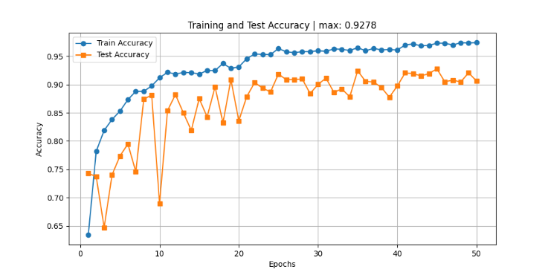 | 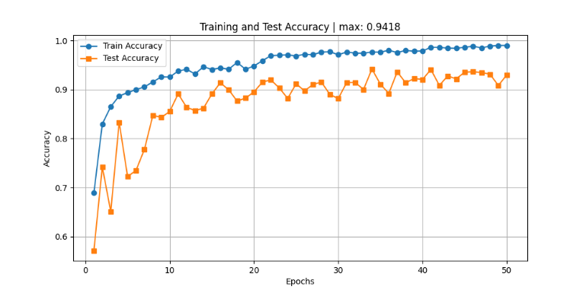

ModelNet40
Only xyz | With normal
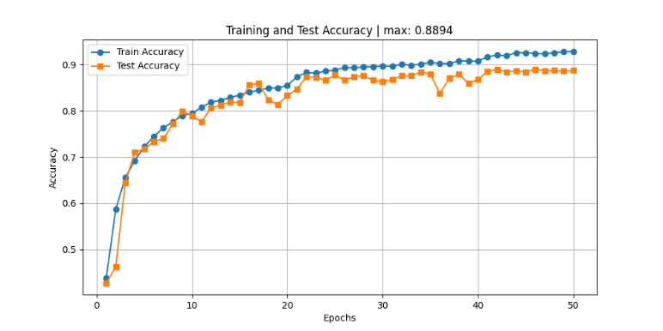 | 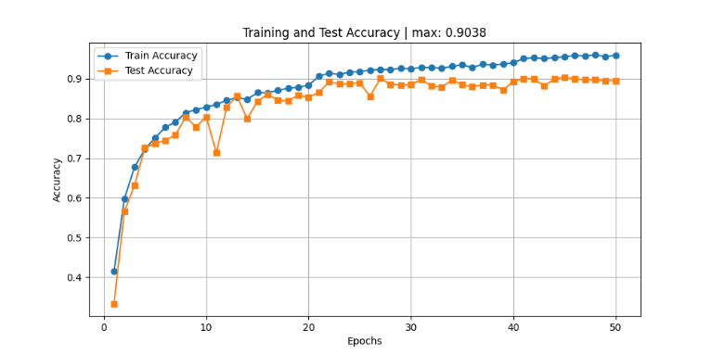

ShapeNetCore (part segmentation)
Only xyz | With normal
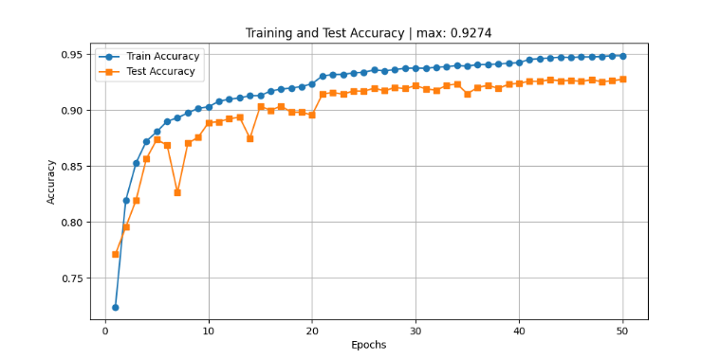 | 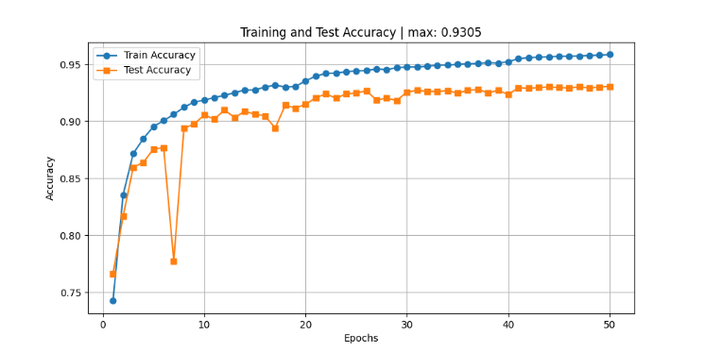

S3DIS (semantic segmentation)
PointNet | https://drive.google.com/drive/folders/1vGtvZFUbaXN_lFfHr0z3z1hiI1XiN8fH?usp=drive_link

PointNet++ Training
ModelNet10
Only xyz | With normal
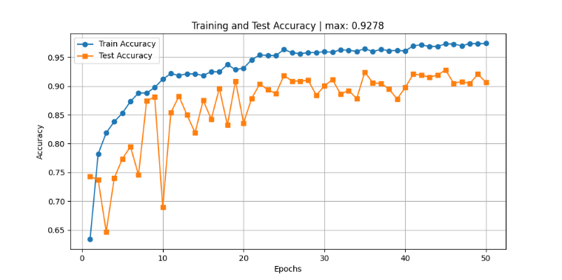 | 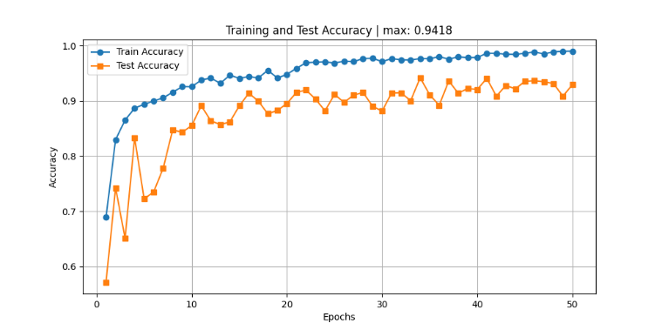

ModelNet40
Only xyz | With normal
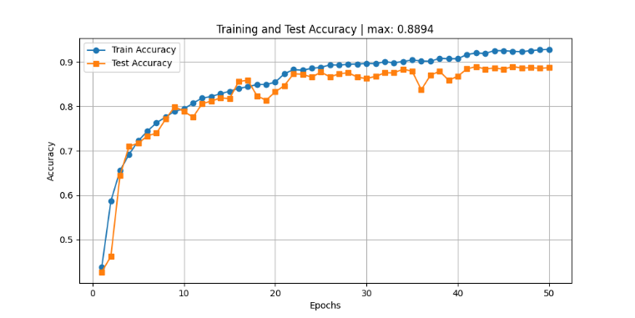 | 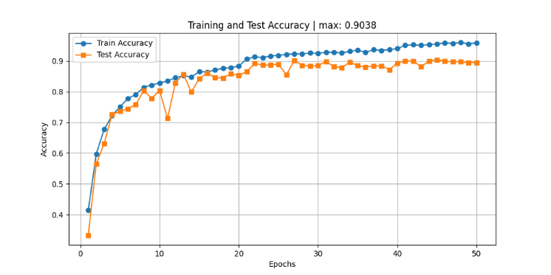

ShapeNetCore (part segmentation)
Only xyz | With normal
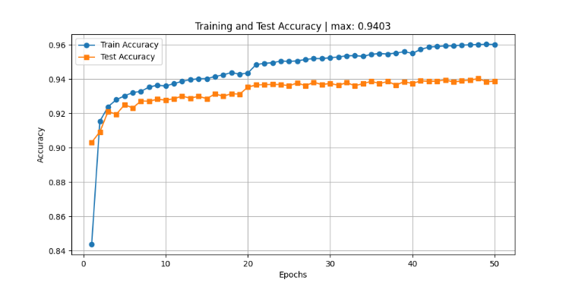 | 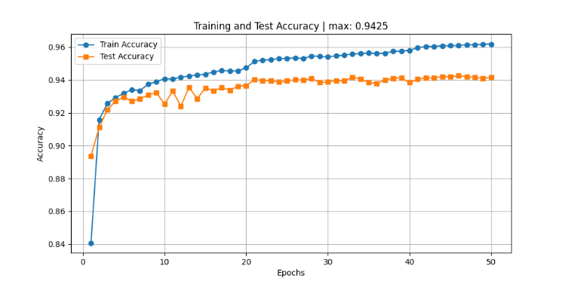

S3DIS (semantic segmentation)
PointNet++ | https://drive.google.com/drive/folders/1YHi2GkCNr3d94QG7-JYfkmzA0Lv86POi?usp=drive_link

Trained model weights
PointNet
ModelNet10 (xyz) | https://drive.google.com/file/d/1vg9PlzLc-8lH8pGVFjkeTe-HQkHiPoZ-/view?usp=sharing
ModelNet10 (xyz + normal) | https://drive.google.com/file/d/1t5fYOC92_6oIh7g_GSvTxkipnipYSn32/view?usp=sharing
ModelNet40 (xyz) | https://drive.google.com/file/d/1qKUTuDdPnP-rQ5ZZMmnUcAMtiPrnqs6u/view?usp=drive_link
ModelNet40 (xyz + normal) | https://drive.google.com/file/d/1ThMo1NaqIn1inWcn8tam73ZUnUhAx9o_/view?usp=sharing
ShapeNetCore (xyz) | https://drive.google.com/file/d/16JC6scMG_2xl2gw5zuED25k8aeCyXU-O/view?usp=drive_link
ShapeNetCore (xyz + normal) | https://drive.google.com/file/d/1TUFndlLGZ2r7Y0aJ7Q5PCICOX-9r3tu8/view?usp=sharing
S3DIS | https://drive.google.com/file/d/1wRI3DFu8fkjz1BD2NmmY8lK-Q1wQorUv/view?usp=drive_link

PointNet++
ModelNet10 (xyz) | https://drive.google.com/file/d/1kDQYkjuE2uCgki_mF3nmnAodQOkli_vl/view?usp=drive_link
ModelNet10 (xyz + normal) | https://drive.google.com/file/d/1yOM0gY00WL9jqB1qc1RD9-yOt4YL5pLm/view?usp=sharing
ModelNet40 (xyz) | https://drive.google.com/file/d/183Auoop7NOJvsTLi494ndBbirK58nvAC/view?usp=drive_link
ModelNet40 (xyz + normal) | https://drive.google.com/file/d/1LKGVVnu9UORx88Qc-hqgjTFcqr_Hui6u/view?usp=drive_link
ShapeNetCore (xyz) | https://drive.google.com/file/d/1xIasVRGiflhS_NVcsg7FIwmdrVg3qFxt/view?usp=drive_link
ShapeNetCore (xyz + normal) | https://drive.google.com/file/d/1sRr9cN-25yf59KVjBh86ngl9mxAC3IdF/view?usp=drive_link
S3DIS | https://drive.google.com/file/d/1eSd-tu9z9Jq4Jdw-6SROwsjIP6AcNkh3/view?usp=drive_link

Classification Train & Test Logs
PointNet
ModelNet10 (xyz) | https://drive.google.com/file/d/15DMX1f_fMHhaBYdBrL94ObubQoC12eAl/view?usp=drive_link
ModelNet10 (xyz + normal) | https://drive.google.com/file/d/1yBgTmkehNmhid2Dng2hjEl7uI9xBREkn/view?usp=drive_link
ModelNet40 (xyz) | https://drive.google.com/file/d/1sKl-C5UJnOyh4YbsF5X2rU5clhVV9u-7/view?usp=drive_link
ModelNet40 (xyz + normal) | https://drive.google.com/file/d/1zNX5Q6RDX2wFmNiPfawLZdteNrSqOLgN/view?usp=drive_link

PointNet++
ModelNet10 (xyz) | https://drive.google.com/file/d/1-JepNie7XD0abap2MeY0g326YMEOV8PH/view?usp=drive_link
ModelNet10 (xyz + normal) | https://drive.google.com/file/d/12d7M7mFkLFOCzqtBzOLuJRPZw7xIw6Rh/view?usp=drive_link
ModelNet40 (xyz) | https://drive.google.com/file/d/1XVSA28r8O08VljS7JPxrgkAXsEZDxHuh/view?usp=drive_link
ModelNet40 (xyz + normal) | https://drive.google.com/file/d/12fGh8oqgYVo15fjrPFcOEfE1cI6pSnas/view?usp=drive_link

Part Segmentation Evaluation Logs
PointNet (xyz) | https://drive.google.com/file/d/1xHT1e24Pb4nrycT4pSn72PYlSMmquVyv/view?usp=drive_link
PointNet (xyz + normal) | https://drive.google.com/file/d/1FqzLcwhti7HZYLdZ_iZnj014CkCeSnLo/view?usp=drive_link
PointNet++ (xyz) | https://drive.google.com/file/d/1njSag69sTdrV46QUhmZOYp0YH1Gh_6QU/view?usp=drive_link
PointNet++ (xyz + normal) | https://drive.google.com/file/d/1Tj27gbAD0VVu01kf1IPNeg5ZXh1v4E7M/view?usp=drive_link

Semantic Segmentation Evaluation Logs
PointNet | https://drive.google.com/file/d/1r5oUeKXBGzogxJnnowhXfUeutC-QnGM3/view?usp=drive_link
PointNet++ | https://drive.google.com/file/d/1JKHX2gKQltW23xYVLRECwugIALV6W7A-/view?usp=drive_link

Classification Sample Output
All samples only have xyz coordinates as input.
PointNet
ModelNet40:
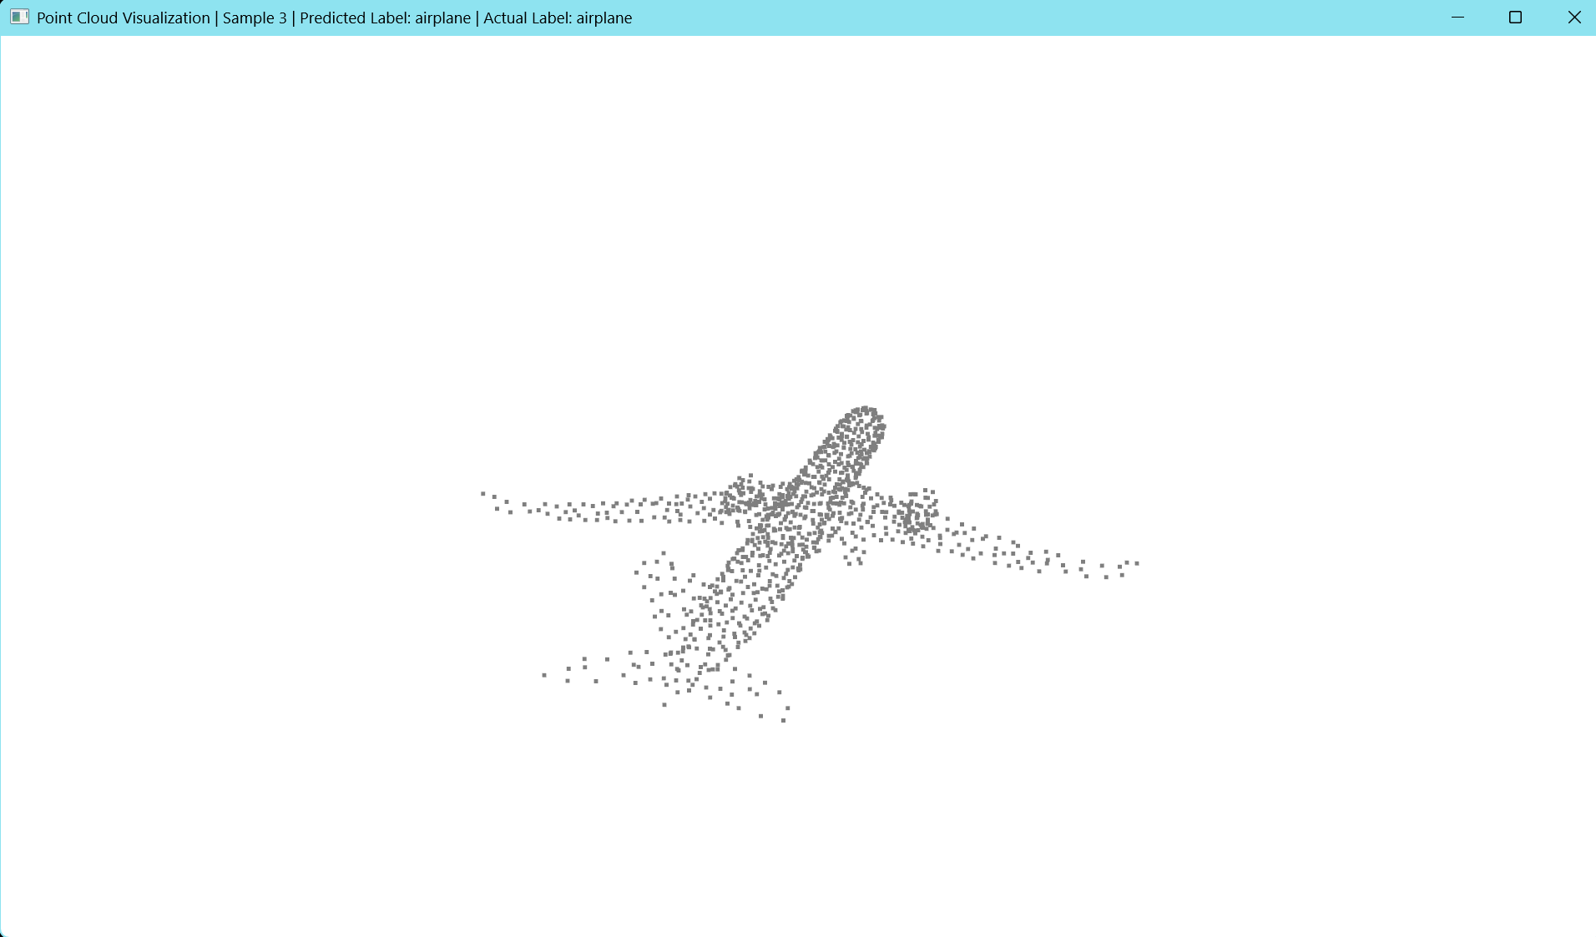
ModelNet40:
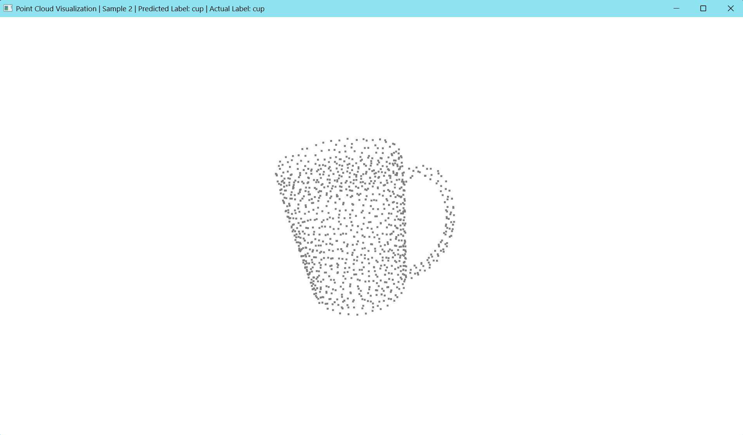

PointNet++
ModelNet40:
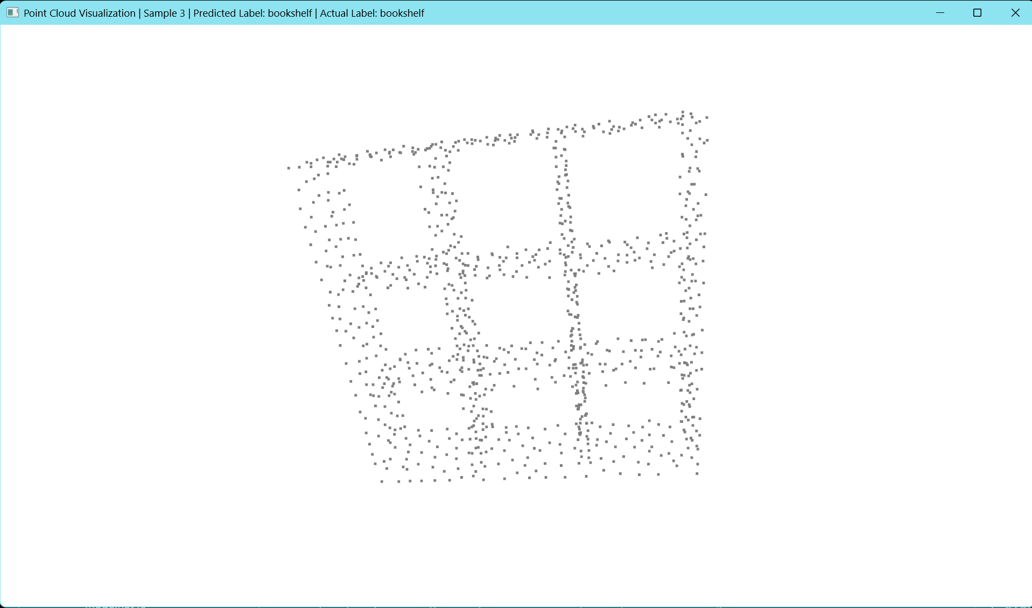
ModelNet40:
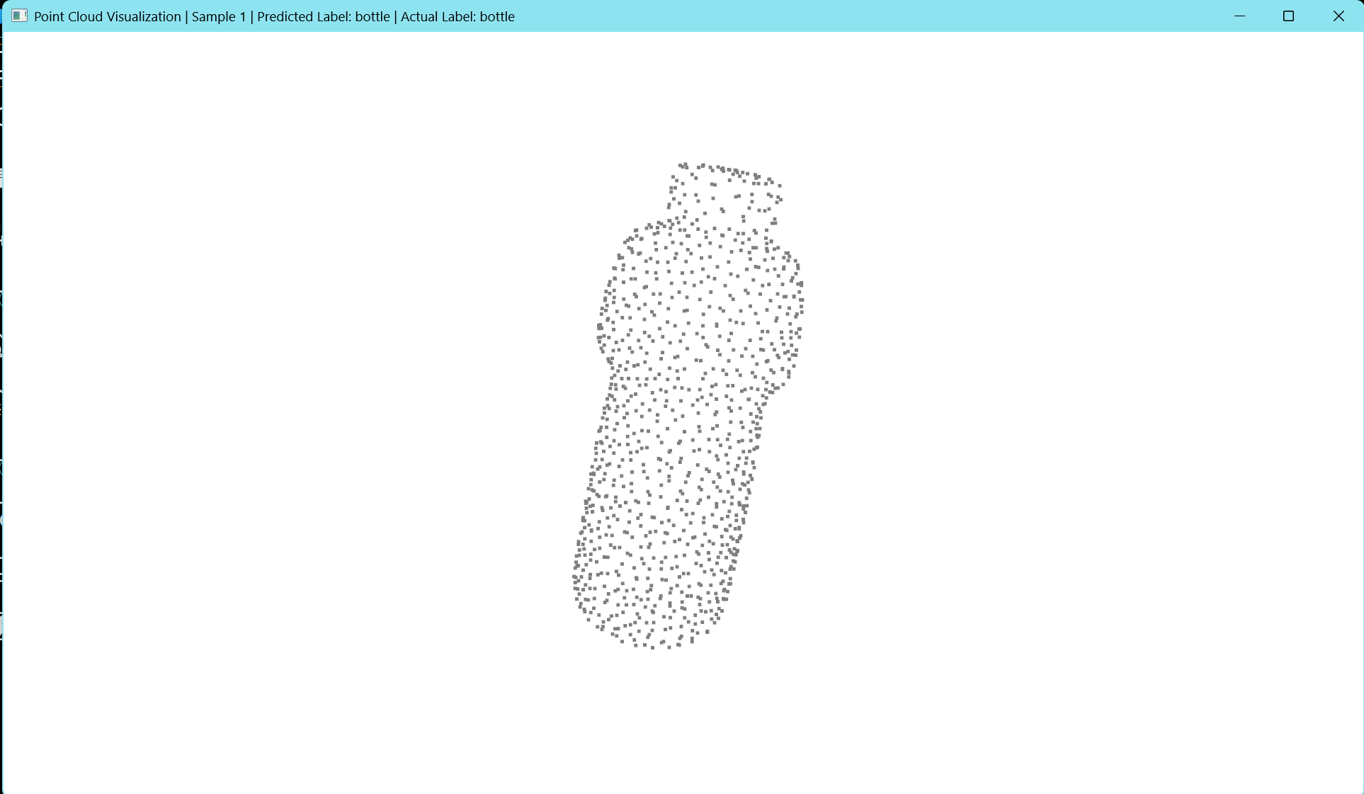

Part Segmentation Sample Output
All samples only have xyz coordinates as input.
PointNet
ShapeNetCore:
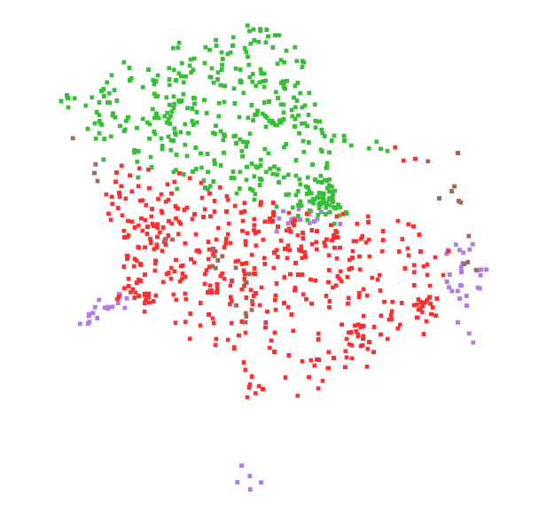
ShapeNetCore:
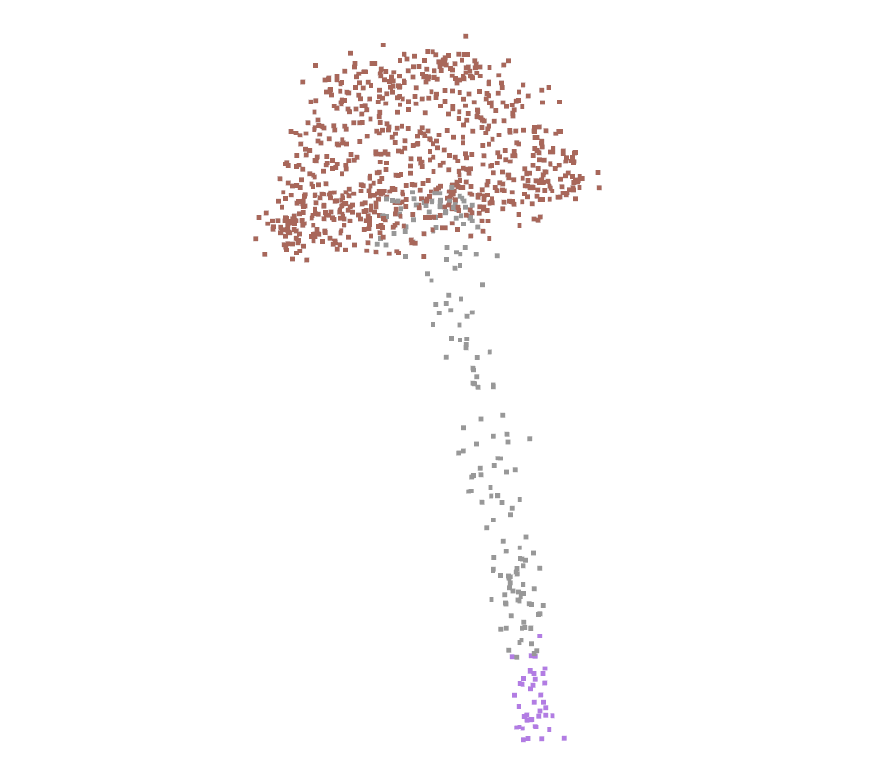

PointNet++
ShapeNetCore:
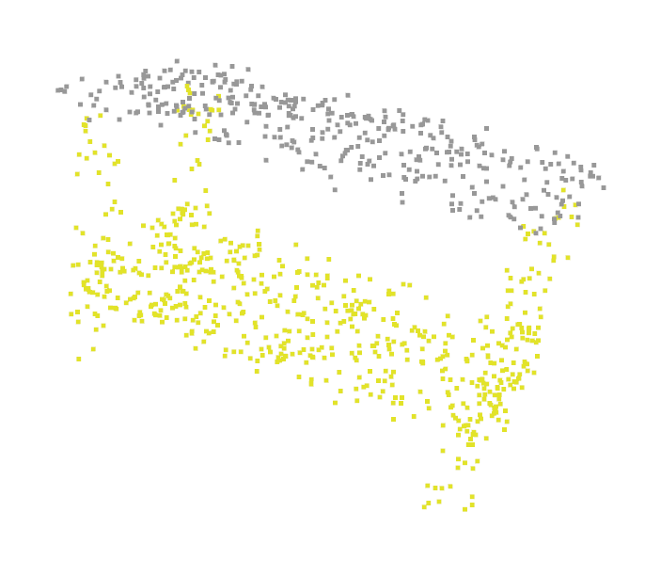
ShapeNetCore:
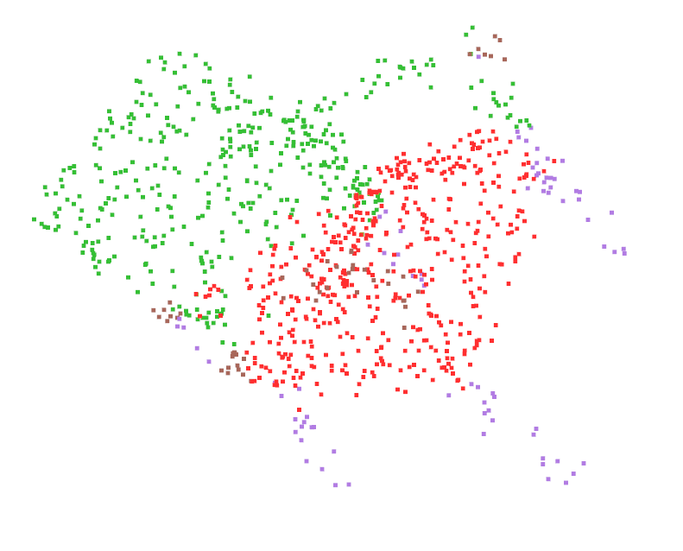

Semantic Segmentation Sample Output
PointNet
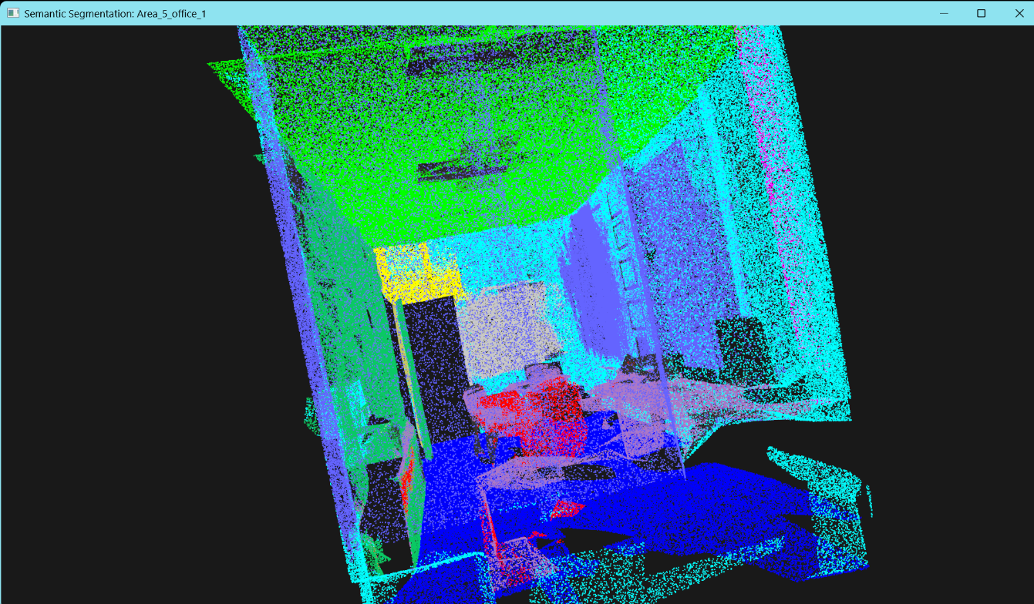
All outputs of Area 5 at: https://drive.google.com/drive/folders/1gsfv1N7rsgwIjSEkd3mB1KZWnUKlYyEG?usp=drive_link

PointNet++
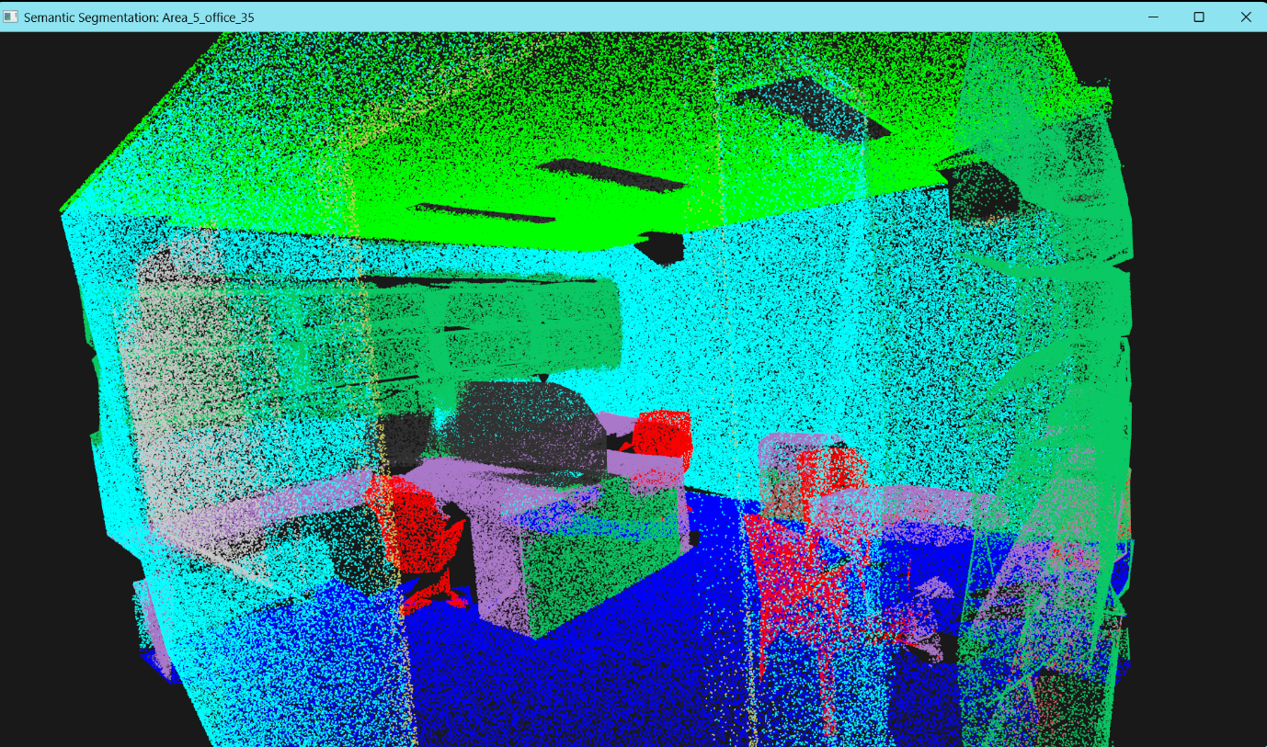
All outputs of Area 5 at: https://drive.google.com/drive/folders/1QWvTUuNznpOljbQ-fF6DU0PuBIYYi9rX?usp=drive_link

More Data Samples
ModelNet40
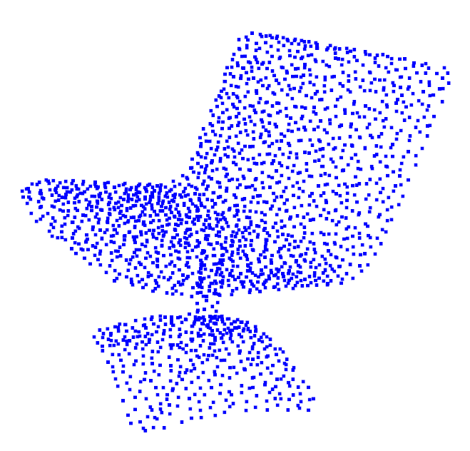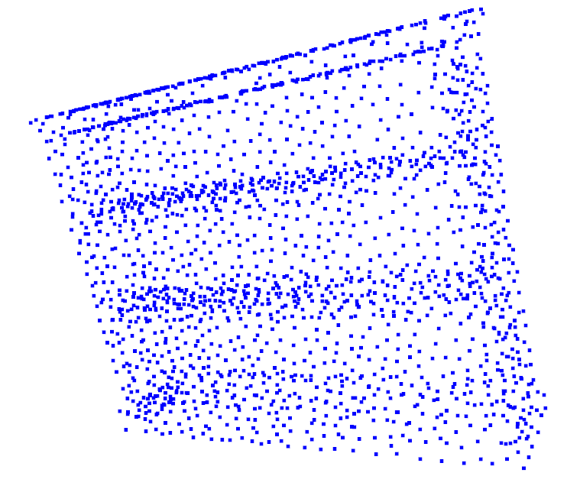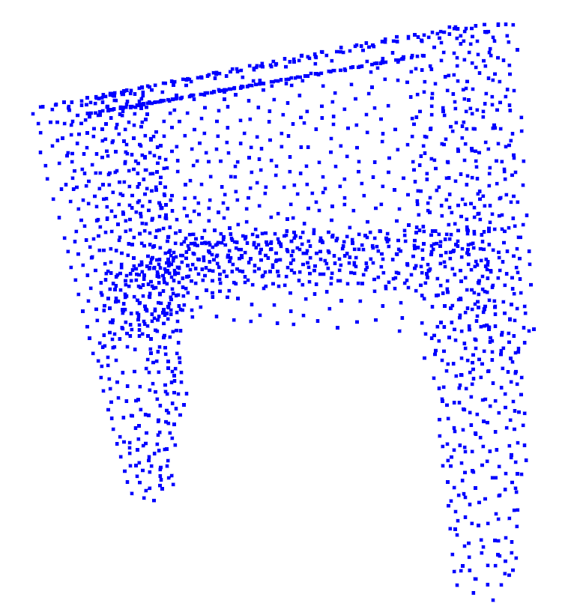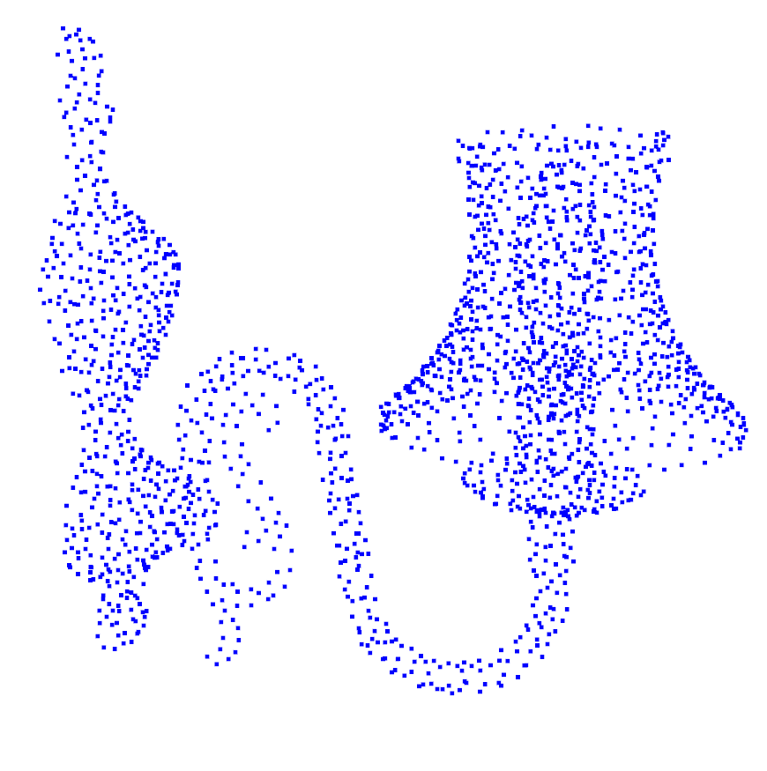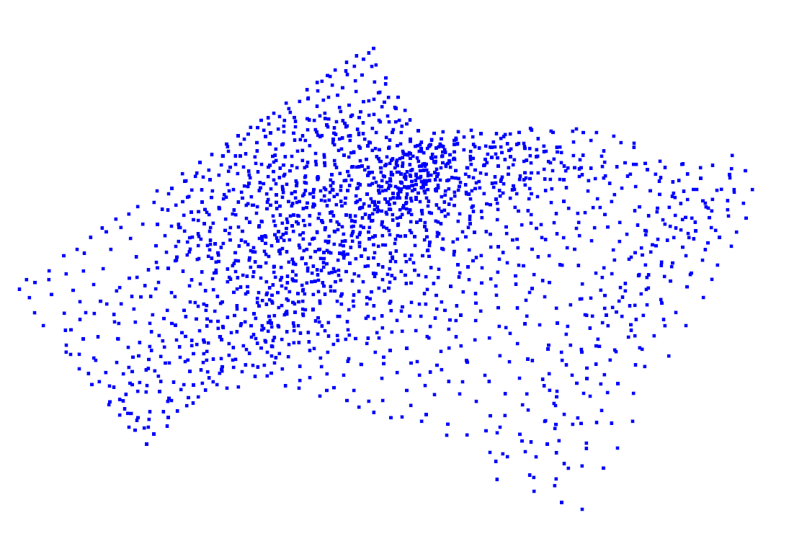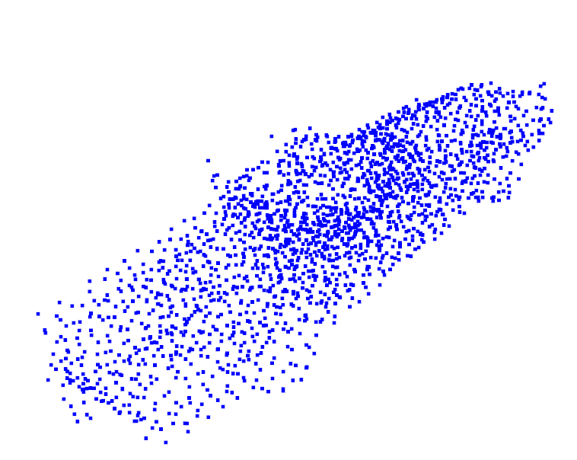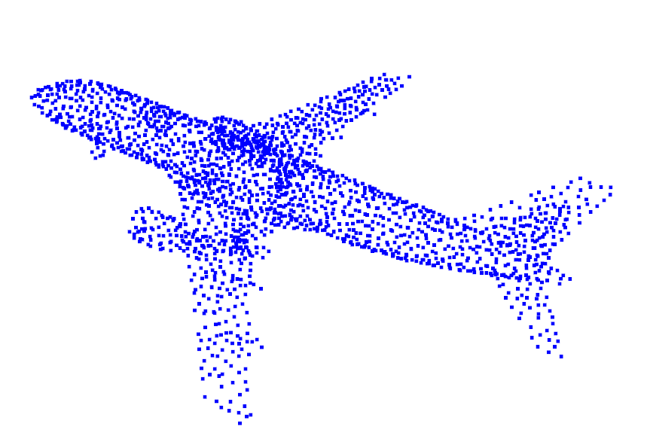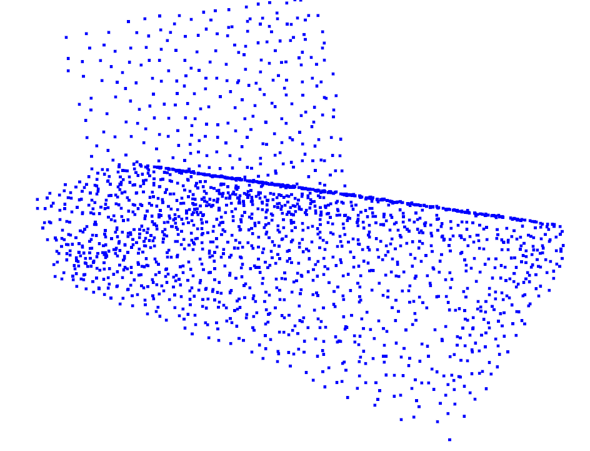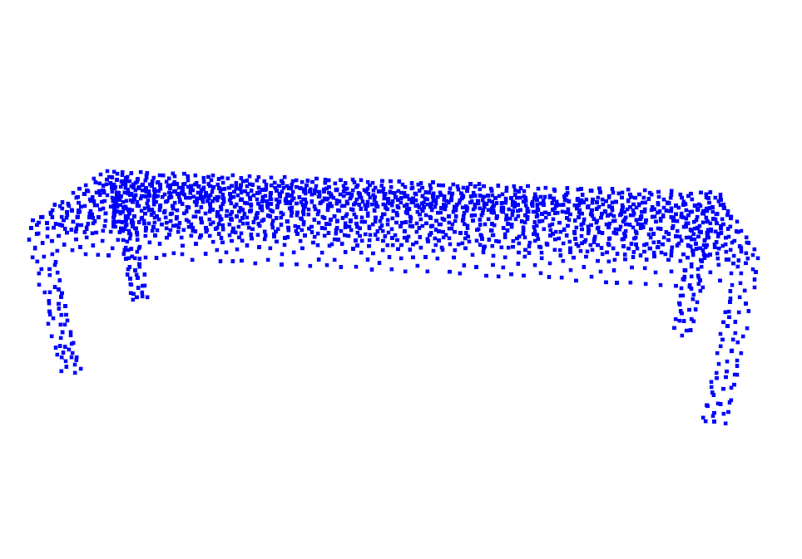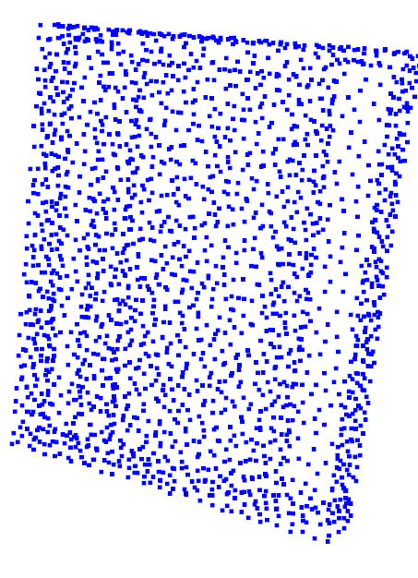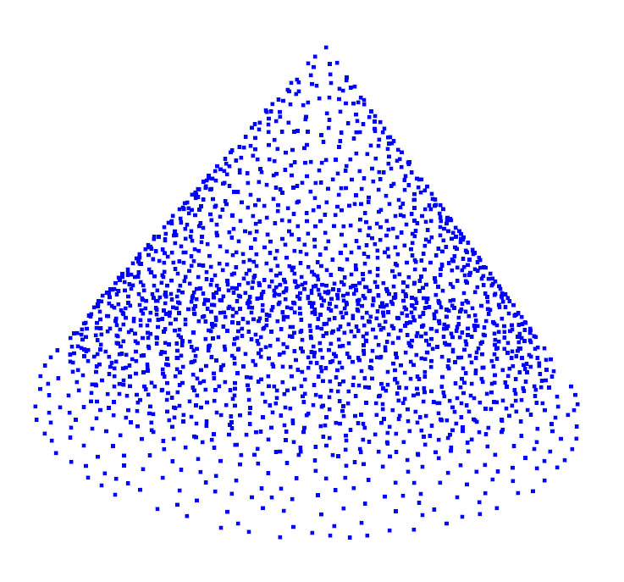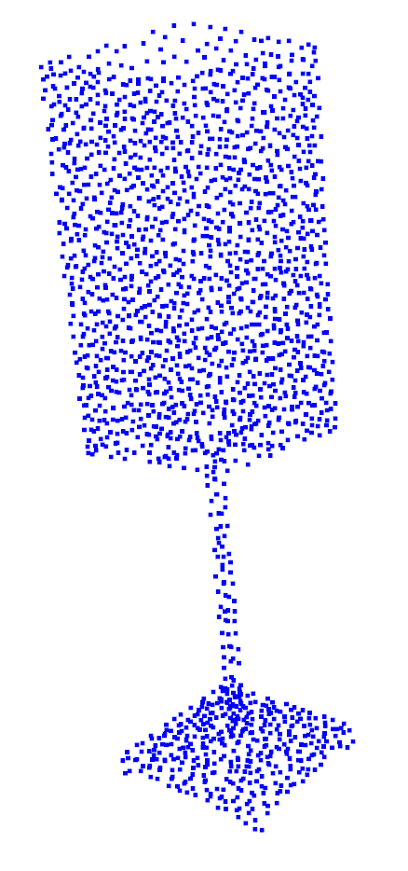

ShapeNetCore
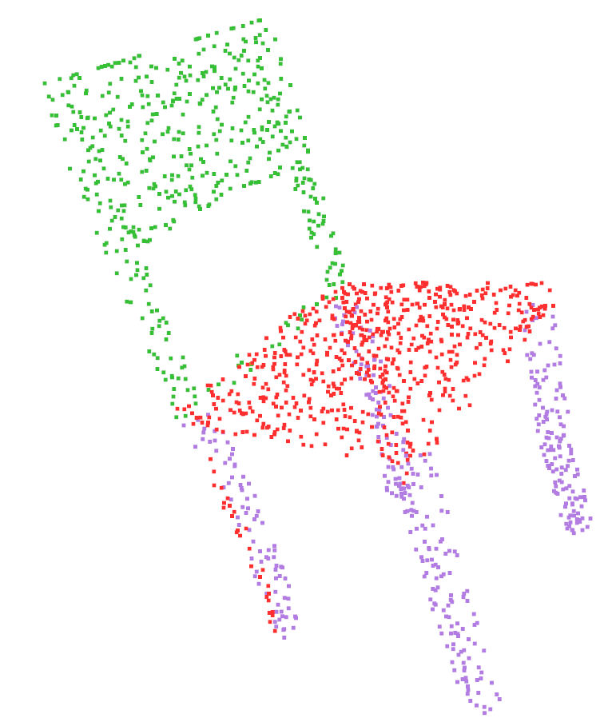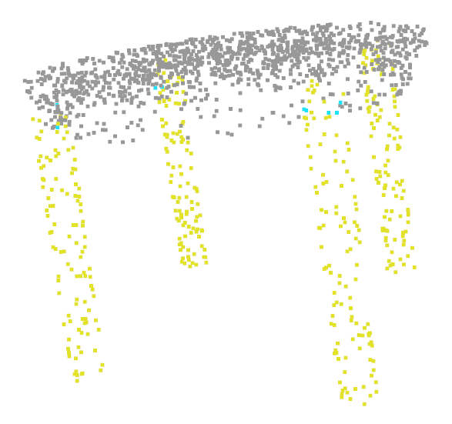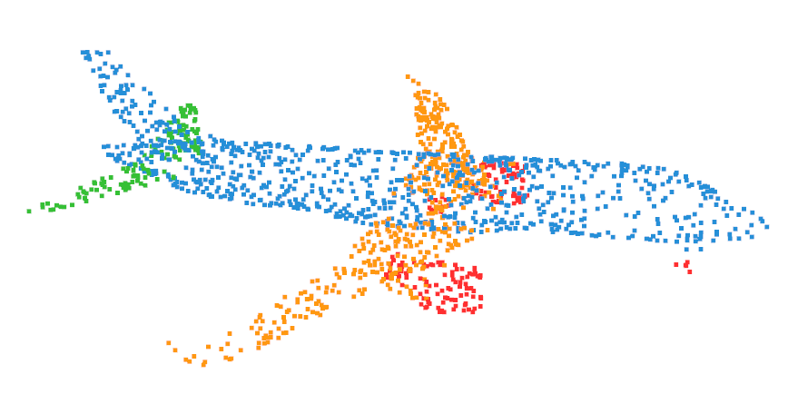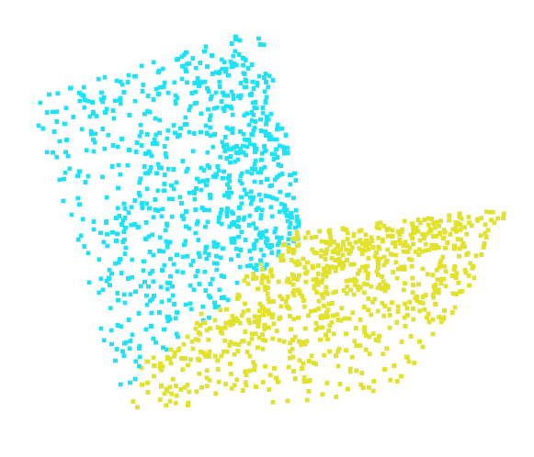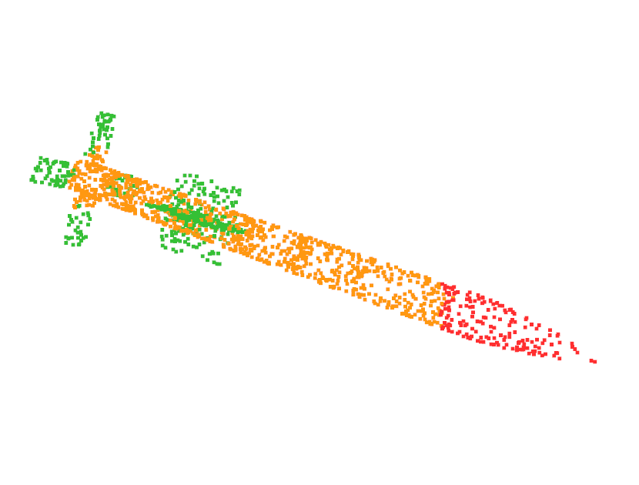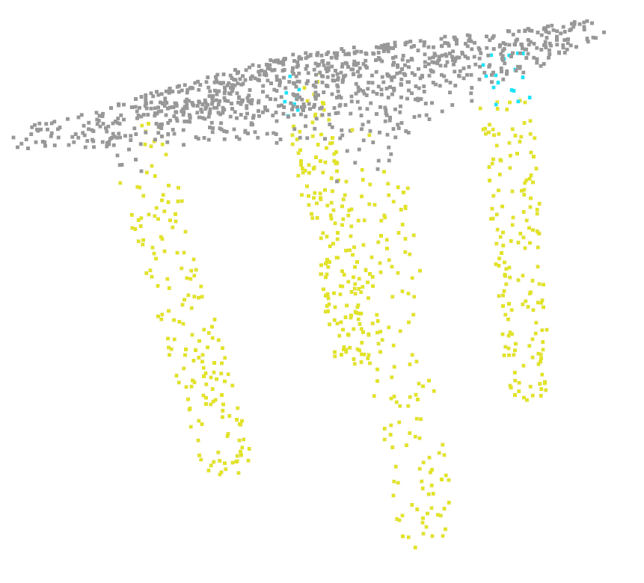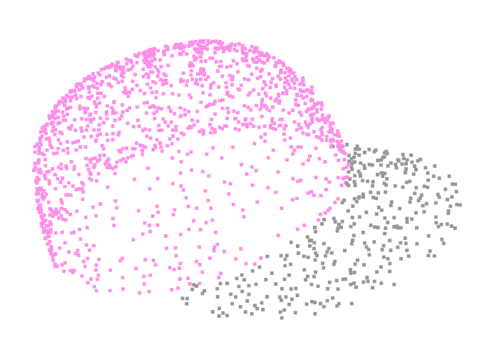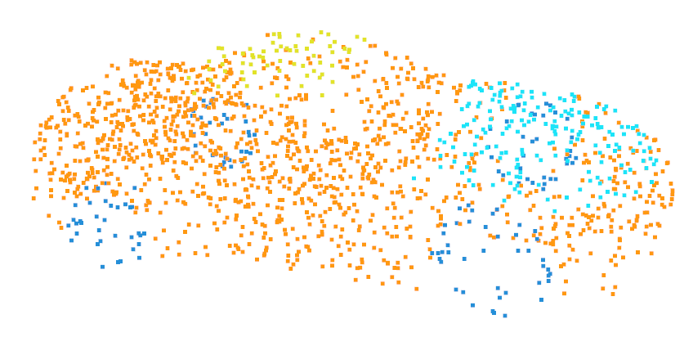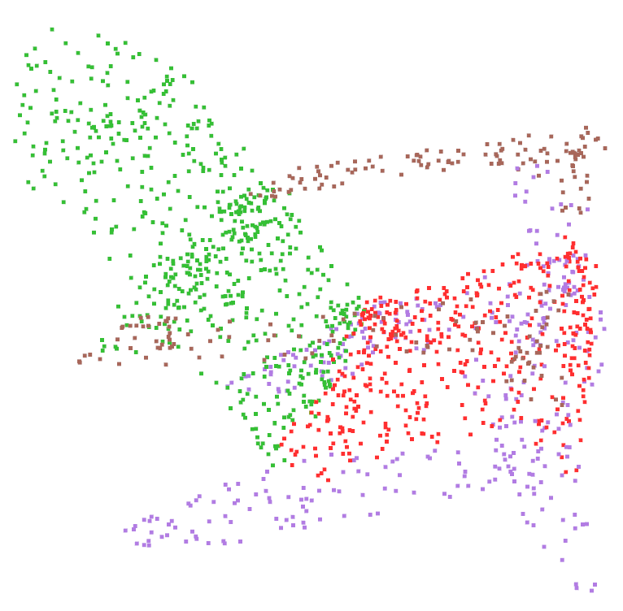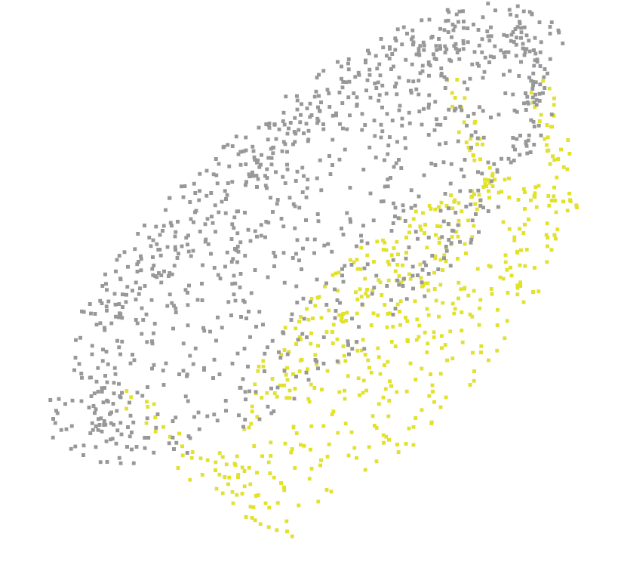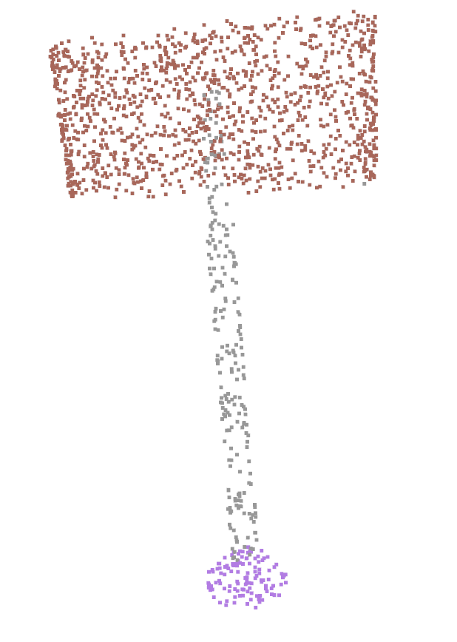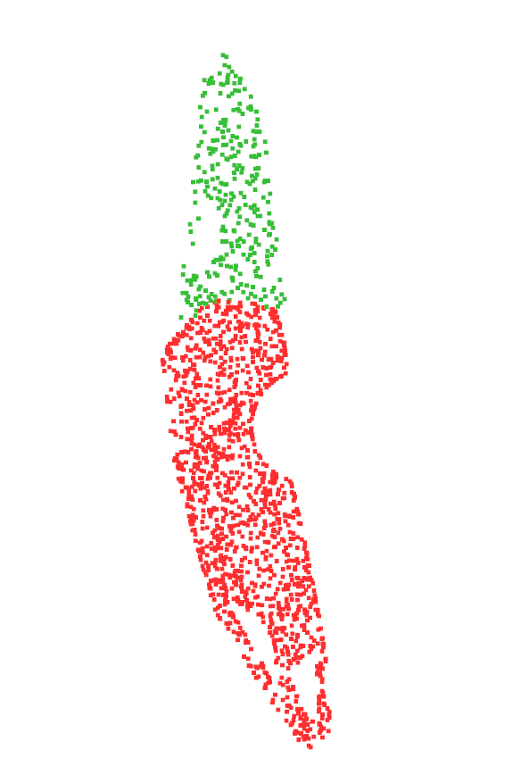

S3DIS
