1. 找到刷机软件包里的PRO_INFO.txt，如果没有请自行创建。

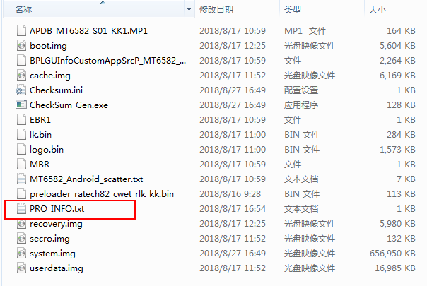

1. 根据以下屏对应表 ，找到相对应的屏序号，将屏序号写入PRO_INFO.txt文件中。

|  |  |  |  |  |  |  |  |  |
| --- | --- | --- | --- | --- | --- | --- | --- | --- |
| 日期 | 供应商 | 尺寸 | 分辨率 | IC | 玻璃 | 软件名 | 兼容软件名 | 屏序号 |
| 2016/11/4 | 勤康 | 10.1 | 800*1280 | JD9365 | CPT | K1001-800X1280-KANG1104-JD9365-CPT-161104(中性软件） | K1001_JD9365_CPT_161104 | 0 |
| 2017/10/13 | 鸿能海 | 10.1 | 800*1280 | JD9365 | BOE | K1001_800X1280_DC10127004_31Y_JD9365_BOE_171013 | K1001_JD9365_BOE_171013 | 1 |
| 2017/9/19 | 欧飞（飞鑫-刘蔡浩） | 10.1 | 800*1280 | JD9365 | BOE | K1001_800X1280_K101_IM2BA02_C_JD9365_BOE_170919 | K1001_JD9635_BOE_170919 | 2 |
| 2017/6/24 | 鸿能海 | 9.6 | 800*1280 | NT51017 | 华为 | K1001-800X1280-9.6WXBP096WX1-HUAWEI-SAMSUNG-170624 | K1001_9.6CUN_HUAWEI_SAMSUNG_170624 | 3 |
| 2017/6/25 | 鸿能海 | 9.6 | 800*1280 | NT51017 | 三星 |
| 2017/5/24 | 坤燃 | 10.1 | 800*1280 | JD9366 | 龙腾 | K1001-800X1280-AC10127004-JD9366-LT-170531 | K1001_JD9366_LT_170531 | 4 |
| 2017/11/2 | 勤康 | 10.1 | 800*1280 | JD9366 | 龙腾 |
| 2017/5/31 | 鸿能海 | 10.1 | 800*1280 | JD9366 | 龙腾 |
| 2017/5/23 | 威耀 | 10.1 | 800*1280 | NT35521S | 群创 | K1001-800X1280-WG10116942781ND-NT35521S-QC-170523 | K1001_NT35521S_QC_170523 | 5 |
| 益丰 |
| 鸿艺达 |
| 鹏信捷通 |
| 2017/8/3 | 华正-勤康 | 10.1 | 800*1280 | JD9364 | 群创 | K1001-800*1280-WJWX101067A-JD9364-QC-170803 | K1001_JD9364_QC_170803 | 6 |
| 2017/6/15 | 勤康 | 10.1 | 800*1280 | NT35521S | CPT | K1001-800*1280-ZB108-L10127-NT35521S-CPT-170615 | K1001_NT35521S_CPT_170615 | 7 |
| 2017/5/10 | 博大 | 10.1 | 800*1280 | JD9365 | AU | K1001-800X1280-P101NWWBP-JD9365-AU-170510 | K1001_JD9365_AU_170510 | 8 |
| 鸿能海 |
| 思强 |
| 2017/3/10 | 欧飞（飞鑫-刘蔡浩） | 10.1 | 800*1280 | JD9365 | AU/CPT | K1001_800X1280_K101_IM2CA02_B_JD9365_AU_170310 | K1001_JD9365_AU_170310 | 9 |
| 2018/9/8 | 鑫聚-易特 | 10.1 | 800*1280 | 奇景HX8260 | 翰彩 | K1001_800X1280_20811010280030XR101IC7S_HX8260_HC_180908 |  | 10 |
| 2017/9/22 | 酷米特-博天 | 10.1 | 800*1280 | NT35521S | CPT | K1001_800X1280_20811010280049_NT35521S_CPT_170922 |  | 11 |
| 2018/10/15 | 飞鑫 | 10.1 | 800*1280 | JD9365 | BOE-8.5代线 | K1001_800X1280_K101_IM2HA01_A_JD9365_BOE_181015 |  | 12 |
| 2018/11/2 | 新鹏-鸿基创 | 10.1 | 800*1280 | JD9364 | 群创 | K1001_800*1280_XPP140B239_JD9364_QC_181102 |  | 13 |
| 2018/11/28 | 谢翔羽-宏杰创 | 10.1 | 800*1280 | OTM1287A | AU | K1001_800X1280_SAT101AU40I28R1_OTM1287A_AU_181128 |  | 14 |
| 2018/12/13 | 新东方-鸿基创 | 10.1 | 800*1280 | JD9365 | 翰彩 | K1001_800X1280_HXH101_JD9365_HC_170905 |  | 15 |

1. 举例：如K1001-800X1280-KANG1104-JD9365-CPT-161104 就写一个数字 0

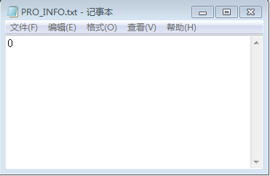

1. 映射文件路径 ，如下图

