**Lab 4**

**Inputting Data and Mapping**

In this lab, you will learn how to:

*Understand tabular formats for storing data

* Enter data from existing visualizations into Tableau

* Present visual summaries of defense data from several South American countries

**Storing Data in Tables**

Computer visualization packages such as Tableau can take in a variety of types of data. One of the most common ways to store data is in a table. This format works great when measuring the same **variables** for a variety of **observations**. An example is a dataset recording population and number of electoral votes for the 50 US states. Here, each state is an observation, and the variables recorded are population and electoral vote count.

When storing data in a table, each observation is recorded on its own row. Each column corresponds to a variable that is being measured. The first column is typically a name to identify the observation (state name or country name for example).

|  |  |  |  |
| --- | --- | --- | --- |
| **Name** | **Variable1** | **Variable2** | **Variable3** |
| Observation 1 | 3123 | 2 | 42 |
| Observation 2 | 31 | 420 | 17 |

Table :Storing data in a table. Here, we have two different observations. For each observation, three different variables are recorded.

Once data is in a table, it can be saved in a format that Tableau likes. Good formats to save as include Excel files (.xlsx) and comma-separated values (.csv). If you can put your data in a table and save it as one of these file types, you can make graphs with it in Tableau!

**Mapping**

**­**Tableau can make a variety of different types of maps, including choropleth and proportional symbols. For details, see:

<http://www.tableausoftware.com/learn/tutorials/on-demand/basic-mapping?signin=7c2df057db680b72baf60af0b24834b8>

**Practice**

This lab considers armed forces size and defense spending for several South American countries. The data is given to us in the following set of barplots:

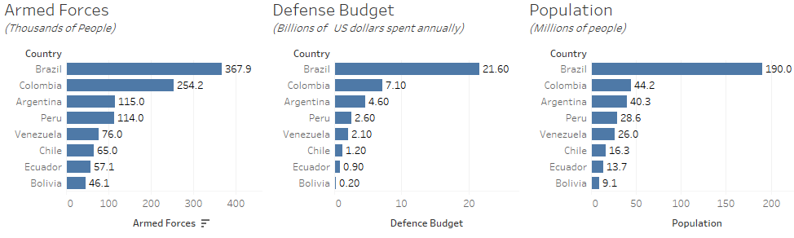

Figure 1: Defense statistics for 8 South American countries in 2009.

* Using Excel, record this data in the format of a table:

|  |  |  |  |
| --- | --- | --- | --- |
| **Country** | **Armed Forces** | **Defense Budget** | **Population** |
| Brazil | 367.9 | 21.6 | 190.0 |
| Colombia | … | … | … |
| … | … | … | … |

Table 2: Recording defense data as a table. Fill in the rest!

* Save this file as an Excel file (.xlsx)
* Open Tableau and connect to the file that you created.
* Raw numbers are difficult to compare due to the vast population differences between the countries. Create the following variables using calculated fields:
  + Percent of the population employed in the armed forces.
  + Per capita spending on defense (in US dollars per person)
  + Amount spent on each armed forces employee (in US dollars per person).

(**NOTE:** Be very careful your calculations have the right units)

* Create the following two maps and place in a dashboard called ‘Practice 1’.
  + **Create a choropleth map of defense spending.**
  + **Create a choropleth map of defense spending per capita.**
  + Create an annotation comparing these two different ways of measuring defense spending.
* Create the following map and place in a dashboard called ‘Practice 2’.
  + **Create a proportional symbols map of percentage of population employed in the armed forces.**
  + **Create a bar plot showing the same information**
  + Which visualization more effectively communicates the information?

**Assignment**

**Due Date: February 9, 2018, 6:00 pm. Value: 10 points**

* Create an Excel file of the South American defense data (instructions in above section) and connect to Tableau.
* Create and put the following two graph in a dashboard called ‘Exercise 1’:
  + **Barplot of population of the 8 countries.**
  + **Barplot of defense spending of the countries.**
    - Sort both barplots in decreasing order.

(These plots should match those in Figure 1)

(2.5 pts)

* Create and put the following three graphs in a dashboard called ‘Exercise 2’:
  + **Barplot of percentage of population employed in the armed forces**
  + **Barplot of per capita defense spending**
  + **Barplot of money spend on each armed forces employee**
    - Sort each barplot in decreasing order. Be careful about units!
  + Add an annotation about what information these plots provide.

(2.5 pts)

* Create and put the following plots in a new dashboard called ‘Exercise 3’:
  + **Choropleth map of defense spending**
  + **Proportional symbol map of defense spending per capita**
  + **Barplot of defense spending**
  + **Barplot of defense spending per capita**
  + Add an annotation describing what these plots tell you about defense spending in South America. (5 pts)
* Submit the three dashboards you created as a **single** .pdf document on Canvas. The .pdf document should have three pages, one page for each dashboard. **You do not need to submit any other charts, or the charts from the practice portion of the lab.**