SAP HANA is an in-memory data platform that is deployable as an on-premise appliance, or in the cloud. It is a revolutionary platform, which is best suited for performing real-time analytics, and developing and deploying real-time applications. At the core of this real-time data platform is the SAP HANA database, which is fundamentally different from any other database engine in the market today. This tutorial will teach you the basics of SAP HANA. The tutorial is divided into sections such as SAP HANA Basics, SAP HANA-Modeling, Reporting, and SAP HANA-SQL. Each of these sections contain related topics with screenshots explaining the SAP HANA database installations.

Audience

This tutorial has been prepared for anyone who has a basic knowledge of SQL. After completing this tutorial, you will find yourself at a moderate level of expertise in administration and operations or implantation and modeling using SAP HANA.

Prerequisites

Before you start proceeding with this tutorial, we assume that you are well-versed with basic database concepts. You should have a good exposure to SQL, as SAP HANA is like a relational database. If you are not aware of these concepts, then we recommend that you first go through our short tutorials on SQL.

SAP HANA is a combination of HANA Database, Data Modeling, HANA Administration and Data Provisioning in one single suite. In SAP HANA, HANA stands for High-Performance Analytic Appliance.

According to former SAP executive, Dr. Vishal Sikka, HANA stands for Hasso’s New Architecture. HANA developed interest by mid-2011 and various fortune 500 companies started considering it as an option to maintain Business Warehouse needs after that.

## **Features of SAP HANA**

The main features of SAP HANA are given below −

* SAP HANA is a combination of software and hardware innovation to process huge amount of real time data.
* Based on multi core architecture in distributed system environment.
* Based on row and column type of data-storage in database.
* Used extensively in Memory Computing Engine (IMCE) to process and analyze massive amount of real time data.
* It reduces cost of ownership, increases application performance, enables new applications to run on real time environment that were not possible before.
* It is written in C++, supports and runs on only one Operating System Suse Linux Enterprise Server 11 SP1/2.

## **Need for SAP HANA**

Today, most successful companies respond quickly to market changes and new opportunities. A key to this is the effective and efficient use of data and information by analyst and managers.

HANA overcomes the limitations mentioned below −

* Due to increase in “Data Volume”, it is a challenge for the companies to provide access to real time data for analysis and business use.
* It involves high maintenance cost for IT companies to store and maintain large data volumes.
* Due to unavailability of real time data, analysis and processing results are delayed.

## **SAP HANA Vendors**

SAP has partnered with leading IT hardware vendors like IBM, Dell, Cisco etc. and combined it with SAP licensed services and technology to sell SAP HANA platform.

There are, total, 11 vendors that manufacture HANA Appliances and provide onsite support for installation and configuration of HANA system.

**Top few Vendors include** −

* IBM
* Dell
* HP
* Cisco
* Fujitsu
* Lenovo (China)
* NEC
* Huawei

According to statistics provided by SAP, IBM is one of major vendor of SAP HANA hardware appliances and has a market share of 50-52% but according to another market survey conducted by HANA clients, IBM has a market hold up to 70%.

## **SAP HANA Installation**

HANA Hardware vendors provide preconfigured appliances for hardware, Operating System and SAP software product.

Vendor finalizes the installation by an onsite setup and configuration of HANA components. This onsite visit includes deployment of HANA system in Data Center, Connectivity to Organization Network, SAP system ID adaption, updates from Solution Manager, SAP Router Connectivity, SSL Enablement and other system configuration.

Customer/Client starts with connectivity of Data Source system and BI clients. HANA Studio Installation is completed on local system and HANA system is added to perform Data modeling and administration

An In-Memory database means all the data from source system is stored in a RAM memory. In a conventional Database system, all data is stored in hard disk. SAP HANA In-Memory Database wastes no time in loading the data from hard disk to RAM. It provides faster access of data to multicore CPUs for information processing and analysis.

## **Features of In-Memory Database**

The main features of SAP HANA in-memory database are −

* SAP HANA is Hybrid In-memory database.
* It combines row based, column based and Object Oriented base technology.
* It uses parallel processing with multicore CPU Architecture.
* Conventional Database reads memory data in 5 milliseconds. SAP HANA In-Memory database reads data in 5 nanoseconds.

It means, memory reads in HANA database are 1 million times faster than a conventional database hard disk memory reads.

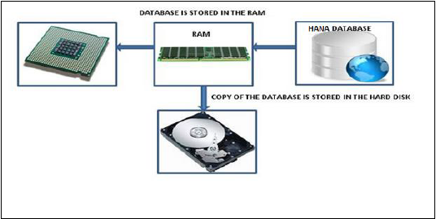

Analysts want to see current data immediately in real time and do not want to wait for data until it is loaded to SAP BW system. SAP HANA In-Memory processing allows loading of real time data with use of various data provisioning techniques.

## **Advantages of In-Memory Database**

* HANA database takes advantage of in-memory processing to deliver the fastest data-retrieval speeds, which is enticing to companies struggling with high-scale online transactions or timely forecasting and planning.
* Disk-based storage is still the enterprise standard and price of RAM has been declining steadily, so memory-intensive architectures will eventually replace slow, mechanical spinning disks and will lower the cost of data storage.
* In-Memory Column-based storage provides data compression up to 11 times, thus, reducing the storage space of huge data.
* This speed advantages offered by RAM storage system are further enhanced by the use of multi-core CPUs, multiple CPUs per node and multiple nodes per server in a distributed environment.

SAP HANA studio is an Eclipse-based tool. SAP HANA studio is both, the central development environment and the main administration tool for HANA system. Additional features are −

* It is a client tool, which can be used to access local or remote HANA system.
* It provides an environment for HANA Administration, HANA Information Modeling and Data Provisioning in HANA database.

SAP HANA Studio can be used on following platforms −

* Microsoft Windows 32 and 64 bit versions of: Windows XP, Windows Vista, Windows 7
* SUSE Linux Enterprise Server SLES11: x86 64 bit
* Mac OS, HANA studio client is not available

Depending on HANA Studio installation, not all features may be available. At the time of Studio installation, specify the features you want to install as per the role. To work on most recent version of HANA studio, Software Life Cycle Manager can be used for client update.

## **SAP HANA Studio Perspectives / Features**

SAP HANA Studio provides perspectives to work on the following HANA features. You can choose Perspective in HANA Studio from the following option −

**HANA Studio → Window → Open Perspective → Other**

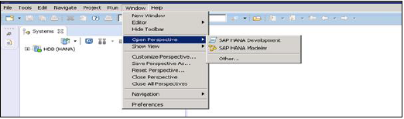

## **Sap Hana Studio Administration**

Toolset for various administration tasks, excluding transportable design-time repository objects. General troubleshooting tools like tracing, the catalog browser and SQL Console are also included.

## **SAP HANA Studio Database Development**

It provides Toolset for content development. It addresses, in particular, the DataMarts and ABAP on SAP HANA scenarios, which do not include SAP HANA native application development (XS).

## **SAP HANA Studio Application Development**

SAP HANA system contains a small Web server, which can be used to host small applications. It provides Toolset for developing SAP HANA native applications like application code written in Java and HTML.

By default, all features are installed.

o Perform HANA Database Administration and monitoring features, SAP HANA Administration Console Perspective can be used.

Administrator Editor can be accessed in several ways −

* **From System View Toolbar** − Choose Open Administration default button
* **In System View** − Double Click on HANA System or Open Perspective

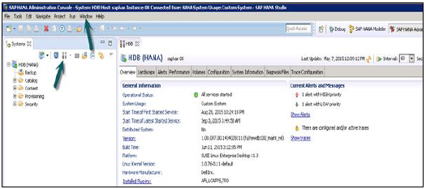

## **HANA Studio: Administrator Editor**

In Administration View: HANA studio provides multiple tabs to check configuration and health of the HANA system. Overview Tab tells General Information like, Operational Status, start time of first and last started service, version, build date and time, Platform, hardware manufacturer, etc.

## **Adding a HANA System to Studio**

Single or multiple systems can be added to HANA studio for administration and information modeling purpose. To add new HANA system, host name, instance number and database user name and password is required.

* Port 3615 should be open to connect to Database
* Port 31015 Instance No 10
* Port 30015 Instance No 00
* SSh port should also be opened

## **Adding a System to Hana Studio**

To add a system to HANA studio, follow the given steps.

Right Click in Navigator space and click on Add System. Enter HANA system details, i.e. Host name & Instance number and click next.

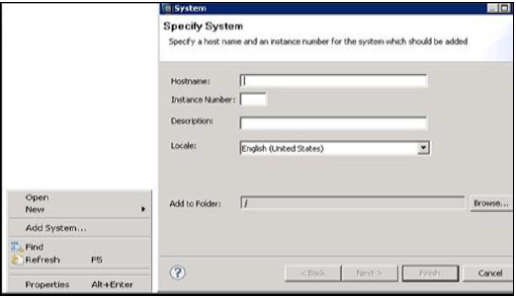

Enter Database user name and password to connect to SAP HANA database. Click on Next and then Finish.

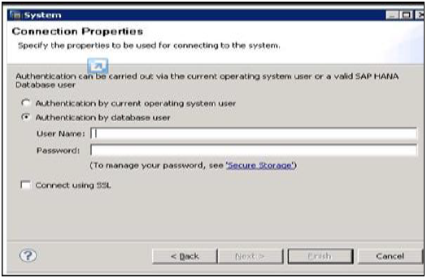

Once you click on Finish, HANA system will be added to System View for administration and modeling purpose. Each HANA system has two main sub-nodes, Catalog and Content.

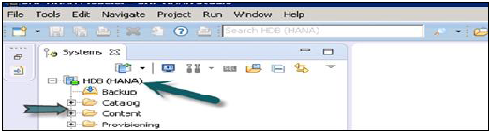

## **Catalog and Content**

### **Catalog**

It contains all available Schemas i.e. all data structures, tables and data, Column views, Procedures that can be used in Content tab.

### **Content**

The Content tab contains design time repository, which holds all information of data models created with the HANA Modeler. These models are organized in Packages. The content node provides different views on same physical data.

System Monitor in HANA studio provides an overview of all your HANA system at a glance. From System Monitor, you can drill down into details of an individual system in Administration Editor. It tells about Data Disk, Log disk, Trace Disk, Alerts on resource usage with priority.

The following Information is available in System Monitor −

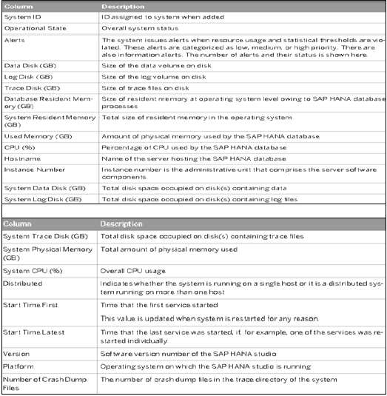SAP HANA Information Modeler; also known as HANA Data Modeler is heart of HANA System. It enables to create modeling views at the top of database tables and implement business logic to create a meaningful report for analysis.

## **Features of Information Modeler**

* Provides multiple views of transactional data stored in physical tables of HANA database for analysis and business logic purpose.
* Informational modeler only works for column based storage tables.
* Information Modeling Views are consumed by Java or HTML based applications or SAP tools like SAP Lumira or Analysis Office for reporting purpose.
* Also possible to use third party tools like MS Excel to connect to HANA and create reports.
* SAP HANA Modeling Views exploit real power of SAP HANA.

There are three types of Information Views, defined as −

* Attribute View
* Analytic View
* Calculation View

## **Row vs Column Store**

SAP HANA Modeler Views can only be created on the top of Column based tables. Storing data in Column tables is not a new thing. Earlier it was assumed that storing data in Columnar based structure takes more memory size and not performance Optimized.

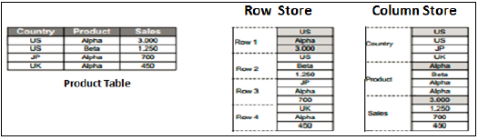

With evolution of SAP HANA, HANA used column based data storage in Information views and presented the real benefits of columnar tables over Row based tables.

### **Column Store**

In a Column store table, Data is stored vertically. So, similar data types come together as shown in the example above. It provides faster memory read and write operations with help of In-Memory Computing Engine.

In a conventional database, data is stored in Row based structure i.e. horizontally. SAP HANA stores data in both row and Column based structure. This provides Performance optimization, flexibility and data compression in HANA database.

Storing Data in Columnar based table has following benefits −

* Data Compression
* Faster read and write access to tables as compared to conventional Row based storage
* Flexibility & parallel processing
* Perform Aggregations and Calculations at higher speed

There are various methods and algorithms how data can be stored in Column based structure- Dictionary Compressed, Run Length Compressed and many more.

In Dictionary Compressed, cells are stored in form of numbers in tables and numeral cells are always performance optimized as compared to characters.

In Run length compressed, it saves the multiplier with cell value in numerical format and multiplier shows repetitive value in table.

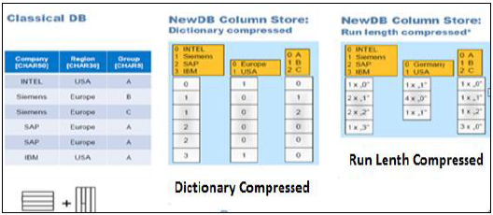

## **Functional Difference - Row vs Column Store**

It is always advisable to use Column based storage, if SQL statement has to perform aggregate functions and calculations. Column based tables always perform better when running aggregate functions like Sum, Count, Max, Min.

Row based storage is preferred when output has to return complete row. The example given below makes it easy to understand.

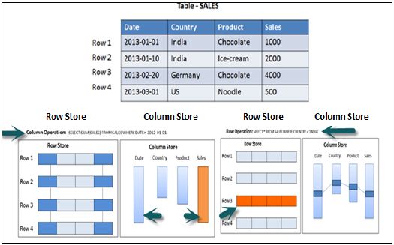

In the above example, while running an Aggregate function (Sum) in sales column with Where clause, it will only use Date and Sales column while running SQL query so if it is column based storage table then it will be performance optimized, faster as data is required only from two columns.

While running a simple Select query, full row has to be printed in output so it is advisable to store table as Row based in this scenario.

## **Information Modeling Views**

### **Attribute View**

Attributes are non-measurable elements in a database table. They represent master data and similar to characteristics of BW. Attribute Views are dimensions in a database or are used to join dimensions or other attribute views in modeling.

Important features are −

* Attribute views are used in Analytic and Calculation views.
* Attribute view represent master data.
* Used to filter size of dimension tables in Analytic and Calculation View.

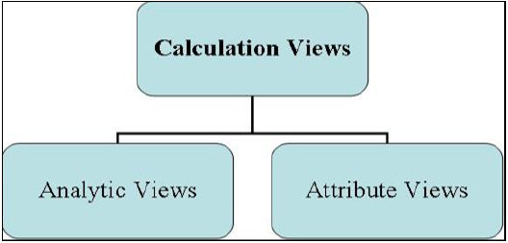

### **Analytic View**

Analytic Views use power of SAP HANA to perform calculations and aggregation functions on the tables in database. It has at least one fact table that has measures and primary keys of dimension tables and surrounded by dimension tables contain master data.

Important features are −

* Analytic views are designed to perform Star schema queries.
* Analytic views contain at least one fact table and multiple dimension tables with master data and perform calculations and aggregations
* They are similar to Info Cubes and Info objects in SAP BW.
* Analytic views can be created on top of Attribute views and Fact tables and performs calculations like number of unit sold, total price, etc.

### **Calculation Views**

Calculation Views are used on top of Analytic and Attribute views to perform complex calculations, which are not possible with Analytic Views. Calculation view is a combination of base column tables, Attribute views and Analytic views to provide business logic.

Important features are −

* Calculation Views are defined either graphical using HANA Modeling feature or scripted in the SQL.
* It is created to perform complex calculations, which are not possible with other views- Attribute and Analytic views of SAP HANA modeler.
* One or more Attribute views and Analytic views are consumed with help of inbuilt functions like Projects, Union, Join, Rank in a Calculation View.

SAP HANA was initially, developed in Java and C++ and designed to run only Operating System Suse Linux Enterprise Server 11. SAP HANA system consists of multiple components that are responsible to emphasize computing power of HANA system.

* Most important component of SAP HANA system is Index Server, which contains SQL/MDX processor to handle query statements for database.
* HANA system contains Name Server, Preprocessor Server, Statistics Server and XS engine, which is used to communicate and host small web applications and various other components.

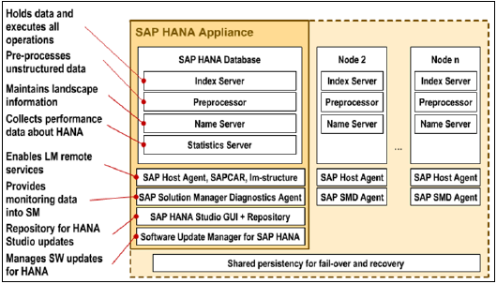

## **Index Server**

Index Server is heart of SAP HANA database system. It contains actual data and engines for processing that data. When SQL or MDX is fired for SAP HANA system, an Index Server takes care of all these requests and processes them. All HANA processing takes place in Index Server.

Index Server contains Data engines to handle all SQL/MDX statements that come to HANA database system. It also has Persistence Layer that is responsible for durability of HANA system and ensures HANA system is restored to most recent state when there is restart of system failure.

Index Server also has Session and Transaction Manager, which manage transactions and keep track of all running and closed transactions.

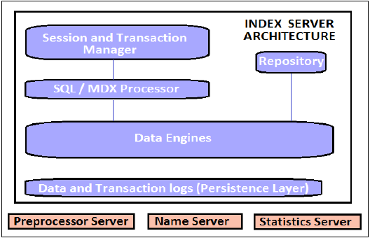

## **Index Server − Architecture**

### **SQL/MDX Processor**

It is responsible for processing SQL/MDX transactions with data engines responsible to run queries. It segments all query requests and direct them to correct engine for the performance Optimization.

It also ensures that all SQL/MDX requests are authorized and also provide error handling for efficient processing of these statements. It contains several engines and processors for query execution −

* MDX (Multi Dimension Expression) is query language for OLAP systems like SQL is used for Relational database. MDX Engine is responsible to handle queries and manipulates multidimensional data stored in OLAP cubes.
* Planning Engine is responsible to run planning operations within SAP HANA database.
* Calculation Engine converts data into Calculation models to create logical execution plan to support parallel processing of statements.
* Stored Procedure processor executes procedure calls for optimized processing; it converts OLAP cubes to HANA optimized cubes.

### **Transaction and Session Management**

It is responsible to coordinate all database transactions and keep track of all running and closed transactions.

When a transaction is executed or failed, Transaction manager notifies relevant data engine to take necessary actions.

Session management component is responsible to initialize and manage sessions and connections for SAP HANA system using predefined session parameters.

### **Persistence Layer**

It is responsible for durability and atomicity of transactions in HANA system. Persistence layer provides built in disaster recovery system for HANA database.

It ensures database is restored to most recent state and ensures that all the transactions are completed or undone in case of a system failure or restart.

It is also responsible to manage data and transaction logs and also contain data backup, log backup and configuration back of HANA system. Backups are stored as save points in the Data Volumes via a Save Point coordinator, which is normally set to take back every 5-10 minutes.

### **Preprocessor Server**

Preprocessor Server in SAP HANA system is used for text data analysis.

Index Server uses preprocessor server for analyzing text data and extracting the information from text data when text search capabilities are used.

### **Name Server**

NAME server contains System Landscape information of HANA system. In distributed environment, there are multiple nodes with each node has multiple CPU’s, Name server holds topology of HANA system and has information about all the running components and information is spread on all the components.

* Topology of SAP HANA system is recorded here.
* It decreases the time in re-indexing as it holds which data is on which server in distributed environment.

### **Statistical Server**

This server checks and analyzes the health of all components in HANA system. Statistical Server is responsible for collecting the data related to system resources, their allocation and consumption of the resources and overall performance of HANA system.

It also provides historical data related to system performance for analyses purpose, to check and fix performance related issues in HANA system.

### **XS Engine**

XS engine helps external Java and HTML based applications to access HANA system with help of XS client. As SAP HANA system contains a web server which can be used to host small JAVA/HTML based applications.

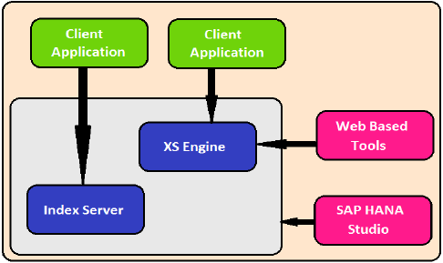

XS Engine transforms the persistence model stored in database into consumption model for clients exposed via HTTP/HTTPS.

### **SAP Host Agent**

SAP Host agent should be installed on all the machines that are part of SAP HANA system Landscape. SAP Host agent is used by Software Update Manager SUM for installing automatic updates to all components of HANA system in distributed environment.

### **LM Structure**

LM structure of SAP HANA system contains information about current installation details. This information is used by Software Update Manager to install automatic updates on HANA system components.

### **SAP Solution Manager (SAP SOLMAN) diagnostic Agent**

This diagnostic agent provides all data to SAP Solution Manager to monitor SAP HANA system. This agent provides all the information about HANA database, which include database current state and general information.

It provides configuration details of HANA system when SAP SOLMAN is integrated with SAP HANA system.

### **SAP HANA Studio Repository**

SAP HANA studio repository helps HANA developers to update current version of HANA studio to latest versions. Studio Repository holds the code which does this update.

### **Software Update Manager for SAP HANA**

SAP Market Place is used to install updates for SAP systems. Software Update Manager for HANA system helps is update of HANA system from SAP Market place.

It is used for software downloads, customer messages, SAP Notes and requesting license keys for HANA system. It is also used to distribute HANA studio to end user’s systems.

### **Certified Appliances**

The certification is valid for a particular group of appliances from the hardware manufacturer wherein multiple models might be included. During the preparation phase of the certification Partner and SAP can jointly agree on the group of appliances. The group of appliances can be defined as a set of appliance models that share and fulfill all of the following criteria:

* They are based on the same architecture
* Within one group of certified appliances different CPU models within the same microarchitecture can be used as released by SAP HANA reference architecture:
  + Nehalem EX architecture:
    - Intel(R) Xeon(R) X7560
  + Westmere EX architecture:
    - Intel(R) Xeon(R) CPU E7- 2870
    - Intel(R) Xeon(R) CPU E7- 4870
    - Intel(R) Xeon(R) CPU E7- 8870
  + Ivy Bridge EX architecture:
    - Intel(R) Xeon(R) CPU E7-2880 v2
    - Intel(R) Xeon(R) CPU E7-2890 v2
    - Intel(R) Xeon(R) CPU E7-4880 v2
    - Intel(R) Xeon(R) CPU E7-4890 v2
    - Intel(R) Xeon(R) CPU E7-8880 v2
    - Intel(R) Xeon(R) CPU E7-8890 v2
  + Haswell EX architecture:
    - Intel(R) Xeon(R) CPU E7-8880 v3
    - Intel(R) Xeon(R) CPU E7-8890 v3
    - Intel(R) Xeon(R) CPU E7-8880L v3
  + Broadwell EX architecture:
    - Intel(R) Xeon(R) CPU E7-8880 v4
    - Intel(R) Xeon(R) CPU E7-8890 v4
    - Intel(R) Xeon(R) CPU E7-8894 v4
  + Skylake SP architecture:
    - Intel(R) Xeon(R) Platinum 8176 CPU
    - Intel(R) Xeon(R) Platinum 8176M CPU
    - Intel(R) Xeon(R) Platinum 8180 CPU
    - Intel(R) Xeon(R) Platinum 8180M CPU
* Empty CPU slots may be filled up to the maximum number supported by the appliance
* Memory chips have to be homogeneous, spread across all CPUs symmetrically providing maximum bandwidth
* They have the same disk layout
* They use the same storage connector(s) and/or RAID controller as described in the documentation
* Comparable components are used as with the tested setup
* All the KPIs are met by the lowest member of the group of appliances
* Consistent documentation for the group of appliances which is applicable for all SAP HANA setup scenarios: single node, scale up and scale out
  + **Scale-up: BWoH/BW4H/DM/SoH/S4H** includes hardware approved for all single server configuration scenarios for **SAP BW powered by SAP HANA**, **SAP Business Suite powered by SAP HANA**, **S/4HANA**and more
  + **Scale-up: SoH/S4H** includes additional single server configurations specific for [SAP Business Suite powered by SAP HANA](http://help.sap.com/soh) and S/4HANA not covered by **Scale-up: BWoH/BW4H/DM/SoH/S4H**
  + **Scale-out: BWoH/BW4H/DM** includes multi-server configuration scenario for **SAP BW powered by SAP HANA**
  + **Scale-out: S4H**includes multi-server configurations scenario for S/4HANA (see SAP note [2408419 - SAP S/4HANA - Multi-Node Support](https://launchpad.support.sap.com/#/notes/2408419))
  + **SAP Business One**includes single server configurations specific for **SAP Business One**
    - **​**Additional CPUs for **SAP Business One:**
      * **​**Haswell EP architecture: Intel E5-2670 v3
      * Broadwell EP architecture: Intel E5-2650 v4 or E5-26## v4 with higher specification;  
        System size <= 256 GB is supported with E5-2630 v4

**HANA SPS / OS Release – Support Matrix**

For a list of supported operating systems please see the SAP note:  
[**2235581 - SAP HANA: Supported Operating Systems**](https://launchpad.support.sap.com/#/notes/2235581)

**SAP HANA 2.0**

For SAP HANA Platform 2.0 SPS 00 on Intel-based hardware platforms the minimum operating system versions are:

* Red Hat Enterprise Linux for SAP HANA (RHEL for SAP HANA) 7.2
* SUSE Linux Enterprise Server (SLES) for SAP Applications 12 SP1

The corresponding SAP notes are:  
[**2380257 - SAP HANA Platform 2.0 SPS 00 Release Note**](https://launchpad.support.sap.com/#/notes/2378962/E)  
[**2378962 - SAP HANA 2.0 Revision and Maintenance Strategy**](https://launchpad.support.sap.com/#/notes/2380257)

For SAP HANA Platform 2.0 SPS 00 on Intel-based hardware platforms the minimum generation has to be Intel**®**Haswell CPU or later.

The corresponding SAP note is:  
[**2399995 - Hardware requirement for SAP HANA 2.0**](https://launchpad.support.sap.com/#/notes/2399995/E)

Further information on SAP HANA 2 can be found under the following links:  
<https://blogs.saphana.com/2016/11/08/sap-announces-sap-hana-2-next-generation-platform-for-digital-transformation/>  
<http://go.sap.com/product/technology-platform/hana/features/whats-new.html>  
<http://help.sap.com/hana_platform>

**HANA on virtualized environment**

For operation of SAP HANA on virtualized environment the combination of Hardware and Hypervisor needs to be supported.  
For details please see the SAP note:  
[**1788665 - SAP HANA Support for virtualized / partitioned (multi-tenant) environments**](https://launchpad.support.sap.com/#/notes/1788665)

**Appliance Certification Scenarios**

There are several scenarios available for HANA Hardware Appliance certification. Please see details below for the test procedure which comes with each scenario version applicable to the [HANA Hardware Certification Check Tool (HWCCT).](http://service.sap.com/sap/support/notes/1943937)Certifications that were released under scenario 1.0 remain valid until their expiration date and to be used with all SAP HANA revisions.

1. Scenario Version 1.0
   * Appliance for SUSE Linux Enterprise Server (SLES): **HANA-HWC-AP SU 1.0**
   * Appliance for Red Hat Enterprise Linux (RHEL): **HANA-HWC-AP RH 1.0**
   * For certification tests, HWCCT based on HANA SPS8 or SPS9 and related revisions is used.
2. Scenario Version 1.1
   * Appliance for SUSE Linux Enterprise Server (SLES): **HANA-HWC-AP SU 1.1**
   * Appliance for Red Hat Enterprise Linux (RHEL): **HANA-HWC-AP RH 1.1**
   * For certification tests, HWCCT based on HANA SPS10 and related revisions is used.
3. Legacy appliances released prior to 2014
   * HWCCT cannot be used for validating storage performance, see [SAP Note 2187426](http://service.sap.com/sap/support/notes/2187426).
   * HWCCT can only be used to validate operating system configuration settings and network performance.

### **Entry Level Systems**

These systems are supported solutions approved for use with SAP HANA scenarios.  SAP HANA hardware certifications do not apply.  Entry Level systems have the following criteria:

* Intel Xeon E5 v2/v3/v4 based systems
* 2-socket systems
* CPU with a minimum of 8 cores
* Memory chips have to be homogeneous, spread across all CPUs symmetrically providing maximum bandwidth.
* Single node solutions
* Valid for specific Support Package Stack (SPS) releases

### **Certified Enterprise Storage**

The certification is valid for a particular enterprise storage family of the hardware manufacturer wherein multiple models might be included. During the preparation phase of the certification, the Partner and SAP can jointly agree on the group of appliances to be certified. The storage family can be defined as a set of enterprise storage models that share and fulfill all of the following criteria:

* They are based on the same architecture
* They use the same storage connector(s)
* Comparable components are used as with the tested setup
* All the KPIs are met by the lowest member of the storage family
* Consistent documentation for the storage family which is applicable for all SAP HANA setup scenarios: single node, scale up and scale out

**Enterprise Storage Certification Scenarios**

There are several scenarios available for SAP HANA enterprise storage certification. Please see details below for the test procedure which comes with each scenario version applicable to the [HANA Hardware Certification Check Tool (HWCCT).](http://service.sap.com/sap/support/notes/1943937)

1. Scenario Version **HANA-HWC-ES 1.0**
   * **​​**For certification tests,  HWCCT based on HANA SPS8 or SPS9 and related revisions is used.
2. Scenario Version **HANA-HWC-ES 1.1**
   * **​​**For certification tests, HWCCT based on HANA SPS10 and related revisions is used.
   * New KPI table is introduce

The Enterprise Storage Certification Scenario HANA-HWC-ES 1.1 is the successor of HANA-HWC-ES 1.0 with an updated testing method and an adopted set of KPIs. Certifications that were released under scenario 1.0 remain valid until their expiration date and to be used with all SAP HANA revisions. From**July 14th 2015** onwards the certification scenario 1.1 is mandatory.