Ingresar a la pagina cd /var/www/html

emacs index.html

Change your working directory to /root/holbertonschool. Then create an empty file called hello\_world using the touch command. Check that the file has been created using the ls command. Once done press the button "Done!".

Project "Make your own website"

Now that your web server is up and running, and that you know how to connect to your server and manipulate files over there, you will be able to build an entire website, only with the command line!

Even if you've never made a website before, no worries, this project is still designed for beginners so we'll help you out a bit. However, do note that not all of the explanations are present here; you are expected to go by yourself find information online about what you don't know or understand.

If you can't find explanations online (and only if you can't), you should ask your peers for help on the Forum, while making your question as detailed and specific as possible. Don't forget to check out the Forum regularly to help your peers out, but do not give them straight solutions.

How far should I go?

This project is willingly loosely constrained, so that you get an opportunity to go beyond what is required, and spend some extra time on aspects of the project you enjoy most. In fact, what you build extra will be taken into account as much as what you're required to do, when your final application will be evaluated.

Important: You are not allowed to install, import or use external libraries. This website must be build with only HTML/CSS/JavaScript. No NodeJS, React, VueJS, Bootstrap, etc.

How creative can I get?

Very creative!

We simply ask that, if you decide your project is finished and click “I’m done with my level 2 project”, your website is at least what the tutorials ask you to do, and possibly more.

Note that we’ll usually support you if you want to stray off the regular path; but this one project must be different, as you are partly tested on your ability to follow a tutorial. We also want this project to showcase your original work, so please do not utilize frameworks such as bootstraps to do the work for you.

Ready to get started? Connect to your server using SSH if you weren't already there, and let's go!

You'll see HTML gives very basic outputs, as it typically only allows to stack vertically unmoving black texts, blue links, and images on a white background. To style your webpage differently, you will use another language later, called CSS (which you will discover in the next part of the project); and to make elements move and change dynamically, you will use again another language, called JavaScript (which you will discover in the part after next).

HTML is called a "markup language" as opposed to a "programming language", because it doesn't allow to program the computer and make it do everything you want, but only to mark text up with tags in order to structure it. The markup you write within the text tells the web browser (for instance, Google Chrome, Mozilla Firefox, Internet Explorer, Safari, …) how to display the text to the user in the webpage.

Here are pieces of HTML code, and what a browser displays for them:

* <p>This is a paragraph.</p>
* This is a paragraph.

Note that <p> opens the paragraph (it's an opening tag), and </p> closes it (it's a closing tag).

See how tags open and close within each other?

If you want to add a link on your webpage, you have to know that links are represented by <a> tags, like this: <a>text to click on</a>. But when you want to create a link, you also need to tell what URL it links to when the user clicks. To tell the link what URL it should link to, you will need to add the URL in a href attribute of the opening <a> tag, like this:

<p>This is a paragraph with a  
<a href="https://www.holbertonschool.com">clickable link</a>.</p>

This is a paragraph with a [clickable link](https://www.holbertonschool.com/" \t "_blank).

The value given to an attribute, just like for the href attribute here, is always put between the " characters, right after an = sign. The <a> tag accepts href as an attribute, because it needs to be told where to take the user when she clicks. Some other tags have attributes for their own purposes. For instance, image tags need to be told where the image file is, and they use the src attribute for that:

some advises from [@Andres Rojas](https://holberton-students.slack.com/team/US16A64NM) engineer:  
Good day number 1 (yes, we start counting from 0), I hope you are all having an amazing experience so far. I would like to share some tips to succeed and have an amazing experience at Holberton:

* Coding is easy, **understanding how a line of code works in any computer is the important**/hard part :muscle:
* You are not here to learn C/Python/Javascript, you are here to**learn how to learn :nerd_face:** and adapt your brain to think systematically so **any programming language becomes easy :brain:**
* Ask where, when, how, and more importantly **ask WHY! :thinking_face:** Asking why will open a lot of doors
* **The Score is just a number :hash:**, the important part is **understanding what you are doing** and being able to**explain the concepts to others easily.**
* You are never alone, **you have an entire community** :couple::dancer:(Colombia, USA, Puerto Rico, Tunisia, Lebanon, Uruguay) to talk to, ask questions and share knowledge
* **Helping others is more important than having a perfect score :dart:**, building relationships is the key to be an amazing Software Developer in the market
* Remember to follow the Framework

And remember, some days this will feel impossible, some days you will be very tired, but when that happens, try to remember what did you know the Day 0, and what you know now... just think about it, some of you did not even know that Vagrant exists, and today, you are creating virtual environments from the command line.

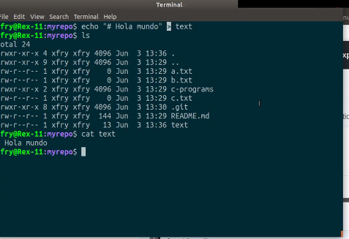

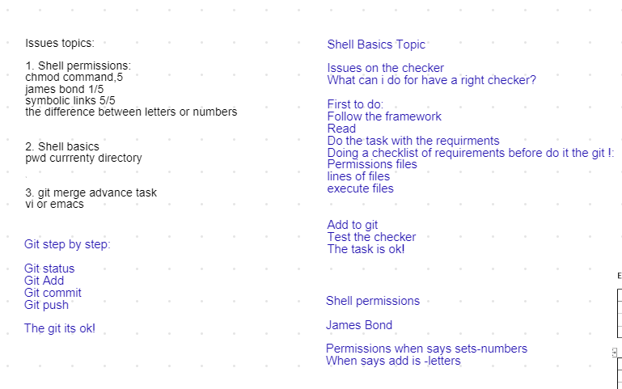

Carta holberton:

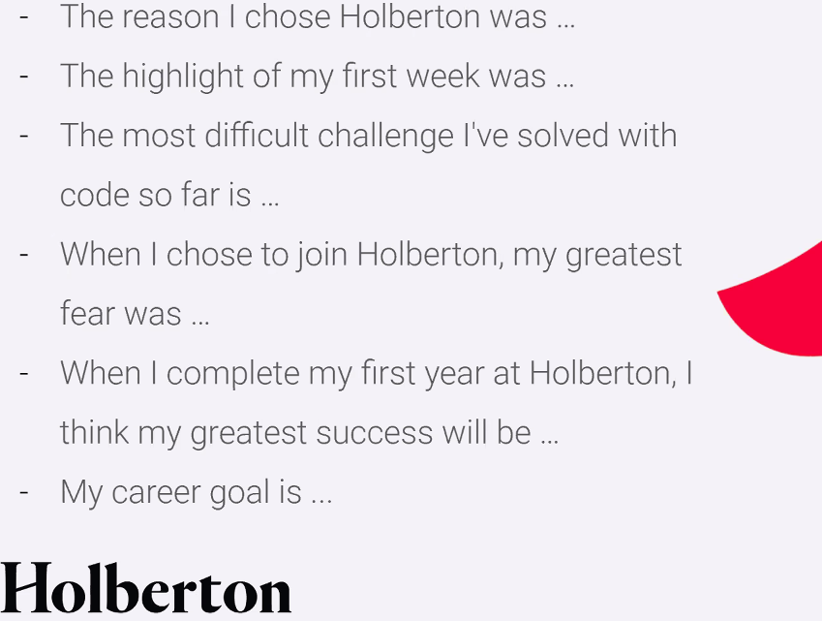

Hackaton ver que es y como funciona y postularce

