General explanations of the system and its goals | The chatbot can provide answers to the user’s questions on a variety of minerals based upon their characteristics, as well general questions associated with minerals. The system also provides the ability to classify images provided from the user, providing information on what mineral it is likely to be.  The user can also interact with the chatbot with the use of a microphone, in which is translated to text. Furthermore, the chatbot can output text-too-speech audio output.  If the chatbot does not recognize the user’s input / query, the chatbot will fallback to use of interpreting the user’s input through cosine similarity of the tf/idf values of the sentence in question.  The chatbot also uses a knowledge base, in which can be used to determine if a statement provided by the user is correct or false. Two knowledge base files are present, with one being utilised with fuzzy logic & another KB acting as a fallback, with statements with just words / phrases. The fuzzy logic knowledge base associates’ numerical values, in which allows the program to determine the output. For example, if the moss hardness of a mineral is greater than 5 for instance, the chatbot will determine the mineral as ‘hard’.  Additionally, the user has the ability to add additional statements to the knowledge base, as long as the statements do not contradict the two corresponding knowledge bases.  Image classification is implemented utilising tensorflow & keras respectively in order to identify the user’s provided picture of a mineral, in which the chatbots output provides the name of the mineral with the highest similarity.
The system requirements, i.e., the list of what the system should do/have from a user’s perspective | Regarding system requirements, the chatbot is required to answer questions relating to minerals and their associated characteristics, as well as basic queries surrounding minerals such as definitions to characteristics.  In order for the user to interact with the chatbot, the user will submit queries utilising text input. Assuming the user’s query does not get triggered via the predetermined commands, the chatbot will provide the most suitable reply.  Furthermore, the user can interact with the chatbot using their voice, in which is translated to text and inputted to the chatbot as normal. If the user chooses to interact with their voice, the chatbot will provide TTS audio output of the answer.  If the text input is a query to classify an image, the chatbot will prompt the user to enter the image’s directory. Assuming the directory is valid, the chatbot will attempt to identify the mineral provided by the user.
The employed AI techniques, and the explanation of program codes and the supplied files. | Natural language processing  The mineral Bot utilises natural language processing methods in order to process the user’s questions and match them with the corresponding pre-stored knowledge.  Comparing the user’s queries with the QA knowledge base, TF-IDF vectorisation is used to convert the knowledge bank & the user’s queries into vectors.  In order to identify the most appropriate response, cosine similarity is utilised to measure the similarity between the user’s question and the QA KB contents. This is achieved via calculating the cosine angle between two vectors, with values closer to 1 indicating higher similarity.  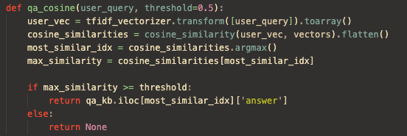  The function qa_cosine takes the user’s input & the minimum acceptable threshold value. It then vectorises the user’s question & compares it to the vectorised QA KB contents. Assuming the threshold value is appropriate, the highest value question is stored in the vector as most_similar_idx and the corresponding answer is returned from the vector.  AIML  To appropriately identify and route the user’s input to the desired functionality, AIML is used. mineralbot-logic.xml stores all the relevant AIML patterns.  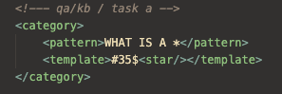  The category above contains the relevant pattern to identify if the user wants to query the chatbot’s QA knowledge base, with the * (wildcard) inferring word(s) after the template.  Input & Text-to-Speech  The SpeechRecognition library is used to capture & process the user’s voice if desired. In order to translate the captured input into text, Google’s Web Speech API is used for translation.  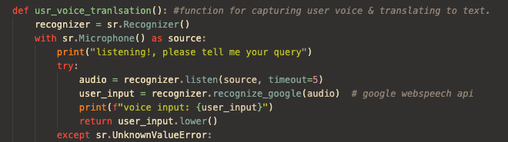  The function usr_voice_translation is used to initialise the user’s microphone & recognizer & capture the audio feed. The audio feed is then translated back to text via the child function recognize_google function / API of the recognizer.  The corresponding string is returned however, exceptions are caught if the translation through the API is not successful.  Pyttsx3 is used to provide text-to-speech functionality for the chatbot. The engine is initalised upon startup & a simple function (chatbot_audio) is used to parse the answer into the child function say of the engine to output the response.  Image classification (Hyper parameter tuned)  Image classification utilises a pre-trained CNN model in order to identify the user’s provided images. The model in question is mineral_cnn_tuned.h5, in which has been trained on a dataset of labelled mineral images (https://www.kaggle.com/datasets/asiedubrempong/minerals-identification-dataset)  TensorFLow/Keras are used to train and load the corresponding model.  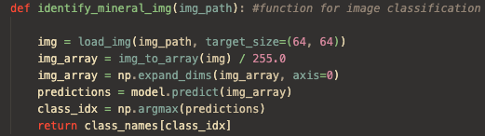  Function identify_mineral_img takes the provided directory path & performs preprocessing such as normalization to prepare the image. The model then predicts the probabilities for each class of mineral. Using a pre-defined dictionary the mineral class is then identified & returned.  cnn_tuned.py contains the relevant code for training / building of the CNN utilised. The dataset used is pre-processed using the ImageDataGenerator in order to normalise the pixel values of the associated images. The images are then split into training & validation subsets (80/20 respectively)  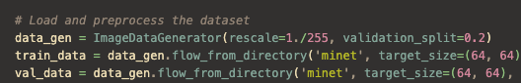  Keras Tuner is used to identify the best hyperparameters for the tuner. A sequential model is employed, to allow for the CNN architecture to be built within a dynamic manor.  The model uses four key layers, including a convolutional layer to extract spatial features from the images, maxPooling layers to prevent overfitting through reducing spatial dimensions, dense layers to perform classification based on extracted features & finally dropout layers, used to prevent overfitting.  In order to ensure the model is trained efficiently with quality validation, Adam optimizer & categorical crossentropy loss are utilized. These techniques help optimize the training process for ensuring accurate validation.  Since 20 trials are ran, Best Model Retrieval (get_best_model()) is used to retrieve the best performing model.  In contrast to the regular CNN, the main employeed difference is the use of the keras tuner, in which allows for automated optimization of values such as kernel size & dropout rate, with the expense of increase resource usage & time.  Overall, the tuned CNN generated an accuracy of 91.3%, while the regular CNN’s accuracy was 89.74%. The marginal increase could have possibly been due to overfitting in the tuned CNN caused by the hyperparameter search. This could have been negated with more trials , in which was tried but with no improvement.  Logical / Fuzzy reasoning  The chatbot utilises two logic files fuzzy-kb.csv & logical-kb.csv respectively for logical & fuzzy logic. This allows the chatbot two handle the user’s questions in which require verification. The use of fuzzy logic expands upon the regular logical reasoning by providing degrees of truth / values to categorise characteristics upon value thresholds.  The basic logical reasoning is implemented using the aforementioned NLP techniques combined with a logical knowledge base. To evaluate provided logical statements & verify against the KB, NLTK Resolution Prover is used.  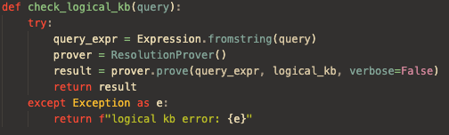  Function check_logical_kb() takes the user’s input & transforms it into a readable logical expression using NLTK’s Expression class. To check the statement the statement is true, NTLK’s ResolutionProver is used in which returns a Boolean which is returned to the main loop.  Fuzzy logic provides the ability to handle characteristics that present uncertainty or degrees of truth.  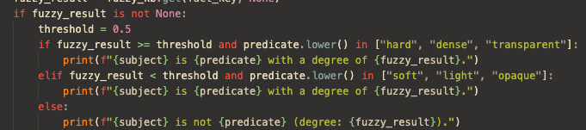  Assuming the user’s query exists within the fuzzy KB, the fuzzy_result will contain the truth value of the fact (In this case the Mohs hardness). If the fuzzy_result is greater than or equal to 0.5, it is determined the mineral is hard.  To allow the user to append to the logical / fuzzy KBs, the NLP also handles ‘ I know that statements’ The query is split into its subject & predicate, with the predicate initially being used to check if the predicate is a fuzzy property or logical.  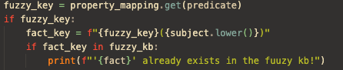  To prevent copies, the fact_key is checked to see if the fact already exists within the fuzzy_kb or the logical_kb if not a fuzzy statement.  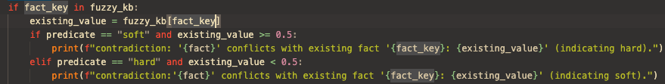  In order to prevent contradictions within the fuzzy_kb, the key value of the fact_key is checks to see if its value exceeds 0.5. An example of this is saying I know that X mineral is soft, but if the existing_value is greater than 0.5, it is hard.  To prevent contradictions within the logical_kb, the negated_fact is used to check if the opposing fact of what the user has said is in the KB, if so a contradictory statement is thrown.

3- Conversation log
Task A -
By default AIML functionality is used to determine the user’s input, in the case of querying the question answer bank query instances that contain phrases such as ‘what is’ or ‘define’ trigger the
Q/A functionality. Assuming the query is a direct match to an entry in the Q/A bank, the corresponding answer is returned.

If the user were to propose a query in which does not match the contents the question-answer bank, utilising TF/IDF & cosine similarity the chatbot will find the most appropriate answer (assuming the cosine similarity score is appropriate)
If the user’s query results in a cosine similarity of zero or does not satisfy any AIML patterns, the default response is returned.

The user can also utilise a microphone to ask questions, via typing ‘voice’ to initiate the voice based input.

Task B –
The chatbot refers to two knowledges for task b, logical and fuzzy knowledge bases (extension task)
The user can check to see if a statement is true or false based on the contents of the two KBs. The above example demonstrates the chatbot referring to the logical knowledge base, in which statements with a boolean characteristic are stored.
If the user’s statement coincides with a property in which has a numerical value, the fuzzy knowledge base is consulted, and its corresponding value is checked.
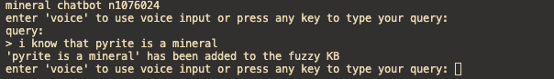

The user can also append to the KBs via ‘I know that’ statements.
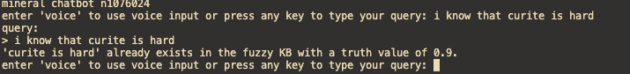

If the fact already exists, its prompted back to the user.

If the fact contradicts the relevant KB, the user is also prompted.

Task C –

If the user inputs ‘what is this image?’, the chatbot will prompt the user to provide the directory path to the desired image.

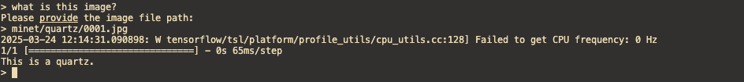

Assuming the directory path provided refers to a suitable file format, the image is processed using a hyperparameter tuned CNN.

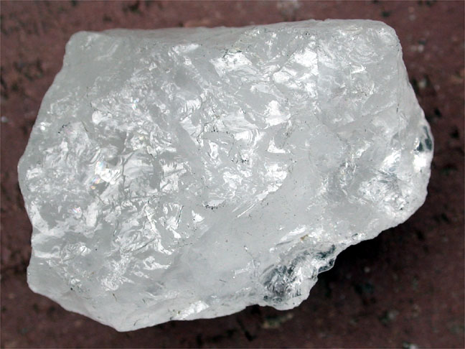

Quartz, https://www.kaggle.com/datasets/asiedubrempong/minerals-identification-dataset

While the chatbot can identify a numerous minerals, unfortunately the model does mix up similar appearing minerals. In this case biotite & bornite.
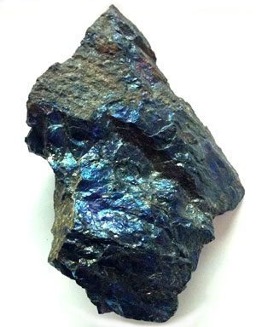
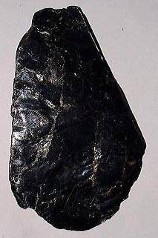

Bornite, https://www.kaggle.com/datasets/asiedubrempong/minerals-identification-dataset
Biotite,https://www.kaggle.com/datasets/asiedubrempong/minerals-identification-dataset

