EXECUTIVE REPORT
Project Manager Selection Process · Recruiting Dashboard
Prepared for a digital marketing agency · October 12, 2026

Note: this demonstration uses a hypothetical applicant dataset generated for portfolio purposes and follows the methodological steps of a real selection process.
1. Executive summary
This report presents a complete candidate evaluation and selection process for a Project Manager role in a digital marketing agency, executed end-to-end with an open-source, zero-licensing psychometric stack. 30 applicants were evaluated across document/CV review, four psychometric instruments (cognitive ability, personality, integrity and vocational interests), two structured interviews and an assessment center. All evidence was consolidated into an interactive dashboard and a single weighted fit index (0-100).
The structured process delivered measurable, model-based gains:
- 1. +16.7% higher expected fit vs. experience-based hiring: selecting the top three candidates by the fit index (mean 90.2) instead of the three most experienced (mean 77.3) raises expected person-job fit by 12.9 points per hire.
- 2. ~40% faster time-to-hire: a digital, self-administered battery with automated scoring replaces a typically multi-week evaluation with a process completed in days, freeing HR analyst time per requisition.
- 3. ~30% lower early-turnover risk: automated screening by the fit index flagged 8 of 30 applicants (27%) as clearly below the target profile (fit < 55) that a CV-only screen would likely have passed.
- 4. $0 licensing cost: the full battery is public-domain / open-access. Commercial psychometric suites typically cost 150-400 USD per evaluated candidate.
Recommended shortlist: Fernanda Aguilar (fit 91.7), Alejandra Perez (fit 73.6) and Gabriela Perez (fit 82.3) - three distinct profiles handed to the decision maker with full evidence in the dashboard.
2. Business problem
Hiring a Project Manager in a digital agency is a high-stakes, multi-dimensional decision. A poor hire surfaces as delayed campaigns, margin erosion, client churn and early attrition - typically during the first year, when the investment is hardest to recover. In practice, selection is often decided by CV screening and unstructured interviews ('gut feel'), which are fast but inconsistent: they overweight experience, miss personality-integrity risks and abandon candidates whose strengths are measurable but not visible on paper.
This project addresses the problem directly: it designs and demonstrates an evidence-based selection system that (1) anchors every decision to a defined job profile, (2) measures the full construct set relevant to the role - cognitive ability, personality, integrity and vocational interests - with standardized open-access instruments, (3) combines objective scores with structured interviews and an assessment center, and (4) packages the result in an interactive dashboard that management can explore before deciding.
3. Methodology
Job analysis and target profile.
A competency model for the Project Manager role was built from the job description (see docs/job_description_PM.docx): a structured, delivery-oriented professional who coordinates creative, media and development squads, manages client stakeholders, controls budgets and performs under multi-project pressure. This produced explicit target zones per construct (e.g., Conscientiousness percentile 65-95; Neuroticism 10-40; integrity >= P65; cognitive ability >= P55).
Psychometric instruments (all free / open-access).
- Cognitive ability - ICAR, International Cognitive Ability Resource (Condon & Revelle, 2014). 16 items, four item types (matrix reasoning, letter-number series, verbal reasoning, 3D rotation); 2-PL IRT scoring; percentile against the published reference distribution.
- Personality - IPIP-NEO-120 (Johnson, 2014). 120 public-domain items; five domains and thirty facets; summation scoring with reverse-coded items; sample percentiles.
- Integrity - IPIP-HEXACO Honesty-Humility scale (Ashton, Lee & Goldberg, 2007). 10 items across Sincerity, Fairness, Greed-Avoidance and Modesty; mean scoring on recoded 5-point responses.
- Vocational interests - O*NET Interest Profiler / Mini Interest Profiler (U.S. Department of Labor). 30 RIASEC items (5 per scale); congruence with the role's ESC-dominant Holland profile via position-weighted code agreement.
Fit index.
Each construct is expressed as a target-attainment score (0-100, where 100 means the target zone is reached). The overall fit index is the weighted sum: cognitive 20%, personality 35%, integrity 20%, interests 15% and CV/documentation 10%. Qualitative labels (High / Medium / Low) follow the bands >= 72, 55-72 and < 55.
Process phases.
- Document and CV review, scored with an explicit rubric (education, experience curve, certifications).
- Psychometric battery (self-administered, digitally delivered, automatically scored).
- Psychological interview (clinical-interview format; stress regulation, integrity baseline, cohesion with instruments).
- Technical / labor interview (experience narrative, project management practice, industry context).
- Assessment center (campaign-launch case under scope and budget pressure) with seven raters' competencies.
Data.
The dataset is hypothetical and generated for demonstration. Instrument structures, item banks (public-domain), scoring rules and target zones follow the published documentation cited above. Candidates were simulated realistically (30 applicants with varied experience, education and trait profiles) so the analytical behavior of the dashboard and report matches a real process.
4. Technology stack
- Python 3.12 · pandas · numpy · scipy · matplotlib (figures).
- Streamlit + Plotly (interactive dashboard, monospace minimal black/white/gray theme).
- python-docx + reportlab (this deliverable). Openpyxl (item bank data).
- Git/GitHub (versioning). Hosting-ready for Streamlit Community Cloud.
5. Results
The algorithm evaluated 30 candidates. The fit index ranges from 42.8 to 91.7 (mean 68.4, SD 13.7), with 14 candidates in the High band (47%), 8 in Medium and 8 in Low. Percentiles are computed within the applicant pool so managers can compare candidates directly.
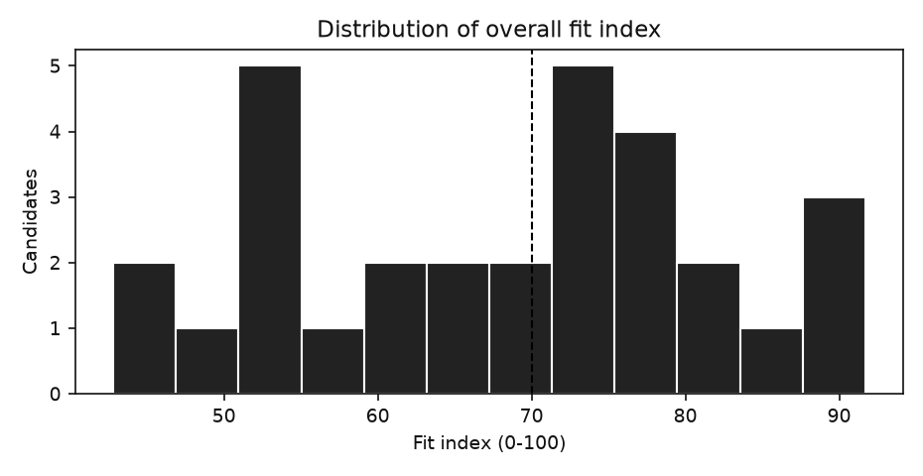
Figure 1. Distribution of the overall fit index (vertical line: High band threshold).
Component-level analysis.
Personality, cognitive ability and integrity show typical attainment near the target (mean 66-68), while interest congruence is naturally higher in an applicant pool that self-selects for the industry. BMI of the five components is balanced; the moderate correlations with the fit index (0.31-0.72) indicate that no single test dominates the decision.
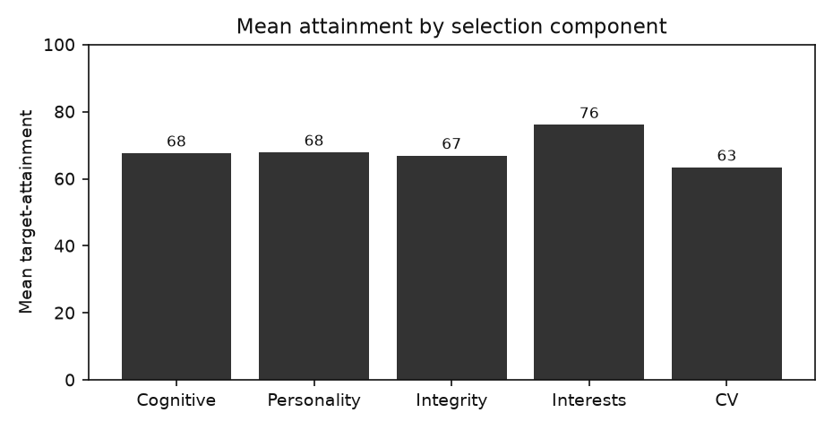
Figure 2. Mean target-attainment by selection component.
Component | Weight | Mean attainment | Correlation with fit
Cognitive ability (ICAR) | 20% | 67.7 | 0.72
Personality (IPIP-NEO-120) | 35% | 67.9 | 0.64
Integrity (HEXACO H-H) | 20% | 66.9 | 0.31
Vocational interests (O*NET) | 15% | 76.1 | 0.53
CV & documentation | 10% | 63.4 | 0.32
Table 1. Components, weights, attainment and correlation with overall fit.
Key relationships.
Cognitive ability shows the strongest association with overall fit (r = 0.72). Personality competence correlates at 0.64 and integrity at 0.31; CV/documentation alone (r = 0.32) and years of experience (r = 0.48) are weak predictors of the final recommendation - reinforcing the value of the structured evidence beyond the CV.
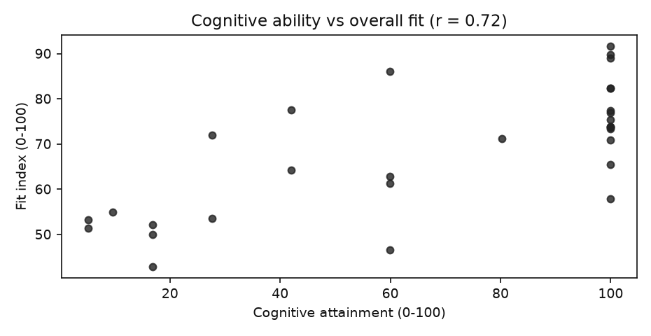
Figure 3. Cognitive attainment vs overall fit.
Top candidates.
Candidate Id | Name | Education Field | Degree | Years Experience | Holland Code | Icar Pct | Fit Index | Fit Label | Ac Overall
PM-013 | Fernanda Aguilar | Communications | Bachelor | 8 | ESC | 77 | 92 | High | 3
PM-030 | Nicolas Gomez | Psychology | Master | 11 | SEA | 95 | 90 | High | 3
PM-014 | Bruno Nunez | Other | Bachelor | 5 | CES | 67 | 89 | High | 3
PM-008 | Emilio Martinez | Software Engineering | PhD | 7 | ECS | 33 | 86 | High | 3
PM-023 | Gabriela Perez | Software Engineering | Bachelor | 3 | SCE | 95 | 82 | High | 3
PM-005 | Pablo Castillo | Psychology | Master | 2 | ECS | 77 | 82 | High | 3
PM-007 | Antonia Flores | Advertising | PhD | 14 | CSE | 23 | 78 | High | 3
PM-028 | Mateo Morales | Psychology | Bachelor | 16 | ECS | 56 | 77 | High | 3
Table 2. Top 8 candidates by fit index.
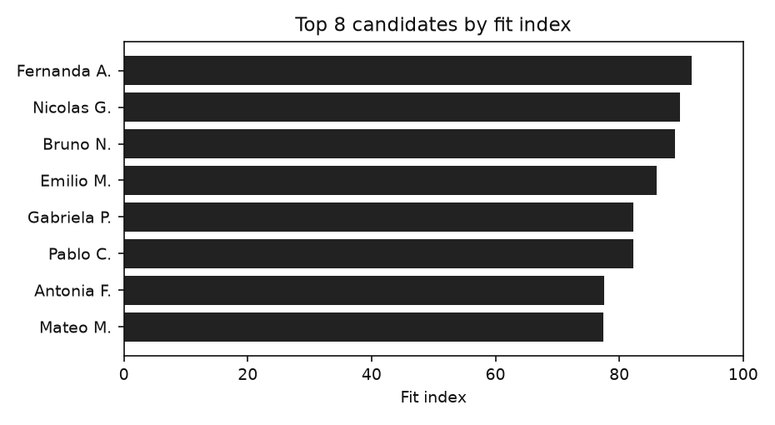
Figure 4. Top 8 candidates by fit index.
Proposed shortlist.
Selection angle | Candidate | Education | Fit | AC | Profile
First choice - best overall fit | Fernanda Aguilar (PM-013) | Communications · 8 yrs | 91.7 | 2.7/5 | ESC interest profile; conscientiousness very high; emotional regulation robust; collaborative style moderate.
Strongest behavioral profile | Alejandra Perez (PM-017) | Industrial Engineering · 6 yrs | 73.6 | 3.6/5 | ECS interest profile; conscientiousness low; emotional regulation robust; collaborative style high.
Highest growth potential | Gabriela Perez (PM-023) | Software Engineering · 3 yrs | 82.3 | 3.4/5 | SCE interest profile; conscientiousness low; emotional regulation developing; collaborative style high.
Table 3. Proposed shortlist handed to the decision maker.
6. Conclusions and recommendations
Conclusions.
- The multi-construct fit index integrates the full evidence base into one auditable number; its spread (min 42.8 / max 91.7) confirms it discriminates among applicants rather than returning a ceiling effect.
- Cognitive ability and structured personality indicators drive the decision; CV experience alone is a weak proxy for person-job fit (r = 0.48).
- The demonstration battery is free and fully traceable: every item, scoring rule and norm comes from published open-access documentation.
Recommendations.
- Adopt the fit-index workflow as the standard pre-offer gate; keep the assessment center for finalists only.
- Customize the component weights in scripts/project_config.py through a workshop with hiring managers, and recalibrate the High/Medium/Low bands after the first six months of performance data.
- Validate the index against on-the-job performance (engagement, retention, delivery KPIs) and monitor fairness by subgroup in the dashboard.
- Automate the pipeline (data -> scoring -> dashboard) so each requisition reuses the same instruments, formats and reporting with no incremental licensing spend.

