Demo 5 test evidence
23 October 2026. Captured automated results for the member management Git workflow demo. The images reproduce actual command output, with line wrapping for readability. They are rendered transcript captures, not photographs or screenshots of a desktop terminal. Original text records are retained alongside the images.

Scope and limitations
The automated UI test checks duplicate registration input retention and successful form reset. Unit tests cover validation, search and CRUD. The history exercise runs in a disposable repository. No manual browser walkthrough, hosted pull request, push, merge to the existing branches or deployment was performed. Node 25 emits a localStorage warning; all tests pass using the capability-checked fallback.

01 tests
Actual recorded output. See the matching TXT file for the complete record.
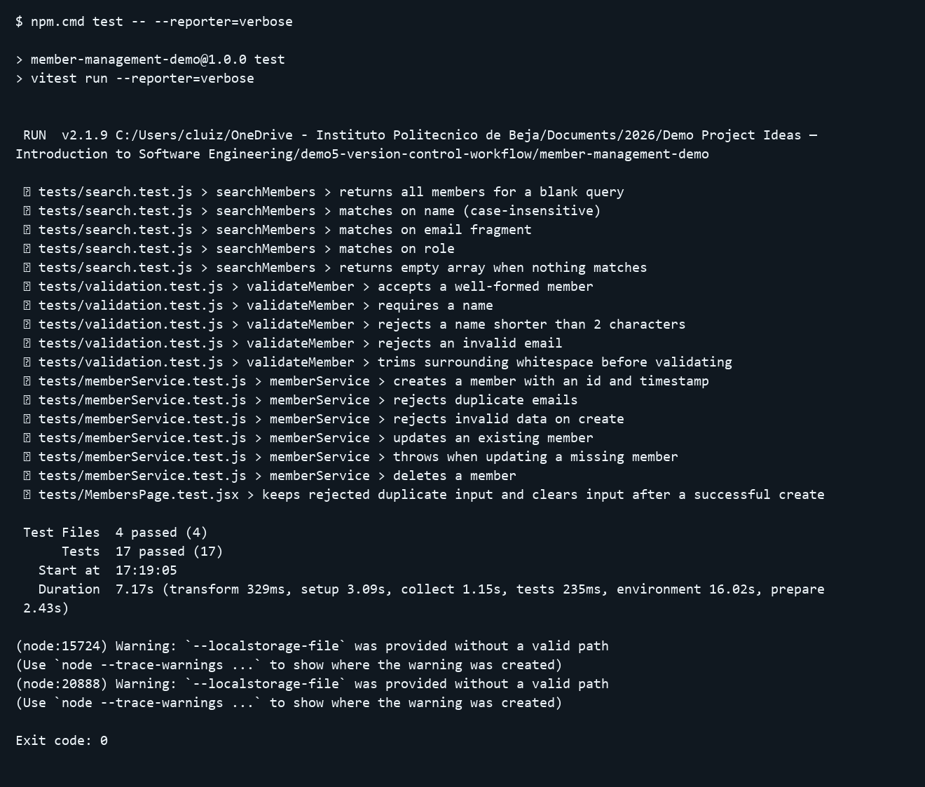

02 lint
Actual recorded output. See the matching TXT file for the complete record.
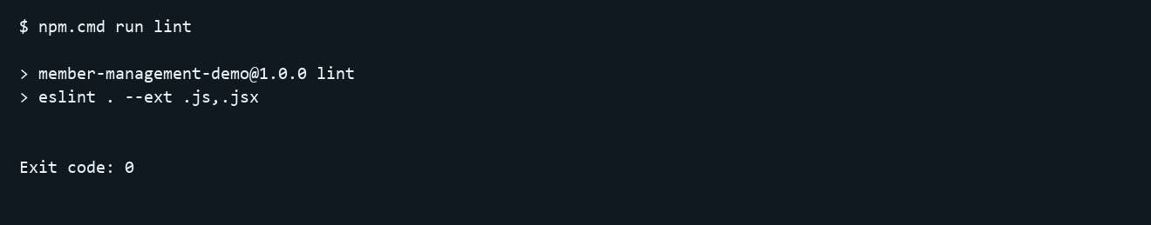

03 build
Actual recorded output. See the matching TXT file for the complete record.
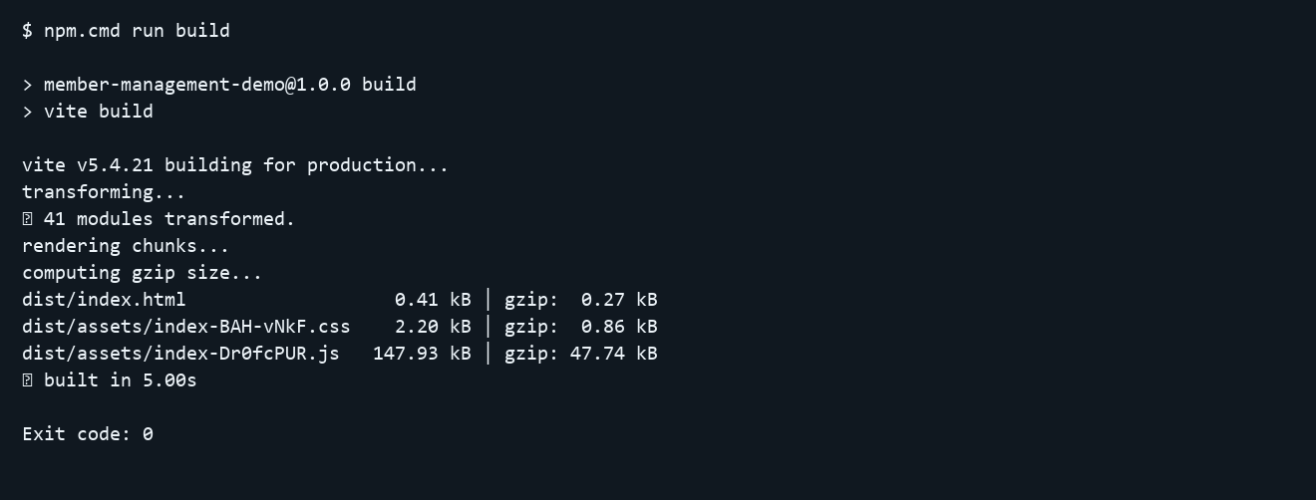

04 history rehearsal
Actual recorded output. See the matching TXT file for the complete record.
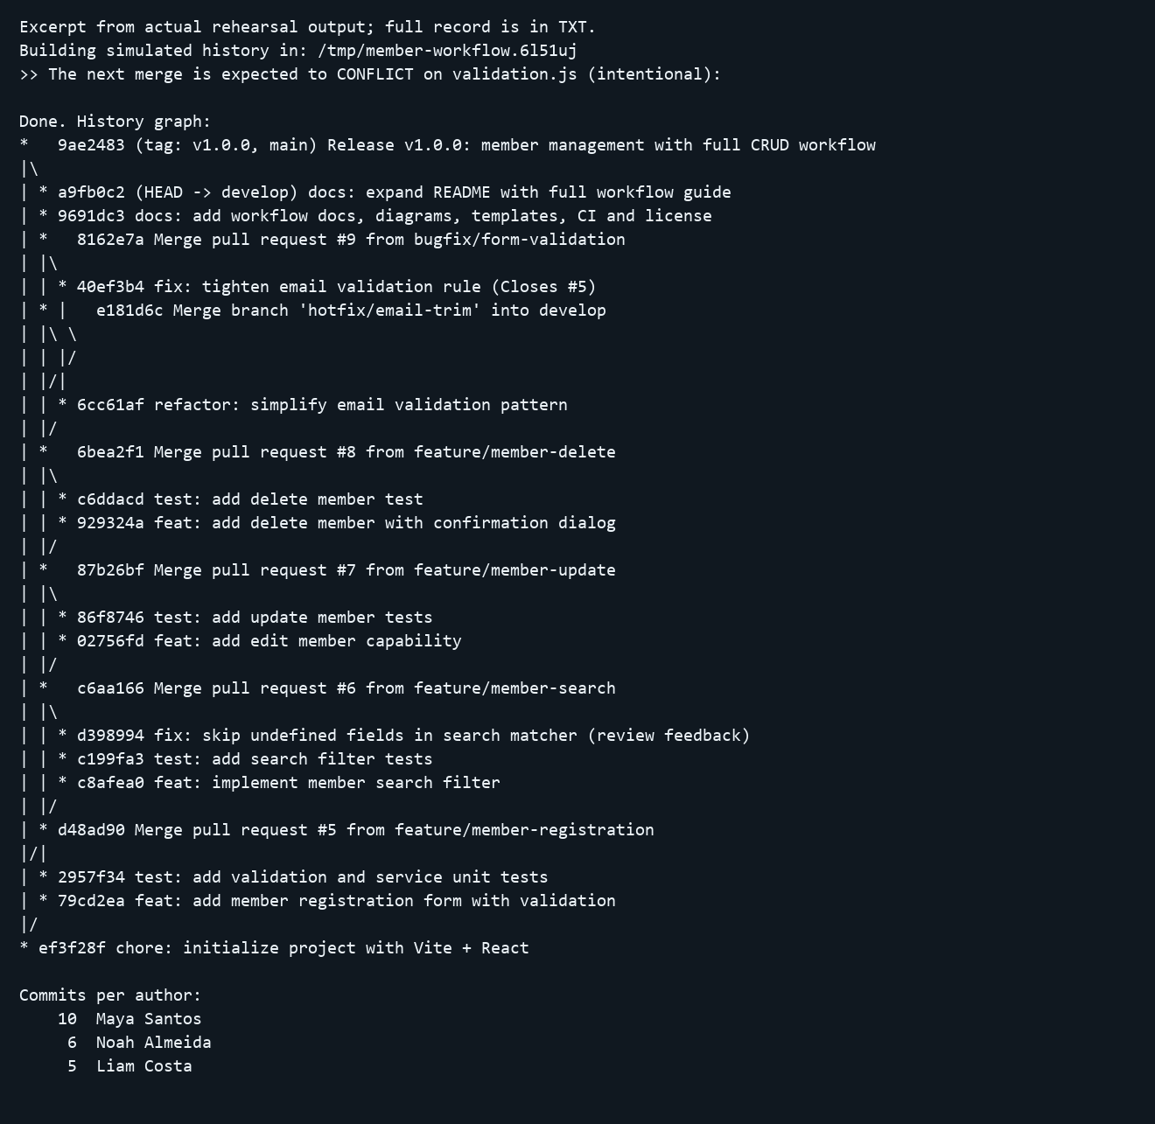

04 history rehearsal
Actual recorded output continued part 2. See the matching TXT file for the complete record.
