

STUDENT FEEDBACK SYSTEM USING MERN STACK

Velamuri Satya Sahiti – 24BRS1014
Mohamed Reihan – 24BRS1030
Swarit M – 24BRS1192
1. ABSTRACT
The Student Feedback System is a web-based application developed using the MERN stack (MongoDB, Express.js, React.js, Node.js) to streamline the process of collecting, managing, and analyzing student feedback for academic courses and faculty members. The system provides a structured and user-friendly interface for students to submit feedback and for administrators to evaluate teaching effectiveness.
The application ensures secure login authentication using credentials stored in MongoDB. Students can select their enrolled courses, view assigned faculty and provide feedback through a star-based rating system along with textual comments. The administrator module allows monitoring of feedback submissions, analysis of ratings, and identification of students who have or have not submitted feedback.
This project eliminates manual feedback collection, reduces redundancy, and enhances transparency and efficiency in academic evaluation processes.

2. INTRODUCTION
Feedback plays a crucial role in improving the quality of education. Traditional feedback systems are often paper-based, time-consuming, and prone to inefficiencies. This project aims to digitize and automate the feedback process using modern web technologies.
The Student Feedback System provides:
- Secure authentication for users
- Interactive feedback submission interface
- Real-time data storage and retrieval
- Administrative analysis tools
The system is designed to be scalable, efficient, and easy to use for both students and administrators.

3. OBJECTIVES
The main objectives of the project are:
- To develop a web-based platform for collecting student feedback
- To ensure secure login authentication using MongoDB
- To provide a user-friendly interface for feedback submission
- To implement a star rating system for evaluation
- To allow administrators to monitor and analyze feedback
- To track feedback submission status of students
- To eliminate manual paperwork and improve efficiency

4. TECHNOLOGY STACK
4.1 MongoDB
- NoSQL database used to store user credentials, feedback data, course details, and faculty information
- Provides flexibility in handling dynamic data
4.2 Express.js
- Backend framework for handling server-side logic
- Manages API routes and request handling
4.3 React.js
- Frontend library used for building dynamic user interfaces
- Handles component-based UI rendering
4.4 Node.js
- Runtime environment for executing JavaScript on the server
- Enables asynchronous operations and efficient handling of requests

5. SYSTEM ARCHITECTURE
The system follows a three-tier architecture:
- Presentation Layer (Frontend)
  - Built using React.js
  - Handles user interaction and UI rendering
- Application Layer (Backend)
  - Built using Node.js and Express.js
  - Processes requests and handles business logic
- Data Layer (Database)
  - MongoDB stores all application data
Data flows from the frontend to backend APIs, which interact with the database and return responses.

6. MODULES OF THE SYSTEM
6.1 Authentication Module
- Users log in using predefined credentials stored in MongoDB
- Validates username and password
- Grants or denies access accordingly
6.2 Student Module
- Allows students to:
  - Select their course
  - View assigned faculty
  - Submit feedback
- Feedback includes:
  - Star ratings
  - Textual comments
6.3 Admin Module
- Admin can:
  - View overall ratings of faculty and courses
  - Analyze feedback data
  - Track which students have submitted feedback
  - Identify students who have not submitted feedback

7. DATABASE DESIGN
The database consists of the following collections:
7.1 Users Collection
- Stores login credentials
- Fields: userId, username, password, role (student/admin)
7.2 Courses Collection
- Stores course details
- Fields: courseId, courseName
7.3 Faculty Collection
- Stores faculty details
- Fields: facultyId, facultyName, courseId
7.4 Feedback Collection
- Stores feedback submitted by students
- Fields:
  - feedbackId
  - studentId
  - courseId
  - facultyId
  - rating
  - comments

8. WORKING OF THE SYSTEM
- User accesses login page
- Credentials are verified with MongoDB
- Based on role:
  - Student is redirected to feedback page
  - Admin is redirected to dashboard
Student Workflow:
- Select course
- View faculty automatically
- Provide star rating and comments
- Submit feedback
Admin Workflow:
- View aggregated ratings
- Analyze performance of faculty
- Check submission status of students

9. FEATURES OF THE SYSTEM
- Secure login authentication
- Role-based access control
- Dynamic course and faculty mapping
- Star-based rating system
- Text-based feedback input
- Admin analytics dashboard
- Submission tracking system
- No dependency on external libraries

10. ADVANTAGES
- Reduces manual work
- Saves time and effort
- Improves accuracy of data
- Provides real-time feedback analysis
- Easy to use interface
- Scalable and flexible system

11. LIMITATIONS
- Uses predefined credentials (no registration system)
- Basic UI without additional libraries
- Limited analytics (no advanced graphs or AI insights)
- No email or notification system

12. FUTURE ENHANCEMENTS
- Add student registration system
- Implement JWT-based authentication
- Include graphical data visualization
- Add email notifications
- Introduce AI-based sentiment analysis
- Improve UI using modern design frameworks

13. CODE SNIPPETS
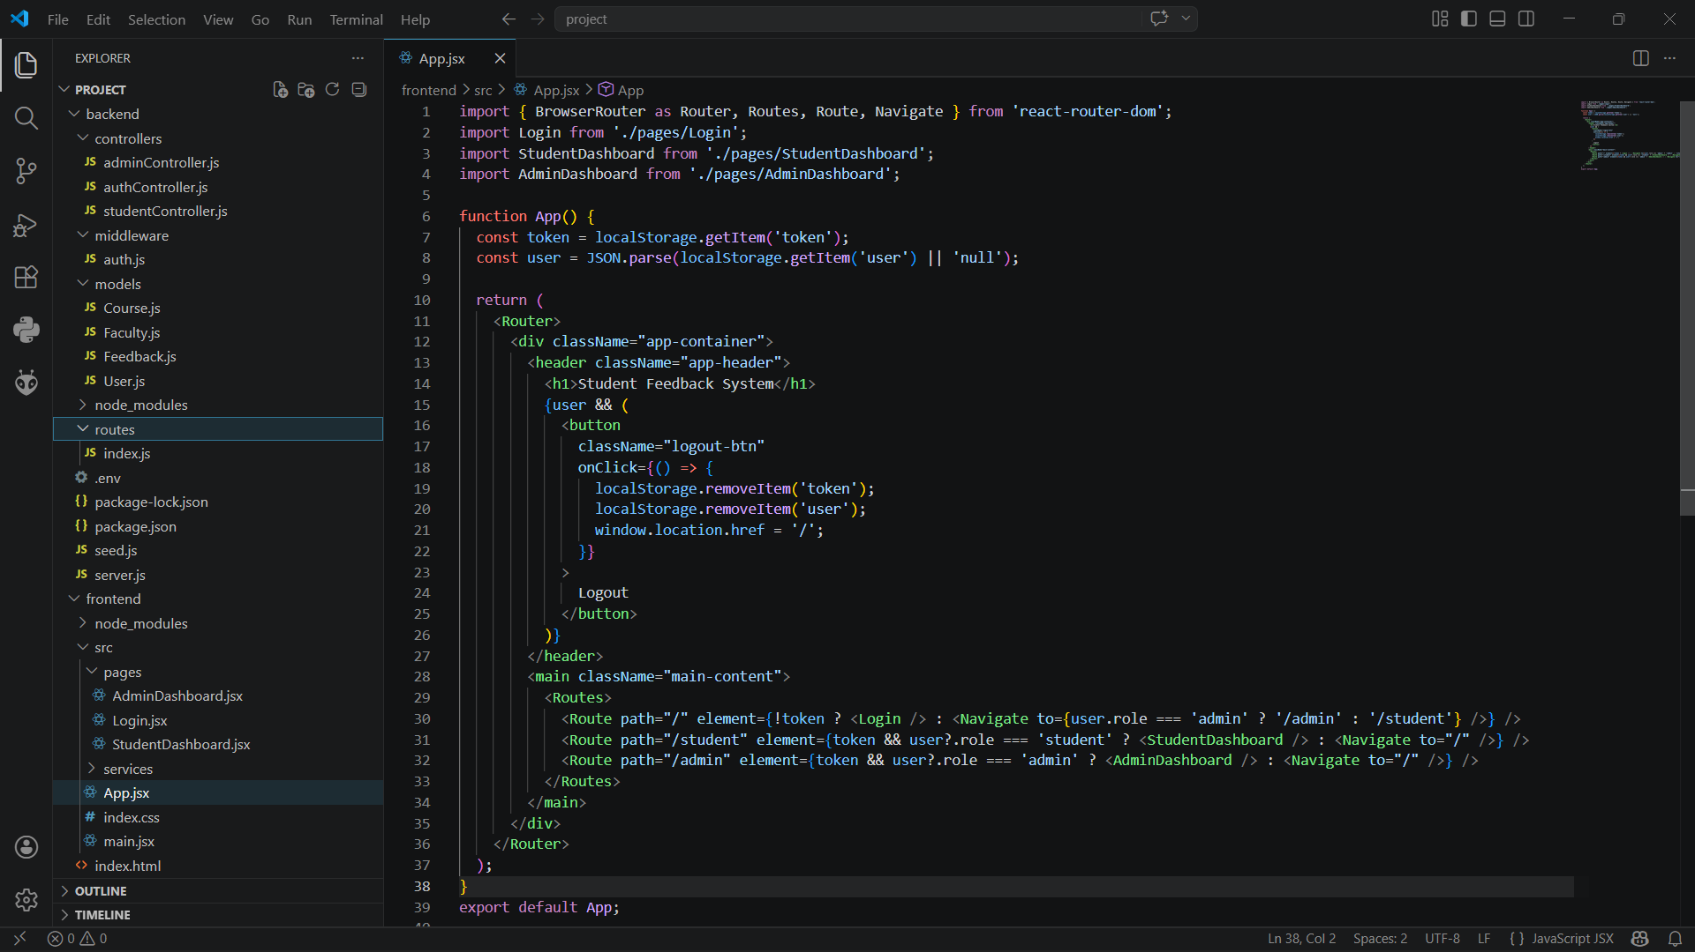

14. SCREENSHOTS
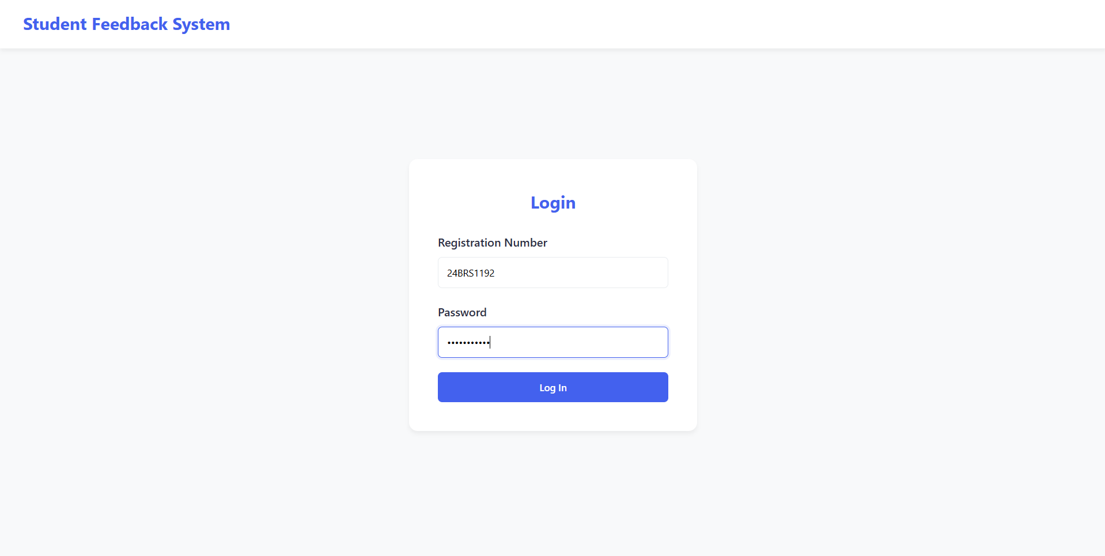
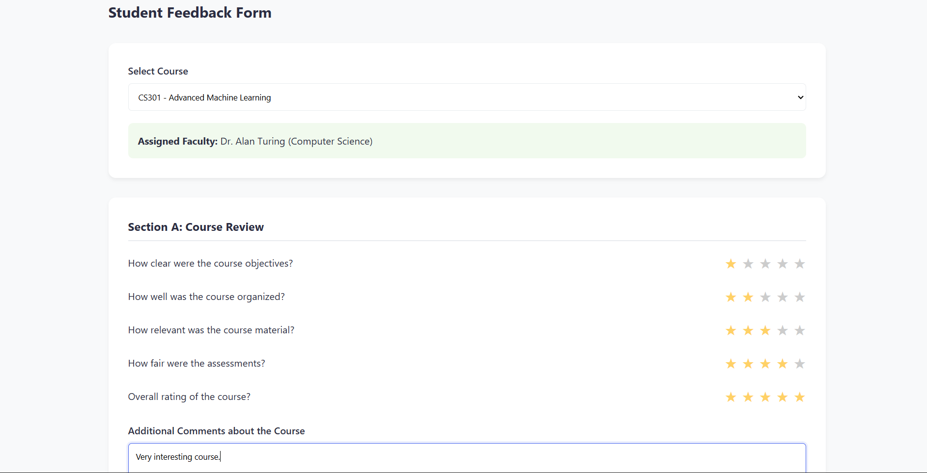
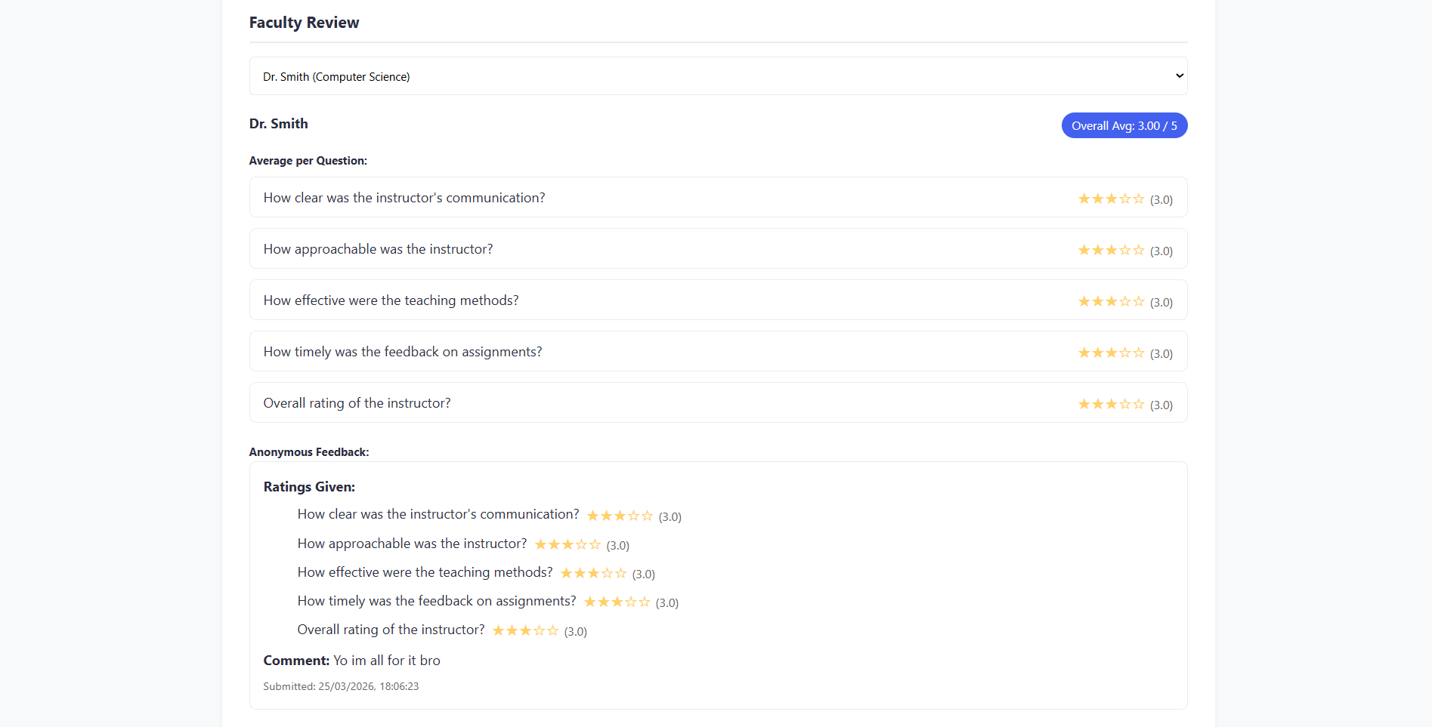

15. CONCLUSION
The Student Feedback System developed using the MERN stack successfully automates the process of collecting and analyzing student feedback. It provides a secure, efficient, and user-friendly platform for both students and administrators.
The project demonstrates the practical implementation of full-stack web development and highlights the effectiveness of modern technologies in solving real-world problems. With further enhancements, the system can be expanded into a comprehensive academic evaluation tool.

