**Crumar.**

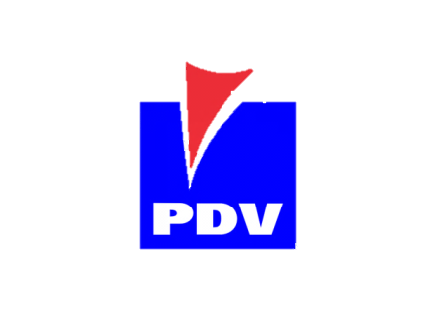

**Characteristics:**

Monograde Lubricant formulated with highly refined base and additives carefully selected that provide high detergency that ensures clean crankcase, crankshaft and areas under the piston crown, proper alkalinity to neutralize acids from combustion, appropriate antioxidants and exceptional qualities to wear to exceed step 10 of the FZG test.

**Uses:**

It has been specially developed to meet the lubrication requirements of diésel engine crankcase type low speed crosshead. Also can be used in bearings and stern drive, moderately loaded gear and air compressors where oil with the qualities described satisfies fully the requirements of lubrication.



**Presentación:** Tambores de 208 I; Granel.