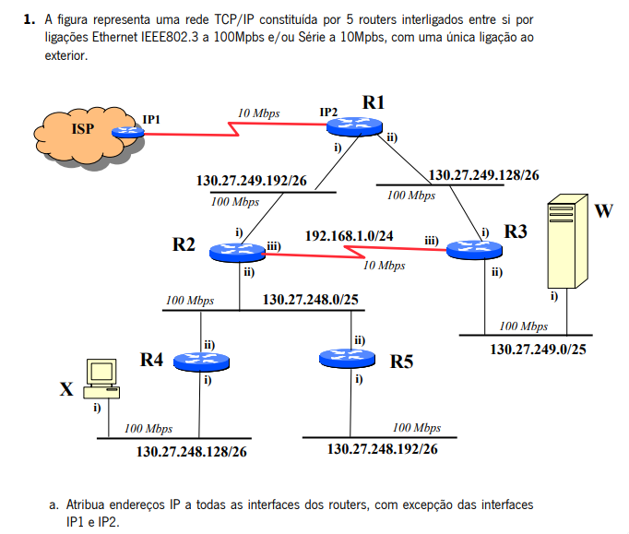
130.27.248.126
130.27.248.189
130.27.249.127

130.27.248.125

192.168.1.1
192.168.1.2
130.27.249.254

130.27.249.190
130.27.249.189
130.27.248.254
130.27.248.127
130.27.249.253

24-1
25-2
256/2=128
0-128->1-127
128-255->129-254

26-4

27-8
28-16
29-32
30-64

192.168.1.2
256/4=64->64-2=62 hosts p subrede
0-63 -->uteis: 1-62
64-127->65-126
128-191-->129-190
192-255-->193-254

R1:
i-130.27.249.254
ii-130.27.249.189

R2:
i-130.27.249.253
ii-130.27.248.127
iii-192.168.1.1

R3:
i-130.27.249.189
ii-130.27.249.127
iii- 192.168.1.2

R4:
i-130.27.248.190
ii-130.27.248.126

R5:
i-130.27.248.254
ii-130.27.248.125

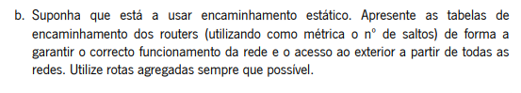
R1
REDE DE DESTINO | INTERFACE DE SAÍDA | PRÓXIMO NÓ | CUSTO
130.27.249.192/26 | 130.27.249.254 | ---- | 0
130.27.249.128/26 | 130.27.249.189 | ---- | 0
130.27.248.0/24 | 130.27.249.254 | 130.27.249.253 | 1
130.27.249.0/25 | 130.27.249.190 | 130.27.249.189 | 1
192.168.1.0/24 | 130.27.249.190 | 130.27.249.189 | 1
0.0.0.0/0 | IP2 | IP1 | ----

R2
REDE DE DESTINO | INTERFACE DE SAÍDA | PRÓXIMO NÓ | CUSTO
130.27.249.192/26 | 130.27.249.253 | ---- | 0
130.27.249.128/26 | 130.27.249.253 | 130.27.249.254 | 1
130.27.248.0/25 | 130.27.248.127 | --- | 0
130.27.248.128/26 | 130.27.248.127 | 130.27.248.126 | 1
130.27.248.192/26 | 130.27.248.127 | 130.27.248.125 | 1
130.27.249.0/25 | 192.168.1.1 | 192.168.1.2 | 1
192.168.1.0/24 | 192.168.1.1 | ---- | 0
0.0.0.0/0 | 130.27.249.253 | 130.27.249.254 | 1

R3
REDE DE DESTINO | INTERFACE DE SAÍDA | PRÓXIMO NÓ | CUSTO
130.27.249.192/26 | 192.168.1.2 | 192.168.1.1 | 1
130.27.249.128/26 | 130.27.249.190 | ---- | 0
130.27.248.0/24 | 130.27.249.254 | 130.27.249.253 | 1
130.27.249.0/25 | 130.27.249.127 | --- | 0
192.168.1.0/24 | 192.168.1.1 | --- | 0
0.0.0.0/0 | 130.27.249.189 | 130.27.249.190 | 1

R4
REDE DE DESTINO | INTERFACE DE SAÍDA | PRÓXIMO NÓ | CUSTO
130.27.249.128/25 | 130.27.248.126 | 130.27.248.127 | 1
130.27.248.0/25 | 130.27.248.126 | --- | 0
130.27.249.192/26 | 130.27.248.126 | 130.27.248.125 | 1
192.168.1.0/24 | 130.27.248.126 | 130.27.248.127 | 1
130.27.249.0/25 | 130.27.248.126 | 130.27.248.127 | 1
130.27.248.128/26 | 130.27.248.189 | ----- | 0
0.0.0.0/0 | 130.27.248.126 | 130.27.248.127 | 2

R5
REDE DE DESTINO | INTERFACE DE SAÍDA | PRÓXIMO NÓ | CUSTO
130.27.249.128/25 | 130.27.248.125 | 130.27.248.127 | 1
130.27.248.0/25 | 130.27.248.125 | --- | 0
130.27.249.192/26 | 130.27.248.125 | 130.27.248.126 | 1
192.168.1.0/24 | 130.27.248.125 | 130.27.248.127 | 1
130.27.249.0/25 | 130.27.248.125 | 130.27.248.127 | 1
130.27.248.192/26 | 130.27.248.254 | -- | ----
0.0.0.0/0 | 130.27.248.125 | 130.27.248.127 | 2

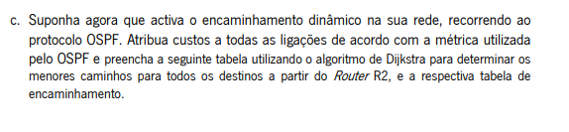
Segundo o ospf a métrica=10⁸/x bps-->100Mbps=100*10⁶bps=10⁸ bps
100Mbps=>1 metrica ospf

10Mbps=>10 metrica ospf

Passo | N | D(R1),P(R1) | D(R3),P(R3) | D(R4),P(R4) | D(R5),P(R5) | ISP
0 | R2 | 1,R2 | 10,R2 | 1,R2 | 1,R2 | ∞
1 | R2,R1 | ----- | 2,R1 | 1,R2 | 1,R2 | 11,R1
2 | R2,R1,R4 | ------ | 2,R1 | ----- | 1,R2 | 11,R1
3 | R2,R1,R4,R5 | -------- | 2,R1 | ------ | ---- | 11,R1
4 | R2,R1,R4,R5,R3 | ----- | ----- | ------ | ----- | 11,R1

Tabela de encaminhamento ospf
DESTINO | INTERFACE DE SAÍDA | PRÓXIMO NÓ | CUSTO
R1 | R2-i | R1-i | 1
R3 | R2-iii | R3-iii | 2
R4 | R2-ii | R4-ii | 1
R5 | R2-ii | R5-ii | 1
ISP | R2-i | R1-i | 11

