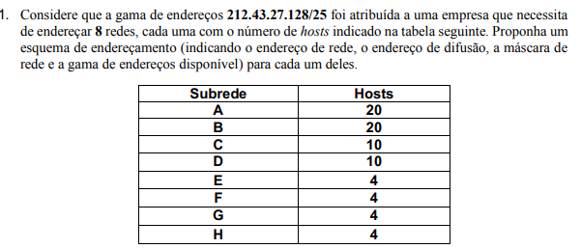

 | End.Rede | End.Difusão | Máscara de rede | Gama de endereços válidos
A | 212.43.27.128 | 212.43.27.159 | /27 | DE 212.43.27.129  ATÉ 212.43.27.158
B | 212.43.27.160 | 212.43.27.191 | /27 | DE 212.43.27.161  ATÉ 212.43.27.190
C | 212.43.27.192 | 212.43.27.207 | /28 | DE 212.43.27.161  ATÉ 212.43.27.206
D | 212.43.27.208 | 212.43.27.223 | /28 | DE 212.43.27.209  ATÉ 212.43.27.222
E | 212.43.27.224 | 212.43.27.231 | /29 | DE 212.43.27.225  ATÉ 212.43.27.230
F | 212.43.27.232 | 212.43.27.239 | /29 | DE 212.43.27.233  ATÉ 212.43.27.238
G | 212.43.27.240 | 212.43.27.247 | /29 | DE 212.43.27.241  ATÉ 212.43.27.246
H | 212.43.27.248 | 212.43.27.255 | /29 | DE 212.43.27.249  ATÉ 212.43.27.254

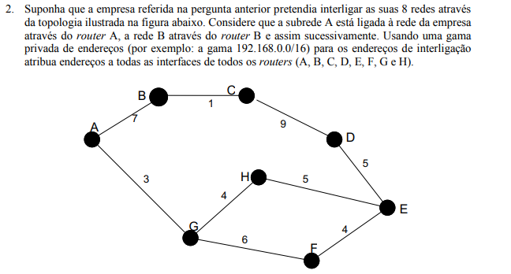
iii
ii
i
ii
i
ii
i
iii
ii
i
ii
i
ii
i
ii
i
ii
i
i

A-
i-192.168.0.1/30
ii-192.168.0.2/30

B-
i-192.168.0.5/30
ii-192.168.0.6/30

C
i-192.168.0.9/30
ii.192.168.0.10/30

D-
i-192.168.0.13/30
ii-192.168.0.14/30

E-
i-192.168.0.17/30
ii-192.168.0.18/30
iii-192.168.0.21/30

F-
i-192.168.0.22/30
ii-192.168.0.25/30

G
i-192.168.0.26/30
ii-192.168.0.29/30
iii-192.168.0.30/30

H

i-192.168.33/30
ii-192.168.0.34/30
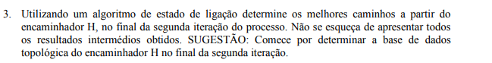
Algoritmo de Dijkstra
Início:
H conhece que pode ir para G e E, diretamente.

1ª iteração:
H conhece os vizinhos de G(A,F) e de E(D,F).

2ªiteração:
H conhece os vizinhos de D(C) e A(B).

LSA-Passo 0:
Passo | N | D(A),P(A) | D(B),P(B) | D(C),P(C) | D(D),P(D) | D(E),P(E) | D(F),P(F) | D(G),P(G)
0 | H | ∞ | ∞ | ∞ | ∞ | 5,H | ∞ | 4,H

[FIM DA ITERAÇÃO INÍCIO]
LSA-Passo 1:

Passo | N | D(A),P(A) | D(B),P(B) | D(C),P(C) | D(D),P(D) | D(E),P(E) | D(F),P(F) | D(G),P(G)
0 | H | ∞ | ∞ | ∞ | ∞ | 5,H | ∞ | 4,H
1 | HG | 3,G | ∞ | ∞ | ∞ | 5,H | 10,G | ----

LSA-Passo 2:
Passo | N | D(A),P(A) | D(B),P(B) | D(C),P(C) | D(D),P(D) | D(E),P(E) | D(F),P(F) | D(G),P(G)
0 | H | ∞ | ∞ | ∞ | ∞ | 5,H | ∞ | 4,H
1 | HG | 7,G | ∞ | ∞ | ∞ | 5,H | 10,G | ----
2 | HGE | 7,G | ∞ | ∞ | 10,E | ---- | 9,E

[FIM DA ITERAÇÃO 1]

LSA-Passo 3:
Passo | N | D(A),P(A) | D(B),P(B) | D(C),P(C) | D(D),P(D) | D(E),P(E) | D(F),P(F) | D(G),P(G)
0 | H | ∞ | ∞ | ∞ | ∞ | 5,H | ∞ | 4,H
1 | HG | 7,G | ∞ | ∞ | ∞ | 5,H | 10,G | ----
2 | HGE | 7,G | ∞ | ∞ | 10,E | ---- | 10,G | ---
3 | HGEA | --- | 14,A | ∞ | 10,E | ---- | 10,G | ---

LSA-Passo 4:
Passo | N | D(A),P(A) | D(B),P(B) | D(C),P(C) | D(D),P(D) | D(E),P(E) | D(F),P(F) | D(G),P(G)
0 | H | ∞ | ∞ | ∞ | ∞ | 5,H | ∞ | 4,H
1 | HG | 7,G | ∞ | ∞ | ∞ | 5,H | 10,G | ----
2 | HGE | 7,G | ∞ | ∞ | 10,E | ---- | 10,G | ---
3 | HGEA | --- | 14,A | ∞ | 10,E | ---- | 10,G | ---
4 | HGEAF | --- | 14,A | ∞ | 10,E | ---- | -----

LSA-Passo5:
Passo | N | D(A),P(A) | D(B),P(B) | D(C),P(C) | D(D),P(D) | D(E),P(E) | D(F),P(F) | D(G),P(G)
0 | H | ∞ | ∞ | ∞ | ∞ | 5,H | ∞ | 4,H
1 | HG | 7,G | ∞ | ∞ | ∞ | 5,H | 10,G | ----
2 | HGE | 7,G | ∞ | ∞ | 10,E | ---- | 10,G | ---
3 | HGEA | --- | 14,A | ∞ | 10,E | ---- | 10,G | ---
4 | HGEAF | --- | 14,A | ∞ | 10,E | ---- | ----- | ----
5 | HGEAFD | --- | 14,A | 19,D | ---- | ---- | ----- | ----

[FIM DA ITERAÇÃO 2]

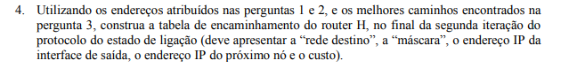
Rede Destino | Máscara | End.IP inter.saída | End. IP prox. Nó | custo
212.43.27.128(A) | /27 | ii-192.168.0.34/30 | 192.168.0.30/30(G-iii) | 7
212.43.27.160(B) | /27 | ii-192.168.0.34/30 | 192.168.0.30/30(G-iii) | 14
212.43.27.192(C) | /28 | i-192.168.33/30 | 192.168.0.21/30(E-iii) | 19
212.43.27.208(D) | /28 | i-192.168.33/30 | 192.168.0.21/30(E-iii) | 10
212.43.27.224(E) | /29 | i-192.168.33/30 | 192.168.0.21/30(E-iii) | 5
212.43.27.232(F) | /29 | ii-192.168.0.34/30 | 192.168.0.30/30(G-iii) | 9
212.43.27.240(G) | /29 | ii-192.168.0.34/30 | 192.168.0.30/30(G-iii) | 4
212.43.27.248(H) | /29 | ------ | -------- | 0

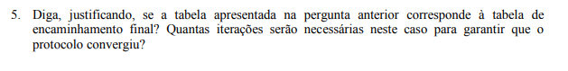
Não, uma vez que existem redes para as quais o router H ainda não sabe que existem caminhos com menos custos para chegar a elas.()
Seriam necessárias 3 iterações(sem ser do dijkstra), para garantir que o protocolo convergiu.

Caso se fizessem as 3 iterações:

Iteração 3:
H conhece os vizinhos de C(B) e B(C)

LSA-Passo 6
Passo | N | D(A),P(A) | D(B),P(B) | D(C),P(C) | D(D),P(D) | D(E),P(E) | D(F),P(F) | D(G),P(G)
0 | H | ∞ | ∞ | ∞ | ∞ | 5,H | ∞ | 4,H
1 | HG | 7,G | ∞ | ∞ | ∞ | 5,H | 10,G | ----
2 | HGE | 7,G | ∞ | ∞ | 10,E | ---- | 10,G | ---
3 | HGEA | --- | 14,A | ∞ | 10,E | ---- | 10,G | ---
4 | HGEAF | --- | 14,A | ∞ | 10,E | ---- | ----- | ----
5 | HGEAFD | --- | 14,A | 19,D | ---- | ---- | ----- | ----
6 | HGEAFDB | ---- | ---- | 15,B | ---- | ---- | ---- | ----

LSA-Passo7
Passo | N | D(A),P(A) | D(B),P(B) | D(C),P(C) | D(D),P(D) | D(E),P(E) | D(F),P(F) | D(G),P(G)
0 | H | ∞ | ∞ | ∞ | ∞ | 5,H | ∞ | 4,H
1 | HG | 7,G | ∞ | ∞ | ∞ | 5,H | 10,G | ----
2 | HGE | 7,G | ∞ | ∞ | 10,E | ---- | 10,G | ---
3 | HGEA | --- | 14,A | ∞ | 10,E | ---- | 10,G | ---
4 | HGEAF | --- | 14,A | ∞ | 10,E | ---- | ----- | ----
5 | HGEAFD | --- | 14,A | 19,D | ---- | ---- | ----- | ----
6 | HGEAFDB | ---- | ---- | 15,B | ---- | ---- | ---- | ----
7 | HGEAFDBC | ---- | ---- | ----- | ---- | ---- | ---- | ----

[FIM ITERAÇÃO 3]
Só após 3 iterações conhece este caminho

