Foundations

Problem Solving

Learning Outcomes
By the end of this lesson, you should be able to do the following:
- Explain the three steps in the problem solving process.
- Explain what pseudo code is and be able to use it to solve problems.
- Be able to break a problem down into subproblems.

How to solve a problem:
- understand, write down and explain the problem.
- Plan how to solve the problem:
  - Does your program have a user interface? What will it look like? What functionality will the interface have? Sketch this out on paper.
  - What inputs will your program have? Will the user enter data or will you get input from somewhere else?
  - What’s the desired output?
  - Given your inputs, what are the steps necessary to return the desired output?
- Write pseudo code.
- Decompose the big problem into smaller subproblems.

Assignment

1. How to think like a programmer — lessons in problem solving
https://www.freecodecamp.org/news/how-to-think-like-a-programmer-lessons-in-problem-solving-d1d8bf1de7d2/
The best way to solve a problem involves a) having a framework and b) practicing it.
Steps to solve a problem:
- Understand
- Plan
- Divide
- Stuck?
  - Debug: Go step by step through your solution trying to find where you went wrong. Programmers call this debugging (in fact, this is all a debugger does). “The art of debugging is figuring out what you really told your program to do rather than what you thought you told it to do.”” — Andrew Singer.
  - Reassess: Take a step back. Look at the problem from another perspective. Is there anything that can be abstracted to a more general approach?
  - Another way of reassessing is starting anew. Delete everything and begin again with fresh eyes. I’m serious. You’ll be dumbfounded at how effective this is.
  - Research: Ahh, good ol’ Google. You read that right. No matter what problem you have, someone has probably solved it. Find that person/ solution. In fact, do this even if you solved the problem! (You can learn a lot from other people’s solutions).
Practice your problem solving skills with chess puzzles, math problems, Sudoku, Go, Monopoly, video-games, cryptokitties, bla… bla… bla….

2. How to think like a programmer – Coding Tech
https://www.youtube.com/watch?v=azcrPFhaY9k
Master the algorithms, not the code languages.

3. What is Pseudo-coding?
https://www.vikingcodeschool.com/software-engineering-basics/what-is-pseudo-coding
Pseudocode is basically just writing down the logic of your solution to a specific coding challenge using plain English.
Pseudocode is a useful thing to learn because it focuses on the building block concepts of programming languages without you having to worry about whether you are using the "right" words.
How a vending machine works with pseudocode:
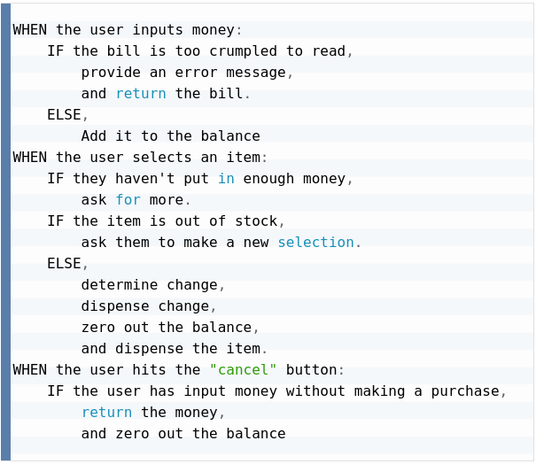
Using pseudocode is important to diagram the problem, you should write down comments explaining how your code will work, and then start putting the actual code, like this:
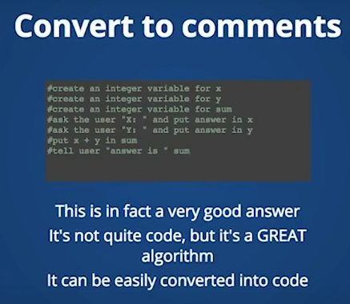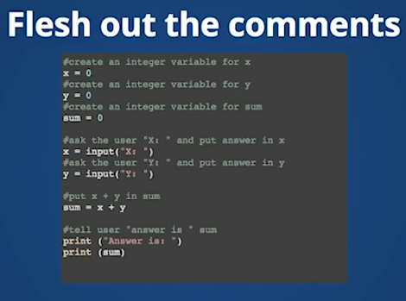

Knowledge check
- What are the three stages in the problem solving process?
Understand the problem, plan, write algorithm (pseudocode).
- Why is it important to clearly understand the problem first?
To know when you have solved it.
- What can you do to help get a clearer understanding of the problem?
Try to explain it to someone else.
- What are some of the things you should do in the planning stage of the problem solving process?
Ask: what inputs and outputs will your program have? and given your inputs, what are the steps necessary to get the desired output?, will your program have an interface?
- What is an algorithm?
It is the list of instructions to perform an operation that a machine or computer can understand.
- What is pseudo code?
Its when you write in English the logic steps to perform an operation or a calculation.
- What are the advantages of breaking a problem down and solving the smaller problems?
Smaller problems are easier to solve, and when you start solving sub-parts of the whole problem, you begin to see a clearer solution to the big problem.

JS Fundamentals Part 4

Arrays

1. JavaScript Arrays
https://www.w3schools.com/js/js_arrays.asp
JavaScript arrays are used to store multiple values in a single variable. An array is a special variable, which can hold more than one value at a time.
Access the Elements of an Array
You can have access to an array element by referring to the index number. For example:

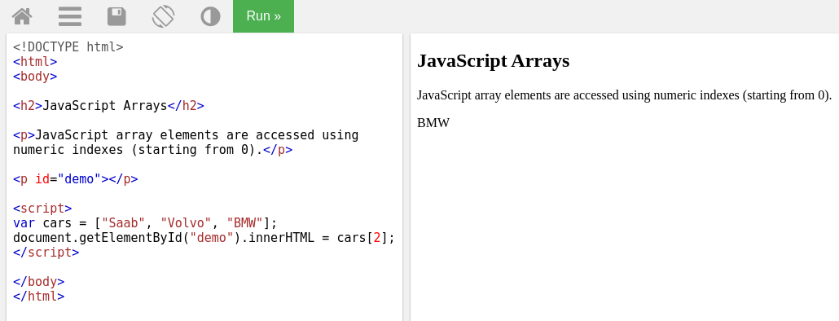

Access the Full Array
With JavaScript, the full array can be accessed by referring to the array name:
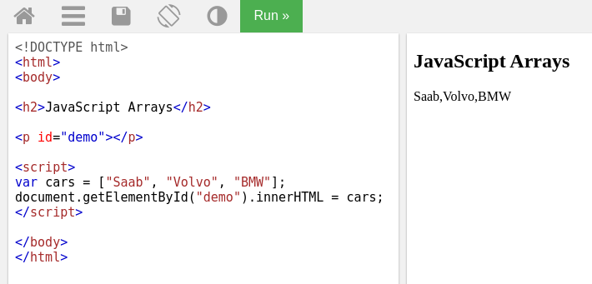

Arrays are Objects
Arrays are a special type of objects. The typeof operator in JavaScript returns "object" for arrays. But, JavaScript arrays are best described as arrays. Arrays use numbers to access its "elements", while objects use names to access its "members".
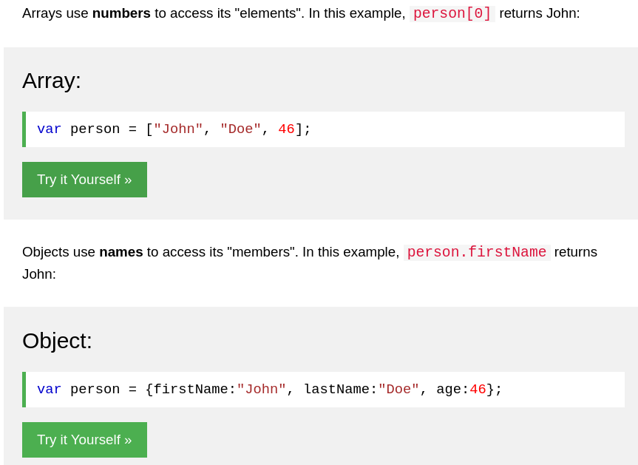

2. JavaScript Array Methods
https://www.w3schools.com/js/js_array_methods.asp
- toString()

- join()

- pop()

- push()

- shift() // removes the first array element and "shifts" all other elements to a lower index.

- Unshift() // adds a new element to an array (at the beginning), and "unshifts" older elements. It returns the new array length

- splice()

- concat() //creates a new array by merging (concatenating) existing arrays

- slice()

- sort()

Loops

1. Looping code
https://developer.mozilla.org/en-US/docs/Learn/JavaScript/Building_blocks/Looping_code
The for loop has the following syntax:
for (initializer; condition; final-expression) {
// code to run
}
Here, we have:
- The keyword for, followed by some parentheses.
- Inside the parentheses we have three items, separated by semi-colons:
  - An initializer — this is usually a variable set to a number, which is incremented to count the number of times the loop has run. It is also sometimes referred to as a counter variable.
  - A condition — as mentioned before, this defines when the loop should stop looping. This is generally an expression featuring a comparison operator, a test to see if the exit condition has been met.
  - A final-expression — this is always evaluated (or run) each time the loop has gone through a full iteration. It usually serves to increment (or in some cases decrement) the counter variable, to bring it closer to the point where the condition is no longer true.
- Some curly braces that contain a block of code — this code will be run each time the loop iterates.
Exiting loops with break
If you want to exit a loop before all the iterations have been completed, you can use the break statement. A break statement will immediately exit the loop and make the browser move on to any code that follows it.
Say we wanted to search through an array of contacts and telephone numbers and return just the number we wanted to find? First, some simple HTML — a text <input> allowing us to enter a name to search for, a <button> element to submit a search, and a <p> element to display the results in. The following code snipped and its live preview by MDN performs that operation:
https://github.com/mdn/learning-area/blob/master/javascript/building-blocks/loops/contact-search.html
https://mdn.github.io/learning-area/javascript/building-blocks/loops/contact-search.html
Skipping iterations with continue
The continue statement works in a similar manner to break, but instead of breaking out of the loop entirely, it skips to the next iteration of the loop.
while and do ... while
for is not the only type of loop available in JavaScript. There are actually many others and, while you don't need to understand all of these now, it is worth having a look at the structure of a couple of others so that you can recognize the same features at work in a slightly different way.
The while loop’s syntax looks like so:
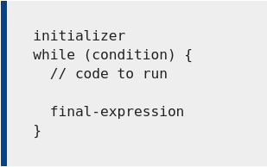

The do...while loop is very similar, but provides a variation on the while structure:
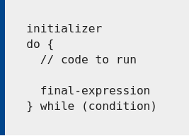

2. Loops: while and for
https://javascript.info/while-for
Breaking the loop
Normally, a loop exits when its condition becomes falsy. But we can force the exit at any time using the special break directive. For example, the loop below asks the user for a series of numbers, “breaking” when no number is entered:
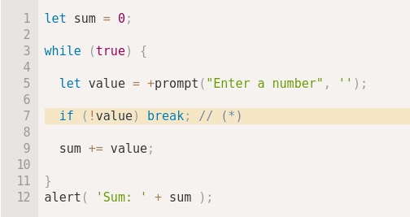

The break directive is activated at the line (*) if the user enters an empty line or cancels the input. It stops the loop immediately, passing control to the first line after the loop. Namely, alert.
Labels for break/continue
Sometimes we need to break out from multiple nested loops at once. For example, in the code below we loop over i and j, prompting for the coordinates (i, j) from (0,0) to (2,2):
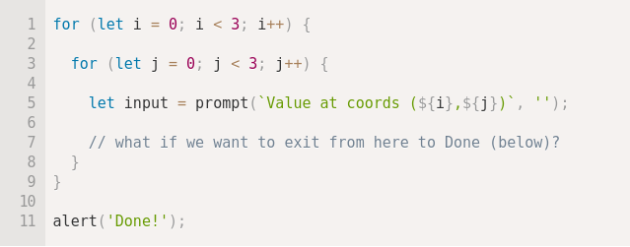

We need a way to stop the process if the user cancels the input. The ordinary break after input would only break the inner loop. That’s not sufficient – labels, come to the rescue! A label is an identifier with a colon before a loop.
The break <labelName> statement in the loop below breaks out to the label:
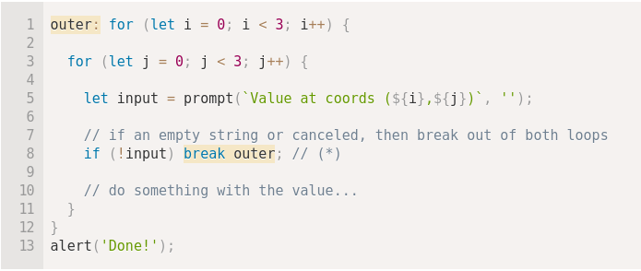

In the code above, break outer looks upwards for the label named outer and breaks out of that loop. So the control goes straight from (*) to alert('Done!').

