Principal Component Analysis
Dataset datos.acp
This dataset contains 100 individuals and 6 variables.

1. Study of the outliers
The analysis of the graphs does not detect any outlier.

2. Inertia distribution
The inertia of the first dimensions shows if there are strong relationships between variables and suggests the number of dimensions that should be studied.
The first two dimensions of analyse express 70.88% of the total dataset inertia ; that means that 70.88% of the individuals (or variables) cloud total variability is explained by the plane. This percentage is high and thus the first plane represents an important part of the data variability. This value is strongly greater than the reference value that equals 44.61%, the variability explained by this plane is thus highly significant (the reference value is the 0.95-quantile of the inertia percentages distribution obtained by simulating 571 data tables of equivalent size on the basis of a normal distribution).
From these observations, it is probably not useful to interpret the next dimensions.
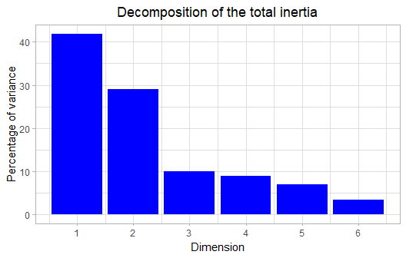
Figure 2 - Decomposition of the total inertia
An estimation of the right number of axis to interpret suggests to restrict the analysis to the description of the first 2 axis. These axis present an amount of inertia greater than those obtained by the 0.95-quantile of random distributions (70.88% against 44.61%). This observation suggests that only these axis are carrying a real information. As a consequence, the description will stand to these axis.

3. Description of the plane 1:2
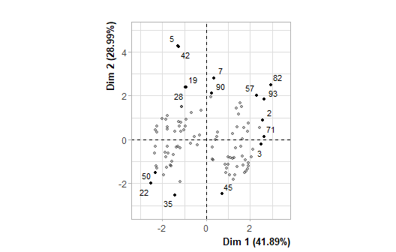
Figure 3.1 - Individuals factor map (PCA) The labeled individuals are those with the higher contribution to the plane construction.
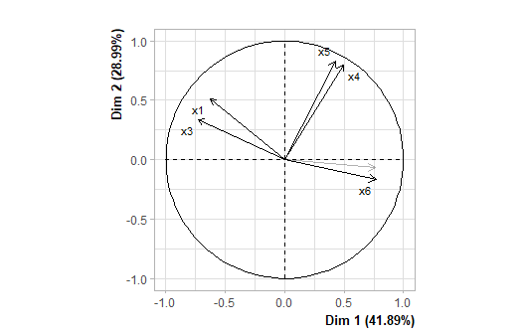
Figure 3.2 - Variables factor map (PCA) The labeled variables are those the best shown on the plane.

The dimension 1 opposes individuals such as 45, 2, 82, 57, 71, 3 and 93 (to the right of the graph, characterized by a strongly positive coordinate on the axis) to individuals such as 35, 22 and 50 (to the left of the graph, characterized by a strongly negative coordinate on the axis).
The group in which the individuals 45, 2, 82, 57, 71, 3 and 93 stand (characterized by a positive coordinate on the axis) is sharing :
- high values for the variables x2, x6 and x4 (variables are sorted from the strongest).
- low values for the variables x3 and x1 (variables are sorted from the weakest).
The group in which the individuals 35, 22 and 50 stand (characterized by a negative coordinate on the axis) is sharing :
- high values for the variables x3 and x1 (variables are sorted from the strongest).
- low values for the variables x4, x6, x5 and x2 (variables are sorted from the weakest).

The dimension 2 opposes individuals such as 5, 42, 28, 19, 7 and 90 (to the top of the graph, characterized by a strongly positive coordinate on the axis) to individuals such as 35, 22 and 50 (to the bottom of the graph, characterized by a strongly negative coordinate on the axis).
The group in which the individuals 5, 42, 28, 19, 7 and 90 stand (characterized by a positive coordinate on the axis) is sharing :
- high values for the variables x5, x3, x4 and x1 (variables are sorted from the strongest).
- low values for the variable x2.
The group in which the individuals 35, 22 and 50 stand (characterized by a negative coordinate on the axis) is sharing :
- high values for the variables x3 and x1 (variables are sorted from the strongest).
- low values for the variables x4, x6, x5 and x2 (variables are sorted from the weakest).

Annexes

