Codebook for datos
Autogenerated data summary from dataMaid
2021-02-25 17:49:47

Data report overview
The dataset examined has the following dimensions:
Feature | Result
Number of observations | 100
Number of variables | 9

Codebook summary table
Label | Variable | Class | # unique values | Missing | Description
 | X1 | numeric | 100 | 0.00 %
 | x1 | numeric | 47 | 0.00 %
 | x2 | numeric | 45 | 0.00 %
 | x3 | numeric | 47 | 0.00 %
 | x4 | numeric | 40 | 0.00 %
 | x5 | numeric | 30 | 0.00 %
 | x6 | numeric | 46 | 0.00 %
 | RC1 | numeric | 99 | 0.00 %
 | RC2 | numeric | 99 | 0.00 %

Variable list

X1
Feature | Result
Variable type | numeric
Number of missing obs. | 0 (0 %)
Number of unique values | 100
Median | 50.5
1st and 3rd quartiles | 25.75; 75.25
Min. and max. | 1; 100
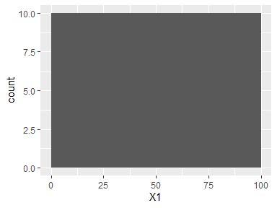

x1
Feature | Result
Variable type | numeric
Number of missing obs. | 0 (0 %)
Number of unique values | 47
Median | 3.4
1st and 3rd quartiles | 2.5; 4.6
Min. and max. | 0; 6.1
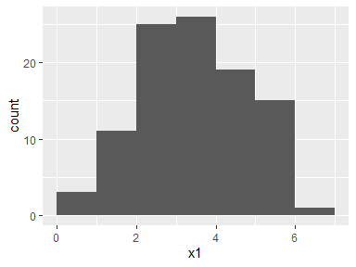

x2
Feature | Result
Variable type | numeric
Number of missing obs. | 0 (0 %)
Number of unique values | 45
Median | 2.15
1st and 3rd quartiles | 1.48; 3.23
Min. and max. | 0.2; 5.4
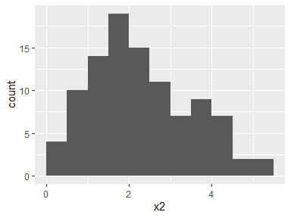

x3
Feature | Result
Variable type | numeric
Number of missing obs. | 0 (0 %)
Number of unique values | 47
Median | 8.05
1st and 3rd quartiles | 6.7; 9.1
Min. and max. | 5; 10
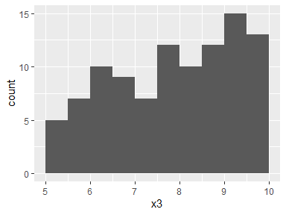

x4
Feature | Result
Variable type | numeric
Number of missing obs. | 0 (0 %)
Number of unique values | 40
Median | 5
1st and 3rd quartiles | 4.57; 6
Min. and max. | 2.5; 8.2
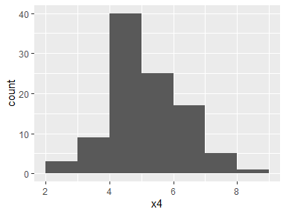

x5
Feature | Result
Variable type | numeric
Number of missing obs. | 0 (0 %)
Number of unique values | 30
Median | 2.6
1st and 3rd quartiles | 2.2; 3
Min. and max. | 1.1; 4.6
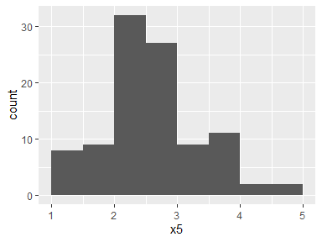

x6
Feature | Result
Variable type | numeric
Number of missing obs. | 0 (0 %)
Number of unique values | 46
Median | 7.15
1st and 3rd quartiles | 5.8; 8.33
Min. and max. | 3.7; 10
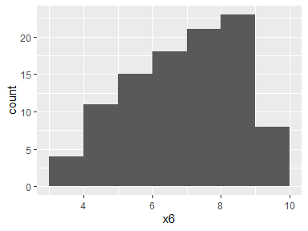

RC1
Feature | Result
Variable type | numeric
Number of missing obs. | 0 (0 %)
Number of unique values | 99
Median | -0.1
1st and 3rd quartiles | -0.82; 0.93
Min. and max. | -2.12; 1.51
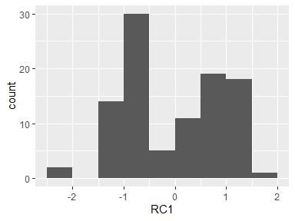

RC2
Feature | Result
Variable type | numeric
Number of missing obs. | 0 (0 %)
Number of unique values | 99
Median | -0.14
1st and 3rd quartiles | -0.59; 0.55
Min. and max. | -2.11; 2.56
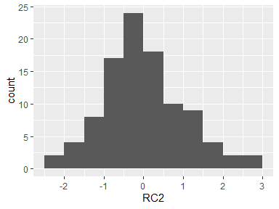

Report generation information:
- Created by: Could not determine from system (username: Unknown)
- Report creation time: jue. Feb. 25 2021 17:49:48
- Report was run from directory: D:/UNALM-2020-2/MULTIVARIADAS1/semana6_a_semana12/proyecto_multi_s6/ACS_luque
- dataMaid v1.4.0 [Pkg: 2019-12-10 from CRAN (R 4.0.3)]
- R version 4.0.3 (2020-10-10).
- Platform: x86_64-w64-mingw32/x64 (64-bit)(Windows 10 x64 (build 18363)).
- Function call: dataMaid::makeDataReport(data = datos, mode = c("summarize", "visualize", "check"), smartNum = FALSE, file = "datosfactorial", checks = list(character = "showAllFactorLevels", factor = "showAllFactorLevels", labelled = "showAllFactorLevels", haven_labelled = "showAllFactorLevels", numeric = NULL, integer = NULL, logical = NULL, Date = NULL), listChecks = FALSE, maxProbVals = Inf, codebook = TRUE, reportTitle = "Codebook for datos")

