grep – searches the named input FILEs for lines containing a match to the given pattern. By default grep prints the matching line

-i ignores case -v prints non-matching lines

Join – For each pair of input lines with identical join fields, write a line to standard output .

-i ignores case -t use CHAR as input and output field separator -1 FIELD join on this FIELD on file 1

-2 FIELD join on this FIELD on file 2

Cut – print selected parts of lines from each FILE to standard output

-f select only these fields

Head – print the first 10 lines of each FILE to standard output

-n –lines=[-]N print the first N lines instead of the first 10

Tail – print the last 10 lines of each FILE to standard output

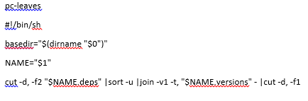-n –lines=N output the last N lines, instead of the last 10

pc-export-packages

#!/bin/sh

basedir="$(dirname "$0")"

NAME="$1"

"$basedir/pc-list-packages" |sort >"$NAME.versions"

for pkg in $(cut -d, -f1 "$NAME.versions"); do

"$basedir/pc-get-deps" "$pkg" |grep -v "^$pkg$" |sed -e "s/^/$pkg,/"

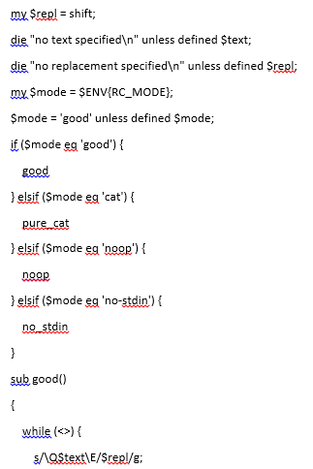done >"$NAME.deps"

Replcat

#!/usr/bin/env perl

use strict;

use warnings;

sub good();

sub pure_cat();

sub noop();

sub no_stdin();

my $text = shift;

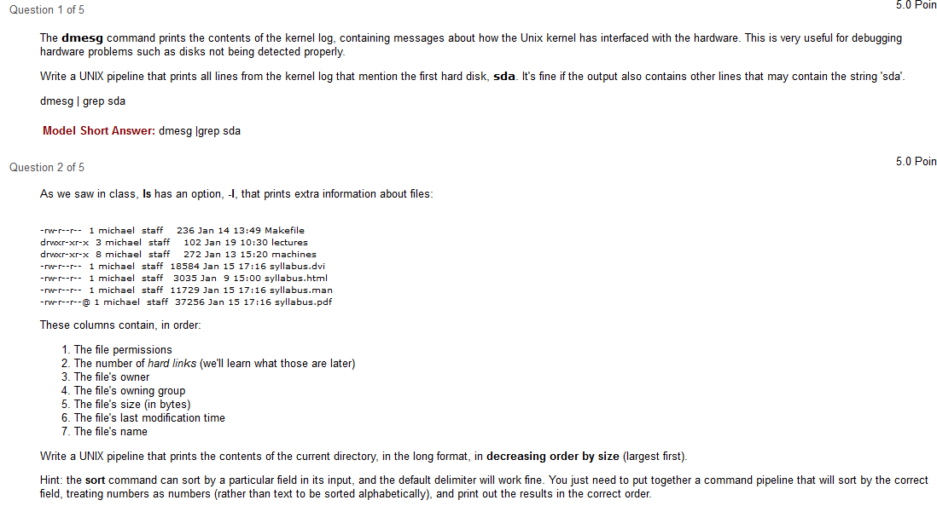 print;

}

}

sub pure_cat()

{

while (<>) {

print;

}

}

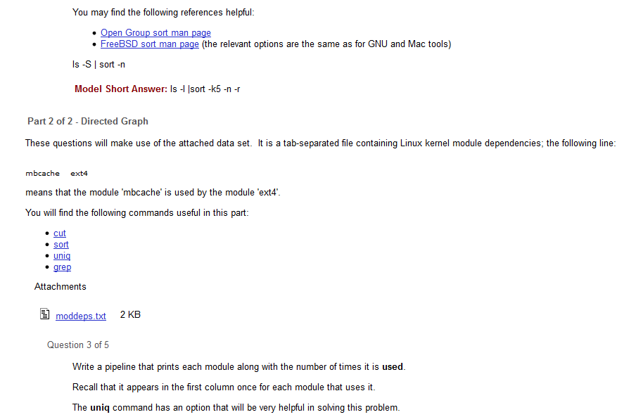sub noop()

{

}

sub no_stdin()

{

for my $f (@ARGV) {

open INF, '<', $f or die "$f: $!\n";

while (<INF>) {

s/\Q$text\E/$repl/g;

print;

}

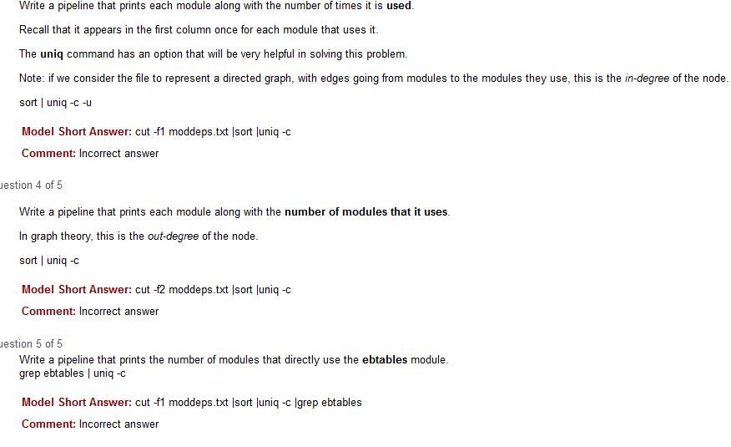 close INF;

}

}