|  |  |  |
| --- | --- | --- |
| ALGORITMO QuickSort | | |
| Complejidad = No comparativo | | |
|  | | |
| Numero Datos | Tiempo en Minutos | |
| Millones | Sin imprimir | Imprimiendo datos |
| 1 | 0,000567 min | 00m00,52s |
| 2 | 0,0012 min | 1m17,63s |
| 5 | 0,0028 min | 4m00,50s |
| 10 | 0,00725 min | 6m41,68s |
| 20 | 0,0015533 min | 13m31,12s |

|  |  |  |
| --- | --- | --- |
| ALGORITMO Insercion | | |
| Complejidad = No comparativo | | |
|  | | |
| Numero Datos | Tiempo en Minutos | |
| Millones | Sin imprimir | Imprimiendo datos |
| 1 | 0,000317 min | 00m19,88s |
| 2 | 0,000633 min | 00m33,65s |
| 5 | 0,001567 min | 1m20,52s |
| 10 | 0,0042 min | 3m,10,06s |
| 20 | 0,009533 min | 5m33,78s |

|  |  |  |
| --- | --- | --- |
| ALGORITMO CountingSort | | |
| Complejidad = No comparativo | | |
|  | | |
| Numero Datos | Tiempo en Minutos | |
| Millones | Sin imprimir | Imprimiendo datos |
| 1 | 0,000683 min | 00m,16,05s |
| 2 | 0,0012 min | 00m,31,47s |
| 5 | 0,00175 min | 1m,13,44s |
| 10 | 0,005667 min | 2m,28,84s |
| 20 | 0,00625 min | 6m,37,06s |

|  |  |  |
| --- | --- | --- |
| ALGORITMO MergeSort | | |
| Complejidad = No comparativo | | |
|  | | |
| Numero Datos | Tiempo en Minutos | |
| Millones | Sin imprimir | Imprimiendo datos |
| 1 | 0,0009667 min | 00m35,93s |
| 2 | 0,0013 min | 1m15,85s |
| 5 | 0,000315 min | 3m05,37s |
| 10 | 0,008233 min | 5m17,91s |
| 20 | 0,014467 min | 10M30,25S |

|  |  |  |
| --- | --- | --- |
| ALGORITMO RadixSort | | |
| Complejidad = No comparativo | | |
|  | | |
| Numero Datos | Tiempo en Minutos | |
| Millones | Sin imprimir | Imprimiendo datos |
| 1 | 0,00065 min | 00m,33,73s |
| 2 | 0,001433 min | 1m,34,84s |
| 5 | 0,004483 min | 4m,24,72s |
| 10 | 0,0077 min | 7m,30,97s |
| 20 | 1.8000.000 min | 30m,20,50s |

|  |  |  |
| --- | --- | --- |
| ALGORITMO HeapSort | | |
| Complejidad = No comparativo | | |
|  | | |
| Numero Datos | Tiempo en Minutos | |
| Millones | Sin imprimir | Imprimiendo datos |
| 1 | 0,000567 min | 00m,16,44s |
| 2 | 0,001133 min | 00m,47,05s |
| 5 | 0,0021 min | 1m,43,23s |
| 10 | 0,0035 min | 3m,14,01s |
| 20 | 0,005767 min | 5m,46,94s |

**COMPARACION DE TIEMPOS**

Se han ordenado una cantidad determinada de elementos aleatorios en una lista mediante distintos métodos de ordenamiento. (En minutos)

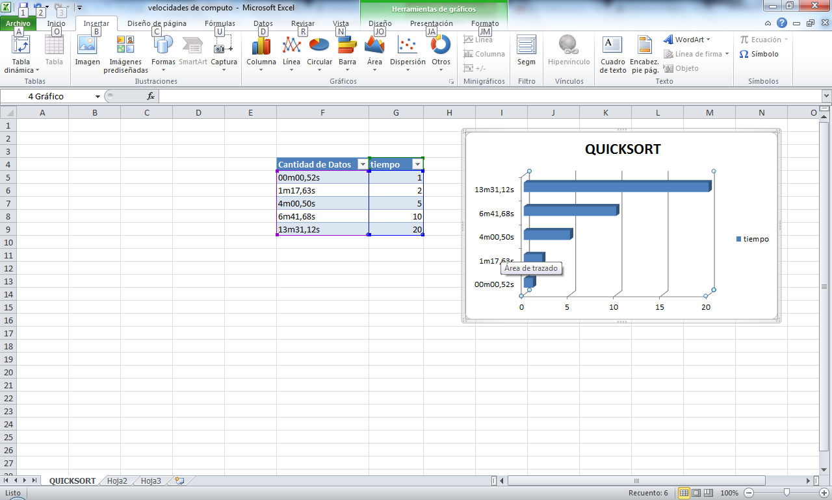

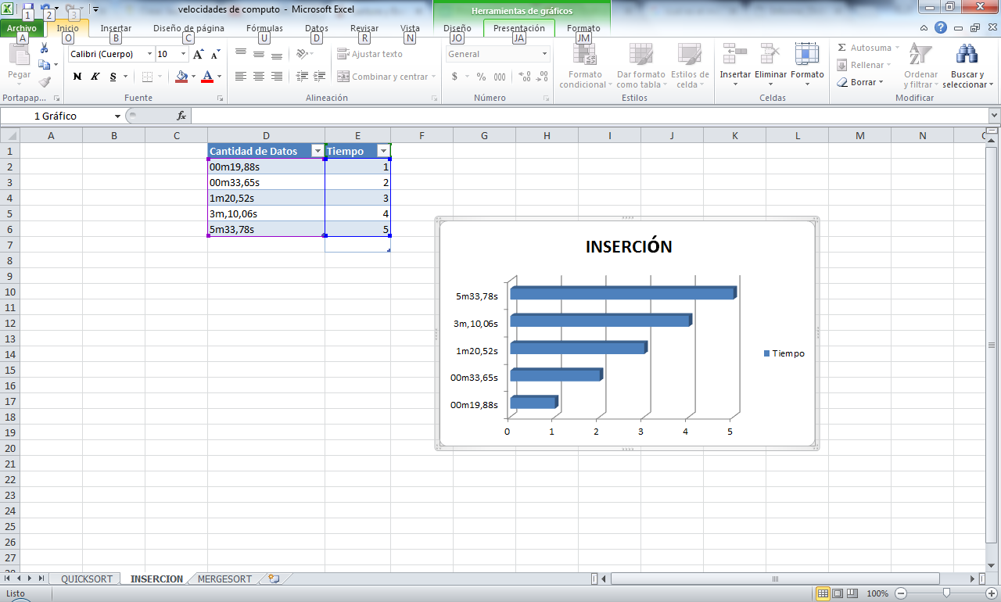

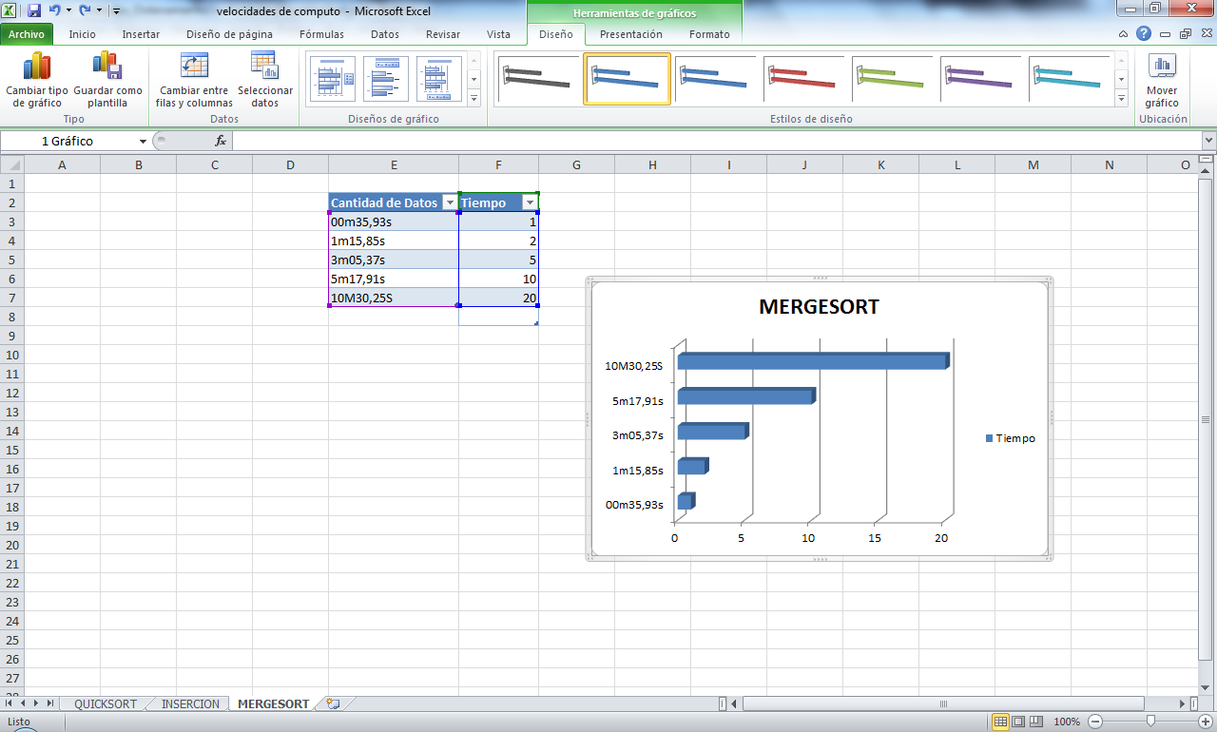

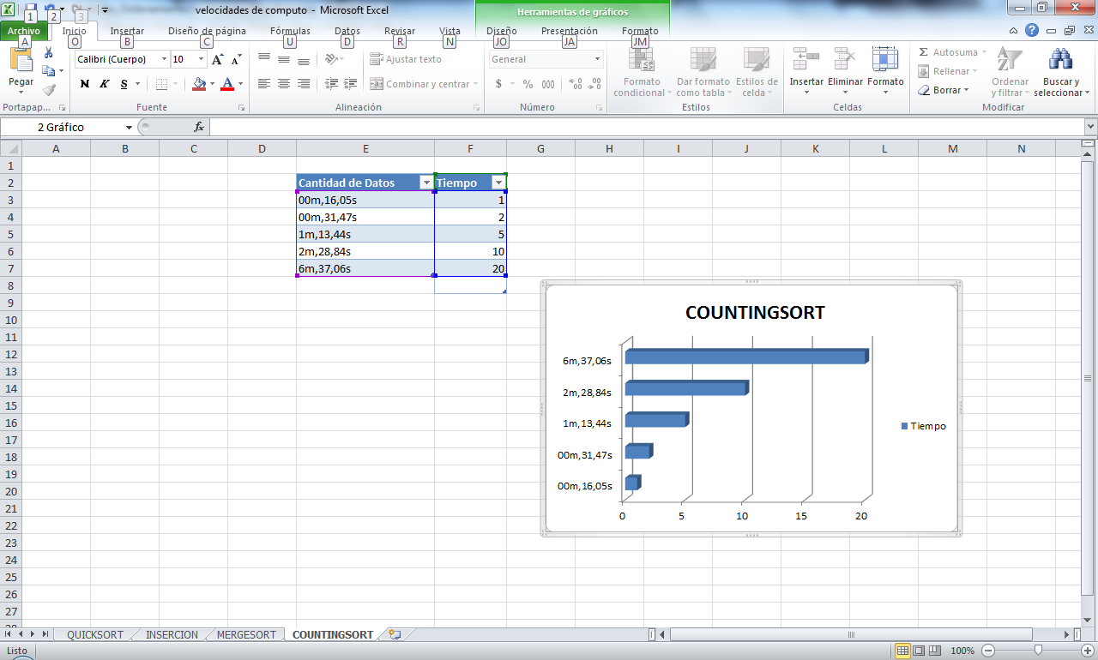

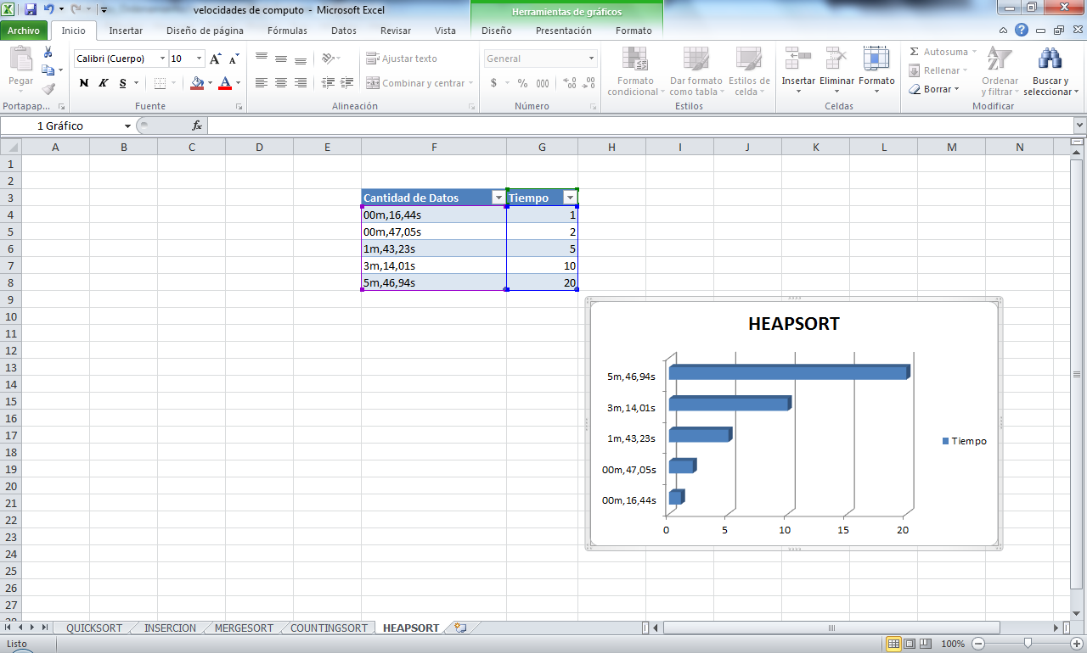

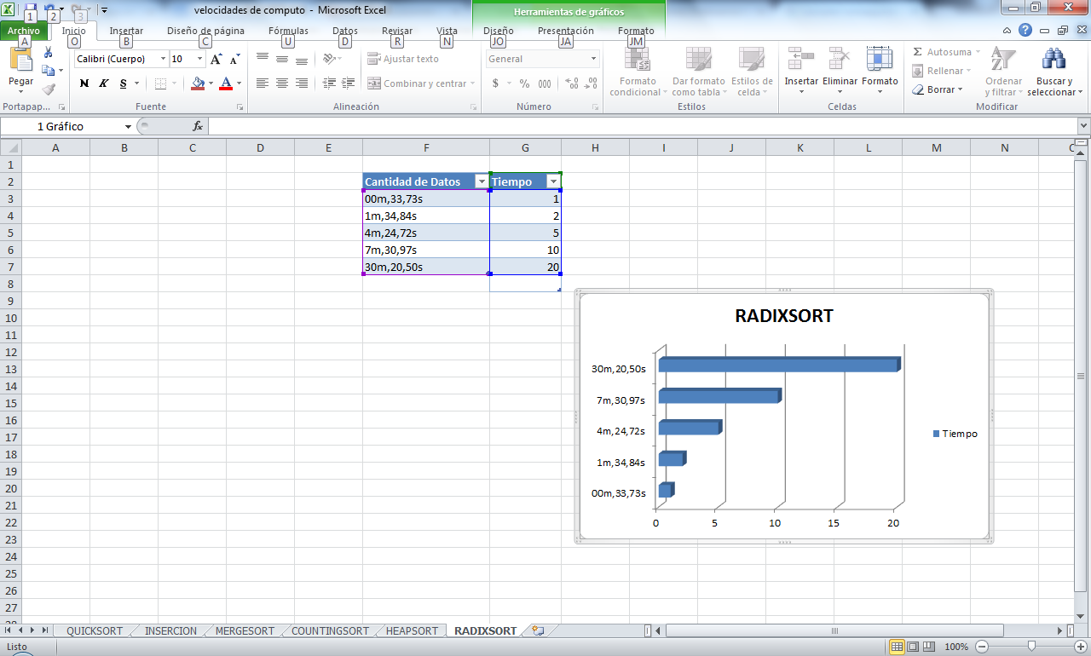

|  |  |
| --- | --- |
| **Numero Datos = 1’000.000** | |
| Métodos de ordenamiento | Tiempo | |
| Inserción | 00m19,88s | |
| Mezcla (Merge) | 00m35,93s | |
| Montones (HeapSort) | 00m,16,44s | |
| Rápido (QuickSort) | 00m00,52s | |
| Conteo (CountingSort) | 00m,16,05s | |
| RADIXSORT | 00m,33,73s | |
|  |  | |

|  |  |
| --- | --- |
| **Numero Datos = 2’000.000** | |
| Métodos de ordenamiento | Tiempo | |
| Inserción | 00m33,65s | |
| Mezcla (Merge) | 1m15,85s | |
| Montones (HeapSort) | 00m,47,05s | |
| Rápido (QuickSort) | 1m17,63s | |
| Conteo (CountingSort) | 00m,31,47s | |
| RADIXSORT | 1m,34,84s | |
|  |  | |

|  |  |
| --- | --- |
| **Numero Datos = 5’000.000** | |
| Métodos de ordenamiento | Tiempo | |
| Inserción | 1m20,52s | |
| Mezcla (Merge) | 3m05,37s | |
| Montones (HeapSort) | 1m,43,23s | |
| Rápido (QuickSort) | 4m00,50s | |
| Conteo (CountingSort) | 1m,13,44s | |
| RADIXSORT | 4m,24,72s | |
|  |  | |

|  |  |
| --- | --- |
| **Numero Datos = 10’000.000** | |
| Métodos de ordenamiento | Tiempo | |
| Inserción | 3m,10,06s | |
| Mezcla (Merge) | 5m17,91s | |
| Montones (HeapSort) | 3m,14,01s | |
| Rápido (QuickSort) | 6m41,68s | |
| Conteo (CountingSort) | 2m,28,84s | |
| RADIXSORT | 7m,30,97s | |
|  |  | |

|  |  |
| --- | --- |
| **Numero Datos = 20’000.000** | |
| Métodos de ordenamiento | Tiempo | |
| Inserción | 5m33,78s | |
| Mezcla (Merge) | 10M30,25S | |
| Montones (HeapSort) | 5m,46,94s | |
| Rápido (QuickSort) | 13m31,12s | |
| Conteo (CountingSort) | 6m,37,06s | |
| RADIXSORT | 30m,20,50s | |
|  |  | |