Purpose: The purpose of the Campus Lost & Found website is to help students quickly recover lost belongings by organizing found items by building location. Instead of searching through one central lost-and-found area, users can browse a campus map or building list, view photos of recently found items, and submit newly found items for review. The website simplifies the search process, increases return rates, and promotes responsibility within the campus community.

Wireframe: 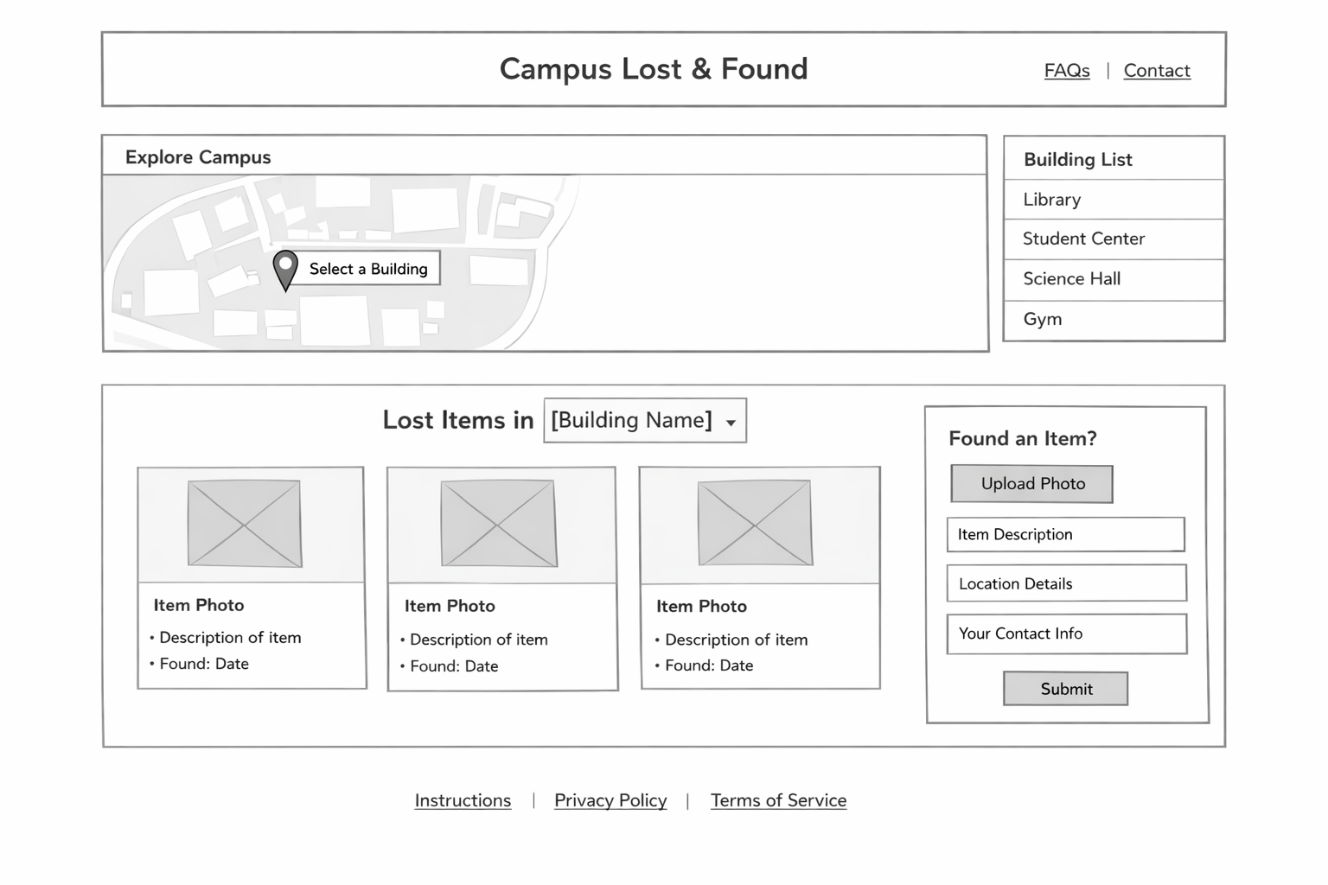
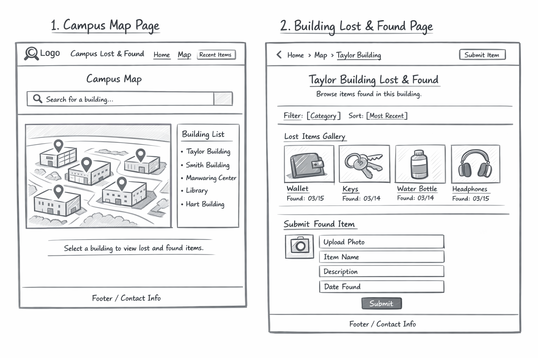

Audience: College students and staff on campus that lose their items

Logo:
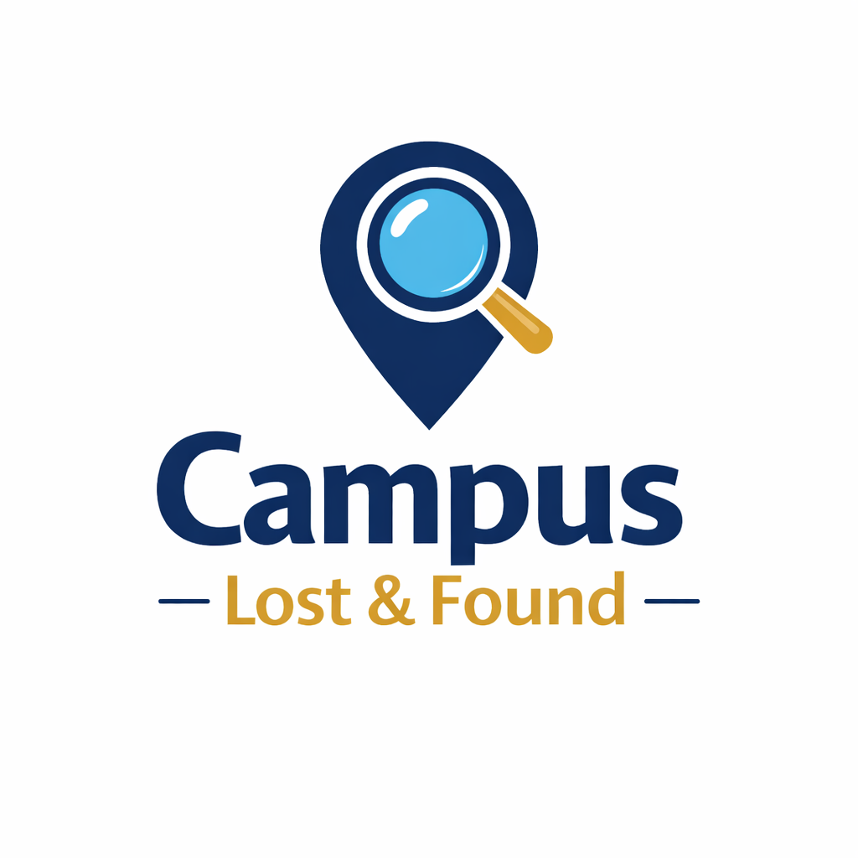
Color and fonts:
Colors

Navy Blue — #1F3A5F

Teal — #2FA4A9

Light Gray — #F5F6F8

Light Blue — #E6F2F8

White — #FFFFFF

Orange (accent) — #FF8A3D

Fonts

Poppins (headings)

Open Sans (body text)

