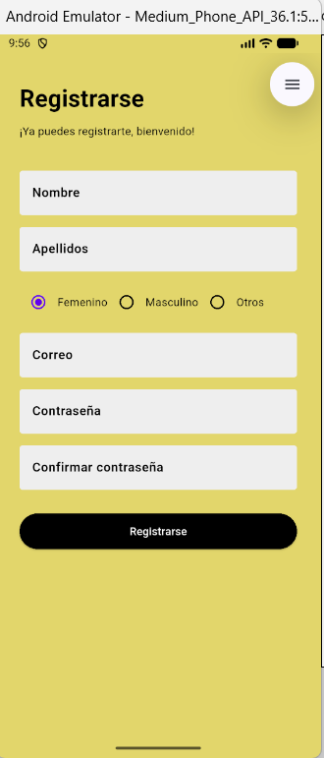

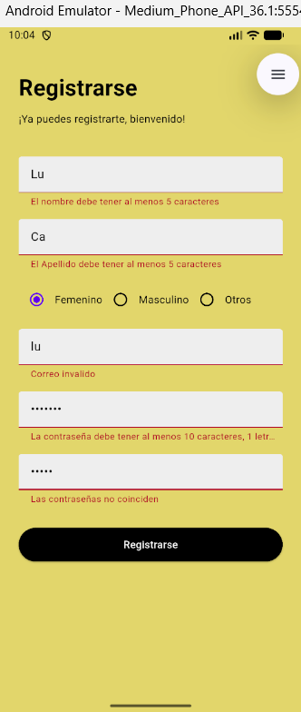

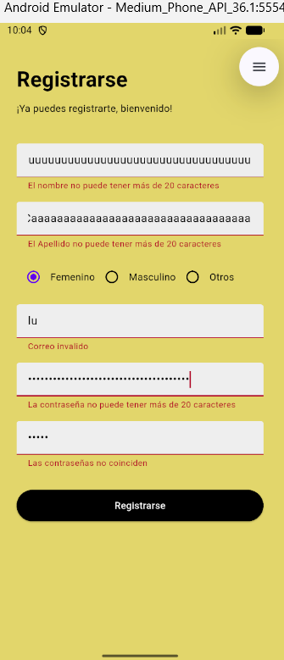

import 'package:flutter/material.dart';

void main() {
runApp(const MyApp());
}

class MyApp extends StatelessWidget {
const MyApp({super.key});

// This widget is the root of your application.
@override
Widget build(BuildContext context) {
return MaterialApp(
title: 'Flutter Demo',
theme: ThemeData(
primarySwatch: Colors.blue,
scaffoldBackgroundColor: const Color.fromARGB(238, 242, 229, 115),
fontFamily: 'Raleway',
colorScheme: const ColorScheme.light()),
debugShowCheckedModeBanner: false,
home: const RegisterPage(title: 'Flutter Demo Home Page'),
);
}
}

enum SinginCharacter { femenino, masculino, otros}

class RegisterPage extends StatefulWidget {
const RegisterPage({super.key, required this.title});
final String title;

@override
State<RegisterPage> createState() => _RegisterPageState();
}

class _RegisterPageState extends State<RegisterPage> {
SinginCharacter? _sex = SinginCharacter.femenino;

String _nombre = '';
final _formKey = GlobalKey<FormState>();
String _password = '';

@override
Widget build(BuildContext context) {
return Scaffold(
body: SingleChildScrollView(
child: Container(
margin: const EdgeInsets.only(top: 40, left: 30, right: 30),
child: Column(
crossAxisAlignment: CrossAxisAlignment.start,
children: <Widget>[
Container(
margin: const EdgeInsets.only(top: 20),
child: const Text(
'Registrarse',
style: TextStyle(fontWeight: FontWeight.bold, fontSize: 30),
),
),
const Padding(
padding: EdgeInsets.symmetric(vertical: 10),
child: Text('¡Ya puedes registrarte, bienvenido!'),
),
Form(
key: _formKey,
child: Column(
children: <Widget>[
Padding(
padding: const EdgeInsets.only(top: 30),
child: TextFormField(
decoration: InputDecoration(
hintText: 'Nombre',
hintStyle:
const TextStyle(fontWeight: FontWeight.w600),
fillColor: Colors.grey.shade200,
focusedBorder: const OutlineInputBorder(
borderSide: BorderSide(
width: 0, style: BorderStyle.none),
),
enabledBorder: const OutlineInputBorder(
borderSide: BorderSide(
width: 0, style: BorderStyle.none),
),
filled: true),
validator: (value) {
if (value == null || value.isEmpty) {
return 'Por favor ingrese su nombre';
}
if (value.length < 5) {
return 'El nombre debe tener al menos 5 caracteres';
}
if (value.length > 20) {
return 'El nombre no puede tener más de 20 caracteres';
}
return null;
},
onSaved: (value) {
setState(() {
_nombre = value.toString();
});
},

)),
Padding(
padding: const EdgeInsets.only(top: 15),
child: TextFormField(
decoration: InputDecoration(
hintText: 'Apellidos',
hintStyle:
const TextStyle(fontWeight: FontWeight.w600),
fillColor: Colors.grey.shade200,
focusedBorder: const OutlineInputBorder(
borderSide: BorderSide(
width: 0, style: BorderStyle.none),
),
enabledBorder: const OutlineInputBorder(
borderSide: BorderSide(
width: 0, style: BorderStyle.none),
),
filled: true),
validator: (value) {
if (value == null || value.isEmpty) {
return 'Por favor ingrese su nombre';
}
if (value.length < 5) {
return 'El Apellido debe tener al menos 5 caracteres';
}
if (value.length > 20) {
return 'El Apellido no puede tener más de 20 caracteres';
}
return null;
},
)),
Padding(
padding: const EdgeInsets.only(top: 15),
child: Row(
children: <Widget>[
Row(
mainAxisAlignment: MainAxisAlignment.spaceBetween,
children: [
Radio<SinginCharacter>(
value: SinginCharacter.femenino,
groupValue: _sex,
onChanged: (SinginCharacter? value) {
setState(() {
_sex = value;
});
},
),
const Text('Femenino')
],
),
Row(
children: [
Radio<SinginCharacter>(
value: SinginCharacter.masculino,
groupValue: _sex,
onChanged: (SinginCharacter? value) {
setState(() {
_sex = value;
});
},
),
const Text('Masculino')
],
),
Row(
children: [
Radio<SinginCharacter>(
value: SinginCharacter.otros,
groupValue: _sex,
onChanged: (SinginCharacter? value) {
setState(() {
_sex = value;
});
},
),
const Text('Otros')
],
),
],
)),
Padding(
padding: const EdgeInsets.only(top: 15),
child: TextFormField(
decoration: InputDecoration(
hintText: 'Correo',
hintStyle:
const TextStyle(fontWeight: FontWeight.w600),
fillColor: Colors.grey.shade200,
focusedBorder: const OutlineInputBorder(
borderSide: BorderSide(
width: 0, style: BorderStyle.none),
),
enabledBorder: const OutlineInputBorder(
borderSide: BorderSide(
width: 0, style: BorderStyle.none),
),
filled: true),
validator: (value) {
String pattern =
r'^(([^<>()[\]\\.,;:\s@\"]+(\.[^<>()[\]\\.,;:\s@\"]+)*)|(\".+\"))@((\[[0-9]{1,3}\.[0-9]{1,3}\.[0-9]{1,3}\.[0-9]{1,3}\])|(([a-zA-Z\-0-9]+\.)+[a-zA-Z]{2,}))$';
RegExp regExp = RegExp(pattern);
if (value!.isEmpty) {
return "El correo es necesario";
} else if (!regExp.hasMatch(value)) {
return "Correo invalido";
} else {
return null;
}
},
)),
Padding(
padding: const EdgeInsets.only(top: 15),
child: TextFormField(
obscureText: true,
onChanged: (value) {
setState(() {
_password = value;
});
},
decoration: InputDecoration(
hintText: 'Contraseña',
hintStyle:
const TextStyle(fontWeight: FontWeight.w600),
fillColor: Colors.grey.shade200,
focusedBorder: const OutlineInputBorder(
borderSide: BorderSide(
width: 0, style: BorderStyle.none),
),
enabledBorder: const OutlineInputBorder(
borderSide: BorderSide(
width: 0, style: BorderStyle.none),
),
filled: true),
validator: (value) {
if (value!.isEmpty) {
return "La contraseña es necesaria";
}
if (value.length > 20) {
return "La contraseña no puede tener más de 20 caracteres";
}
String pattern =
r'^(?=.*\d)(?=.*[a-z])(?=.*[A-Z]).{10,}$';
RegExp regExp = RegExp(pattern);
if (!regExp.hasMatch(value)) {
return "La contraseña debe tener al menos 10 caracteres, 1 letra mayúscula, 1 minúscula y 1 número. Además puede contener caracteres especiales.";
}
return null;
},
)),
Padding(
padding: const EdgeInsets.only(top: 15),
child: TextFormField(
obscureText: true,
decoration: InputDecoration(
hintText: 'Confirmar contraseña',
hintStyle:
const TextStyle(fontWeight: FontWeight.w600),
fillColor: Colors.grey.shade200,
focusedBorder: const OutlineInputBorder(
borderSide: BorderSide(
width: 0, style: BorderStyle.none),
),
enabledBorder: const OutlineInputBorder(
borderSide: BorderSide(
width: 0, style: BorderStyle.none),
),
filled: true),
validator: (value) {
if (value == null || value.isEmpty) {
return 'Please enter some text';
}
if (value != _password) {
return 'Las contraseñas no coinciden';
}
return null;
},
)),
Padding(
padding: const EdgeInsets.symmetric(vertical: 30),
child: SizedBox(
width: double.infinity,
height: 45,
child: ElevatedButton(
onPressed: () {
if (_formKey.currentState!.validate()) {
ScaffoldMessenger.of(context)
.showSnackBar(SnackBar(
content: Row(
mainAxisAlignment:
MainAxisAlignment.start,
children: const <Widget>[
Icon(
Icons.check_circle,
color: Color.fromARGB(
255, 255, 255, 255),
),
SizedBox(
width: 5,
),
Text(
"Usuario registrado correctamente",
style: TextStyle(
color: Color.fromARGB(
255, 255, 255, 255)),
)
],
),
duration:
const Duration(milliseconds: 2000),
width: 300,
padding: const EdgeInsets.symmetric(
horizontal: 8.0, vertical: 10),
behavior: SnackBarBehavior.floating,
shape: RoundedRectangleBorder(
borderRadius: BorderRadius.circular(3.0),
),
backgroundColor:
const Color.fromARGB(255, 12, 195, 106),
));
}
},
style: ElevatedButton.styleFrom(
backgroundColor:
Colors.black, // background (button) color
foregroundColor:
Colors.white, // foreground (text) color
),
child: const Text('Registrarse')),
)),
],
))
],
),
),
));
}
}

