Crear

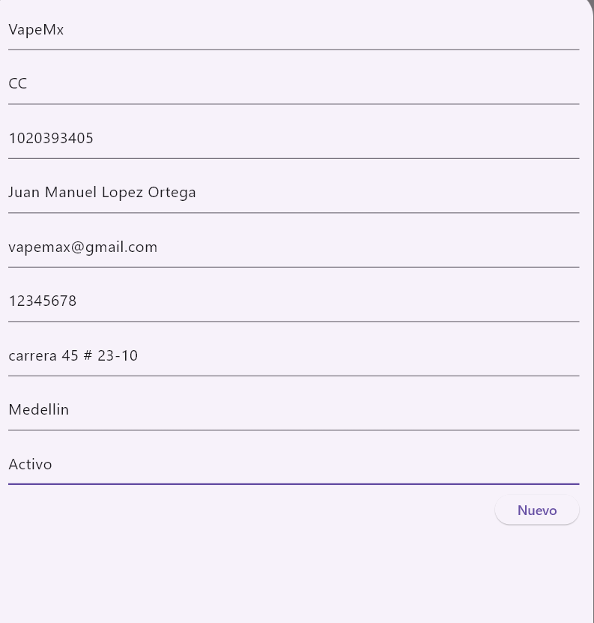

Actualizar, trae los datos

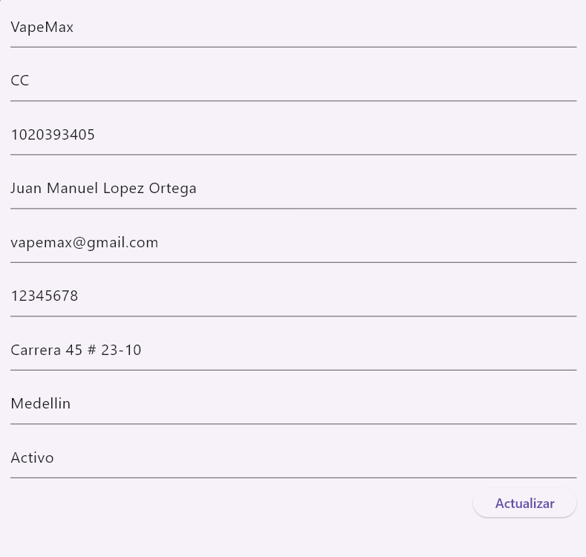

Lista

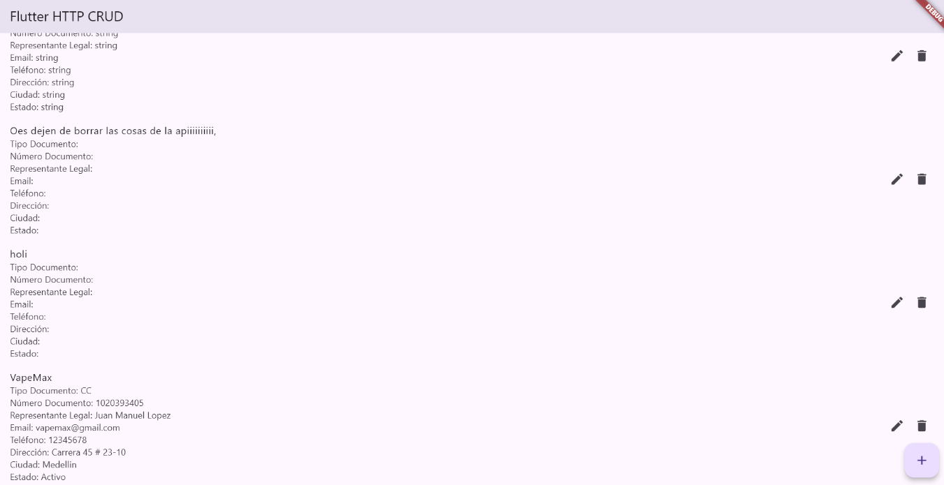

import 'dart:convert';
import 'package:flutter/material.dart';
import 'package:http/http.dart' as http;

void main() {
runApp(MyApp());
}

class MyApp extends StatelessWidget {
@override
Widget build(BuildContext context) {
return MaterialApp(
title: 'Flutter HTTP CRUD',
theme: ThemeData(
primarySwatch: Colors.blue,
),
home: MyHomePage(title: 'Flutter HTTP CRUD'),
);
}
}

class MyHomePage extends StatefulWidget {
MyHomePage({Key? key, required this.title}) : super(key: key);

final String title;

@override
_MyHomePageState createState() => _MyHomePageState();
}

class _MyHomePageState extends State<MyHomePage> {
List<dynamic> _data = [];

@override
void initState() {
super.initState();
_fetchData();
}

final TextEditingController _nombreCompletoORazonSocialController = TextEditingController();
final TextEditingController _tipoDocumentoController = TextEditingController();
final TextEditingController _numeroDocumentoController = TextEditingController();
final TextEditingController _representanteLegalController = TextEditingController();
final TextEditingController _emailController = TextEditingController();
final TextEditingController _telefonoController = TextEditingController();
final TextEditingController _direccionController = TextEditingController();
final TextEditingController _ciudadController = TextEditingController();
final TextEditingController _estadoController = TextEditingController();

void _showForm(String? id) async {
// Clear all controllers first
_nombreCompletoORazonSocialController.clear();
_tipoDocumentoController.clear();
_numeroDocumentoController.clear();
_representanteLegalController.clear();
_emailController.clear();
_telefonoController.clear();
_direccionController.clear();
_ciudadController.clear();
_estadoController.clear();

if (id != null) {
// id == null -> create new item
// id != null -> update an existing item
final existingJournal =
_data.firstWhere((element) => element['id'].toString() == id);
_nombreCompletoORazonSocialController.text = existingJournal['nombreCompletoORazonSocial'] ?? '';
_tipoDocumentoController.text = existingJournal['tipoDocumento'] ?? '';
_numeroDocumentoController.text = existingJournal['numeroDocumento'] ?? '';
_representanteLegalController.text = existingJournal['representanteLegal'] ?? '';
_emailController.text = existingJournal['email'] ?? '';
_telefonoController.text = existingJournal['telefono'] ?? '';
_direccionController.text = existingJournal['direccion'] ?? '';
_ciudadController.text = existingJournal['ciudad'] ?? '';
_estadoController.text = existingJournal['estado'] ?? '';

}

showModalBottomSheet(
context: context,
elevation: 5,
isScrollControlled: true,
builder: (_) => Container(
padding: EdgeInsets.only(
top: 15,
left: 15,
right: 15,
// this will prevent the soft keyboard from covering the text fields
bottom: MediaQuery.of(context).viewInsets.bottom + 120,
),
child: SingleChildScrollView(
child: Column(
mainAxisSize: MainAxisSize.min,
crossAxisAlignment: CrossAxisAlignment.end,
children: [
TextField(
controller: _nombreCompletoORazonSocialController,
decoration: const InputDecoration(hintText: 'Nombre completo o Razón Social'),
),
const SizedBox(
height: 10,
),
TextField(
controller: _tipoDocumentoController,
decoration: const InputDecoration(hintText: 'Tipo de documento'),
),
const SizedBox(
height: 10,
),
TextField(
controller: _numeroDocumentoController ,
decoration: const InputDecoration(hintText: 'Número de documento'),
),
const SizedBox(
height: 10,
),
TextField(
controller: _representanteLegalController,
decoration: const InputDecoration(hintText: ' Representante Legal'),
),
const SizedBox(
height: 10,
),
TextField(
controller: _emailController,
decoration: const InputDecoration(hintText: 'Email'),
),
const SizedBox(
height: 10,
),
TextField(
controller: _telefonoController,
decoration: const InputDecoration(hintText: 'Telefono'),
),
const SizedBox(
height: 10,
),
TextField(
controller: _direccionController,
decoration: const InputDecoration(hintText: 'Dirección'),
),
const SizedBox(
height: 10,
),
TextField(
controller: _ciudadController,
decoration: const InputDecoration(hintText: 'Ciudad'),
),
const SizedBox(
height: 10,
),
TextField(
controller: _estadoController,
decoration: const InputDecoration(hintText: 'Estado'),
),
const SizedBox(
height: 10,
),
ElevatedButton(
onPressed: () async {
// Save new journal
if (id == null) {
await _createData();
}

if (id != null) {
await _updateData(id);
}

// Clear the text fields
_nombreCompletoORazonSocialController.text = '';
_tipoDocumentoController.text = '';
_numeroDocumentoController.text = '';
_representanteLegalController.text = '';
_emailController.text = '';
_telefonoController.text = '';
_direccionController.text = '';
_ciudadController.text = '';
_estadoController.text = '';

// Close the bottom sheet
Navigator.of(context).pop();
},
child: Text(id == null ? 'Nuevo' : 'Actualizar'),
)
],
),
)));
}

// Metodo consultar
Future<void> _fetchData() async {
try {
final response = await http
.get(Uri.parse('http://vaperapi.somee.com/api/Proveedores'));

if (response.statusCode == 200) {
setState(() {
_data = jsonDecode(response.body);
});
} else {
throw Exception('Error al cargar los datos');
}
} catch (error) {
print(error);
}
}

// Metodo insertar
Future<void> _createData() async {
try {
final response = await http.post(
Uri.parse('http://vaperapi.somee.com/api/Proveedores'),
headers: <String, String>{
'Content-Type': 'application/json; charset=UTF-8',
},
body: jsonEncode(<String, dynamic>{
'nombreCompletoORazonSocial': _nombreCompletoORazonSocialController.text,
'tipoDocumento': _tipoDocumentoController.text,
'numeroDocumento': _numeroDocumentoController.text,
'representanteLegal': _representanteLegalController.text,
'email': _emailController.text,
'telefono': _telefonoController.text,
'direccion': _direccionController.text,
'ciudad': _ciudadController.text,
'estado': _estadoController.text

}));

if (response.statusCode == 200 || response.statusCode == 201) {
ScaffoldMessenger.of(context).showSnackBar(const SnackBar(
content: Text('Registro creado con exito!'),
));
_fetchData();
} else {
throw Exception('Failed to create data');
}
} catch (error) {
print(error);
}
}

Future<void> _updateData(String id) async {
try {
final response = await http.put(
Uri.parse('http://vaperapi.somee.com/api/Proveedores/${id}'),
headers: <String, String>{
'Content-Type': 'application/json; charset=UTF-8',
},
body: jsonEncode(<String, dynamic>{
'id': id,
'nombreCompletoORazonSocial': _nombreCompletoORazonSocialController.text,
'tipoDocumento': _tipoDocumentoController.text,
'numeroDocumento': _numeroDocumentoController.text,
'representanteLegal': _representanteLegalController.text,
'email': _emailController.text,
'telefono': _telefonoController.text,
'direccion': _direccionController.text,
'ciudad': _ciudadController.text,
'estado': _estadoController.text
}));

if (response.statusCode == 200 || response.statusCode == 204) {
ScaffoldMessenger.of(context).showSnackBar(const SnackBar(
content: Text('Registro actualizado con exito!'),
));
_fetchData();
} else {
throw Exception('Failed to update data');
}
} catch (error) {
print(error);
}
}

Future<void> _deleteData(String? id) async {
if (id == null) return;
try {
final response = await http.delete(
Uri.parse('http://vaperapi.somee.com/api/Proveedores/${id}'));

if (response.statusCode == 200) {
ScaffoldMessenger.of(context).showSnackBar(const SnackBar(
content: Text('Registro eliminado con exito!'),
));
_fetchData();
} else {
throw Exception('Failed to delete data');
}
} catch (error) {
print(error);
}
}

@override
Widget build(BuildContext context) {
return Scaffold(
appBar: AppBar(
title: Text(widget.title),
),
body: ListView.builder(
itemCount: _data.length,
itemBuilder: (BuildContext context, int index) {
final data = _data[index];
return ListTile(
title: Text(data['nombreCompletoORazonSocial'] ?? 'Sin nombre'),
subtitle: Column(
crossAxisAlignment: CrossAxisAlignment.start,
children: [
Text('Tipo Documento: ${data['tipoDocumento'] ?? 'N/A'}'),
Text('Número Documento: ${data['numeroDocumento'] ?? 'N/A'}'),
Text('Representante Legal: ${data['representanteLegal'] ?? 'N/A'}'),
Text('Email: ${data['email'] ?? 'N/A'}'),
Text('Teléfono: ${data['telefono'] ?? 'N/A'}'),
Text('Dirección: ${data['direccion'] ?? 'N/A'}'),
Text('Ciudad: ${data['ciudad'] ?? 'N/A'}'),
Text('Estado: ${data['estado'] ?? 'N/A'}'),
],
),
trailing: Row(
mainAxisSize: MainAxisSize.min,
children: [
IconButton(
icon: Icon(Icons.edit),
onPressed: () => _showForm(data['id'].toString()),
),
IconButton(
icon: Icon(Icons.delete),
onPressed: () => _deleteData(data['id'].toString()),
),
],
),
);
},
),
floatingActionButton: FloatingActionButton(
onPressed: () => _showForm(null),
tooltip: 'Create',
child: Icon(Icons.add),
),
);
}
}

