**Screen Shots**

1) Home Page

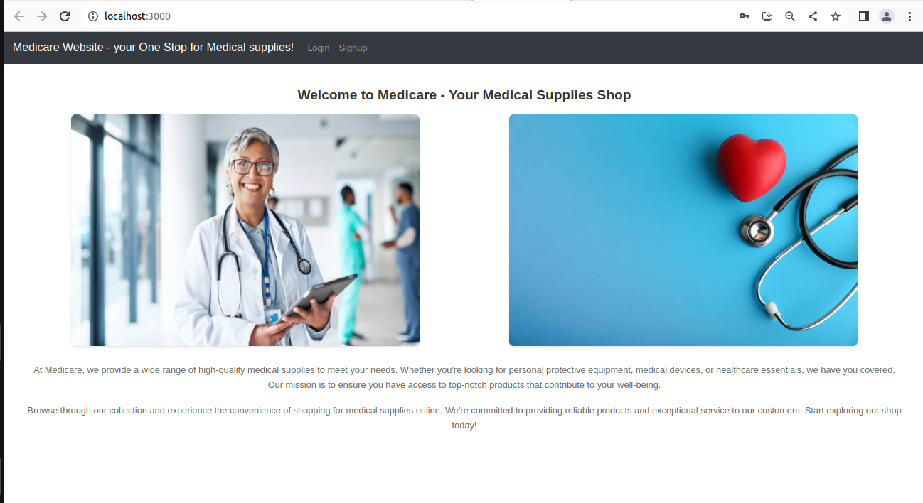

2) Login Page

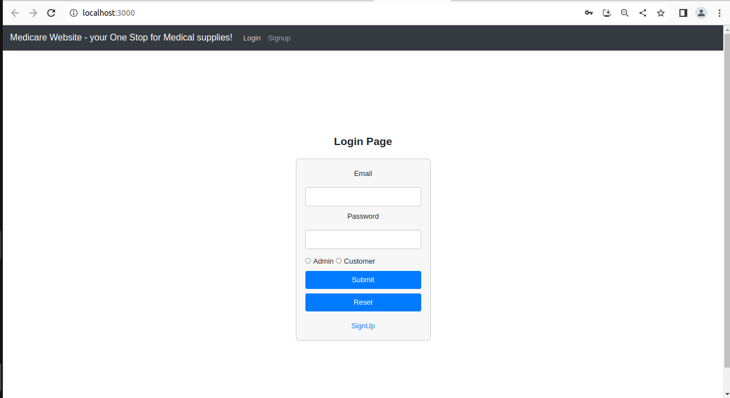

3) Sign Up Page

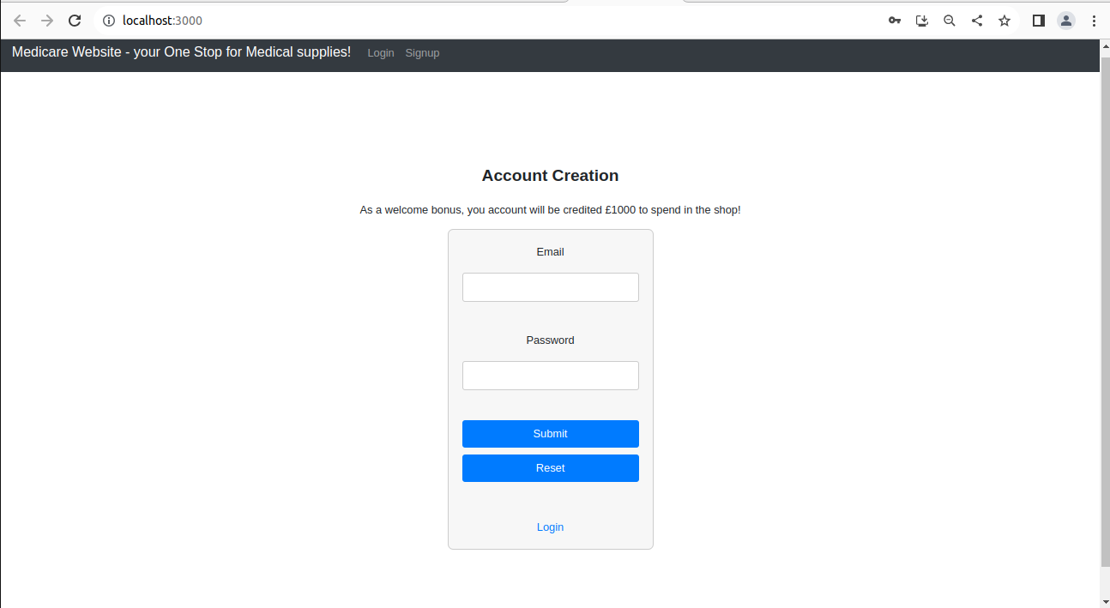

4) Sign Up Success !

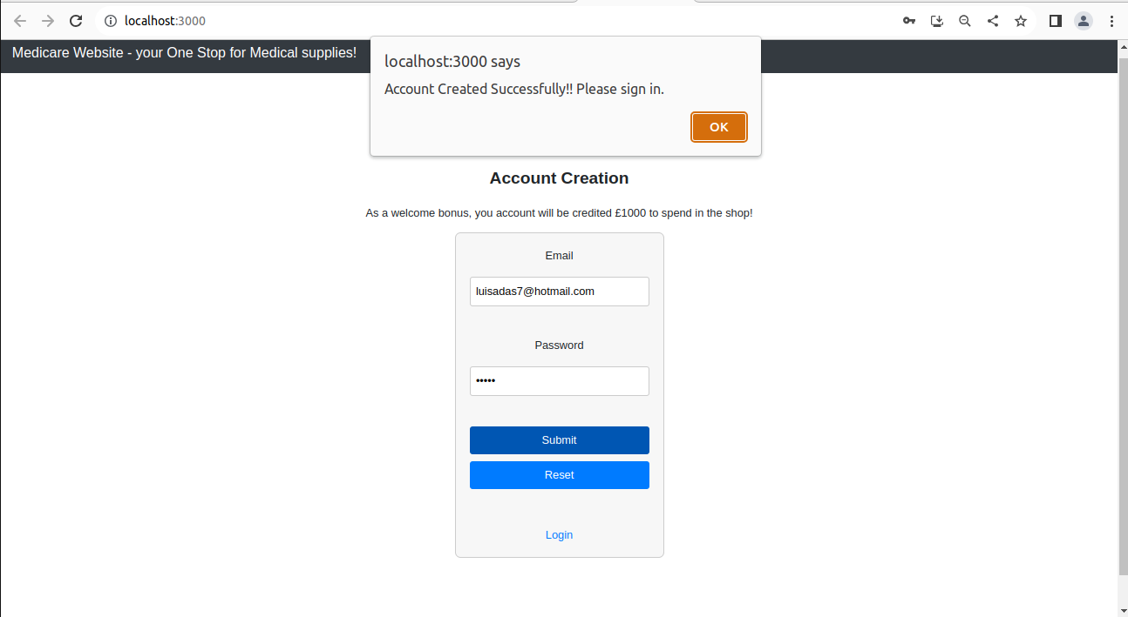

5) Login Page Customer

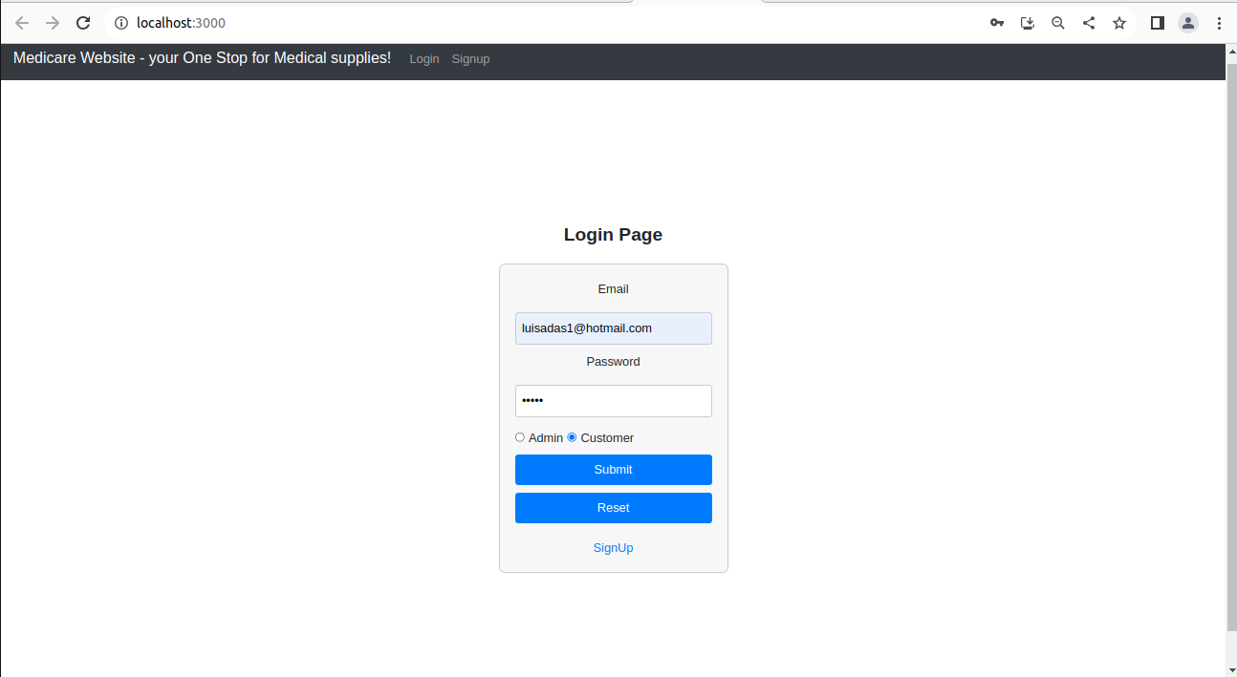

6) Customer Home Page – Purchase Medicine

Customer can search by name any product.

Basket is embedded

Total account amount is displayed

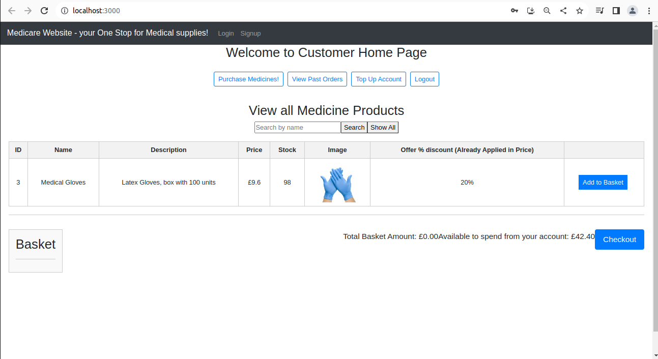

7) Item Added to Basket

Basket has the ability to be changed, removing any previously added item.

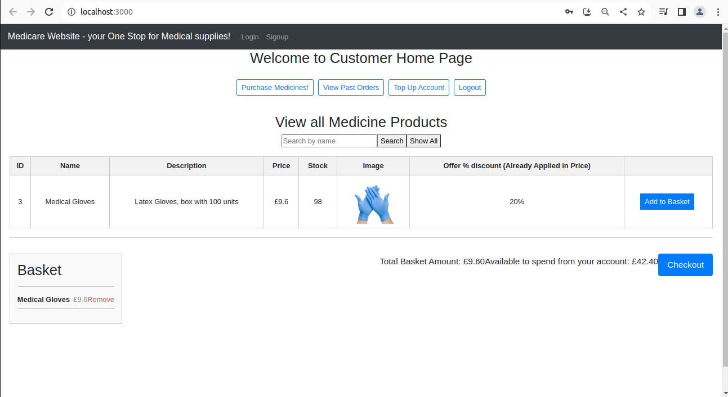

8) Once Checkout is pressed, Order Summary is displayed to the customer.

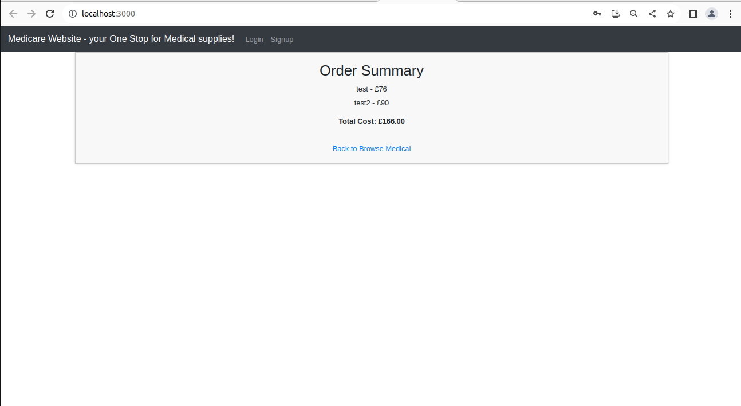

9) Customer can see any of his previously made Orders. View Past Orders Page

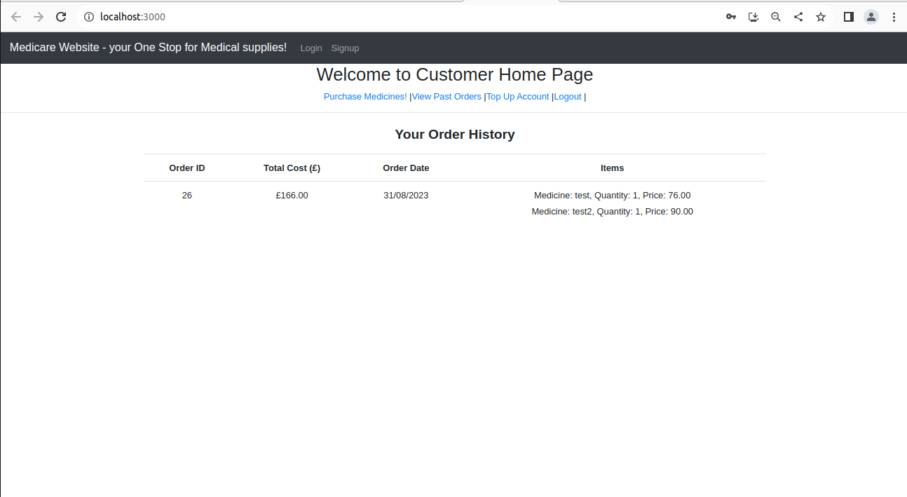

10) Top Up Account Customer page

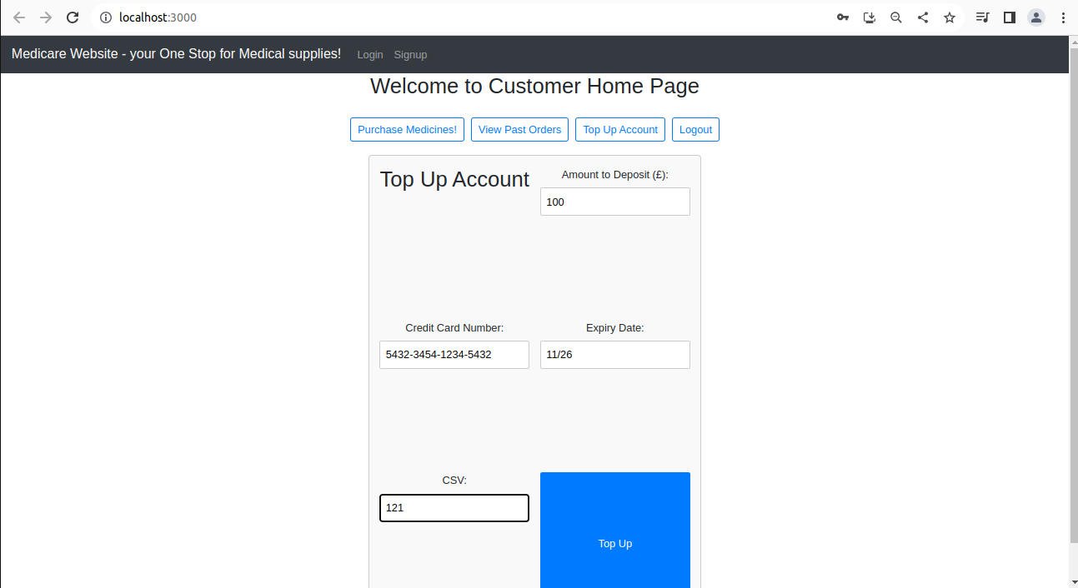

11) Top Up Account Customer page success!

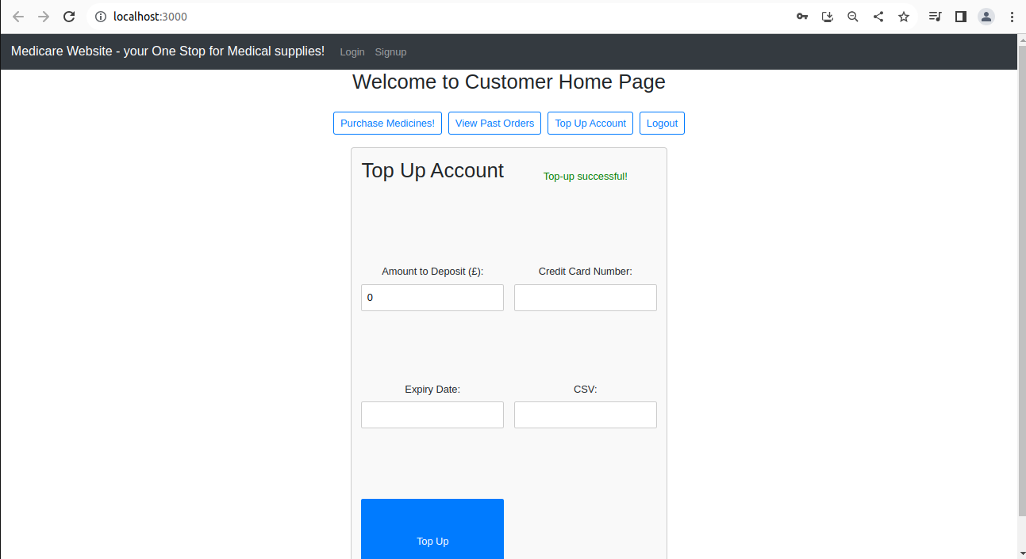

12) Login page for Admin

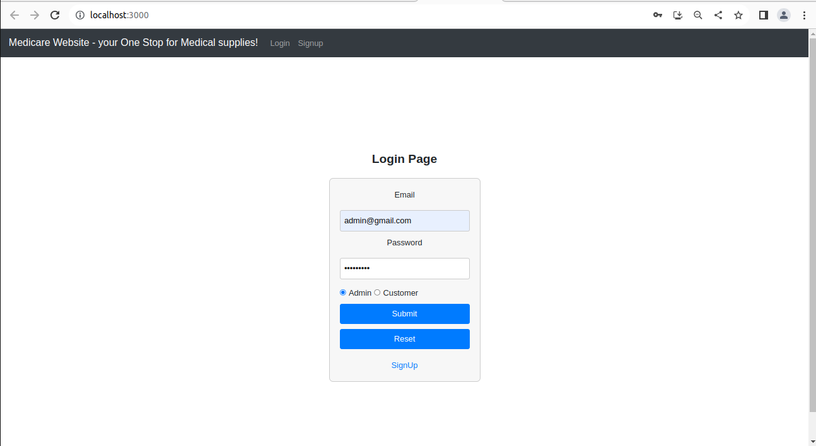

13) Login page for Admin password incorrect prompt

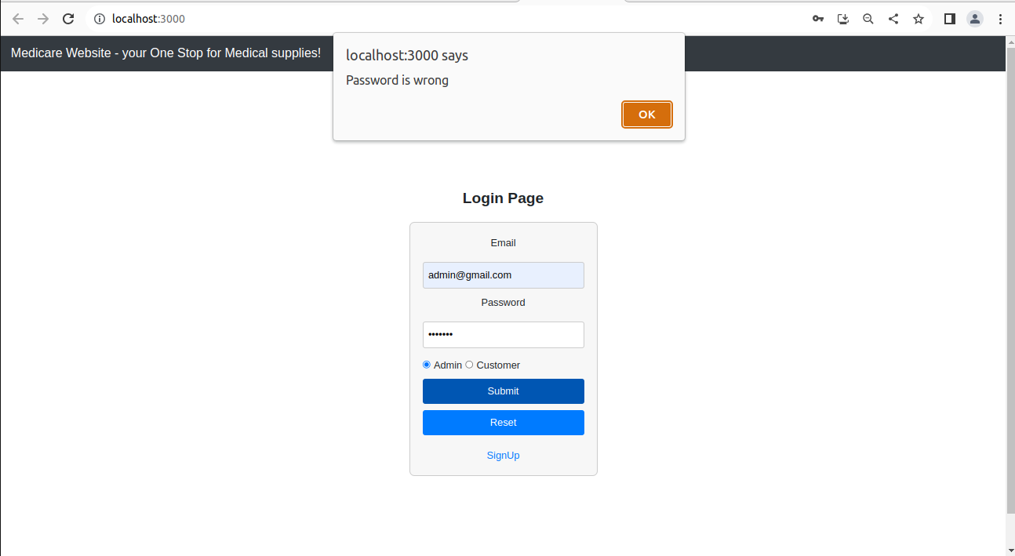

14) Admin Home Page

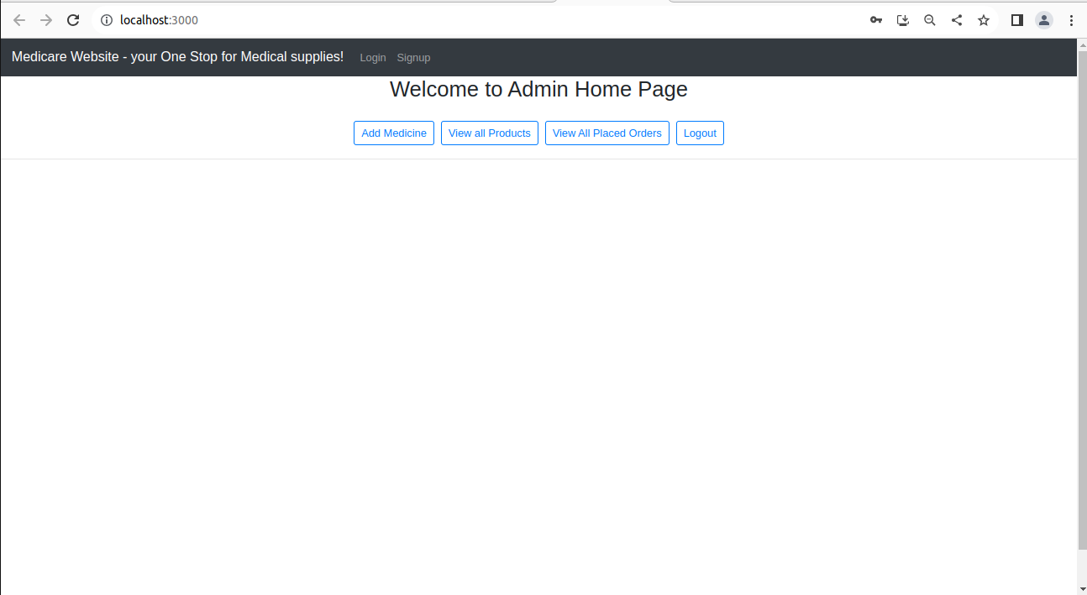

15)Add Medicine Page

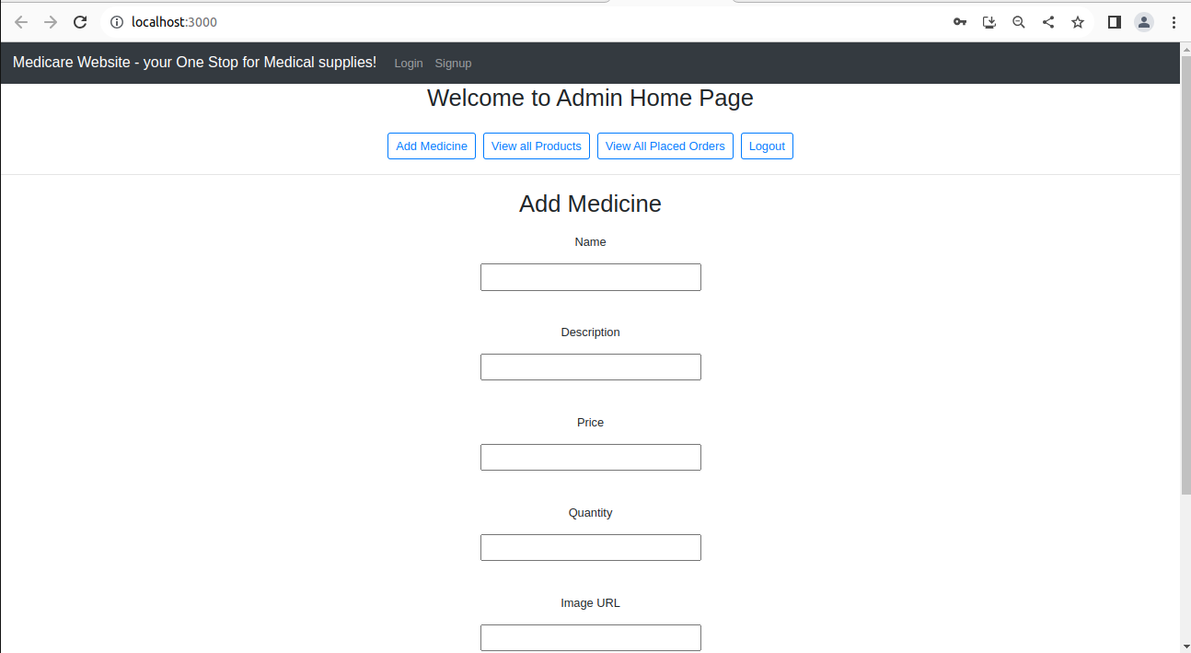



16) Add Medicine Page with data filled

If enable is clicked, the Item will appear to the customer!

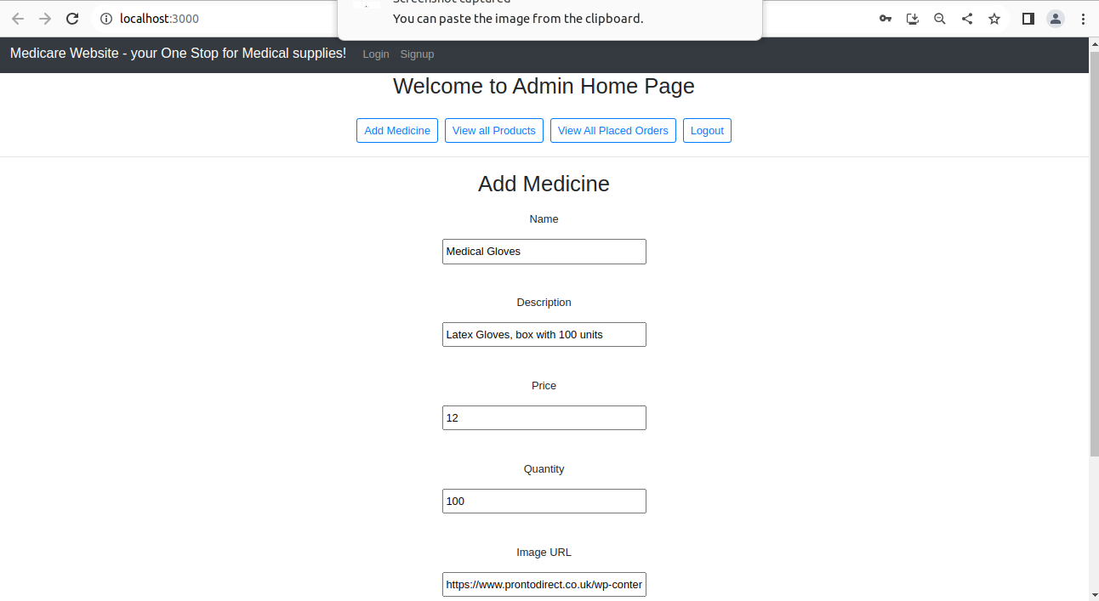



17) Medicine Created prompt

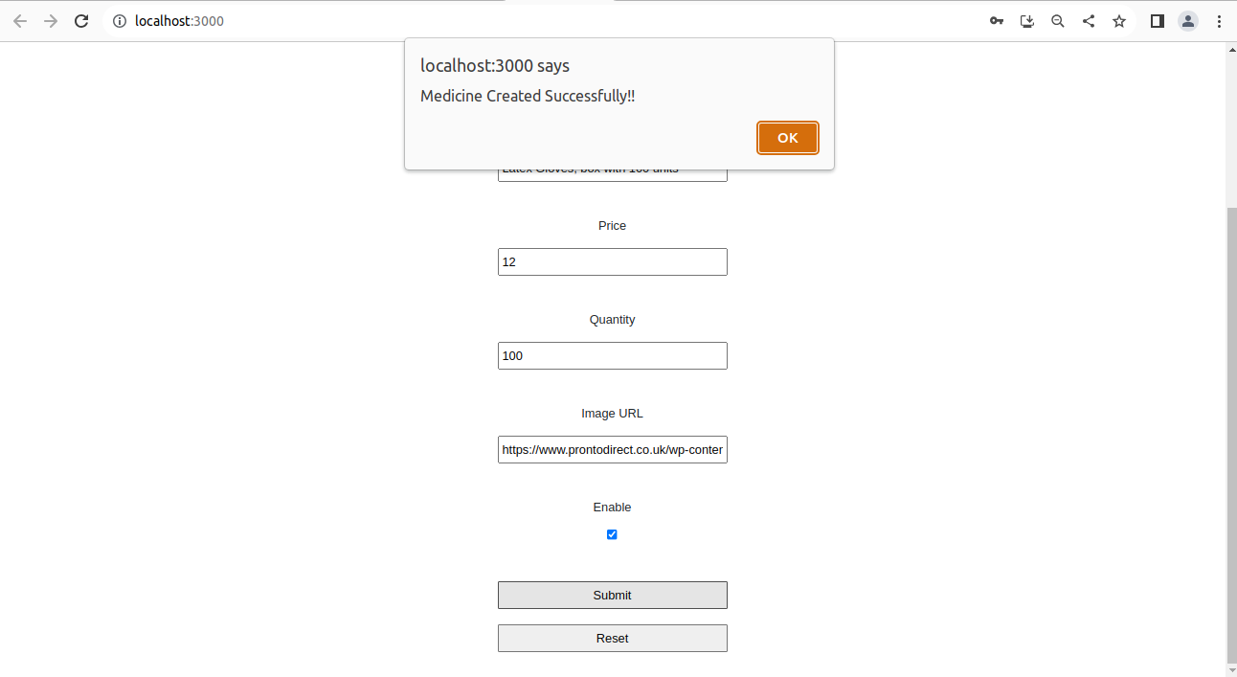

18) View All Products page

Can be search by name, or all are shown.

Edit, delete and Enable button! If enable button is clicked, it gets disabled and does not appear in the products shown to the customer.

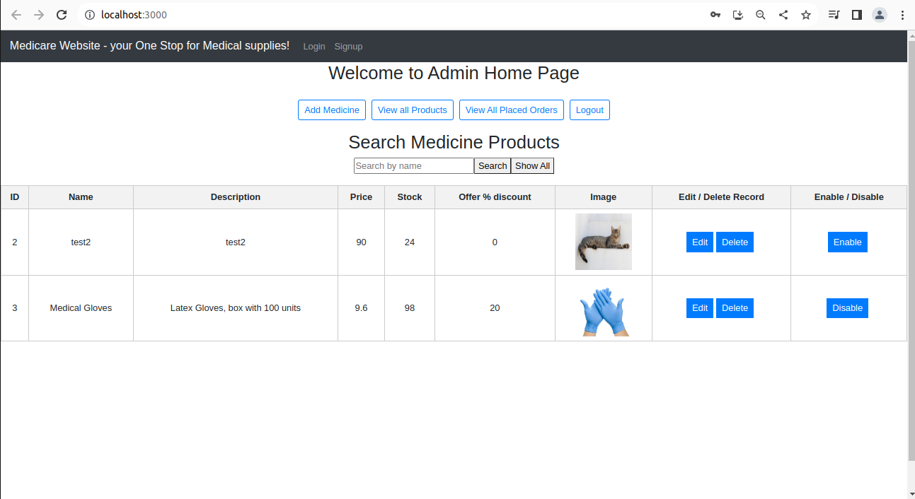

19)Edit Medicine

Offer in percentage can be inputted, the customer would see the discounted price. If empty it would return to the original price

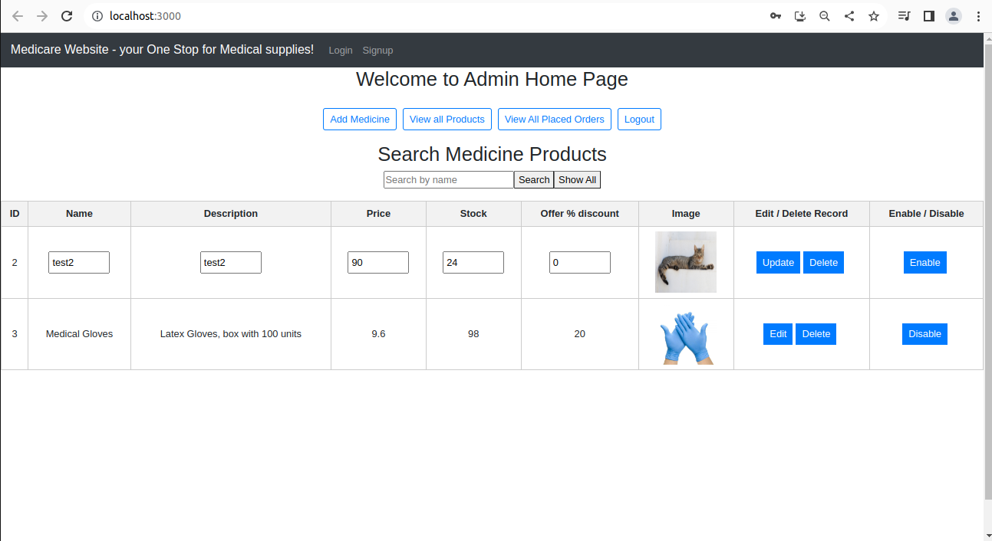

20) Admin can see all placed Orders Page

Page has pagination showing 10 orders per page

Filtering and ordering depending on order date, total cost or orderid

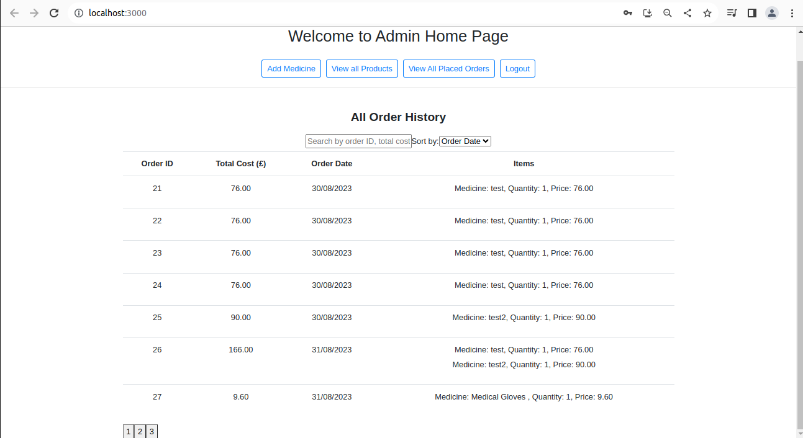

21) Tables created in the Database

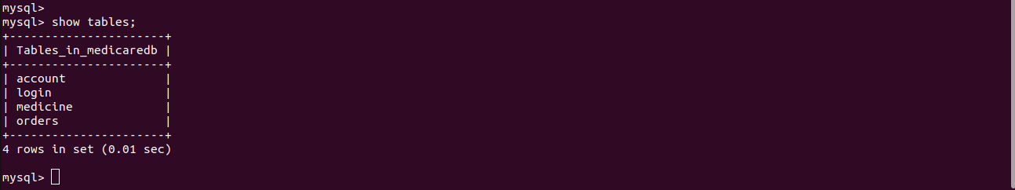

22) Account Table

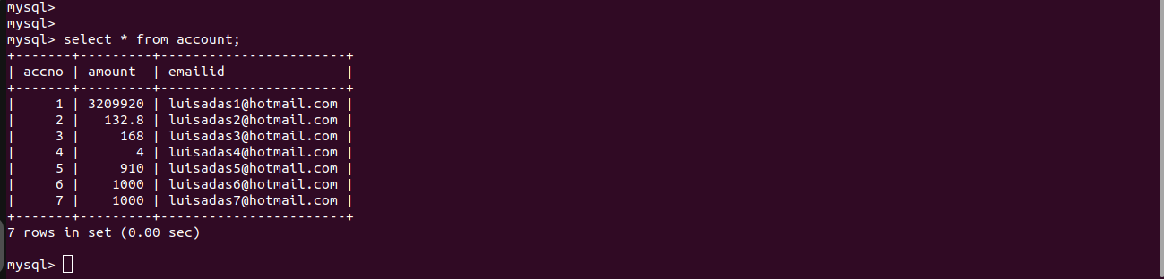

23) Login Table

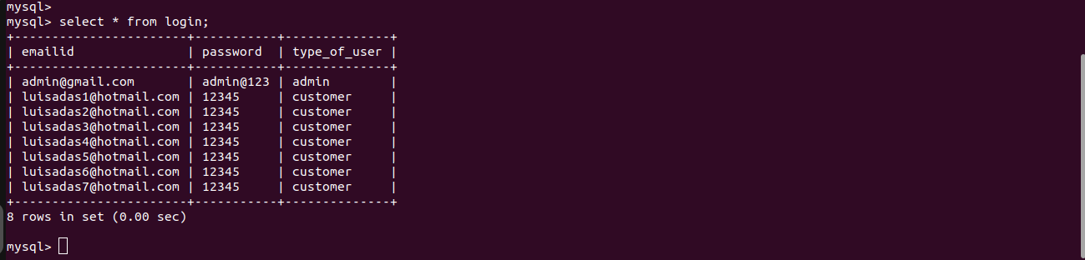

24) Medicine table

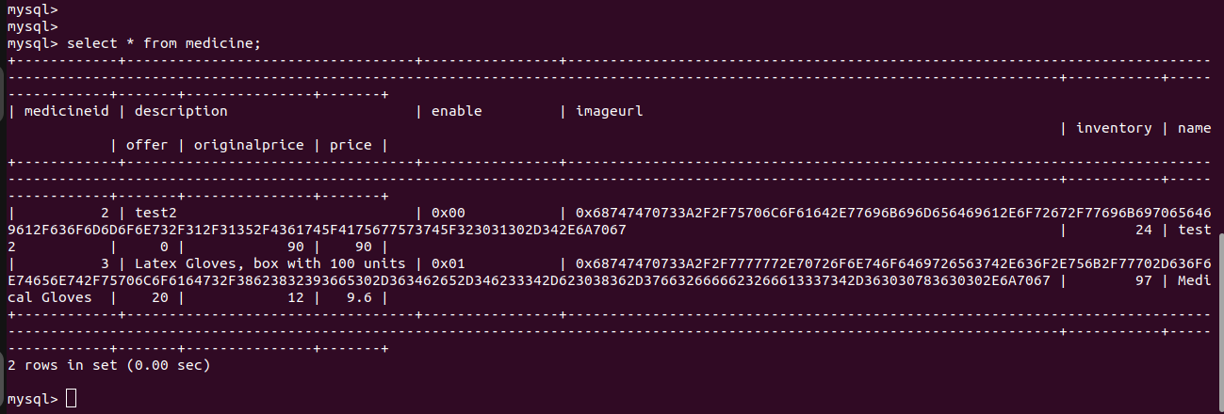

25) Orders table

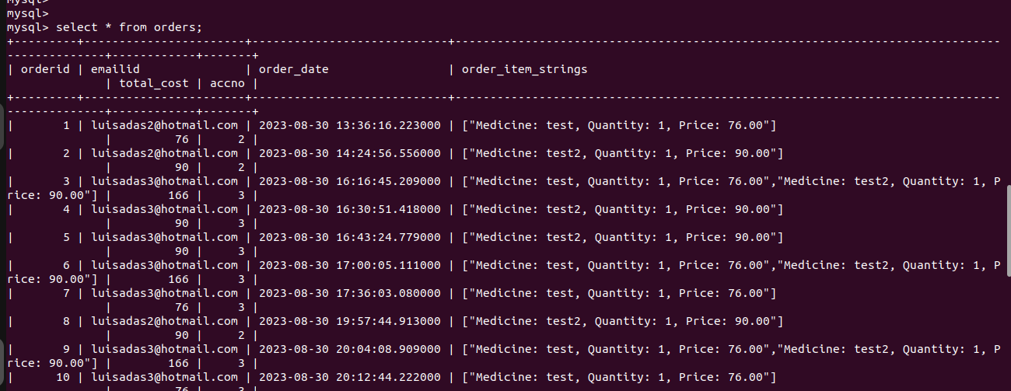

26) Jenkins create new User

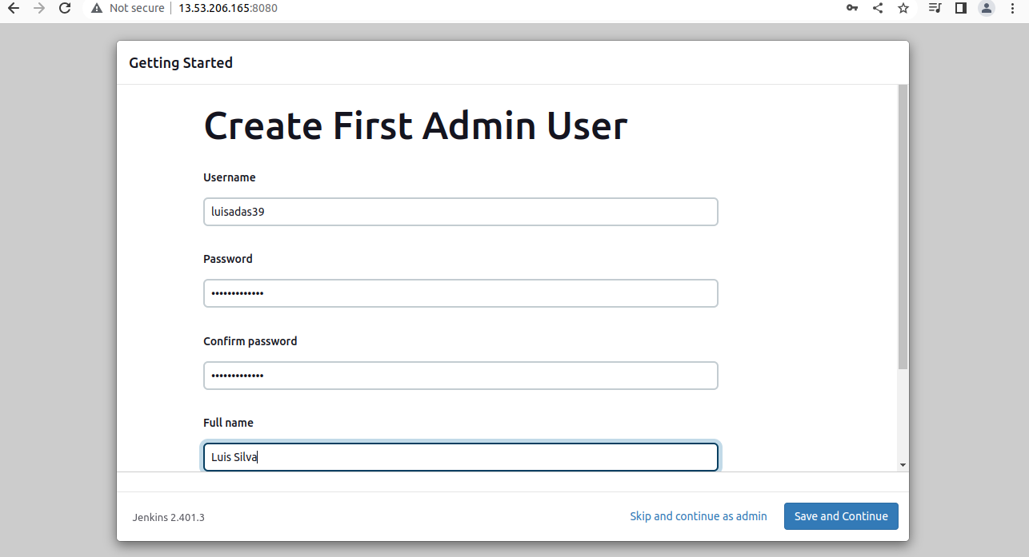

27) Jenkins Home Page

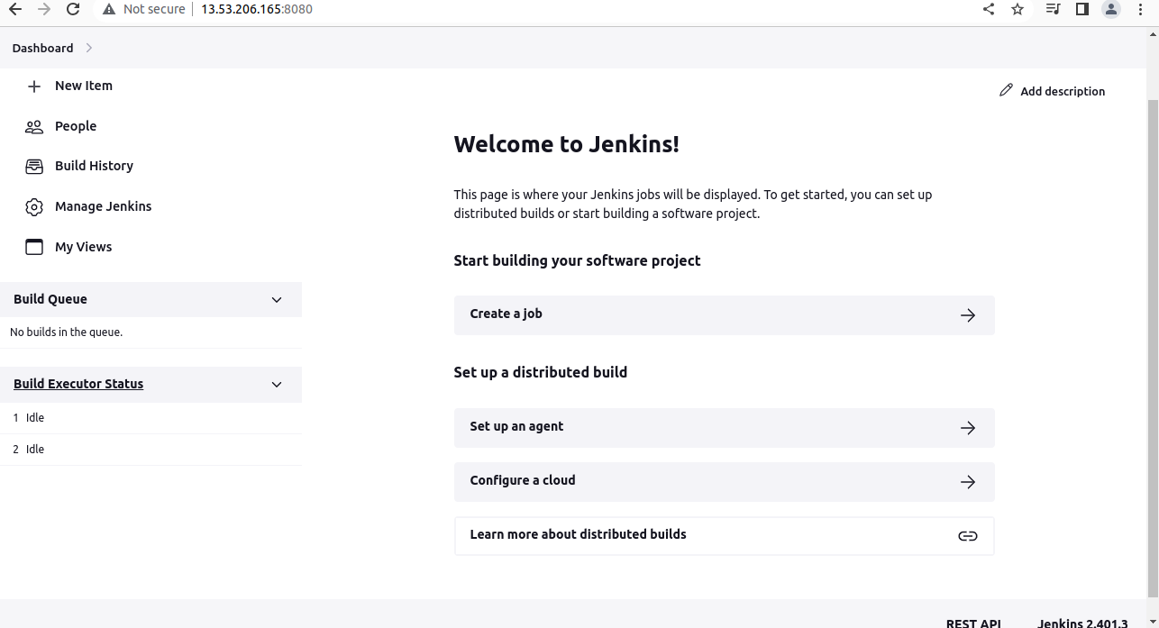

28) AWS SSH

