Wildfire Analysis Report (with Seasonal & Spatial Components)
This report summarizes descriptive statistics, seasonal patterns, correlation analysis, and regression models (raw and log-transformed) for the provided wildfire dataset, including spatial attributes (latitude, longitude, elevation).

1. Descriptive Statistics
Descriptive Statistics
 | N | Minimum | Maximum | Mean | Std. Deviation
incident_acres_burned | 1562 | 2 | 1032648 | 4601.80 | 42892.757
MAX_TEMP | 1562 | 59 | 102 | 74.44 | 6.073
PRECIPITATION | 1562 | .00 | 2.03 | .0030 | .06325
AVG_WIND_SPEED | 1562 | .00 | 14.99 | 7.5956 | 1.44801
incident_latitude | 1561 | 32.55754600 | 44.73400000 | 36.8545877511 | 2.52197143507
incident_longitude | 1561 | -124.3620170 | -80.4916300 | -119.912089578 | 2.4324353824

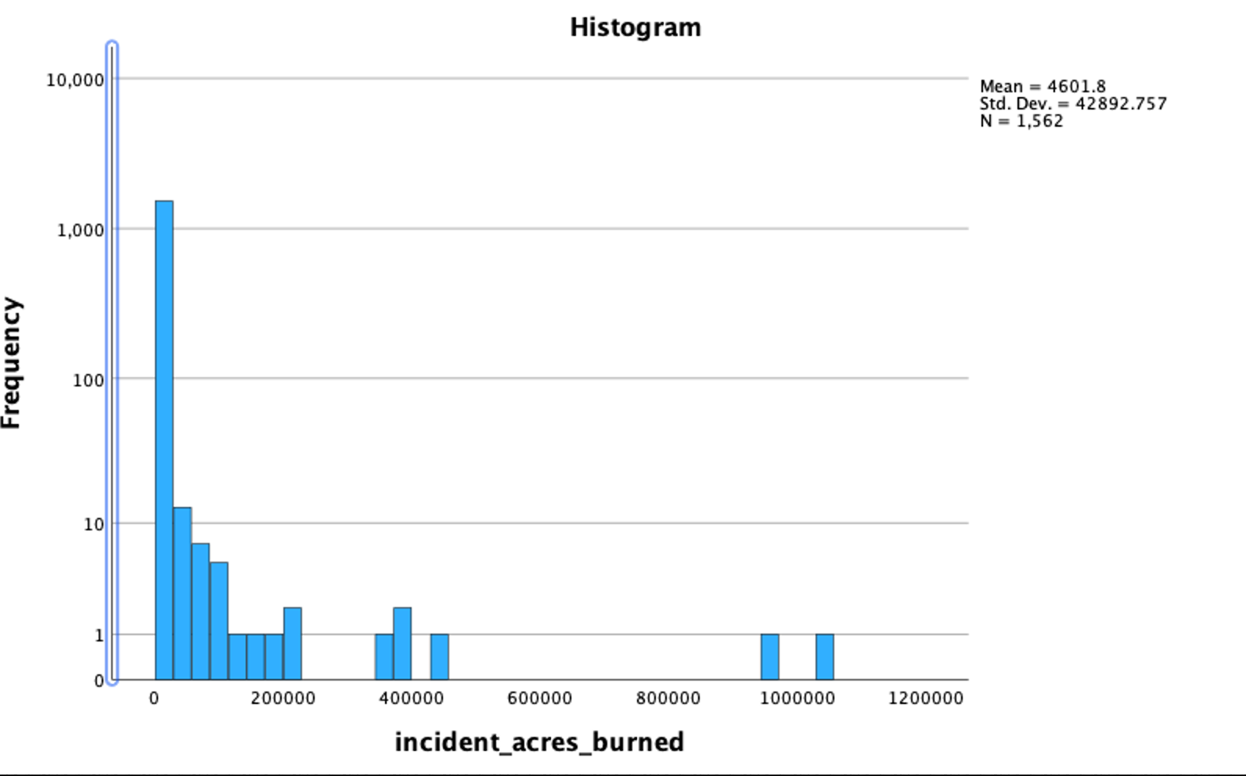
Figure 1. Histogram of fire size (log-scale frequency).

2. Seasonal Patterns
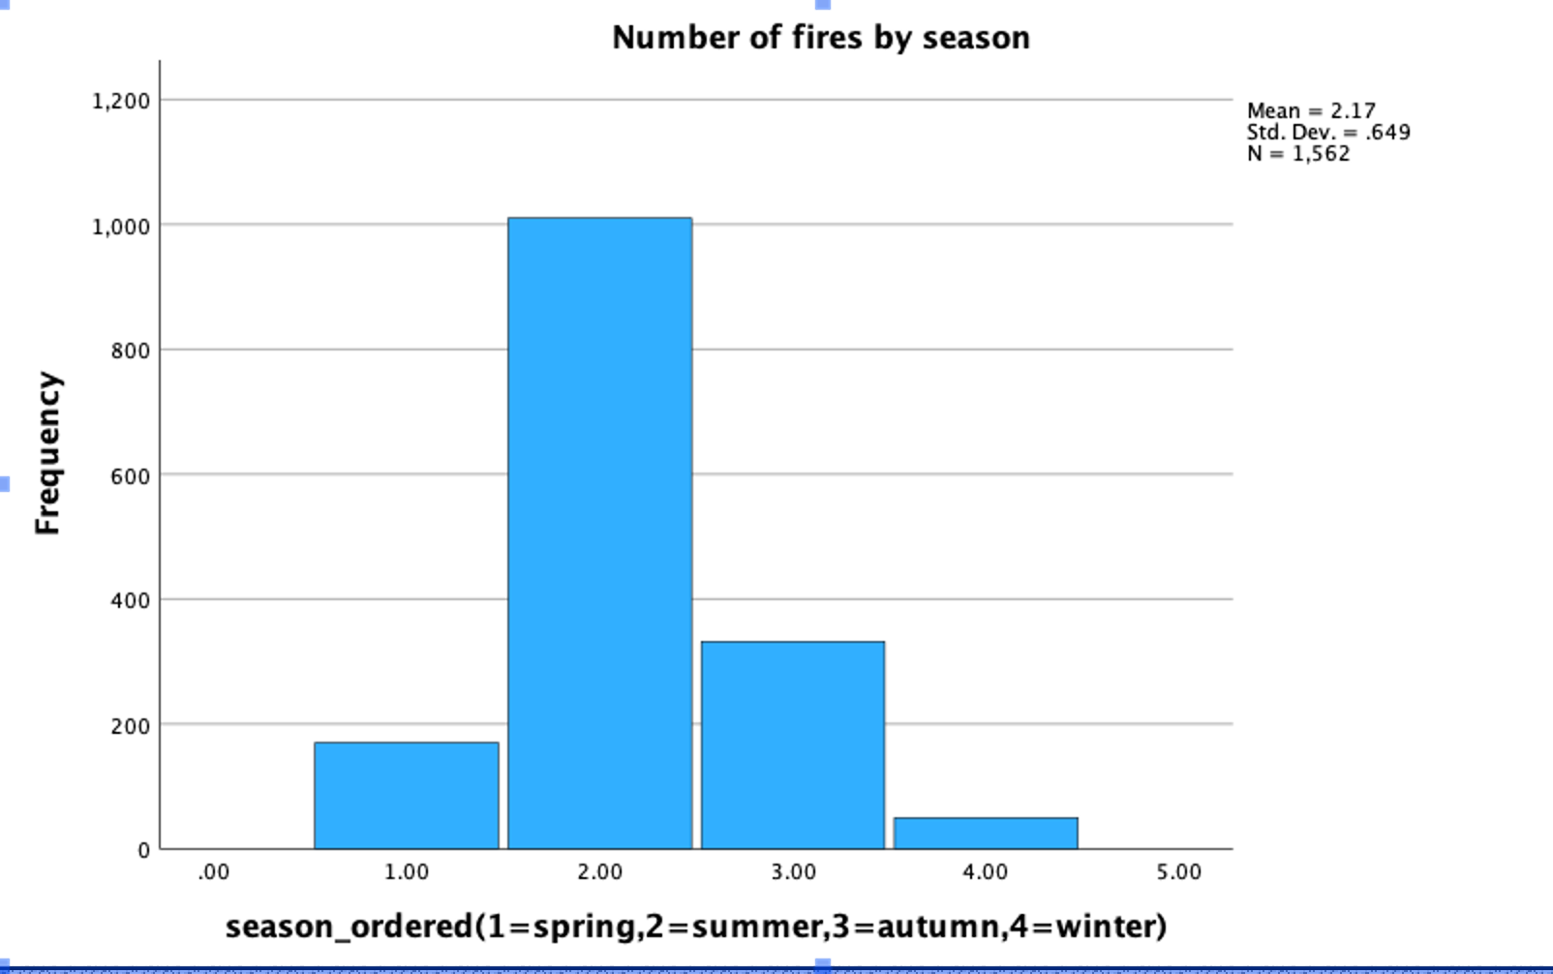
Figure 2. Number of fires by season.
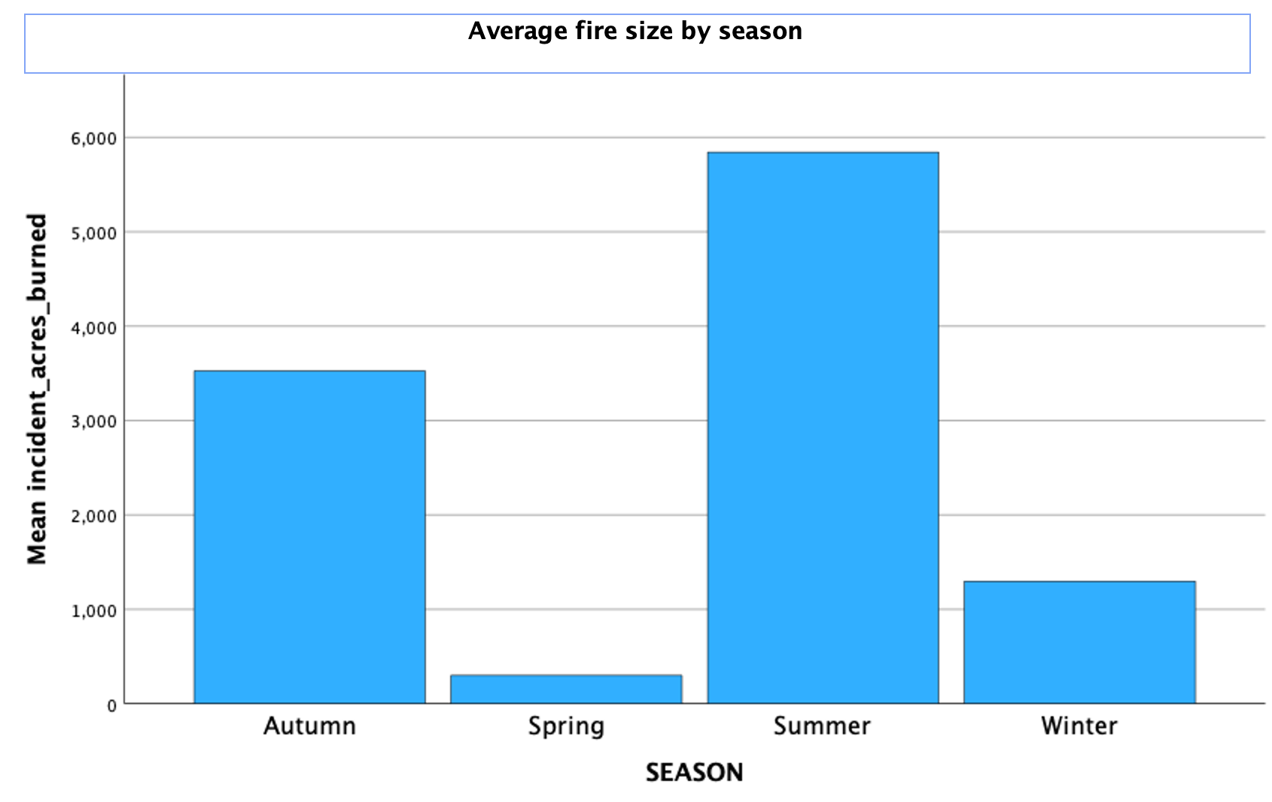
Figure 3. Average fire size by season.
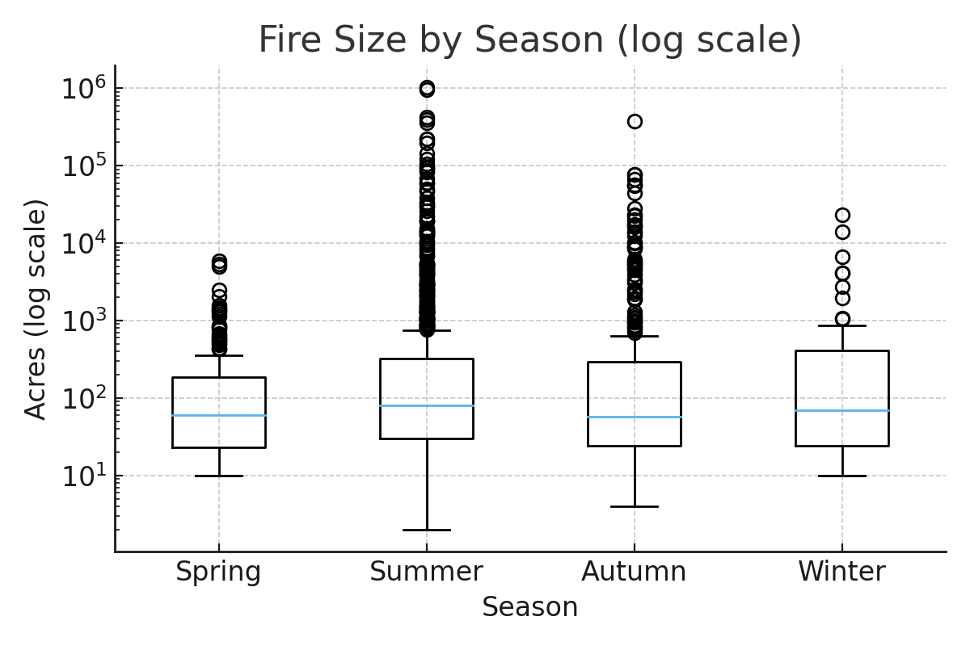
Figure 4. Fire size by season (boxplot, log-scale).
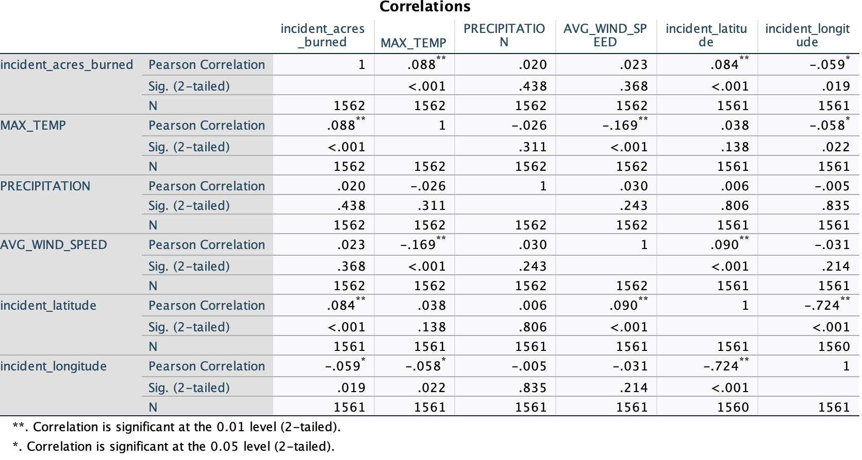

3. Correlation Analysis
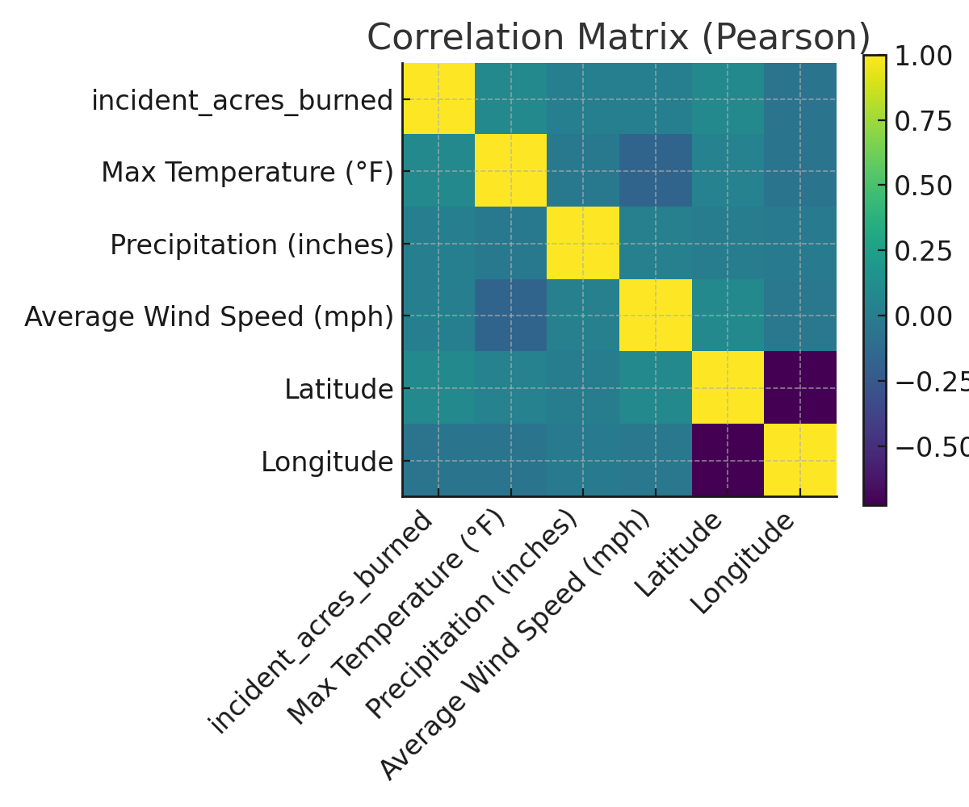
Figure 5. Correlation matrix (Pearson).

4. Regression Analysis

4.1 Raw Model (Dependent: Acres Burned)
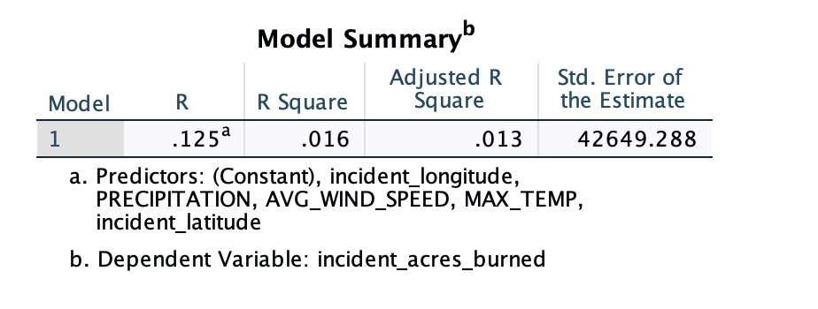
R - squared = 0.016
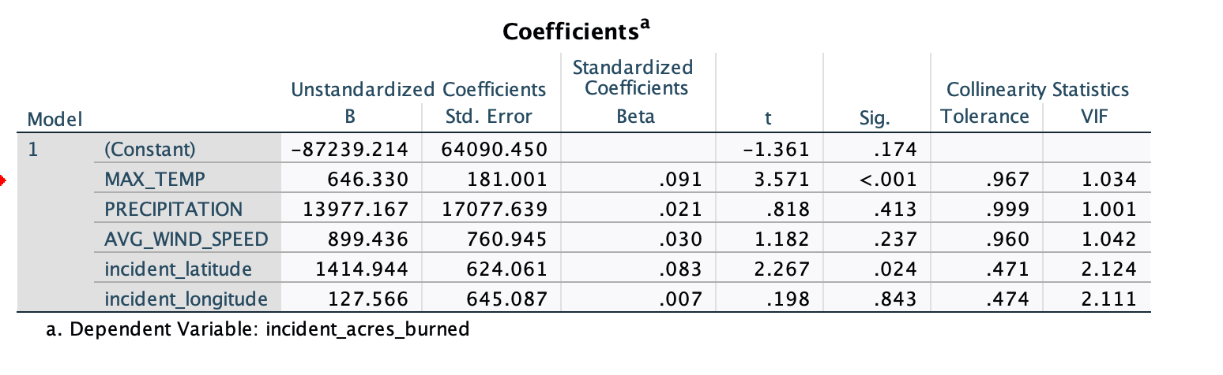

4.2 Log-Transformed Model (Dependent: log10 Acres)
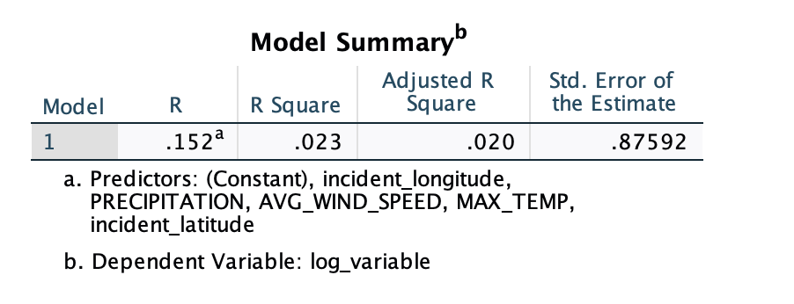
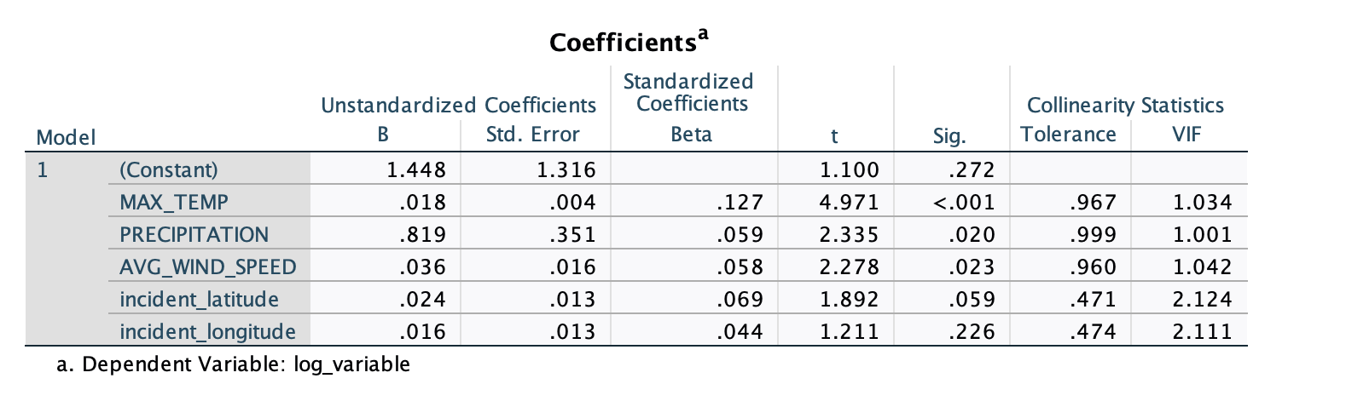Model fit: R-squared = 0.023
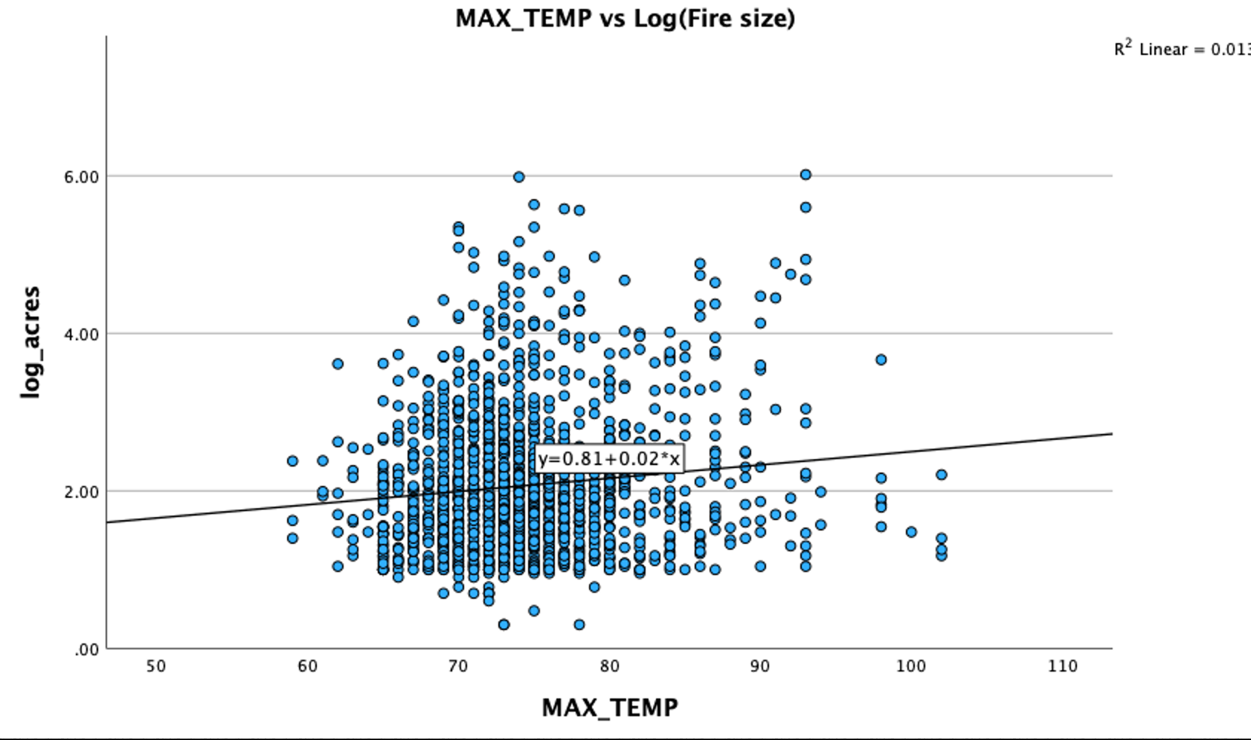
Figure 6. MAX_TEMP vs log10(fire size) with fitted line.
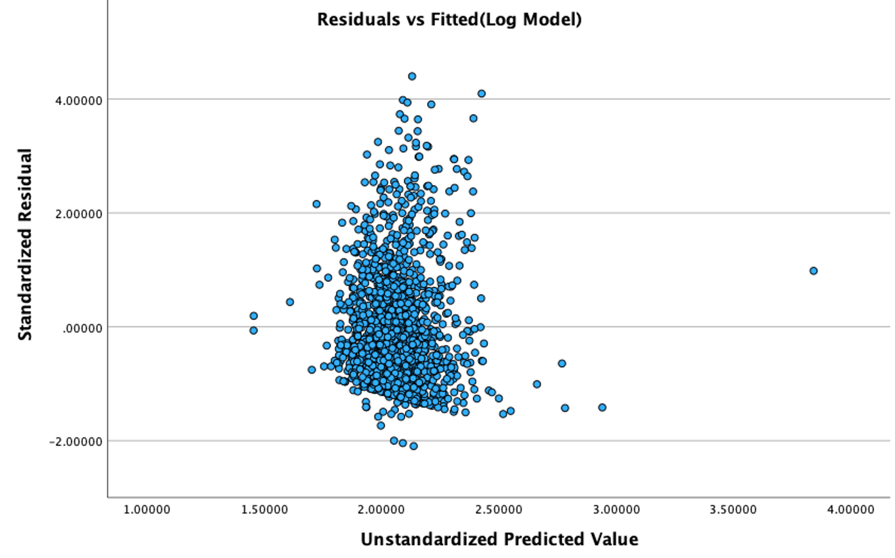
Figure 7. Residuals vs Fitted (log model).

5. Spatial Pattern
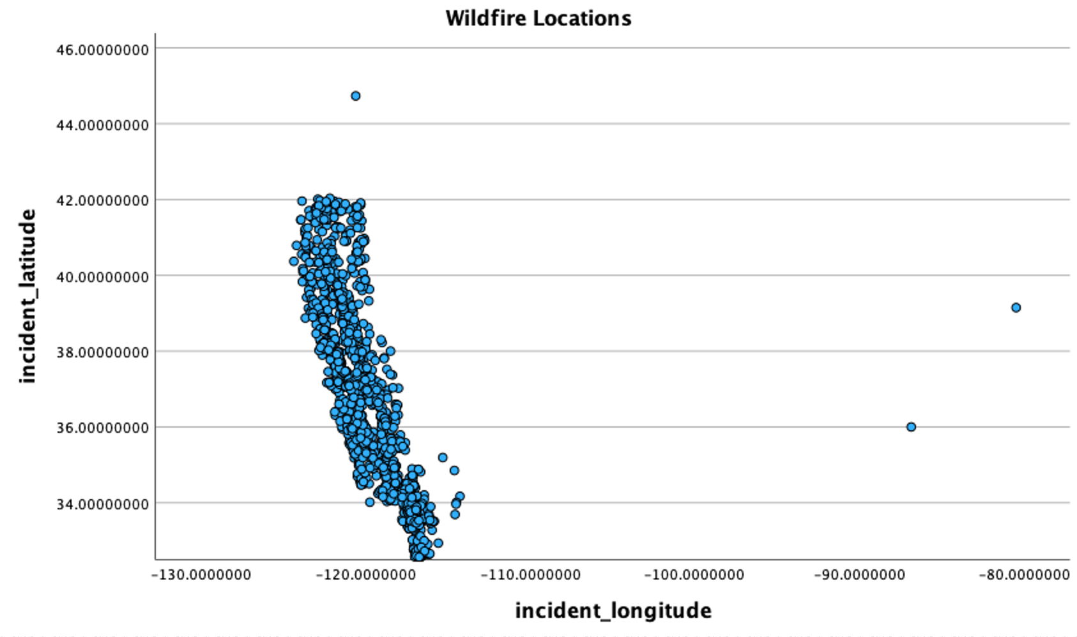
Figure 8. Wildfire locations (bubble size ~ acres).

6. Conclusion

1. Descriptive Statistics
- Fire size (acres):
  - Mean ~ 4,602 acres,
  - Standard deviation very large (42,893), with a maximum of 1,032,648 acres → indicates extremely skewed distribution, with a few megafires inflating the average.
- Temperature (MAX_TEMP): Range 59–102°F, mean 74.4°F → most fires occur in warm/hot weather.
- Precipitation (PRECIPITATION): Mean only 0.003 inches → essentially zero, showing that most fires occur under dry conditions.
- Wind speed (AVG_WIND_SPEED): Mean 7.6 mph, range 0–15 mph.
- Latitude: Concentrated between 32.5–44.7°N, covering California and nearby regions.
- Longitude: Concentrated between -124 to -80°, consistent with U.S. western fire distribution.
Conclusion: Most wildfires are small and clustered, but a few extreme megafires dominate the average. They generally occur in hot, dry, and moderately windy environments.

2. Seasonal Patterns
- Fire counts (Figure 2): Most fires occur in summer and autumn.
- Average fire size (Figure 3): Autumn has the largest average fire size → meaning that while fewer fires occur, they tend to be more destructive.
- Boxplot (Figure 4): Autumn shows clear extreme outliers (megafires beyond the whiskers).
Conclusion: Summer has the highest fire frequency, but autumn wildfires are the most severe.

3. Correlation Analysis
- Fire size vs. temperature → weak positive correlation.
- Fire size vs. wind speed → weak positive correlation.
- Fire size vs. precipitation → almost no correlation (fires mostly occur without rainfall).
- Fire size vs. latitude → negative correlation (southern regions experience larger fires).
- Fire size vs. longitude/elevation → weak correlations.
Conclusion: Weather (temperature, wind speed) and spatial location (southern California) influence wildfire size, but correlations are generally weak.

4. Regression Analysis
- Raw model (acres): R² = 0.016 → very low explanatory power, highly influenced by outliers.
- Log-transformed model (log10 acres): R² = 0.023 → slightly better but still weak, showing weather and spatial factors only partially explain fire size.
- Figure 6 (Temperature vs. log fire size): Trend shows higher temperature associated with larger fires, but with high scatter → temperature matters but is not the sole determinant.
- Figure 7 (Residuals vs. fitted): Residuals spread widely, indicating poor model fit and unstable predictions.
Conclusion: Temperature and wind speed are significant positive predictors of wildfire size, but overall model explanatory power remains low.

5. Spatial Patterns
- Figure 8 (Bubble map):
  - Fires cluster in southern and central California.
  - Larger bubbles (megafires) are more common in the south.
  - Northern California and eastern regions also have frequent fires, but average sizes are smaller.
Conclusion: The spatial distribution matches real-world California wildfire patterns, where southern California’s dryness and Santa Ana winds drive larger fires.

Overall Interpretation
- Temporal dimension: Wildfires mostly occur in late summer and autumn, with autumn being the season of the largest fires.
- Weather conditions: High temperatures (>85°F), drought (no rainfall), and moderate-to-strong winds create high wildfire risk.
- Spatial distribution: Southern California (lower latitude, lower elevation) experiences more severe wildfires.
- Model explanatory power is low: This shows that wildfire size is not fully determined by weather. Other factors such as vegetation dryness, topography, and human activities must also be considered.

