Google Cloud Platform:

How to Create a Project & Access BigQuery

This document will describe in detail how to set a project in your Google Cloud Platform as well as accessing Google BigQuery in Python through Pandas. Please follow the steps in order.

**Step 1:** Once you have created your account for Google Cloud Platform, you will need to create a new project. You can call this project whatever you like, I called mine “Capstone”. To do this, click on the icon in the upper left corner that is next to “Google Cloud Platform”. Which will bring you to another window where you can create a new project.

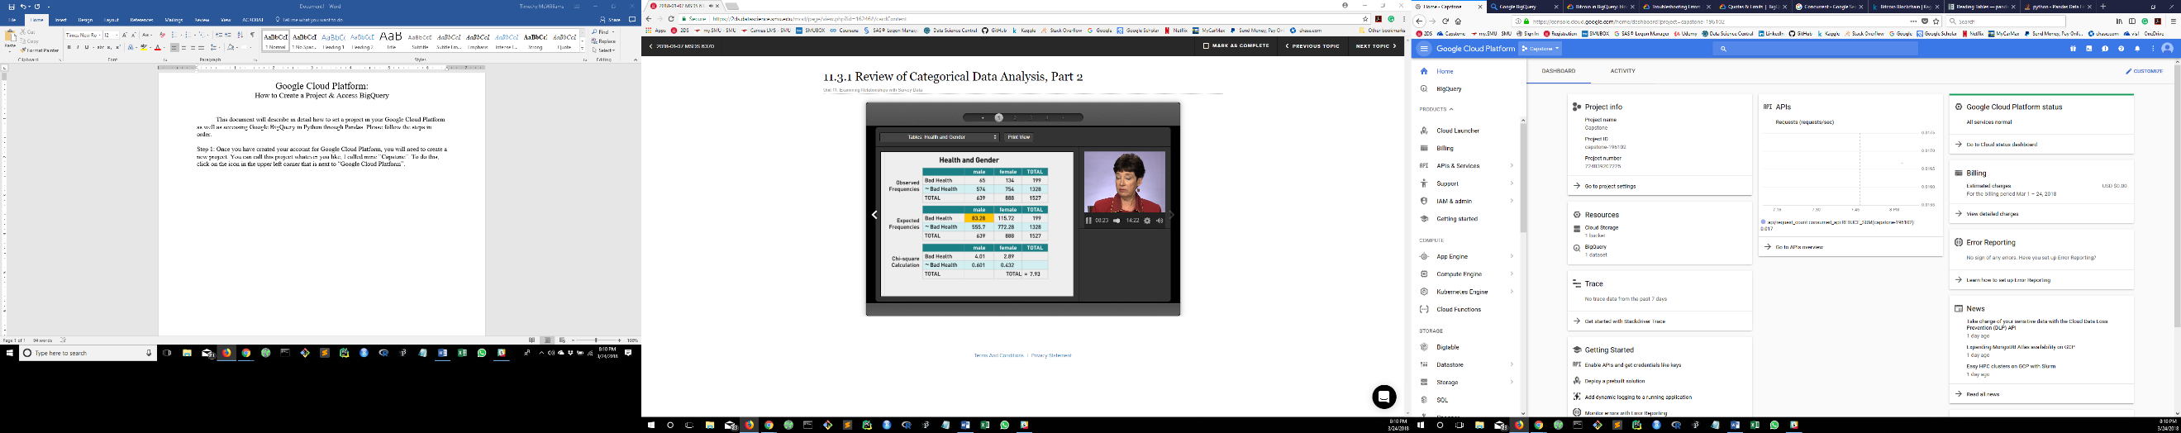

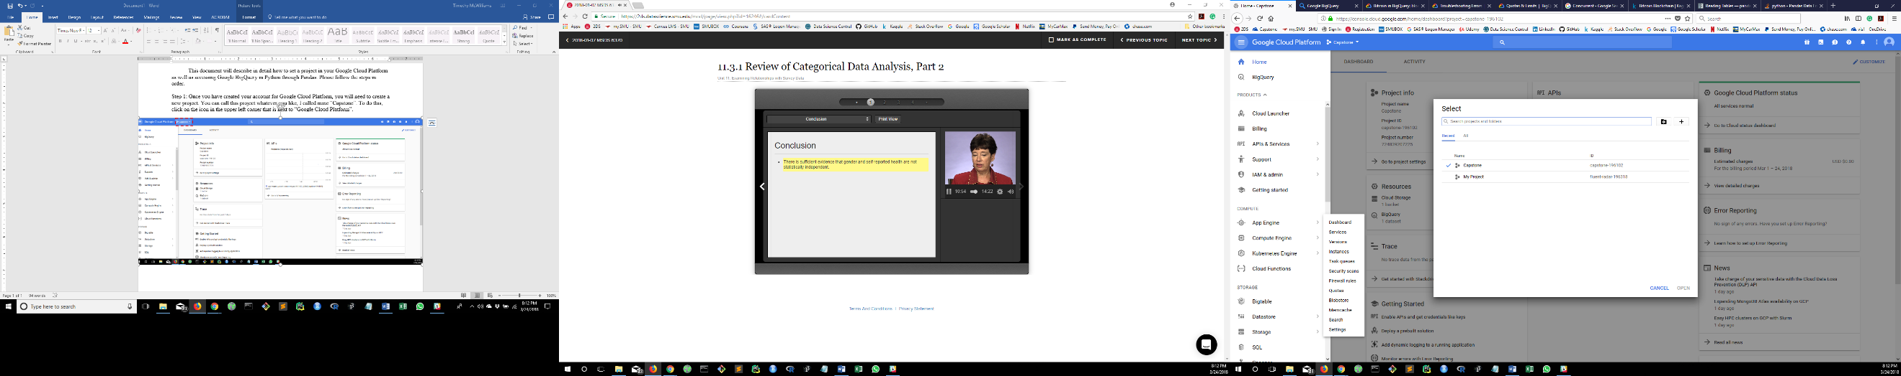

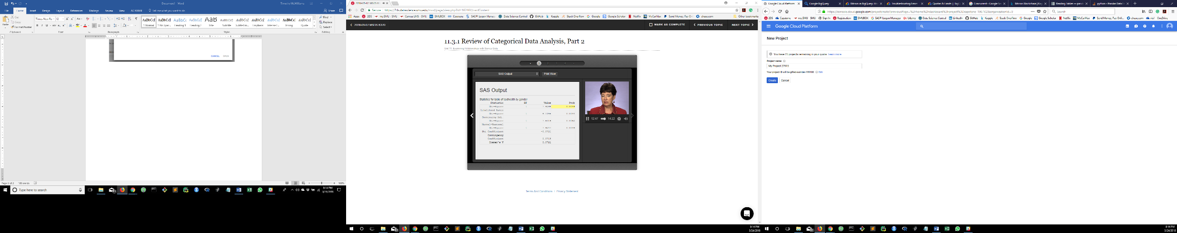

**Step 2:** Now, you are going to need to enable Google BigQuery. To do this you will need to go to the home page of your project (simply click on the “Home” link in on the left). On the home page of your project, scroll down and you will see a section that reads “Getting Started”. The first link in this section reads “Enable APIs and get credentials like keys”, click this. This will bring you to another page where you can enable certain APIs for the project, in our case BigQuery API. Click on “Enable APIs and Services” located up at the top of the page next to “Dashbard”. When clicking the “Enable APIs and Services” link it will bring you to another page. Simply search “BigQuery API” and then select the api. Then click “Enable”. Return to the home page of the project by clicking the “Google Cloud Platform” in the upper left corner.

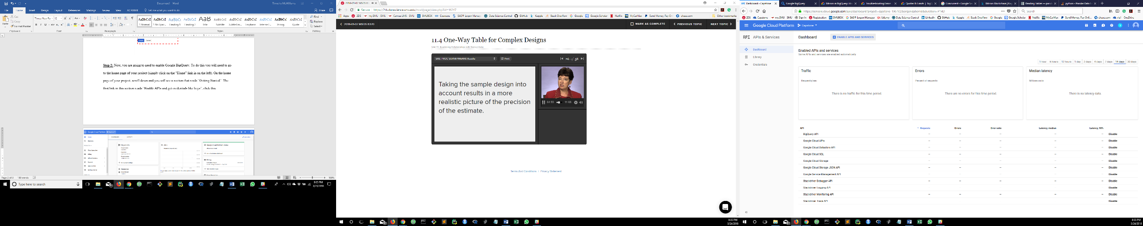

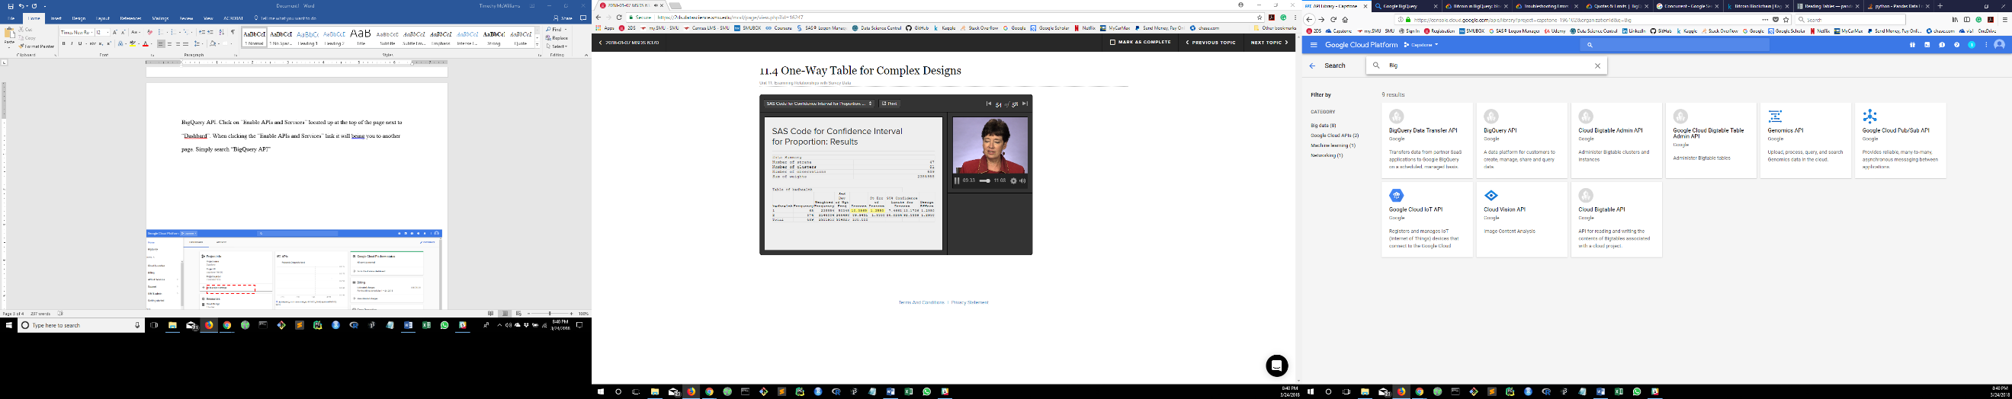

**Step 3:** On the home page of your project, there is a menu bar on the left hand side. These are all of the features you can have with your account for all of your projects. Now, scroll down this menu bar till you see the section called “Big Data”. You can access BigQuery this way. However, here is the link to the data we are looking for, <https://bigquery.cloud.google.com/dataset/bigquery-public-data:bitcoin_blockchain> . This will bring you right to the data. Click on the table you want to open, when opened there are options on the upper right side of the page. Click “copy table”. Pick your project, name the destination data set, and name the destination table (the dataset and table can be named whatever you want them to be. Do this for each table.

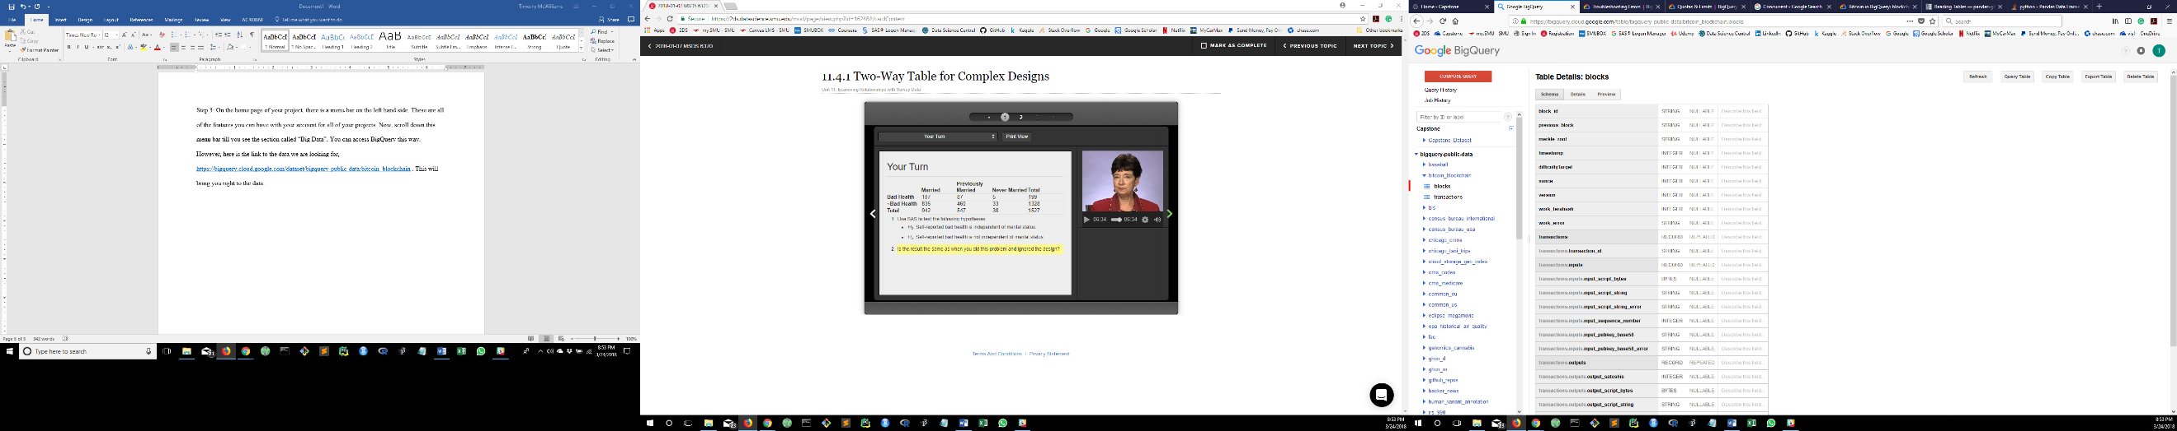

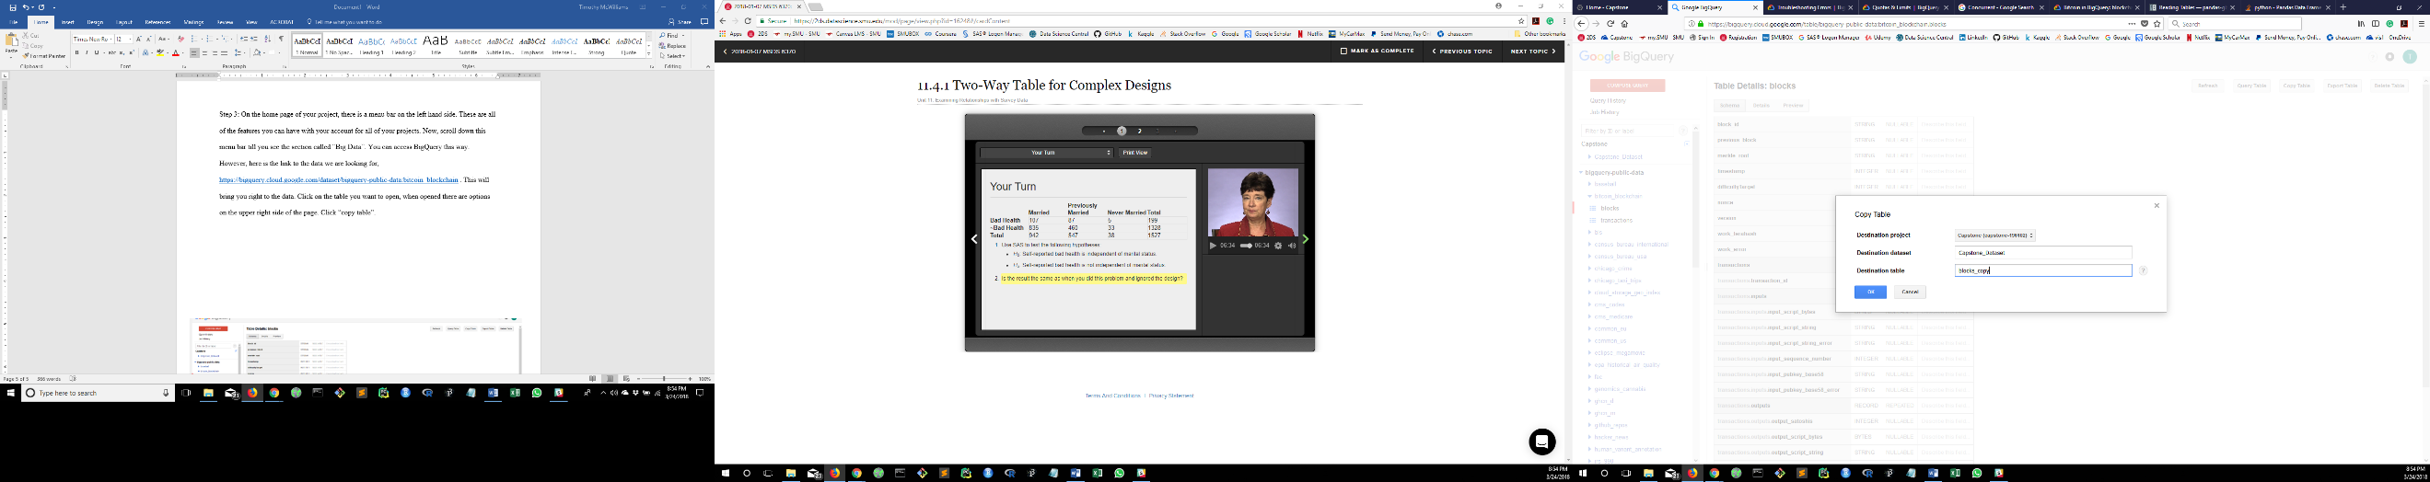

**Step 4:** Now that you have the datasets copied into your project we can open up python and make some queries. Navigate to your folder in which you want to store your code locally. Right click on folder where you want your code stored, and open Git Bash. Type in,

pip install pandas-gbq -U , this will install the needed library. Open python. Refer to my notebook that I uploaded along with this document. It will be easier to follow without screen shots.