AMERP Themes
Plugin: org.amerpsoft.themes
A collection of themes from different sources.

Amtheme: Standard Theme similar to ferrythem.
See FerryTheme from Hieplq on:
http://wiki.idempiere.org/en/Plugin:_Theme_ferrytheme

Amthemeblu: Blue Theme, Bigger Icons.

Ksys:
Maintainer: Ken_longnan - [ken.longnan@gmail.com]
Status: Beta, up to date with release 5.1
License: GPLv2
Sources: ksys-idempiere-theme

BusinessTeam and BusinessTeamBlue:

Maintainer: User:PabloValdivia
Main Copyright: Pablo Valdivia, EGS GROUP, Lima, PERU,

SYSConfig Considerations.

There are four undocumented variables in ZK_ family, that can be configured using SysConfig. In Class ‘ThemeManager.java’ these values are assigned using getValue Method:

‘ThemeManager.java’ (part)
/**
* @return url for large logo
*/
public static String getLargeLogo() {
String theme = getTheme();
String def =ITheme.THEME_PATH_PREFIX+theme+ITheme.LOGIN_LOGO_IMAGE;
return MSysConfig.getValue(MSysConfig.ZK_LOGO_LARGE, def);
}

/**
* @return url for small logo
*/
public static String getSmallLogo() {
String theme = getTheme();
String def = ITheme.THEME_PATH_PREFIX+theme+ITheme.HEADER_LOGO_IMAGE;
String url = MSysConfig.getValue(MSysConfig.ZK_LOGO_SMALL, null);
if (url == null)
url = MSysConfig.getValue(MSysConfig.WEBUI_LOGOURL, def);
return url;
}

/**
* @return name of active theme
*/
public static String getTheme() {
String theme = System.getProperty(MSysConfig.ZK_THEME);
return Util.isEmpty(theme) ? MSysConfig.getValue(MSysConfig.ZK_THEME, ITheme.ZK_THEME_DEFAULT) : theme;
}

/**
* @return url for browser icon
*/
public static String getBrowserIcon() {
String theme = getTheme();
String def = ITheme.THEME_PATH_PREFIX + theme + ITheme.BROWSER_ICON_IMAGE;
return MSysConfig.getValue(MSysConfig.ZK_BROWSER_ICON, def);
}

Default values are assigned on ‘ITheme.java’ interface.

//default theme
public static final String ZK_THEME_DEFAULT = "default";
//logo
public static final String LOGIN_LOGO_IMAGE = "/images/login-logo.png";
public static final String HEADER_LOGO_IMAGE = "/images/header-logo.png";
public static final String BROWSER_ICON_IMAGE= "/images/icon.png";
//theme resource url prefix
public static final String THEME_PATH_PREFIX = "/theme/";

Sysconfig Configurable Values:

ZK_LOGO_LARGE

This is the image that is shown when User Log in.

ZK_LOGO_SMALL

Default Value for image on upper left corner where search field and menu button is located.
It can’t be modified by each Client, in order to have information on what client user is working.
It has to be very small graphic file, otherwise may override main search field and menu button.
See included header-logo-amerp.png ( 3 KB) sample on documentation folder.

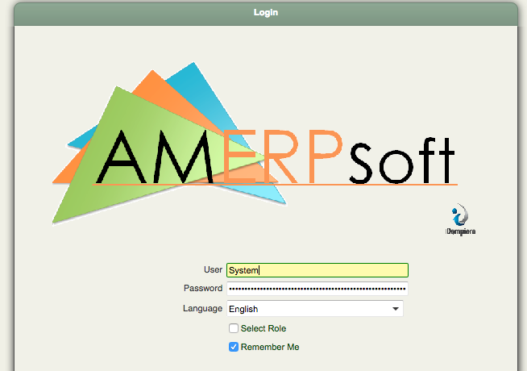

Is similar to default value: LOGIN_LOGO_IMAGE.
Configured Value: /theme/amtheme/images/login-logo-amerp.png
* theme: SIMILAR Default THEME_PATH_PREFIX.
** amtheme: Theme’s name.

ZK_LOGO_SMALL
This is the image located on main Window, close to Menu Button.
Is similar to default value: HEADER_LOGO_IMAGE.
Configured Value: /theme/amtheme/images/header-logo-amerp.png
* theme: SIMILAR Default THEME_PATH_PREFIX.
** amtheme: Theme’s name.

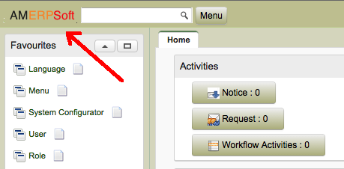

ZK_BROWSER _ICON
This is icon image locate at the top of navigator:

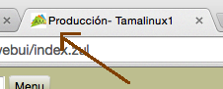

Is similar to default value: BROWSER_ICON_IMAGE.
Configured Value: /theme/amtheme/images/icon-amerp.png
* theme: SIMILAR Default THEME_PATH_PREFIX.
** amheme: Theme’s name.

ZK_THEME
This Variable is already configured on iDempiere.
Option Values:
Configured Value: default
When using this Plugin, user can select betwen Themes defined:

Values for plugin Themes:
amtheme
amthemeblu
ksys
businessteam
businessTeamBlue

CARLOS RUIZ : Sample HeaderPanel Extends
https://groups.google.com/forum/#!searchin/idempiere/client$20logo$20carlos$20ruiz%7Csort:date/idempiere/mRhPxhL5seQ/JsVsecCHAQAJ
What I have done is to include a class in my theme plugin.
A local HeaderPanel extending org.adempiere.webui.panel.HeaderPanel
and overwriting this method like:
@Override
protected void onCreate() {
//log.warning("...onCreate...AMHeaderPanel..");
super.onCreate();
Image image = (Image) getFellow("logo");
if (image != null) {
try {
org.zkoss.image.Image logo = ThemeManager.getClientWebLogo();
if (logo != null) {
image.setContent(logo);
} else {
image.setSrc(ThemeManager.getSmallLogo());
}
image.setVisible(true);
} catch (IOException e) {
// TODO Auto-generated catch block
e.printStackTrace();
}
}
}
Then you can use the desktop-header class and the clientlogo image in
your theme header.zul file. Also desktop.zul file must contain include header,zul.

