LCO_Gobalqss Withholding
Multiple Vendor Invoices by Luis Amesty Updated 2-feb-2018
Updated Dec-2018
Update October 2019: Procedure for Withholding Document generation

Description:

This Plugin is intended to solve Venezuela´s requirement for Withholding Documents Registration and Printing. These Modifications include Multiple Invoices registering.
Carlos Ruiz – GlobalQSS, developed original Plugin. Actually is tested on Idempiere Version 2.1, 5.1 and intended to be tested on Version 361 soon.

Model:

Added two tables LCO_InvoiceWHDoc and LCO_InvoiceWHDocLines support Multi-invoice Withholding Document. LCO_InvoiceWithholding Table has been modified to support additional field C_BaseTax_ID, this has been done in order to establish relation between C_Invoice Table and LCO_InvoiceWithholding Table using C_Invoice_ID and C_BaseTax_ID.

Callout:
LCO_CalloutWithholding Callout Modifyed for Invoice Validation. Method: InvoiceDocWHValues.

Pack out:

New Pack 2Pack.zip file.
Old Pack file renamed to 2Pack_old.zip
It can be located on META-INF folder on source code.

Plugin Source:

Source code may be downloaded from:
https://bitbucket.org/amerpsoft/amerpsoft-idempiere-community/src/default/

Application Dictionary:

Create DocumentType:
AP Withholding Document Multiinvoice and
AR Withholding Multiinvoice.
Create Reference: C_DocType DocBaseType. Add Options APW y ARW.
Create Validation Code:
C_DocType ARW/APW Invoices Withholding
Code: C_DocType.DocBaseType IN ('ARW', 'APW') AND C_DocType.IsSOTrx='@IsSOTrx@' AND C_DocType.AD_Client_ID=@#AD_Client_ID@
Create Sequence for Document Type included:
AP Invoice - Withholding Number MultiInvoice.
See Figure 1 for Sequence Details.
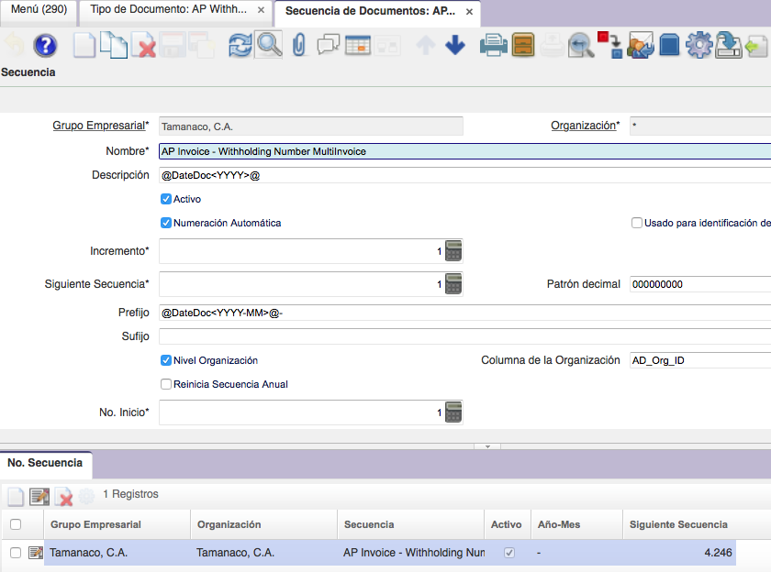
Figure 1

