1.- Demonstrate single threaded 120K pixel sharpening 10+ times and examine htop noting CPU used and number of cores. Compare to 12M pixel sharpening 10+ times and again note CPU used.

1.a: ./sharpen Cactus-120kpixel-sharpen.ppm Cactus-120kpixel-sharpened.ppm

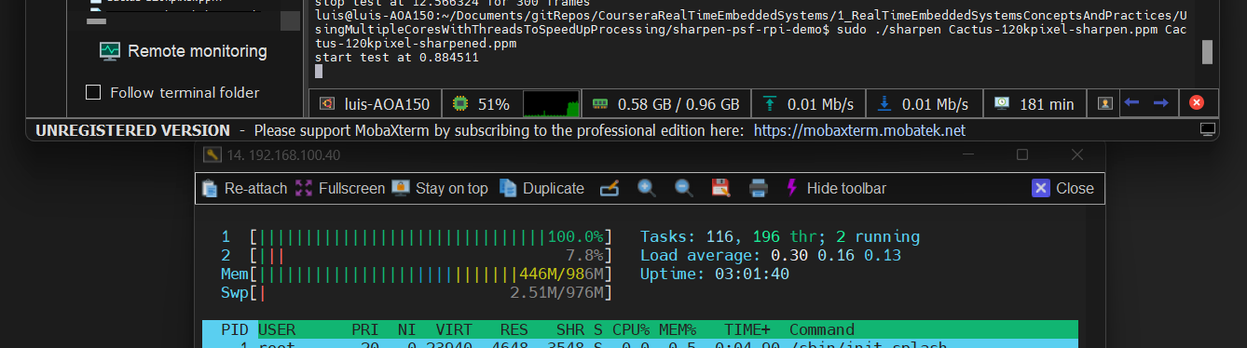
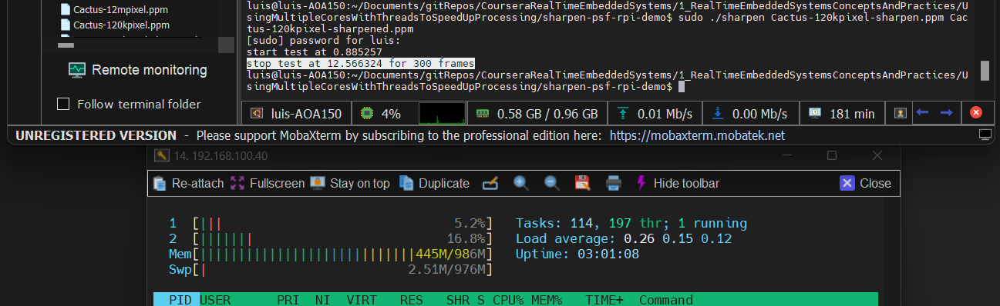
Total time 12.56 s
1.b: ./sharpen Cactus-12mpixel.ppm Cactus-12mpixel.ppm

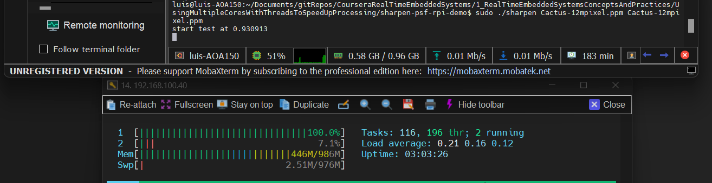

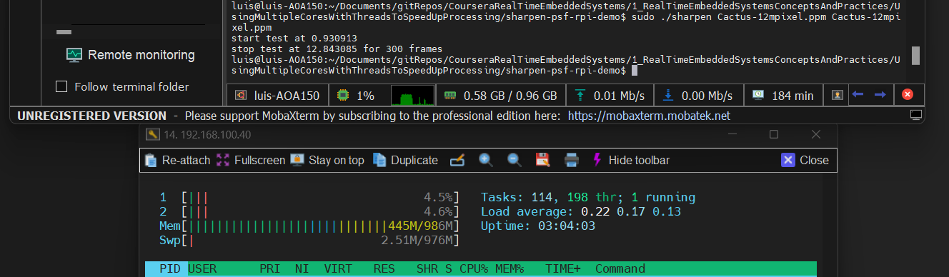
Total time 12.84 s

./sharpen Cactus-120kpixel-sharpen.ppm Cactus-120kpixel-sharpened.ppm ---- 12.56s
./sharpen Cactus-12mpixel.ppm Cactus-12mpixel.ppm ----------------------------- 12.84s

2.- Demonstrate 4+ threaded 120K pixel sharpening 10+ times and examine htop noting CPU used and number of cores. Compare to 12M pixel sharpening 10+ times and again note CPU used.

2.a ./sharpen_grid Cactus-120kpixel-sharpen.ppm Cactus-120kpixel-sharpened.ppm

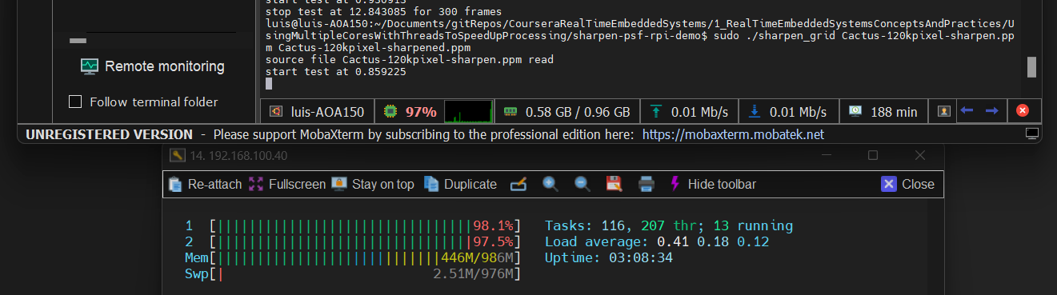
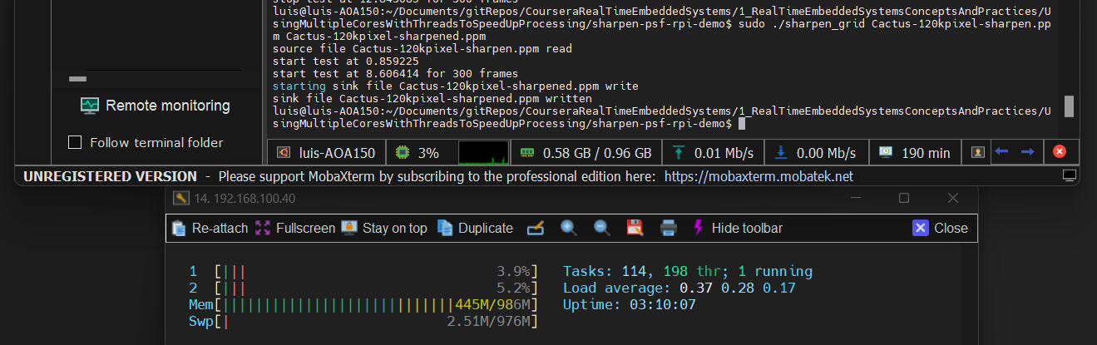
Total time 8.60 s

2.b ./sharpen_grid Cactus-12mpixel.ppm Cactus-12mpixel.ppm

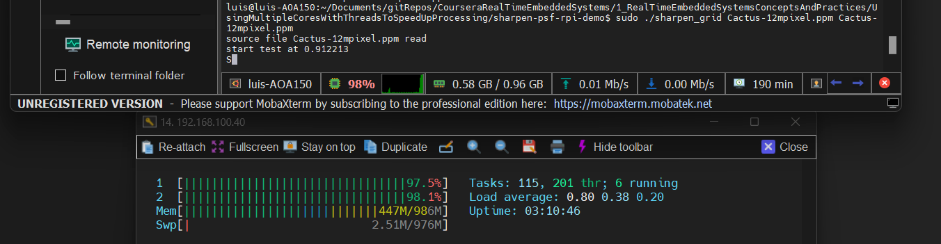
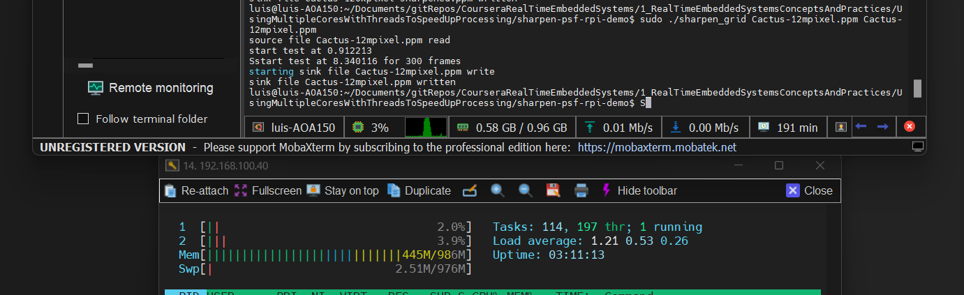

Total time 8.34 s

./sharpen_grid Cactus-120kpixel-sharpen.ppm Cactus-120kpixel-sharpened.ppm ---- 8.606s
./sharpen_grid Cactus-12mpixel.ppm Cactus-12mpixel.ppm ----------------------------- 8.34s

3.- Compare 4+ threaded 12M pixel sharpening frame rate and completion time latency to single-threaded.

./sharpen Cactus-12mpixel.ppm Cactus-12mpixel.ppm ----------------------------------- 12.84s
./sharpen_grid Cactus-12mpixel.ppm Cactus-12mpixel.ppm ----------------------------- 8.34s

Conclusion: with more threads the time is better.

