Capstone Project
The battle of the neighborhoods

1.Introduction

Problem Background
Public Schools in Madrid had experimented a big increase of people demanding running activities for their children out of school premises. Madrid City Hall is creating a new project to cover those requests and, in order to better aim the activities to be done, Madrid City Hall asked for a way to group Public Schools taking into account the kind of activities that could take place near them since creating a program per school is not feasible due lack of resources.

Success Criteria
Create groups of Public Schools attending to the close amusement venues.

2.Data

Madrid City Public School Data

- Source: Madrid City Hall - https://datos.madrid.es/egob/catalogo/202311-0-colegios-publicos.csv
- Data of interest: School name and coordinates
- Data overview:

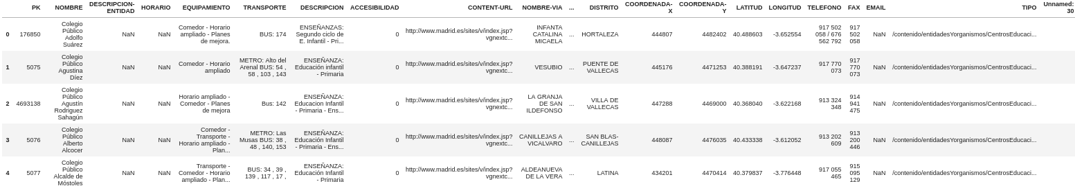

Foursquare Venues Data

- Source: Foursquare API - https://foursquare.com/
- Data of interest: Near venues, category and coordinates
- Data Overview:
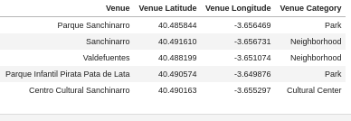

3.Methodology

Analytic Approach

These are the steps to create the groups of Public Schools:
• Gather and clean Schools data
• Select coordinates per school and look for close venues of certain categories
• Create a list of the most common kind of venues of those categories per school
• Create clusters of schools attending to most common venues
• Review information about generated clusters to better understand the schools categories

4.Exploratory Data Analysis

Madrid City Public School Data
After some data cleaning and filtering, it can be seen how the different Public Schools are distributed in Madrid:

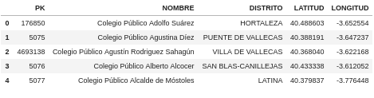

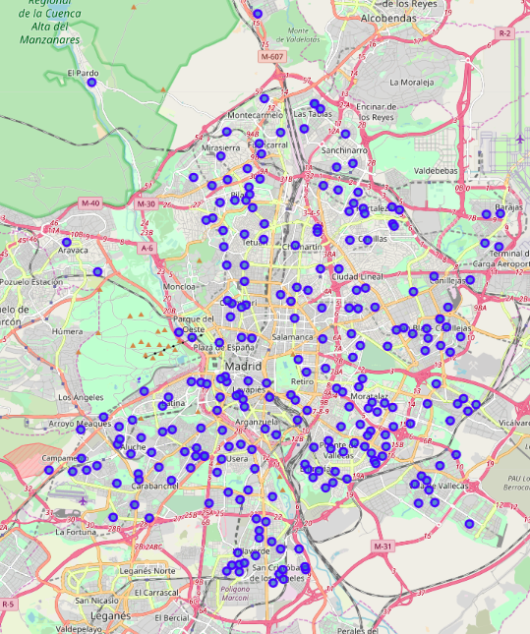

Foursquare Venues Data
Foursquare API provides a way to get close venues of certain categories. Reviewing all categories, some of them are interesting for obtaining possible locations to run activities with children, such "Outdoors & Recreation", "Museum", "Music Venue" and "Performing Arts Venue" for each school: https://developer.foursquare.com/docs/resources/categories

Those categories have some subcategories, and some of them are out of the interest for the propose of this document so were removed from the study. Those categories are the ones including these words in their names: 'Gym', 'Neighborhood', 'Fitness', 'Yoga', 'Bar', 'Dog', 'Restaurant', 'Club', 'Park', 'Plaza'

Using the search endpoint of the Forusquare API and matching with the location of the Public Schools it’s possible to get a list of the most common venue categories close to each school:

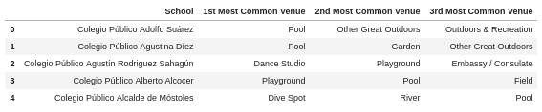

5.Results
After some tests, grouping Public Schools in 3 types seems to be a good approach. These are some of the most common venues in those groups:

Group 0:
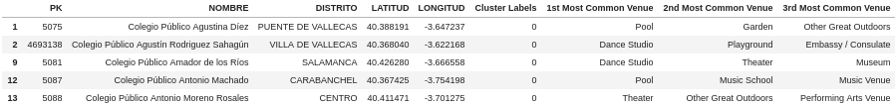
Group 1:
Group 2:

It's possible to have 3 differentiated groups of Public Schools in Madrid attending to their close venues than can be used for running activities with children:

- Type 0: School with close water activities
- Type 1: School with close sport centers and (possible) outdoor activities
- Type 2: School with close music and arts venues

Regarding location of each type, there is a clear distinction between the distribution of type 2 and type 0/1.

Type 2 schools are mainly located downtown while types 0 and 1 are in the suburbs. Type 1 is also mainly distributed among south-east of Madrid city.

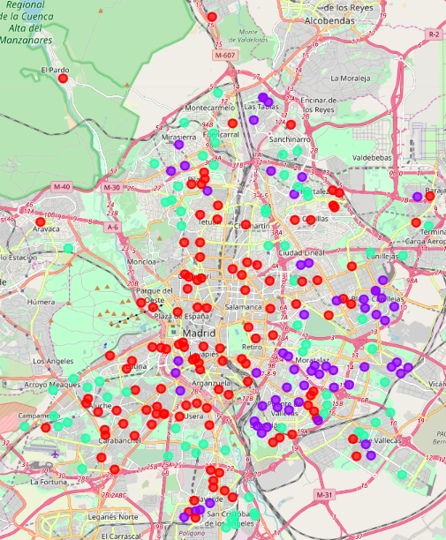

6.Conclusion

From the results it's clear that Madrid City Hall should promote art/music activities for Public Schools located in Downtown, since it this kind of venues are more easily to access from them. For Public Schools located in the suburbs the recommendation would be to promote sports activities, and it could be a good idea to specifically focus in water activities (pools) since those ones are close to the majority of Public Schools in that areas.

Another option is to have two different programs for Public Schools in the suburbs, one focused in indoor/outdoor sports and another one focused just in pool activities.

Even though we end up with three categories of Public Schools, due the kind of the most common categories of closest venues, it could make sense to have to big programs one focused in arts and music for downtown Public Schools and another one focused in sports for suburbs Public Schools.

